Câu 1

Wach 1: 2134

Wach 2: 533

Wach 3: 133

Câu 2

12.0

Câu 4

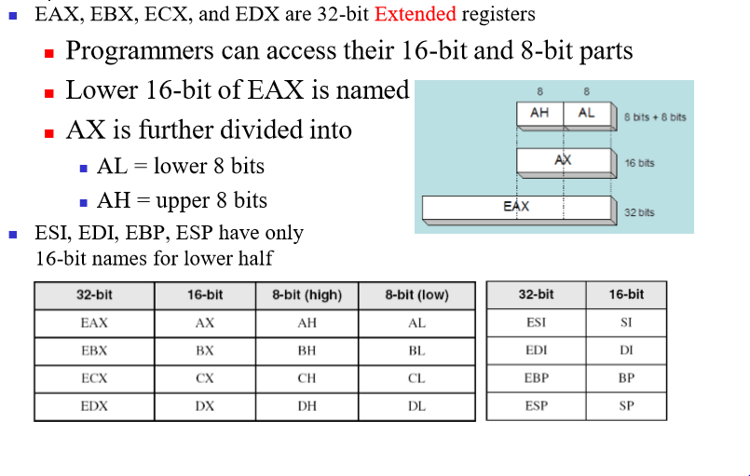

MOV AL, 0F

ADD AL, F1

0000 1111

+

1111 0001

1 0000 0000

Carry = 1

Zero = 1

Câu 6

A rotational delay (độ trễ truyền lệnh)is the amount of time between information requests and how long it takes the hard drive to move to the sector where the requested data is located. In other words, it is a time measurement, in ms (milliseconds), of how long before a rotating drive can transfer data.

Seek time (tìm kiếm vị trí) is the time taken for a hard disk controller to locate a specific piece of stored data. Other delays include transfer time (data rate) and rotational delay (latency).

Access time(thời gian truy cập giữa 2 lần liên tiếp) is the time from the start of one storage device access to the time when the next access can be started.

Transfer time (thời gian vận chuyển dữ liệu)

Access time = (seek time) + (rotational delay) + (transfer time)

Câu 7

-89.2345

C2B27810 = 1100 0010 1011 0010 0111 1000 0001 0000

Câu 8

in the interconnection system among computer components (e.g.. CPU, memory, I/O) the number of address line goverms

->The maximum

Câu 11

CMP a,0

JAE L1

JMP next

L1:

CMP 9,a

JAE L2

JMP next

L2:

ADD a,48

MOV x, a

next:

CMP a, 10

JAE L3

JMP end

L3:

CMP 15, a

JAE L4

JMP end

L4:

ADD a, 55

MOV x, a

end:

Câu 12:

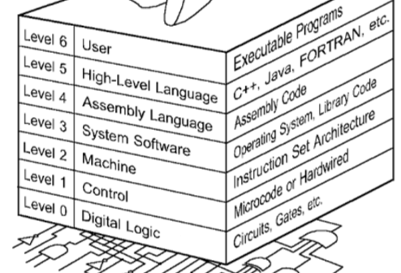

Câu 14

Registers for x86 processor

CS =>IP

SS => SP

Bù 2 <https://ncalculators.com/digital-computation/1s-2s-complement-calculator.htm>

Câu 18

Encrypt XOR

Câu 19

PUSH => decrment by 2

Câu 20

Có dấu:

JE =

JLE <=

JGE >=

JL <

JG >

Không dấu

JE =

JA >

JB<

JAE >=

JBE >=

Chọn JL

Câu 22

CMP => comparing

Câu 26

A0-A10

D1-D8

Có 2^11x8

=2^10x8x2

=2Kx8

TMS4016 SRAM 2Kx8bit

Câu 27

EAX is the full 32-bit value

AX is the lower 16-bits

AL is the lower 8 bits

AH is the bits 8 through 15 (zero-based)

Câu 32

Speed CPU

Pipelining

Branch prediction

Data flow analysis

Speculative execution

Câu 33

Floating point 32 bit

76650000h=

1.16116794980905813177098013612E33

Câu 34

DL= 10 Chọn 10h

DL=0FFh chọn 1

DL=17h chọn 1

DL = 0Ah chọn 10h

Câu 35

MOV AL,-5

SUB AL, 123

= -128 = 1111 1111 1000 0000 (bù 2)

Zero flag 0

Sign flag 1

Carry flag 1

Câu 36: Bài tập 2 tính CPI