**Chapter 4: Basic SQL**

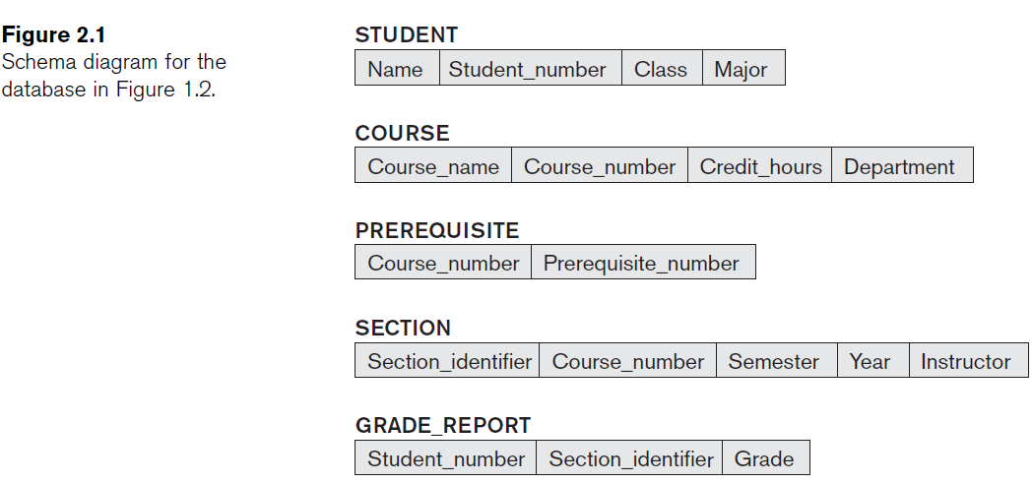

1. **Consider the database shown in Figure 1.2, whose schema is shown in Figure 2.1. What are the referential integrity constraints that should hold on the schema? Write appropriate SQL DDL statements to define the database.**

**CREATE TABLE STUDENT** (Name **VARCHAR(30)** **NOT NULL**,

StudentNumber **INTEGER NOT NULL**,

Class **CHAR NOT NULL**,

Major **CHAR(4),**

**PRIMARY KEY** (StudentNumber));

**CREATE TABLE COURSE** ( CourseName **VARCHAR(30) NOT NULL**,

CourseNumber **CHAR(8) NOT NULL**,

CreditHours **INTEGER**,

Department **CHAR(4),**

**PRIMARY** **KEY** (CourseNumber),

**UNIQUE** (CourseName));

**CREATE TABLE PREREQUISITE** ( CourseNumber **CHAR(8)** **NOT NULL**,

PrerequisiteNumber **CHAR(8) NOT NULL**,

**PRIMARY KEY (**CourseNumber, PrerequisiteNumber),

**FOREIGN KEY** (CourseNumber) **REFERENCES**

**COURSE** (CourseNumber),

**FOREIGN KEY** (PrerequisiteNumber) **REFERENCES**

**COURSE** (CourseNumber));

**CREATE TABLE SECTION** ( SectionIdentifier) **INTEGER NOT NULL,**

CourseNumber **CHAR(8) NOT NULL**,

Semester **VARCHAR(6) NOT NULL,**

Year **CHAR(4) NOT NULL,**

Instructor **VARCHAR(15),**

**PRIMARY KEY** (SectionIdentifier),

**FOREIGN KEY** (CourseNumber) **REFERENCES**

**COURSE** (CourseNumber) );

**CREATE TABLE GRADE_REPORT** ( StudentNumber **INTEGER NOT NULL,**

SectionIdentifier **INTEGER NOT NULL**,

Grade CHAR,

**PRIMARY KEY** (StudentNumber, SectionIdentifier),

**FOREIGN KEY** (StudentNumber) **REFERENCES**

**STUDENT** (StudentNumber),

**FOREIGN KEY** (SectionIdentifier) **REFERENCES**

**SECTION** (SectionIdentifier));

1. **Figure:** One possible database state for the COMPANY relational database schema.

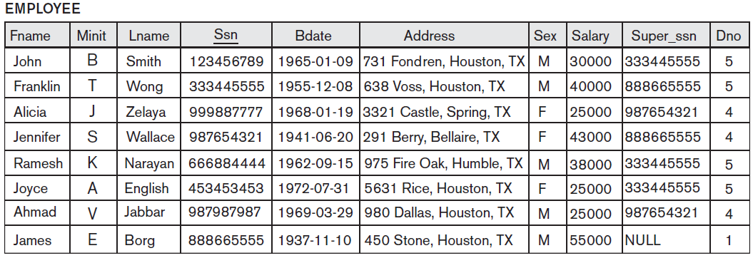

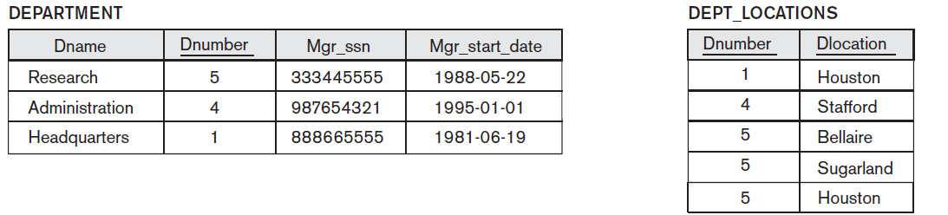

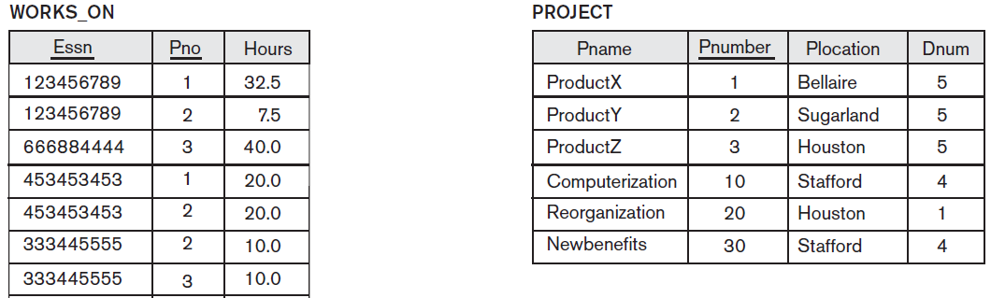 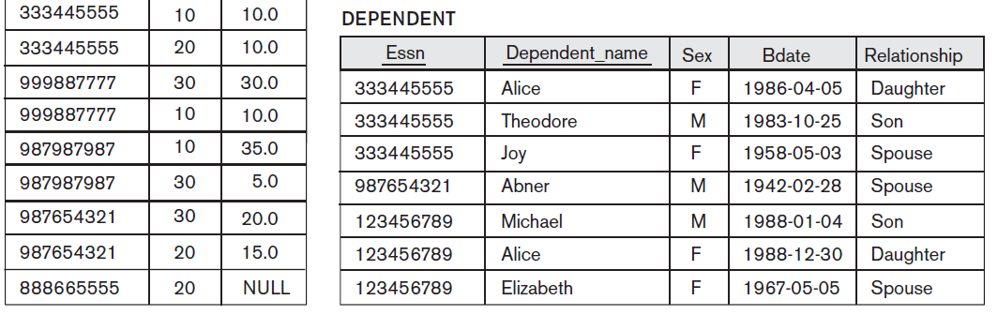

**Specify the updates for the below using the SQL update commands.**

1. Insert <‘Robert’, ‘F’, ‘Scott’, ‘943775543’, ‘1972-06-21’, ‘2365 Newcastle Rd,

Bellaire, TX’, M, 58000, ‘888665555’, 1> into EMPLOYEE.

Answer: **INSERT INTO EMPLOYEE**

**VALUES** ('Robert', 'F', 'Scott', '943775543', '21-JUN-42', '2365 Newcastle Rd, Bellaire, TX',

M, 58000, '888665555', 1)

1. Insert <‘ProductA’, 4, ‘Bellaire’, 2> into PROJECT.

Answer: **INSERT INTO PROJECT**

**VALUES** ('ProductA', 4, 'Bellaire', 2)

1. Insert <‘Production’, 4, ‘943775543’, ‘2007-10-01’> into DEPARTMENT.

Answer: **INSERT INTO DEPARTMENT**

**VALUES** ('Production', 4, '943775543', '01-OCT-88')

1. Insert <‘677678989’, NULL, ‘40.0’> into WORKS_ON.

Answer: **INSERT INTO WORKS_ON**

**VALUES** ('677678989', NULL, '40.0')

1. Insert <‘453453453’, ‘John’, ‘M’, ‘1990-12-12’, ‘spouse’> into DEPENDENT.

Answer: **INSERT INTO DEPENDENT**

**VALUES** ('453453453', 'John', M, '12-DEC-60', 'SPOUSE')

1. Delete the WORKS_ON tuples with Essn = ‘333445555’.

Answer**: DELETE FROM WORKS_ON**

**WHERE ESSN**= '333445555'

1. Delete the EMPLOYEE tuple with Ssn = ‘987654321’.

Answer: **DELETE FROM EMPLOYEE**

**WHERE SSN**= '987654321'

1. Delete the PROJECT tuple with Pname = ‘ProductX’.

Answer: **DELETE FROM PROJECT**

**WHERE PNAME**= 'ProductX'

1. Modify the Mgr_ssn and Mgr_start_date of the DEPARTMENT tuple with Dnumber = 5 to ‘123456789’ and ‘2007-10-01’, respectively.

Answer: **UPDATE DEPARTMENT**

**SET MGRSSN** = '123456789', MGRSTARTDATE = '01-OCT-88'

**WHERE DNUMBER**= 5

1. Modify the Super_ssn attribute of the EMPLOYEE tuple with Ssn = ‘999887777’ to ‘943775543’.

Answer: **UPDATE EMPLOYEE**

**SET SUPERSSN** = '943775543'

**WHERE SSN**= '999887777'

1. Modify the Hours attribute of the WORKS_ON tuple with Essn = ‘999887777’ and Pno = 10 to ‘5.0’.

Answer: **UPDATE WORKS_ON**

**SET HOURS** = '5.0'

**WHERE ESSN**= '999887777' AND PNO= 10