**Team 8:**

Trần Quang Đại 18110266

Nguyễn Văn Linh 18110311

Lê Thị Phương Thảo 18110366

Thi Lý Vũ 18110399

**Project Requirements Document**

# Require

**Project Description**

This is a E- commerce app used for depict image and information about woman clothes and bags, it also provided recommend system, order system, saved products and ….

**Project Purpose and Scope**

The site offers channels for sellers and customer to interact with each other.

The seller (ie the website owner) sells beauty related products, and the customer can choose and order the products that the website does business.

**Technical Challenges/Issue\**

It is hard to deal with the old technology like jsp- servlet.

Choose the database management is hard because our budget is small and after choosing the database we need to learn all the syntax and also how to push it in to the server and the most difficult is connect the database to the Ui and make data visible.

**Timeline**

|  |  |
| --- | --- |
| Design database | February 28,2020 |
| Design UI | March 22,2020 |
| Up database to serve | March 22,2020 |
| Connect UI to database | March 22,2020 |
| Review product | May 5,2021 |
| Production Roll-Out | May 5,2021 |
| Annual Review | May 10,2021 |

**Requirements**

**-Functional Requirements**

Primary

1, Users can see all products and prices.

2, Users can rate products and also make recommendations for they.

3, Users can create an account.

4, Users can see their bag and products which have been bought earlier.

5, Users can choose where to receive the products and they will also be noticed about the ship price and time the products arrived.

Secondary:

1, Admin can add, delete, edit products.

2, Admin can see the statistics of products sold and also the income.

**-Technical Requirements**

Primary:

1, Using jsp-servlet technology to develop.

2, Java mail api.

3, Responsive for all devices.

4, Realtime communication between customers and shipper.

5, Javascript Document object management for UI design.

6, Mysql database and Jpa used for communicate between the UI and database.

7, Postman used for test the method post get… .

8, Json convert to java object and java object to javascript array

Secondary:

1, Statistics and reporting.

2, The System should be built using free open source software of locally hosted.

**-Policy Requirements**

Primary:

1, The system functionality will be driven by policy whenever possible.

2, The same polices apply to all devices.

Secondary:

1, The recommend system will be adjusted to accommodate technical limitations.

**-Usability Requirements**

Primary:

1, The system functionality will fully funtion in major browser.

2, The system will support mobile and other users in some way.

Secondary:

1, The host is free so the speed is not a good point to show out.

**Project Constraints**

***-Time constraints*:** we only have 16 weeks to do this project so it will be not oke in many ways but, we all do our best to this project.

-***Scope constraints***: This project will be limited to dealing with a large amount of people.

**Documentation**

**-**Administrative Documentation

<https://docs.google.com/document/d/1vdHsiNrkCwQt2lDbumb6l5zvT5j3avuCEj8aaQEKAko/edit?usp=sharing>

<https://youtu.be/SBIrZHvdScE>

**-**Technical Documentation

<https://drive.google.com/file/d/1HTWgUK9MMdGdsxhRh8eiygWWMgEFsMQi/view?usp=sharing>

<https://youtu.be/oKfjOZXh0KM>

**-**End-User Documentation

<https://drive.google.com/file/d/1ZF4b8OvknL2Y8ijgd05SXtv5LEaDApYZ/view?usp=sharing>

**References and Related Documents**

.Github – <https://github.com/thilyvu/Web-.git>

# Project Charter

**Project Title:** Online web used for sell clothes and bags

**Project Start Date:** 21/12/2020 **Project Finish Date:**01/03/2021

**Budget Information:** 25.000.000 d

**Project Manager:** Thi Ly Vu, 0563010901, thilyvu.2000@gmail.com

**Project Objectives:** Inform woman about trendy clothes and bags.

Reach your target market easily

Convenient payment collections

Low-cost promotion strategy

**Approach:**

* Research about processing, operate of online web sale.
* Survey current modern fashion (styles, colors).
* Research about layout components, user interface.
* Design small modules and plan.
* Implement project.

**Roles and Responsibilities:**

|  |  |  |  |
| --- | --- | --- | --- |
| Role | Name | Organization/ Position | Contact Information |
| Font-end Developer, Tester | Tran Quang Dai | Employee | Tqdai@gmail.com |
| Back-end Developer | Nguyen Van Linh | Employee | linhdaigia@gmail.com |
| Font-end Developer | Le Thi Phuong Thao | Employee | 0333,87,53,98 thaole301000@gmail.com |
| Project Manager, Team Lead | Thi Ly Vu | Manager | Thilyvu.2000@gmail.com |

**Sign-off:** (signed)

**Comments:**

# **Scope Statement**

|  |  |
| --- | --- |
| **Project title:** Online web used for sell clothes and bags | |
| **Date:** 04/07/2021 | **Prepare by:** Le Thi Phuong Thao |
| **Project justification:**  The site offers channels for sellers and customer to interact with each other.  The seller (ie the website owner) sells beauty related products, and the customer can choose and order the products that the website does business.  Provide accounts for customer.  Customer are allowed to view products, place their orders in the basket, and then pay for them.  Sellers are provided with professional functions related to the entry, statistics, total income ... of products and sales.  There are also channels for employees, shippers to do their specific jobs. | |
| **Project Characteristics and Requirements: -** Well Designed and Functional   * Easy to Use * Optimized for Mobile * Readily accessible contact and location * Optimized for Search and the Social Web * Fresh, Quality Content * Clear calls to action * Responsive Design * Metrics / Accountability | |
| **Summary of Project Deliverables:**  Based on the analysis and design of the system to meet the needs of users, survey the real market as well as learn and develop based on available resources. Helped the team design and complete the software  **Project management-related deliverables**:  Results of analysis, survey user request.  System analysis results  Review of the project administrator  Documentation of the project board  Documentation of the project scope.  Document work structure decomposition  Other documents  **Product-related deliverables:**  Design document  Software source code  Manual for customer and developer  Video introduction for the owner | |
| **Project Success Criteria: -** Project is completed on time   * Project is completed in budget * Project meet the appropriate quality targets * Project team satisfaction target is achieved * Customer satisfaction target is achieved * Customer/Staff awareness about the project was raised to the appropriate level * Project uses the approved technology * Project meets all the internal appropriate information security policies * Project meets the functional requirements | |

# Work Breakdown Structure

1. Survey
2. Survey current systems
3. Determine the requirement
4. Subject requirements
5. User requirements
6. Determine the function
7. Basic functions
8. Technical functions
9. Planning
10. Media Planning
11. Work Breakdown Structure planning
12. Design
13. System design
14. Database design
15. Database software
16. Server
17. User interface design
18. Main UI
19. Requirement for each of UI component
20. Implement
21. Database
22. Public database to host
23. Test connection
24. Front-end
25. Front-end
26. Responsive
27. Back-end
28. Extend
29. Functions
30. Migrate
31. Maintenance
32. Testing
33. Document
34. Manual
35. Report

# Work distribution table

|  |  |  |  |
| --- | --- | --- | --- |
| Annotate | Activity | Immediate Predecessor | Duration (days) |
| A | Survey current systems | _ | 3 |
| B | Subject requirements | _ | 3 |
| C | User requirements | _ | 5 |
| D | Basic functions | B, C | 7 |
| E | Technical functions | D | 15 |
| F | Media Planning | A, B, C | 2 |
| G | Work Breakdown Structure planning | D | 7 |
| H | System design | G | 3 |
| I | Database software | G | 5 |
| J | Server | I | 2 |
| K | Main UI | E | 2 |
| L | Requirement for each of UI component | K | 3 |
| M | Public database to host | J | 4 |
| N | Test connection | J | 2 |
| O | Front-end | L | 12 |
| P | Responsive | O | 14 |
| Q | Back-end | N, H | 21 |
| R | Functions | Q | 10 |
| S | Migrate | R | 8 |
| T | Testing | R | 3 |
| U | Manual | S, P | 3 |
| V | Report | S, P | 4 |

# PERT

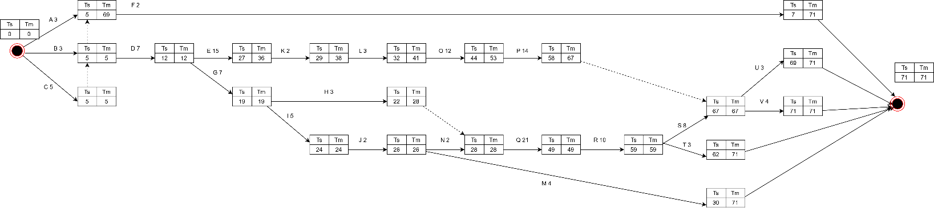

Figure 1: Full Pert diagram

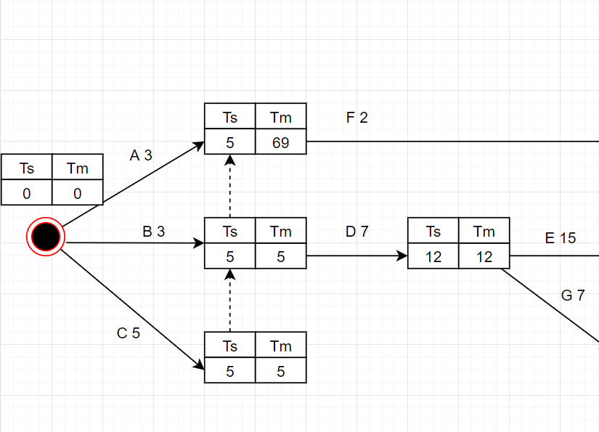

Figure 2: Pert- part-1-diagram

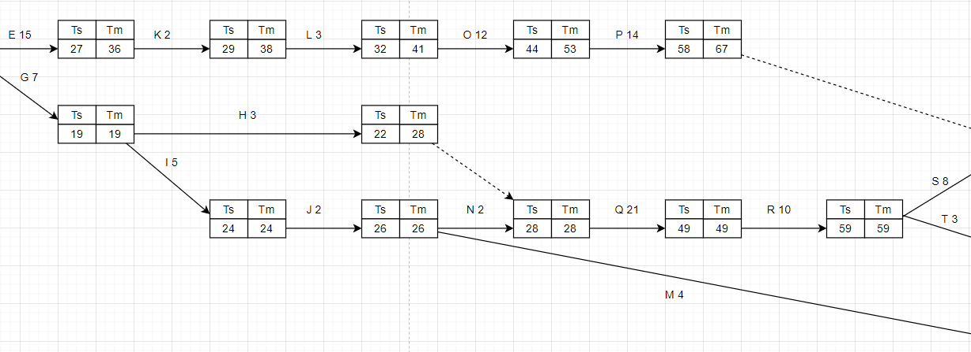

Figure 3: Pert-part-2-diagram

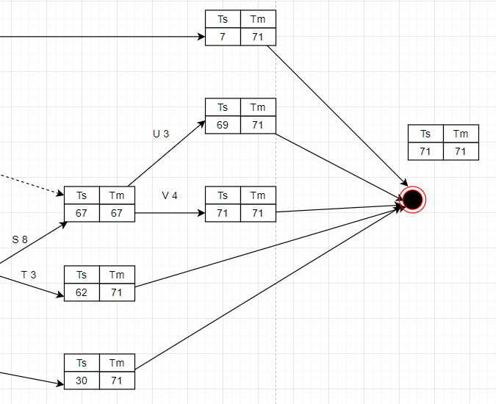

Figure 4: Pert-part-3-diagram

**Critical Path**: C, D, G, I, J, N, Q, R, S, V.

**Minimum time to complete the project** =5+ 7+ 7+ 5+ 2+ 2+ 21+ 10 +8+4= 71**.**

# Assignment table

Annotation:

TQD: Trần Quang Đại

NVL: Nguyễn Văn Linh

LTPT: Lê Thị Phương Thảo

TLV: Thi Lý Vũ

|  |  |  |  |  |
| --- | --- | --- | --- | --- |
| Annotate | Activity | | Assign | Duration (days) |
| A | | Survey current systems | TLV, LTPT | 3 |
| B | | Subject requirements | TLV, TQD, | 3 |
| C | | User requirements | TQD, NVL | 5 |
| D | | Basic functions | TQD, NVL | 7 |
| E | | Technical functions | TQD, NVL, TLV, LTPT | 15 |
| F | | Media Planning | TLV, TQD | 2 |
| G | | Work Breakdown Structure planning | LTPT, TLV | 7 |
| H | | System design | TQD, NVL | 3 |
| I | | Database software | NVL, LTPT | 5 |
| J | | Server | NVL | 2 |
| K | | Main UI | TQD, LTPT | 2 |
| L | | Requirement for each of UI component | LTPT | 3 |
| M | | Public database to host | NVL | 4 |
| N | | Test connection | LTPT, TQD | 2 |
| O | | Front-end | TQD, LTPT, TLV | 12 |
| P | | Responsive | TLPT, TLV | 14 |
| Q | | Back-end | TQD, NVL, LETP, TLV | 21 |
| R | | Functions | TQD, NVL | 10 |
| S | | Migrate | NVL, LTPT | 8 |
| T | | Testing | NVL, TLV | 3 |
| U | | Manual | TQD, LTPT | 3 |
| V | | Report | TQD, LTPT | 4 |
|  | |  |  |  |

# Test plan

## Introduction

### Scope

– Frontend: registration, login, homepage, product details page, add to cart, filter and search

– Backend: users management, product management, brand management, product type management, order management, revenue management

### Quality Objective

* Make sure the registration, login, payment, mailing functions work correctly
* Ensure user-friendly interface
* Ensure data is filtered and stored correctly

### Roles and Responsibilities

|  |  |  |  |
| --- | --- | --- | --- |
| STT | Member | Role | Responsibilities |
| 1 | Thi Ly Vu | Test Manager | Manage the entire project, Assign tasks to members |
| 2 | Tran Quang Dai | Tester | Build test cases for each function, log results, report bugs |
| 3 | Nguyen Van Linh | Developer executes testcase | Execute test cases, test programs |
| 4 | Le Thi Phuong Thao | Developer executes testcase | Execute test cases, test programs |

## Test Methodology

### Overview

We use waterfall model to manage project because this software Engineering model is very simple to plan and manage. Hence, projects, where requirements are clearly defined and stated beforehand, can be easily tested using a waterfall model.

The first phase in the waterfall model is the requirements phase in which all the project requirements are completely defined before starting the testing

Only once the design of software is complete, the team will move on to execution of the test cases to ensure that the developed software behaves as it expected.

In this methodology, the testing team proceeds to the next phase only when the previous phase is completed.

### Test Completeness

* 100% test coverage
* All Manual & Automated Test cases executed
* All bugs are fixed

## Test Environment

* Device: PC, laptop, android devices
* Browser: Chrome, Internet Explorer, android chrome

# 9 Risks and difficulties

- Customer can change request yêu

- Misunderstanding customer requirements

- Having difficulty choosing technology for the project

- Can't predict the progress of work

- Maybe the members are sick

# Experiences

- Scope management: the scope must be consistent with the actual ability and situation of the market

- Human resource management: must monitor and make timely adjustments during project implementation

- Risk management: predict risks, regularly monitor and update risks so that risks can be minimized.

- If implementing similar projects:

o Reasonable time analysis

o Analyze and learn about costs incurred

o Hold regular audits

o Change scope and personnel if necessary