Vigenere Cipher, Kasiski and Friedman Attacks

Kasiski attack or Kasiski test (based on the textbook: Making Breaking Codes, At Introduction to Cryptology, by Paul Garret)

- The goal is to determine the key length
- The idea is that if two trigrams in the plaintext occur at a distance apart which is a multiple of key length, then they will encrypt to the same trigram in ciphertext.
- The method: we look fro trigrams which occur more than once in the ciphertext, and speculate that their distances apart may be multiples of the keylength.
- The implementation:
  - For each trigram in the ciphertext that occurs more than once, we compute the GCD of the collection of all distances apart of its occurrences.
  - If GCD > 1 than we list the trigram and the associated GCD.
  - We would guess that the keyword length is a divisor of at least one of these great common divisors.
- Problems:
  - if the ciphertext is too small, then the chances are small that the same trigram will occur twice or more at a distance apart which happens to be a multiple of the key
  - if the ciphertext is too large, the chances are greater that identical trigrams appear in siphertext for other reasons

- Friedman Attack or Friedman Test
(based on the textbook: Making Breaking Codes, At Introduction to Cryptology, Paul Garret and Invitation to Cryptology, by Thomas H. Barr)

- The goal is to find a key length
- This attack is affective in determining the key length for any periodic substitution cipher

- The Index of Coincidence:

Given two streams of characters

Y = (y0, y1, y2, ….yN)
Z = (z0, z1, z2, …..zN)

The index of coincidence is
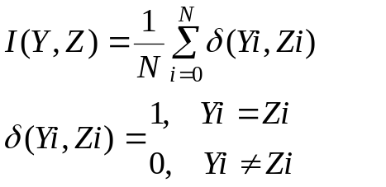

- If two streams are identical, I(Y, Z) = 1,
- If one (or both) of two streams are completely random, the index of coincidence would be expected to be 1/26 = 0.038 – if all the letters are random, then the probability is 1/26 that the two characters at the i - th place will match. So the index would be expected to be:
I(Y, Z) = (1/26 +1/26 +….1/26)/N = N*(1/26)/N = 1/26 = 0.0385

- Different formula for index of coincidence I(Y, Z):

  - Let n0, n1, …n25 be the respective frequencies of letters A, B…..Z in the ciphertext
  - n = n0+n1+…n25 be the total number of letters in the text.

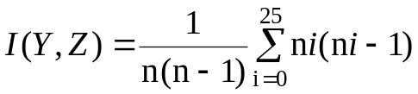

- The key length could be found by using the following formula:

