DOT Security RED TEAM

Summary
The following lists the most common exploited defaults and misconfigurations from previous RAs
Security Recommendations
Observations from Client Risk Audits

Table of Contents
Local Name Resolution (LLMNR, NBT-NS, MDNS) 2
SMB Signing 4
Insecure Outbound Traffic 6
Domain User Ability to Add Workstations 7
Block Common Lateral Movement Protocols 8
Limit Internet Access on Servers 9
Idle logged on sessions 10
Permissive File Shares 11
KRBTGT vulnerability 12
Kerberos Attacks 13
Local Account Password Reuse 14

Local Name Resolution (LLMNR, NBT-NS, MDNS)
In default configurations, Microsoft maintains the activation of almost all protocols to streamline setup and ensure compatibility with minimal user intervention. However, historical priorities have often placed less emphasis on security considerations. Many of these protocols, classified as legacy, lack built-in security features, rendering them vulnerable to exploitation.
Among these protocols are:
• Local Link Multicast Name Resolution (LLMNR),
• NetBIOS Name Service (NBT-NS)
• Multicast DNS (mDNS).
Attackers can exploit vulnerabilities in these protocols, employing Man-in-the-Middle (MitM) attacks to intercept and manipulate data. Specifically, attackers can poison responses, extracting NetNTLMv2 hashes for potential relay or cracking purposes.
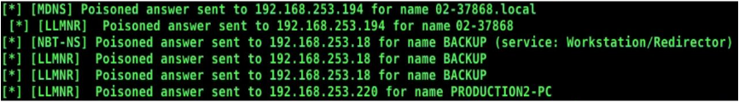
Figure 1:Example of all three protocols on a typical network, Responder can see and respond/poison these requests from network devices
This exploitation occurs particularly when a user on the same subnet requests a resource location that is not yet resolved. Furthermore, attackers can instigate such requests with minimal user interaction, exacerbating the risk of compromise. As such, disabling these protocols, following thorough testing, becomes a critical step in mitigating potential security threats.

Fix Actions:
To disable LLMNR,NBT-NS, and mDNS from GPO, select “Turn OFF Multicast Name Resolution” under computer Configuration > Administrative Templates > Network > DNS Client in the Group Policy Editor.
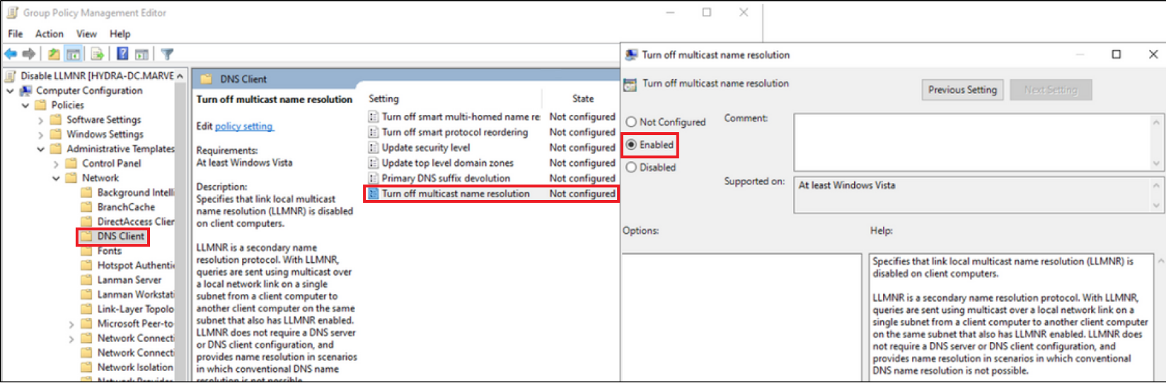
Figure 2: Disable LLMNR via GPO

If WINS is enabled on client or server, NBT-NS will override GPO and continue to send requests, you will need to be disabled individually from workstations and laptops, navigate to Network Connections > Network Adapter Properties > TCP/IPv4 Properties > Advance Tab > WINS tab and select “Disable NetBIOS over TCP/IP”. This only works locally.
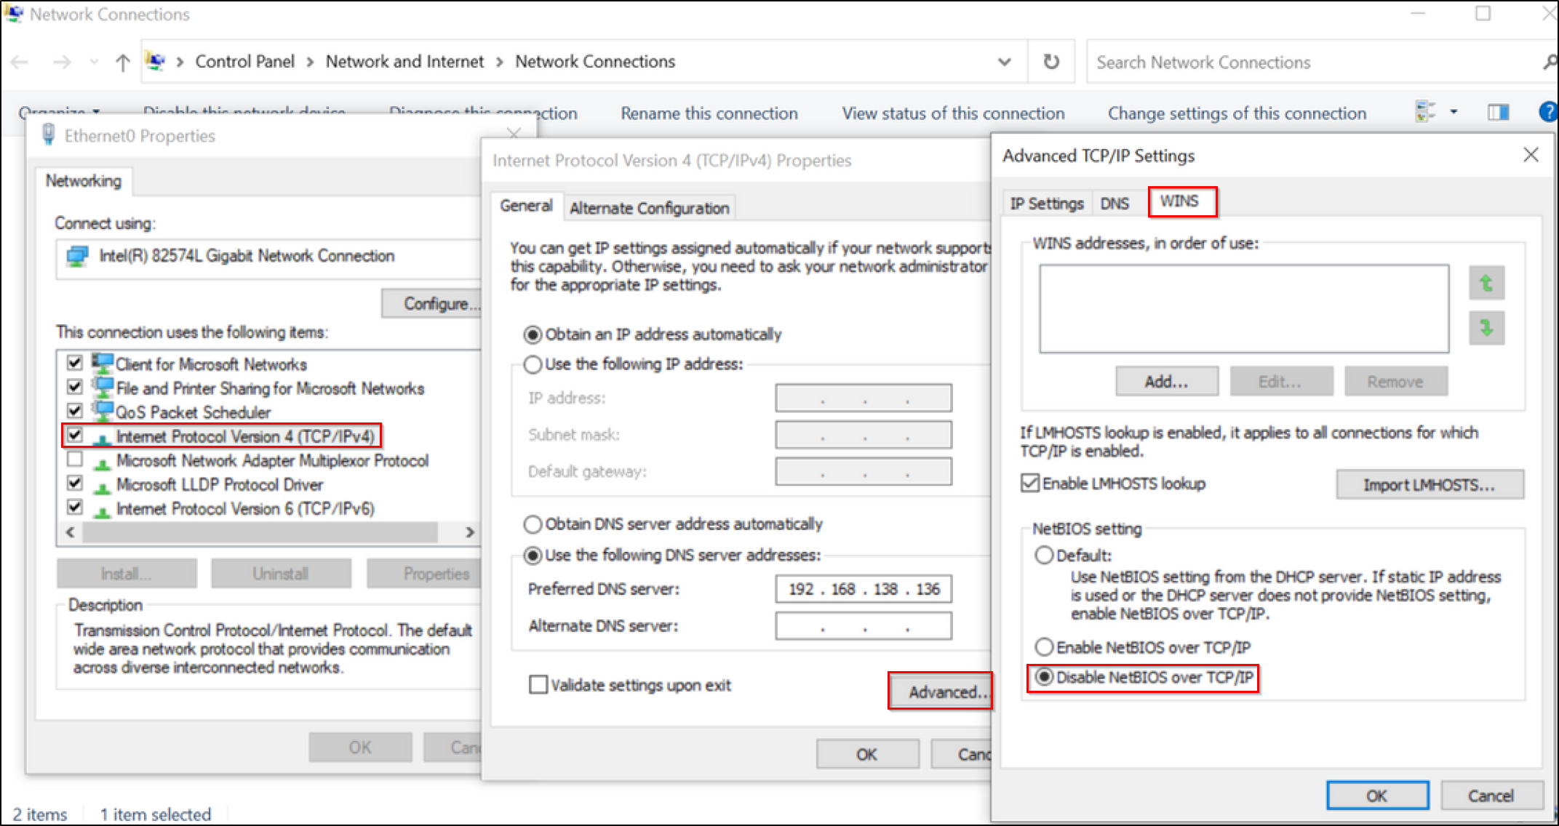
Figure 3: Disable NetBIOS on WINS
To disable mDNS, mDNS can be disabled through the registry editor. The following registry key can be added to disable mDNS on the local machine.
Navigate to HKLM\SYSTEM\CurrentControlSet\Services\Dnscache\Parameters, create a DWORD entry and label it “EnableMDNS” with a value of “0”
Note: Microsoft currently advises leaving this running as some technologies utilise the protocol (Display adapters, chrome cast, printer discover).
- Open Windows Registry Editor
- Navigate to HKLM\SYSTEM\CurrentControlSet\Services\Dnscache\Parameters
- create a DWORD "EnableMDNS" with the value “0”.

SMB Signing
Server Message Block (SMB) signing, also known as security signatures, is a crucial security measure embedded within the SMB protocol. It adds a layer of protection by appending a signature to each SMB message, generated using the session key. This signature, containing a hash of the entire message, is embedded within the SMB header. Initially introduced in Microsoft Windows 2000, Windows NT 4.0, and Windows 98, SMB signing has evolved with newer versions, incorporating advancements in signing algorithms to enhance its effectiveness.
This security feature serves to validate the authenticity of SMB authentication attempts, thereby thwarting attempts to exploit captured credentials for lateral movement across devices. However, despite its significance, SMB signing is often disabled across many Microsoft Domains, leaving networks vulnerable to exploitation.
Attackers exploit vulnerabilities in SMB by manipulating local name resolution protocols or coercing authentication from user devices through various means. This manipulation allows them to gain access to devices other than the original one using compromised credentials. Enabling SMB signing serves as a barrier against lateral movement within a network and mitigates the risk of unauthorized access through pilfered network credentials.

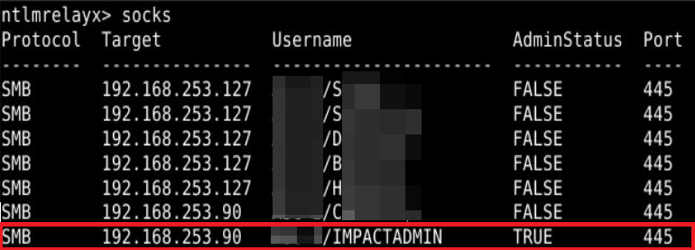
Figure 4: Example of a successful MiTM connection to a device w/o SMB Signing using captured credentials.

Presently, SMB signing is automatically activated only on servers acting as Domain Controllers and Windows 11 systems released after June 2023. By default, it is disabled on everything else. While it's advisable to enable SMB signing across all devices, prioritizing its implementation on domain servers is crucial for comprehensive network security.

FIX Actions:
To enforceSMB signing, enable the following policies in Computer Configuration > Policies > Windows Settings > Security Settings > Local Policies > Security Options:
On the client side:
Microsoft network client: Digitally sign communications (always)
Microsoft network client: Digitally sign communications (if server agrees)
On the server side:
Microsoft network server: Digitally sign communications (always)
Microsoft network server: Digitally sign communications (if client agrees)
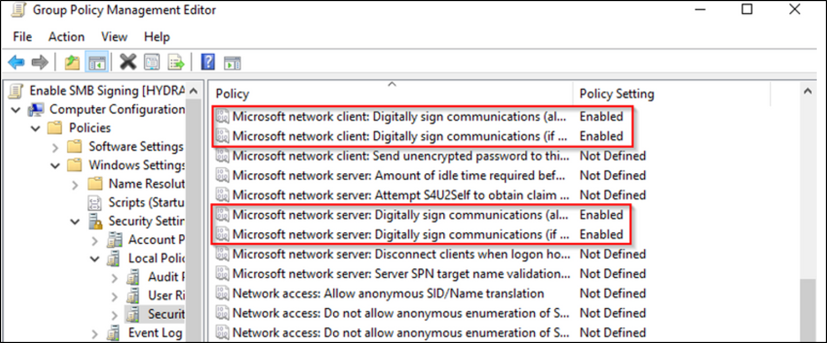
Figure 5: Enabling SMB Signing via Policy
You can confirm that policy is in place and mitigated SMB attacks by running the following command in cmd.exe and receiving ‘0x1’ for both items returned:
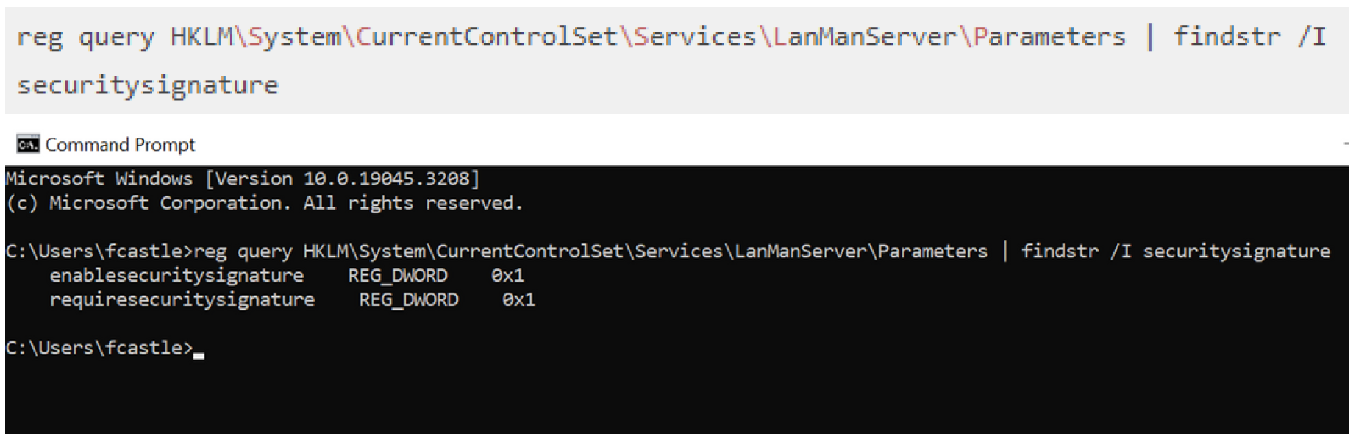
Figure 6: Reg Query results of enabled SMB signing
It is important to note that enabling SMB signing may introduce latency issues due to the additional cryptographic processing required, impacting file sharing performance. IT staff should carefully assess the trade-offs between security and performance before enabling SMB signing, considering potential network slowdowns and user experience degradation.

Insecure Outbound Traffic
While much attention is often placed on safeguarding against inbound threats, it's crucial not to overlook the significance of monitoring and controlling outbound traffic. Internal users can inadvertently or maliciously engage in insecure protocols for connection or authentication, presenting potential vulnerabilities. Among these protocols, HTTP is commonly used and serves legitimate purposes, but others like SMB and FTP are less likely to be utilized for everyday outbound traffic.
SMB, in particular, poses a significant risk as it can be exploited to extract NetNTLMv2 hashes when an internal user is coerced into connecting to a malicious server via email, wallpaper, chat file, etc. This not only facilitates credential harvesting but also enables data exfiltration from within the network. Such data may then be intercepted by other attackers monitoring the traffic.
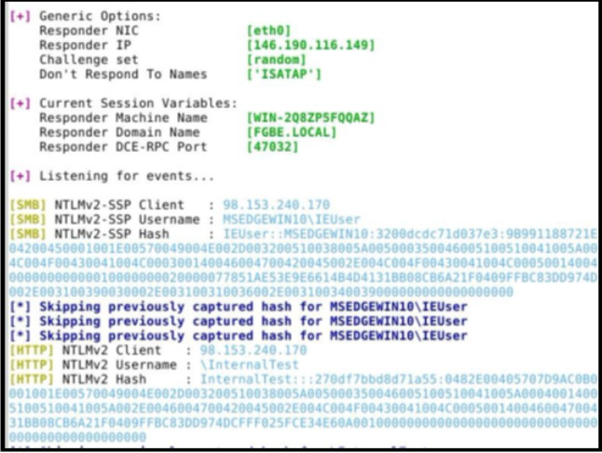
Figure 7: Example of an internal device requesting external resource and giving logged in user and password hash to retrieve it
To mitigate these risks, it's essential to review outbound traffic and implement firewall rules to block insecure protocols. Key ports to consider include:
- Port 53 (DNS)
- Port 445 (SMB)
- Ports 137 and 139 (NetBIOS/SMB)
- Port 389 (LDAP)
- Port 25 (SMTP)
- Port 3389 (RDP)
By proactively monitoring and restricting outbound traffic, organizations can enhance their overall security posture and minimize the risk of unauthorized data exfiltration and exploitation of internal systems. Of particular importance, implementing firewall rules to block SMB traffic should be considered over all other protocols. This serves as a critical minimum measure to mitigate potential risks stemming from a commonly exploited oversight.

Fix Actions:
• Block outbound SMB Traffic on TCP port 445, 137, and 139 on the Firewall
• Review outbound traffic and block commonly abused protocols listed above.

Domain User Ability to Add Workstations
The default domain policy grants domain users the ability to add up to 10 computers to the domain, a setting that may inadvertently introduce security vulnerabilities. Malicious actors could exploit this policy to escalate privileges or move laterally within the domain, potentially compromising network security.
By default, this policy is often left undefined ('Not Defined'), leaving it susceptible to misuse. It's crucial to reconfigure this setting to assign the privilege to 'Domain Admins' or another designated privileged group. This adjustment ensures that only authorized domain administrators can manage computer additions, effectively mitigating the risk of unauthorized changes by everyday users.
Fix Actions:
Domain Policy > Computer Configuration > Policies > Windows Settings > Security Settings > User Rights Assignment > Add workstations to domain.
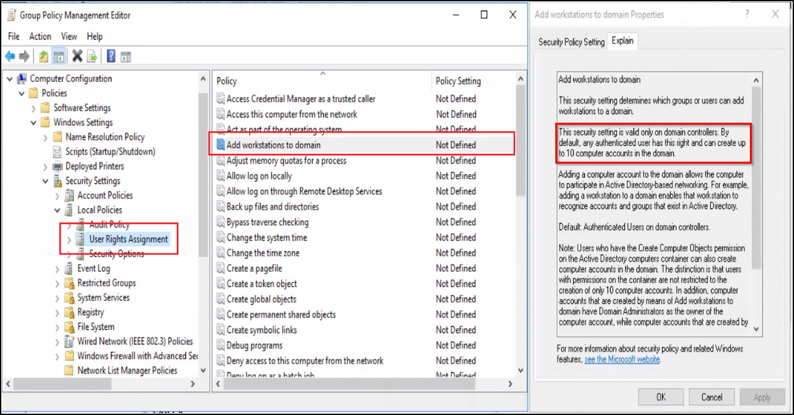
Figure 8: Default setting in domain policy
Change to enable, and designate users or privilege groups.

Block Common Lateral Movement Protocols
The Windows Firewall serves as a critical tool in mitigating the risk of lateral movement within a network by controlling connections to servers from specific servers and workstations, particularly those utilizing management and Remote Desktop protocols. When these protocols are in use, it's imperative to carefully consider which machines require access and which connections should be blocked. Allowing unrestricted access from any machine with any protocol can significantly heighten the organization's vulnerability and play into the hands of malicious attackers.
Fix Actions:
Key protocols to consider restricting access to include:
- Windows Management Instrumentation (WMI)
- Windows Remote Management (WinRM)
- Remote Desktop Protocol (RDP)
By selectively permitting connections based on predefined rules, organizations can significantly enhance their network security posture and reduce the risk of unauthorized lateral movement and exploitation.
Windows Inbound Firewall rule
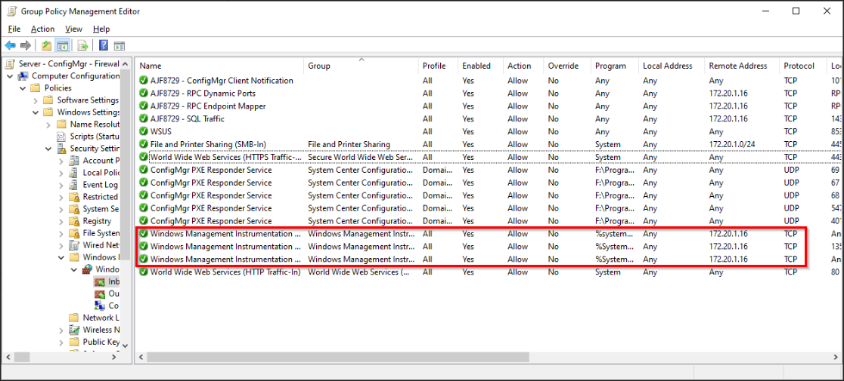
Figure 9: Example of Windows Firewall configured to allow WMI connections from 172.20.1.16 only

Limit Internet Access on Servers
Domain Controllers and member servers play crucial roles in facilitating an organization's business operations. As integral components of a network, these resources are assigned specific roles within an organization and should ideally be dedicated solely to their intended functions. However, it's observed that in many instances, these servers are granted unrestricted access to the internet.

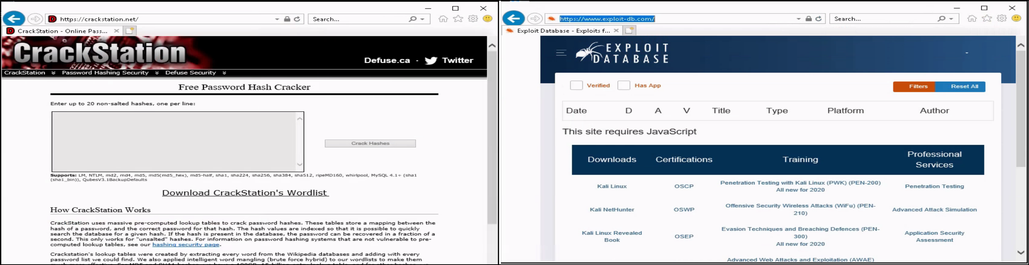
Figure 10: Examples of sites a Domain Controller was able to access during an audit
Granting such unfettered access poses significant security risks. It could potentially expose these critical servers to malicious actors who could exploit this access to infiltrate their repositories or establish direct communication channels with their command-and-control servers.

Fix actions:
To mitigate these risks, it's essential to implement access controls and restrict internet access for Domain Controllers and member servers. By limiting their exposure to external networks, organizations can bolster their security posture and safeguard these essential resources against unauthorized access and exploitation.

Idle logged on sessions
High-value target accounts are frequently discovered to have idle sessions, particularly on servers. These idle sessions present a prime opportunity for attackers to hijack them through token impersonation or by exploiting credentials stored in the Local Security Authority Subsystem Service (LSASS). Attackers often capitalize on this vulnerability to execute lateral movement within environments.

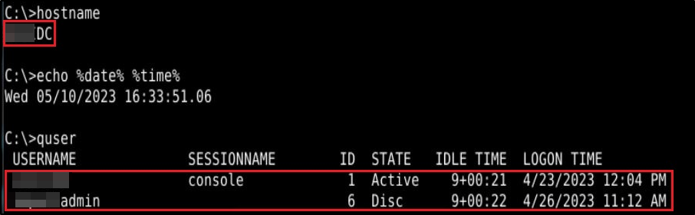
Figure 11: Example of idle sessions found on a Domain Controller 9 days and 22 minutes
Fix actions:
Implementing limitations on idle user sessions offers several advantages:
- Limiting Lateral Movement: By reducing the time window in which idle sessions are available, organizations can minimize the potential for attackers to traverse laterally across the network.
- Reducing Credential Compromise: Idle sessions pose a risk of credential theft, which can be mitigated by promptly terminating idle sessions and preventing unauthorized access.
- Preventing Unauthorized Physical Access: Terminating idle sessions helps prevent unauthorized physical access to machines that have been left unattended and unlocked, enhancing overall security posture.
- Mitigating Persistence and Impact: By minimizing the duration of idle sessions, organizations can limit the persistence of attackers within the network and mitigate the potential impact of security incidents.
- Facilitating Incident Response: A reduction in idle sessions aids in incident response efforts by minimizing noise and false positives, allowing security teams to focus on genuine threats and expedite investigation and remediation processes.

Incorporating these measures into session management strategies enhances overall security resilience and helps mitigate the risks associated with idle sessions.

Permissive File Shares
File shares are typically configured with broad permissions, allowing every Domain User to read and write files to facilitate resource sharing. While this permissive setting aims to promote collaboration, it can inadvertently expose sensitive information to unauthorized individuals. For instance, a compromised HR user may gain access to files shared between accountants, leading to potential data breaches or privacy violations.
Moreover, the problem escalates when the file share hosts files regularly accessed or viewed by users across different departments or roles. In such cases, indiscriminate access granted to every Domain User poses a significant risk of unauthorized data exposure and compromise.

To mitigate these risks, organizations must conduct a thorough review of their business requirements surrounding file shares. This review should include an assessment of the data sensitivity, user roles, and access needs associated with each file share. Subsequently, guidelines should be established to enforce the principle of least privilege, ensuring that users only have access to the files and resources necessary for their respective roles.

Fix actions:
By implementing least privilege access controls and aligning file share configurations with business requirements, organizations can mitigate the risk of unauthorized data access and enhance overall security posture.

KRBTGT vulnerability
While often overlooked, the KRBTGT account, a fundamental component of the Kerberos authentication system in Windows domains, warrants closer attention due to its inherent security implications. Despite being disabled by default, many KRBTGT accounts retain their original password since their creation, presenting a significant security risk.

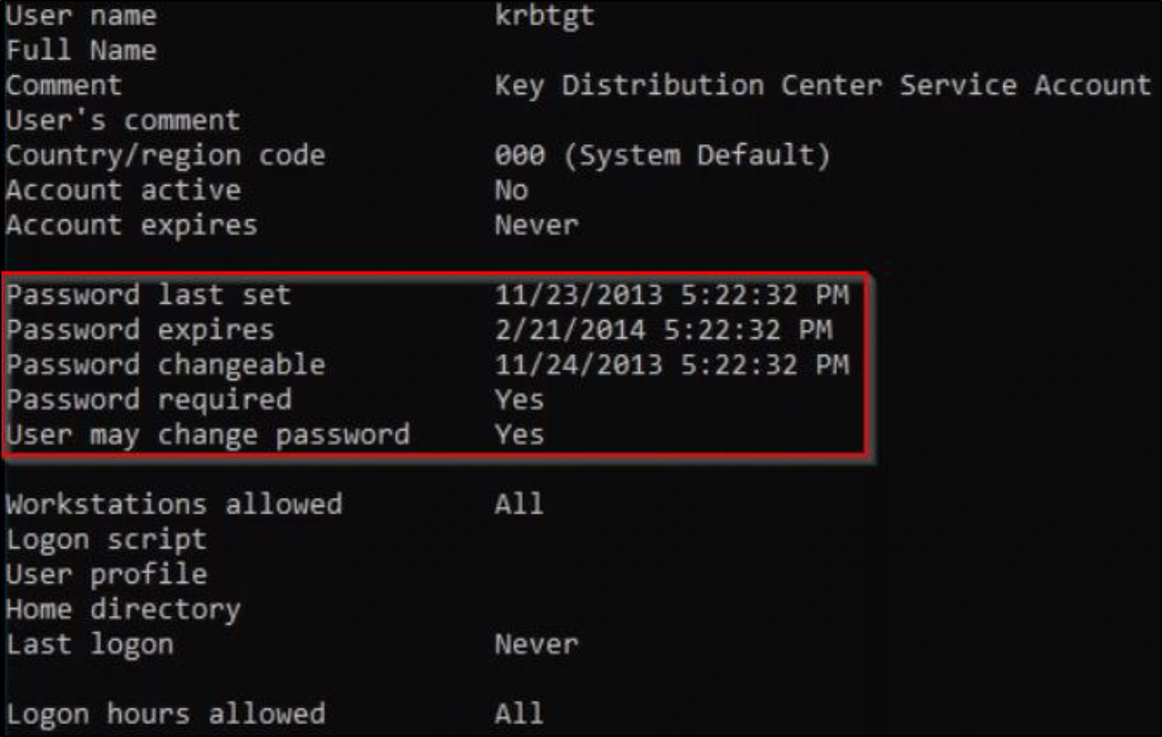
Figure 12: Example of a krbtgt account with original password when Domain was created.
This seemingly innocuous practice creates an avenue for exploitation by malicious actors, who can leverage compromised KRBTGT credentials to infiltrate the network and establish persistence. As a crucial element of the Kerberos authentication process, the compromised KRBTGT account serves as a gateway for adversaries to create forged trust tickets, enabling them to impersonate users, gain unauthorized access to sensitive resources, and manipulate Active Directory objects.
Fix actions:
To mitigate this risk, organizations must prioritize regular monitoring and management of KRBTGT account credentials. Implementing robust passwords and using rotation policies, coupled with proactive threat detection measures, can help prevent unauthorized access and safeguard the integrity of the Kerberos authentication system.
Since the KRBTGT account is an important part of the Kerberos authentication system passwords should be:
- Length: At least 16 characters long (more the better)
- Complexity: Mix uppercase, lowercase, numbers, and symbols.
- Avoid dictionary words, personal information, patterns, or predictable sequences
- Unique don’t reuse and ensure randomness.

Kerberos Attacks
When a malicious actor gains access to a client's domain environment, their primary objective is to obtain credentials that grant administrative privileges, allowing them to control the domain. Attackers often exploit common administrative practices, security lapses, and protocol misconfigurations to achieve this. Two prevalent and straightforward attacks are Kerberoasting and AS-Reproasting. These attacks exploit vulnerabilities and misconfigurations in the Kerberos authentication protocol, a system used for authenticating service requests between trusted hosts.

In Kerberoasting attacks, adversaries specifically target service accounts within the domain. Service accounts are often less monitored and may have weaker security controls. By exploiting weaknesses in the Kerberos protocol, attackers can request Kerberos service tickets for these accounts. These tickets contain encrypted hashes of the service account passwords. The attacker then extracts these hashed passwords and attempts to crack them offline using various tools. If successful, the attacker can gain access to these service accounts and potentially escalate their privileges, leading to unauthorized access to sensitive information or critical systems.

Similarly, AS-Reproasting attacks take advantage of a specific misconfiguration in Active Directory where certain user accounts do not have the pre-authentication attribute enabled. Pre-authentication is a security feature designed to require users to verify their identity before receiving a Kerberos ticket. Without this attribute, an attacker can impersonate these users and request Kerberos tickets on their behalf. These tickets also contain hashed passwords, which the attacker can extract and crack offline. Once cracked, the attacker can use these credentials to gain unauthorized access to the network.

Fix actions:
To mitigate Kerberoasting attacks, organizations can implement the following actions:
- Utilize Group Managed Service Accounts (gMSA) and Standalone Managed Service Accounts (sMSA): These accounts are recommended alternatives to using user Service Principal Names (SPNs) because they provide better security and automatic password management.

- Use Strong Passwords for User Service Principal Name (SPNs): If a user SPN is required or in use, ensure the user account is configured with a long, complex, and randomly generated password. This reduces the risk of attackers successfully cracking the password hash obtained from Kerberoasting.
To defend against AS-Reproasting attacks, organizations can implement the following actions:
- Re-enable Kerberos pre-authentication for the affected user accounts: Locate the user within Active Directory, navigate to the Account tab, and uncheck the 'Do not require Kerberos preauthentication' option.

Incorporating these fix actions into security practices, along with regular audits of Active Directory configurations and strong password policies, can help mitigate the risks posed by kerberoasting and as-reproasting attacks and enhance overall network security.

Local Account Password Reuse
Password reuse poses significant security risks, especially when domain administrator or service accounts share passwords with local administrative accounts on workstations and servers. If an attacker compromises one set of credentials, they can exploit this access to pivot laterally across the network, potentially compromising sensitive data or systems.
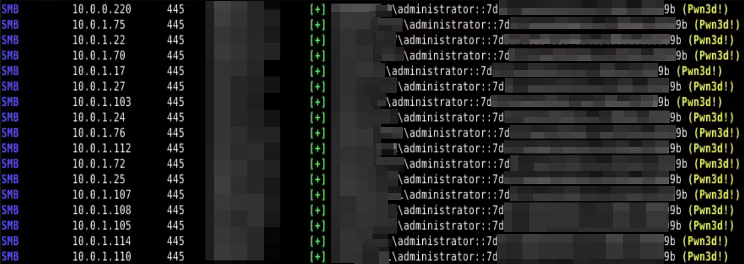
Figure 13:Example of shared passwords for local admin across workstations and laptops
This risk is further amplified when legacy local accounts with administrative privileges persist on older systems, potentially sharing the same password across multiple devices.

Fix actions:
To mitigate these risks, organizations must take proactive measures:

1. Microsoft LAPS: Utilize Microsoft's Local Administrator Password Solution (LAPS) to centrally manage local administrator passwords across devices, enhancing security and mitigating the risk of unauthorized access.
2. Regular Review of Systems: Conduct regular reviews of systems, with a specific focus on older systems and servers, to identify and address outdated or redundant local accounts.
3. Unique Passwords: Ensure that any local accounts still in use have their passwords made unique between devices to prevent lateral movement.

By enforcing unique passwords for each local administrative account, leveraging Microsoft LAPS, and avoiding password reuse, organizations can effectively mitigate the risk of unauthorized lateral movement and strengthen overall security posture.

