**Moving containers or objects between two storage accounts:**

Created a Resource Group with Name, East us,

**Next:**

**Go to All resource and search Storage account and open it**

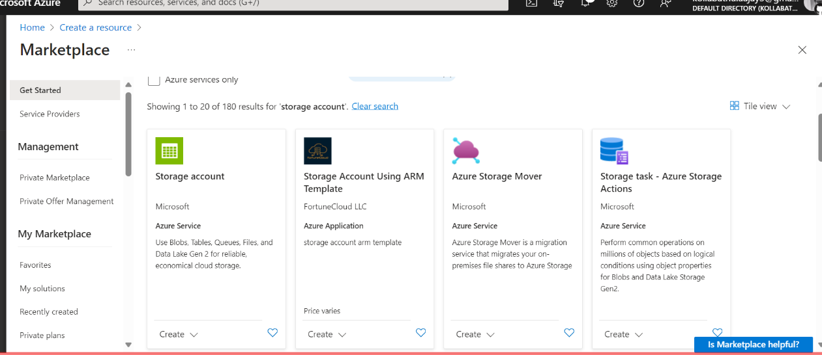

**Select the storage ACC and create with resource name and storage acc name and Create**

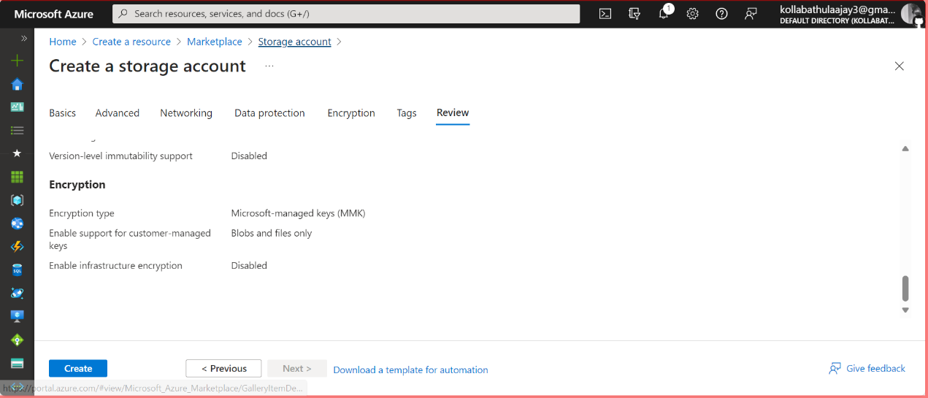

**In storage acc create one container** 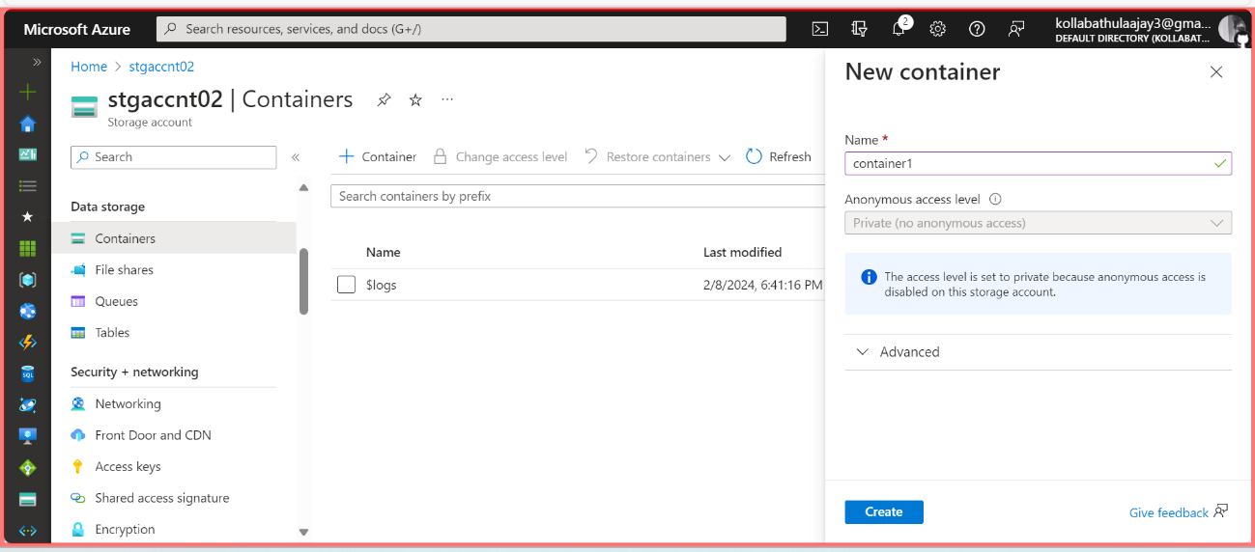

Repeat the process to add the destination storage account2.

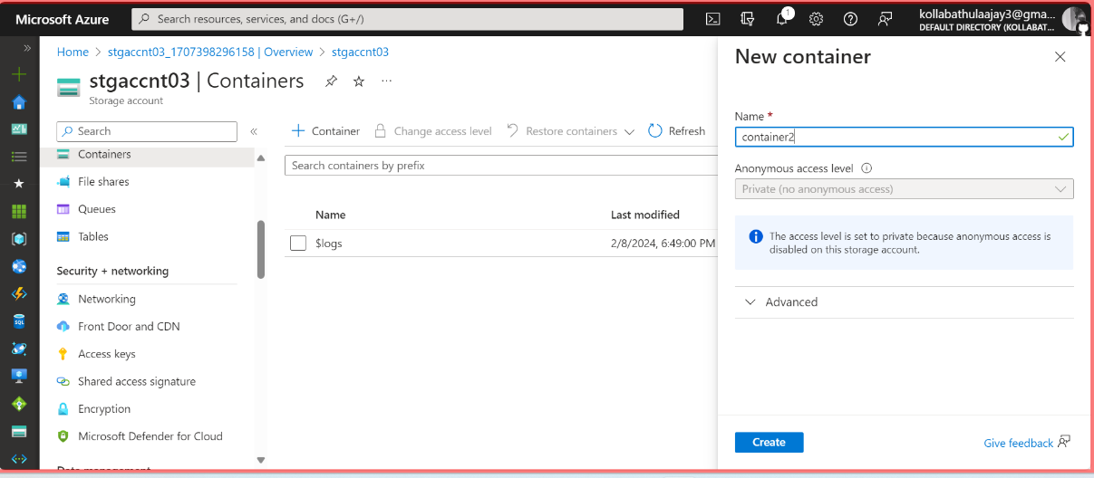

**Navigate to the First Container**

And upload a Blob file

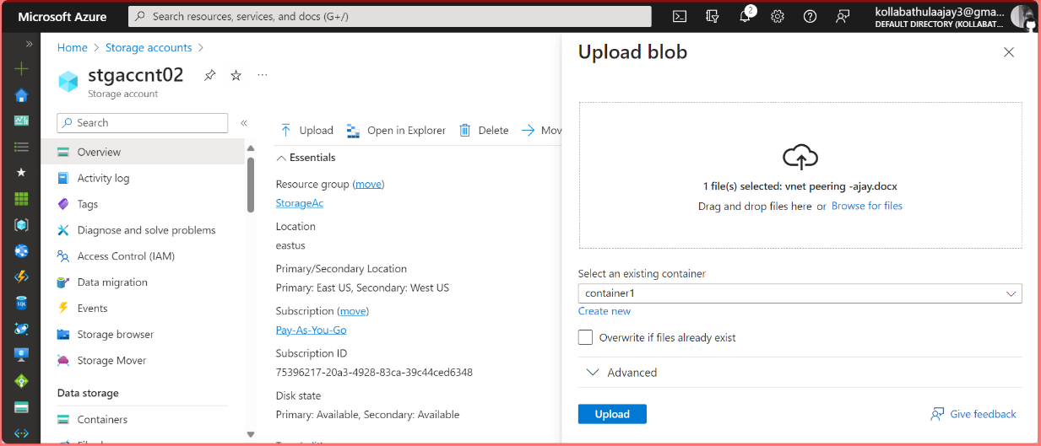

**Generate the SAS URLs for both container’s and**

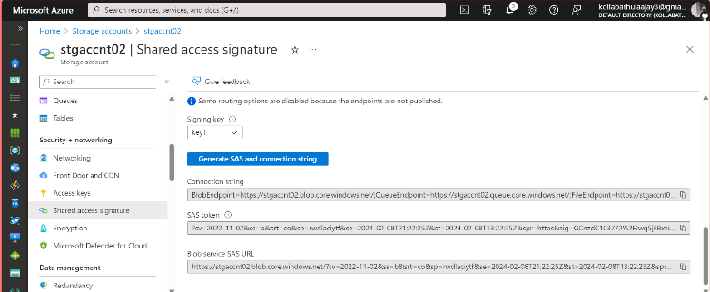

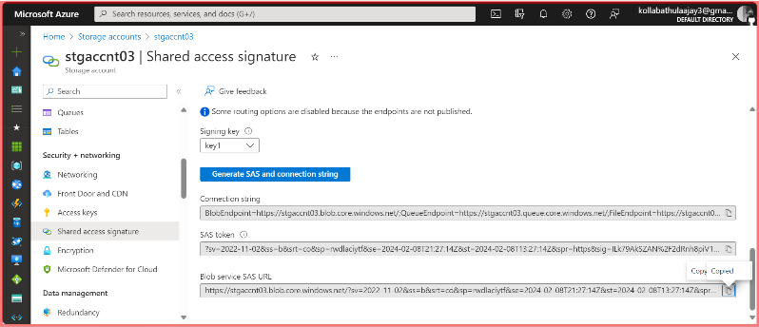

**Next goto powershell or Bash and give the below code Azcopy copy**

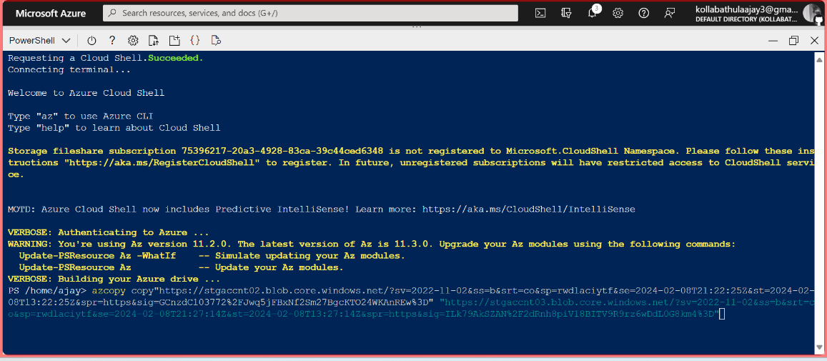**azcopy copy --recursive <source> <destination>**

**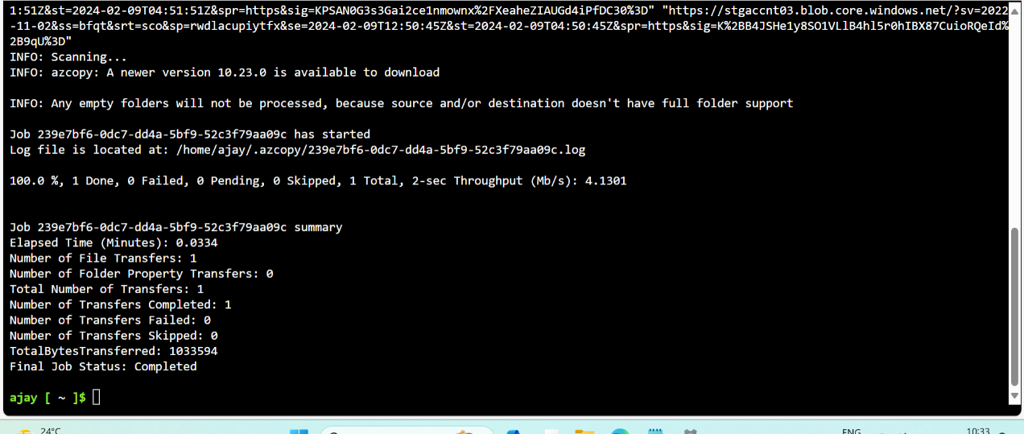  
Successful done**

**Now to the second ‘container’ their you can first container blob file**

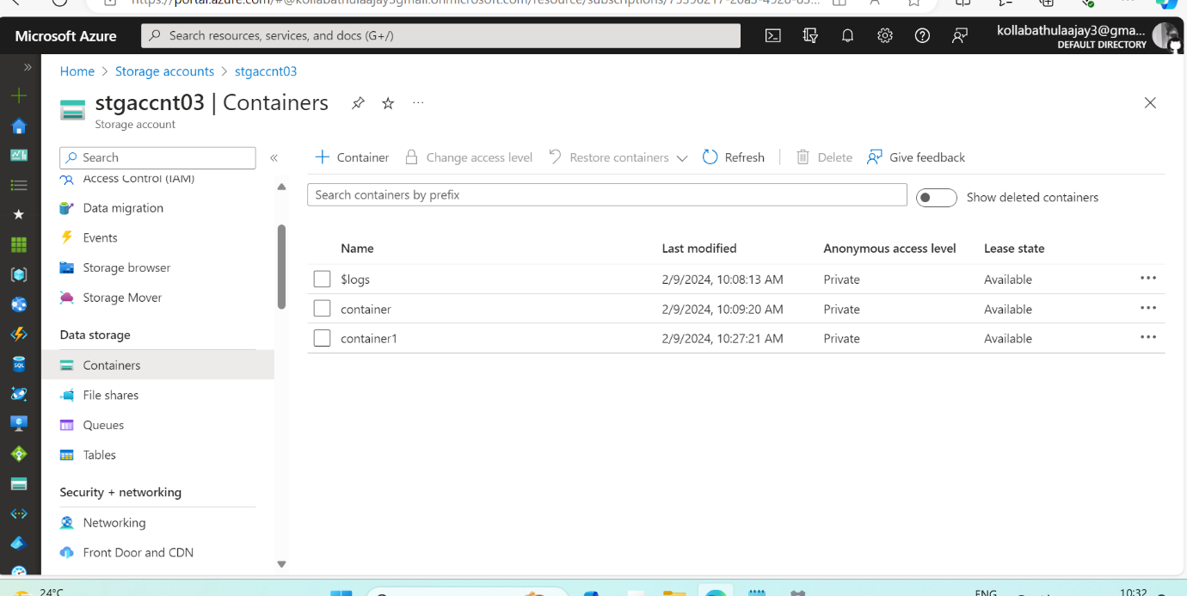

* **Ajay Kollabathula**