**Create Users and assign Roles to them in your preferred cloud.**

Go to Azure portal and select Entra ID create one user.

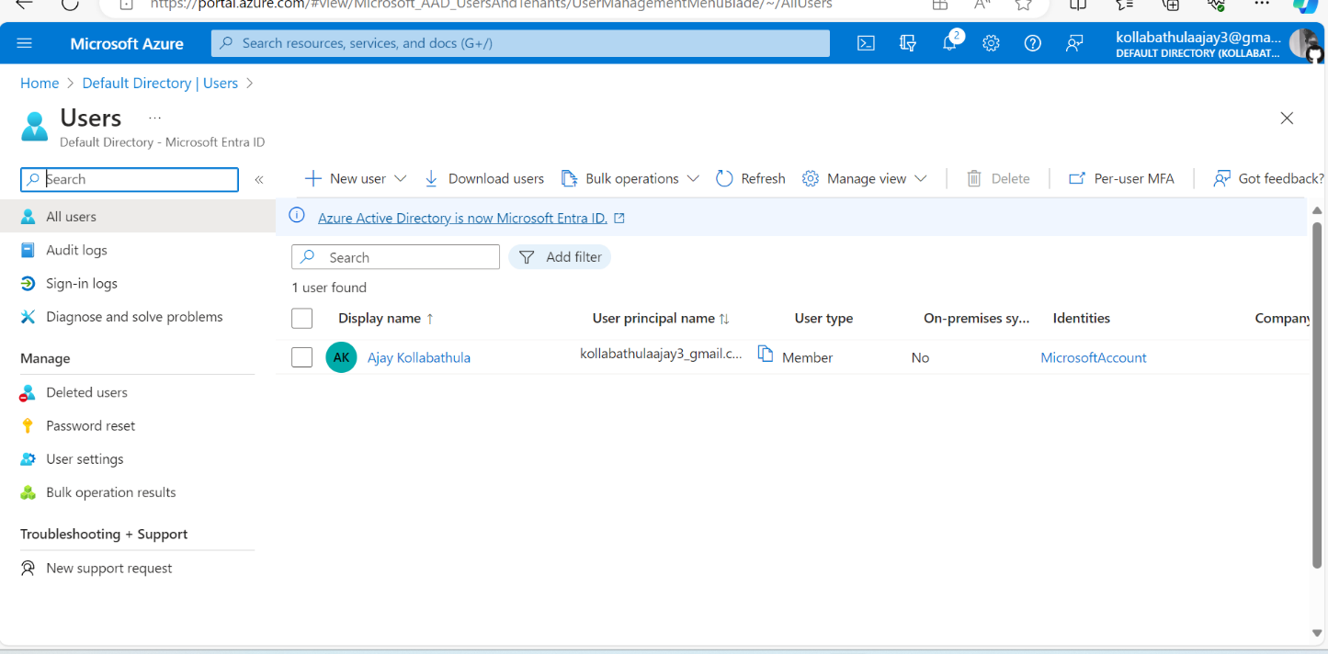

**.Create user identity and password ,mail.**

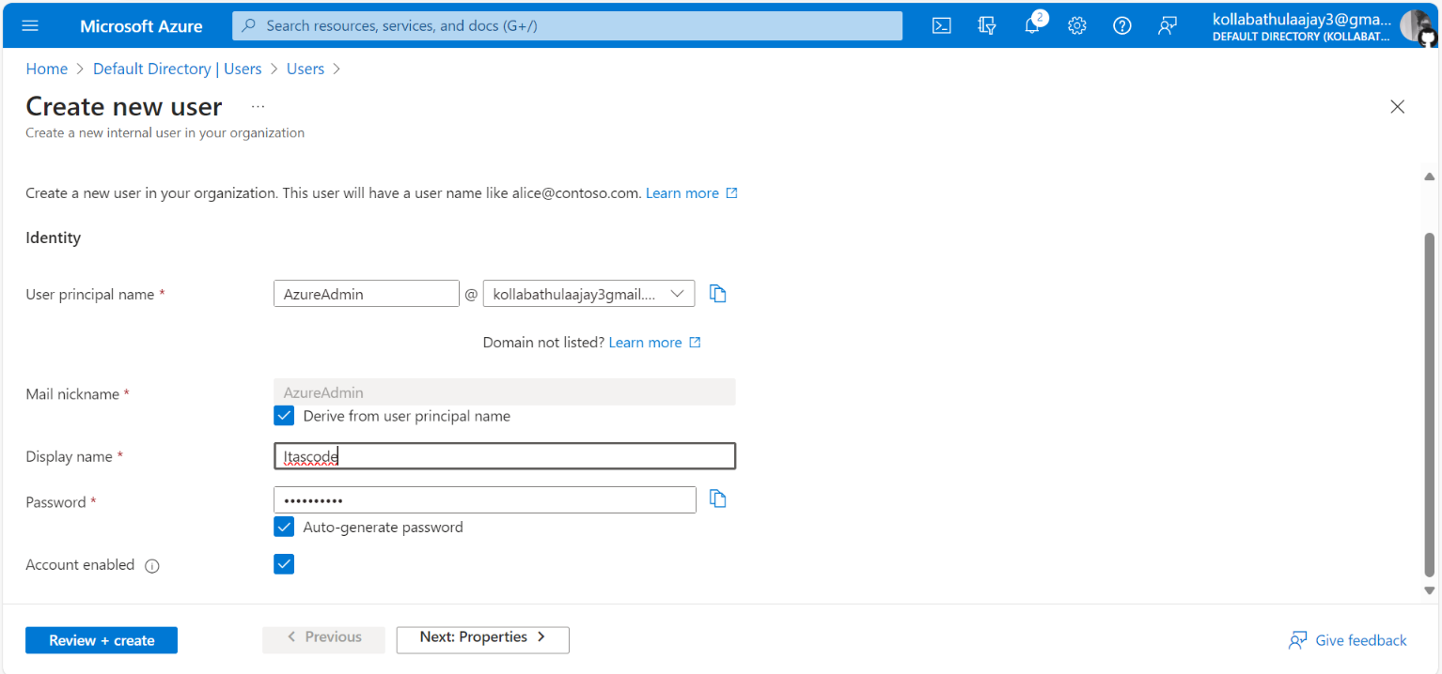

**Select the role for user wants to access it**

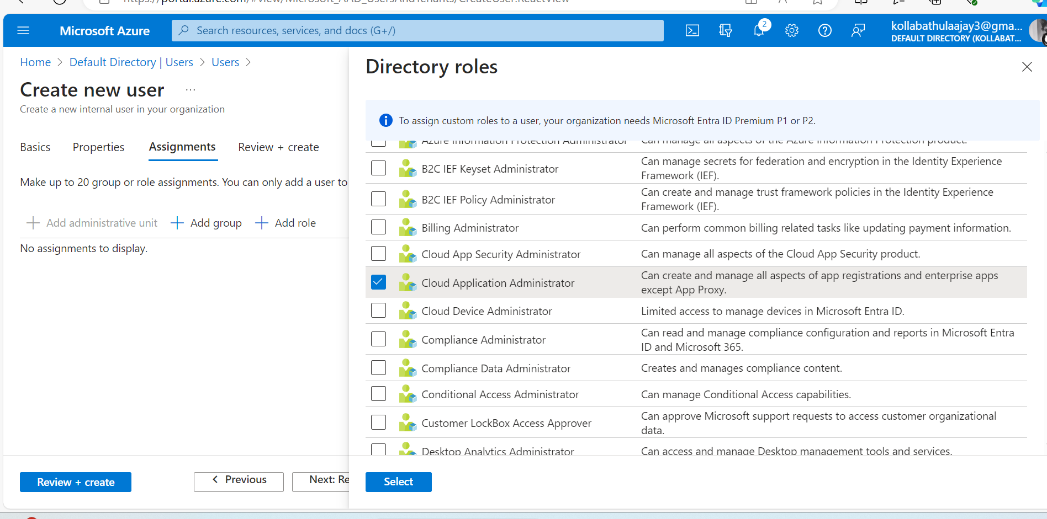

**And create it ready to access for user**

