**SSet up a Virtual Private Cloud (VPC)/ Vnet on Azure/AWS cloud**

### Azure Portal:

**1.select on resource groups**

### 

**2.** Created resource groups with required name-VNET and region-EASTUS

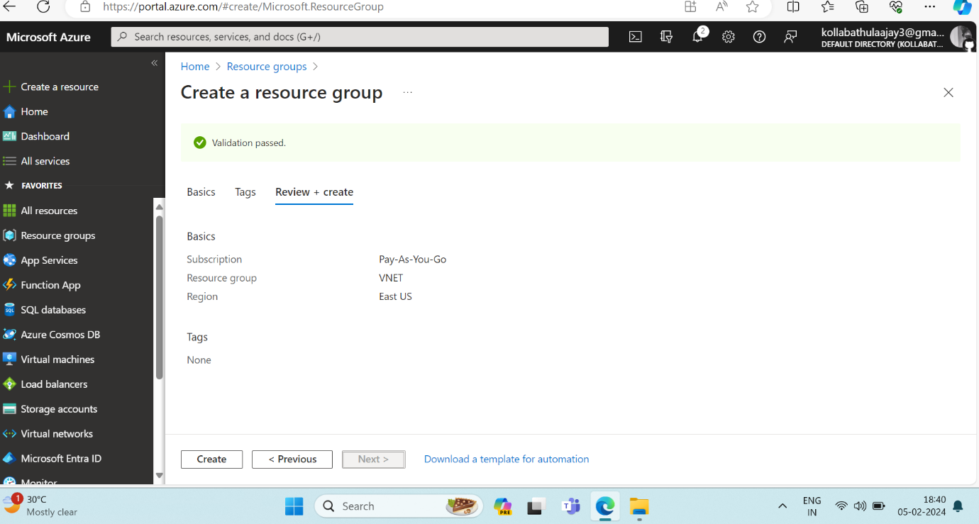

**3**. Virtual network Create

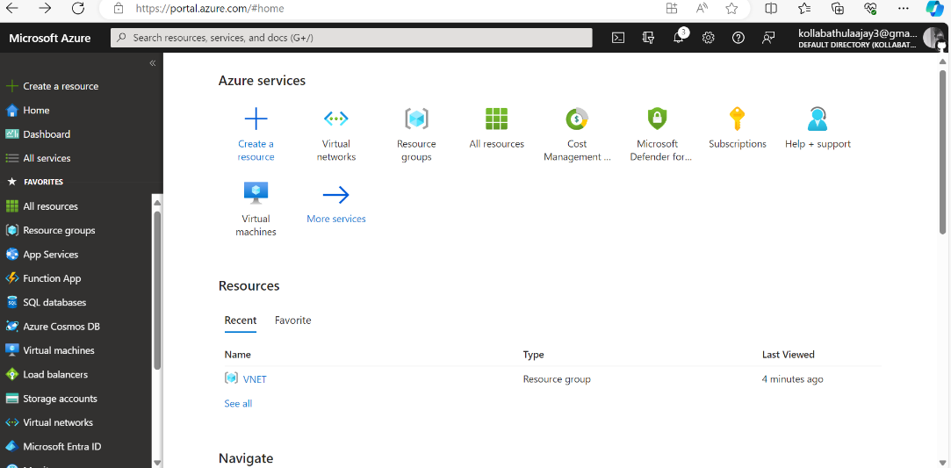

4.created a virtual network required name vnetwork1 ,Address space 10.60.0.0/16

Selected resource group name Vnet

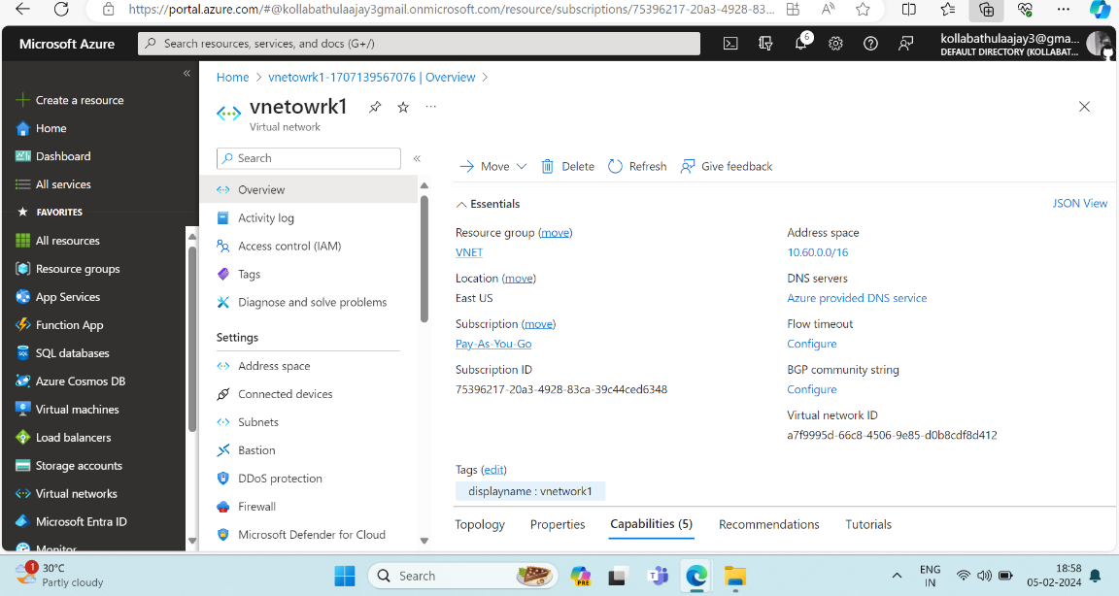

Added one subnet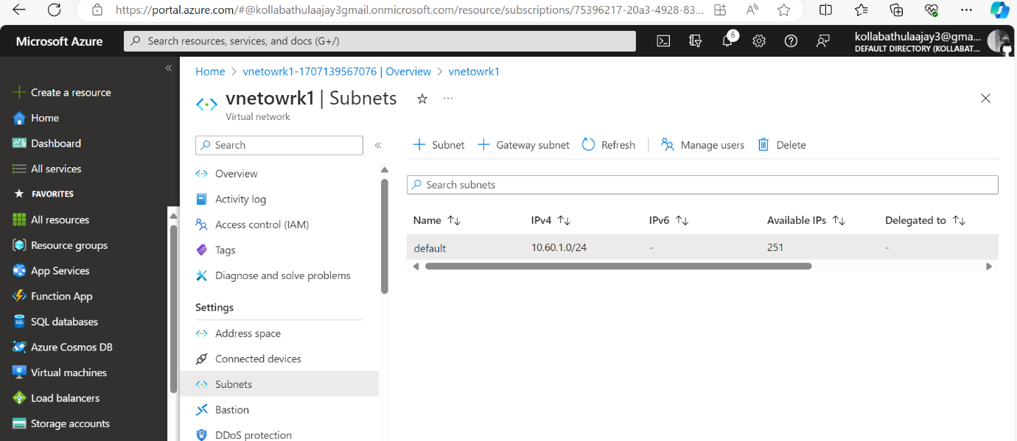

**Network Security Groups:**

Configure security groups to control inbound and outbound traffic.

Optionally, you can use Network Security Groups (NSG) to control traffic at the network level.