**Implement load balancing and high availability to open-source application**

Open azure portal .com

Create one resource group and open it select create **vnet** with resource group create

And add one subnet 10.60.0.0.

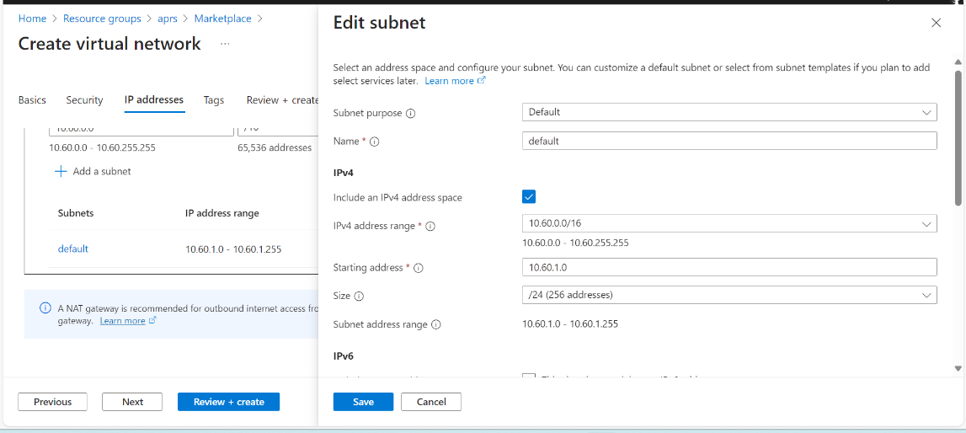

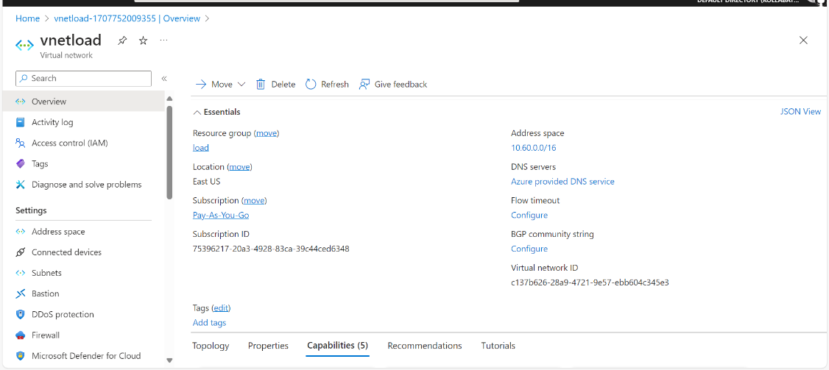

Next step:

Create a resource group for Virutal Machines

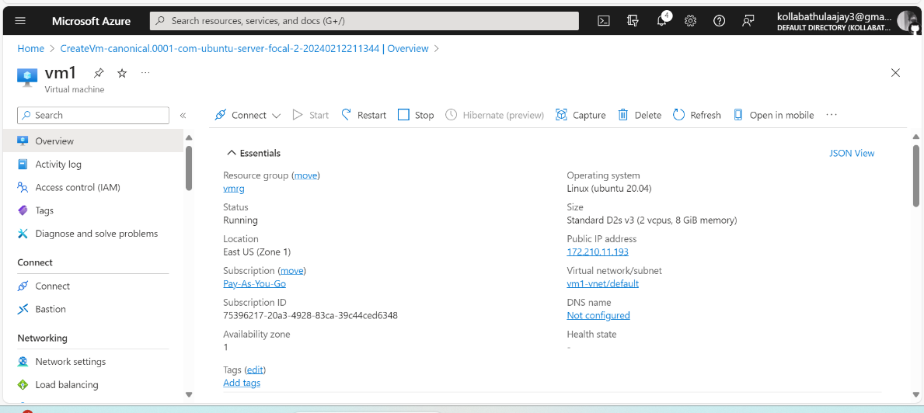

Repeat same process for VM2

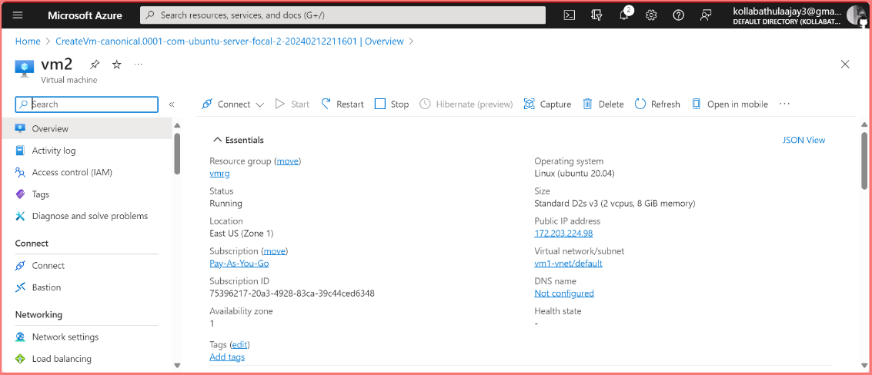

Create one resource group for load balancer and add frontend.

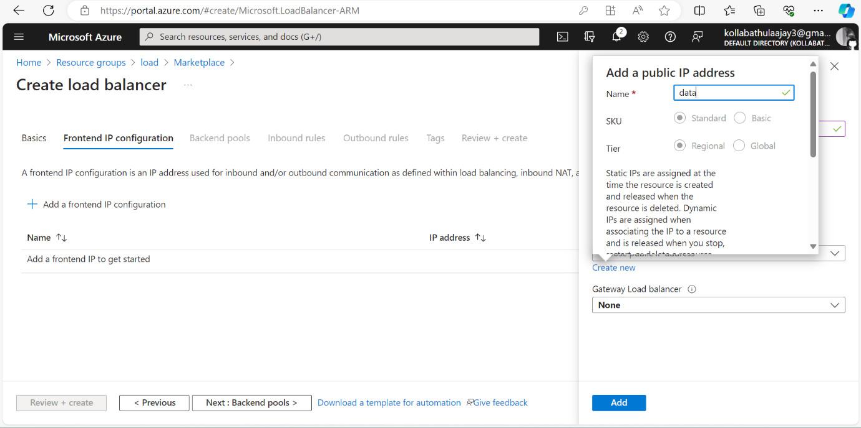

Backend pool ip address taken from vm1,vm2

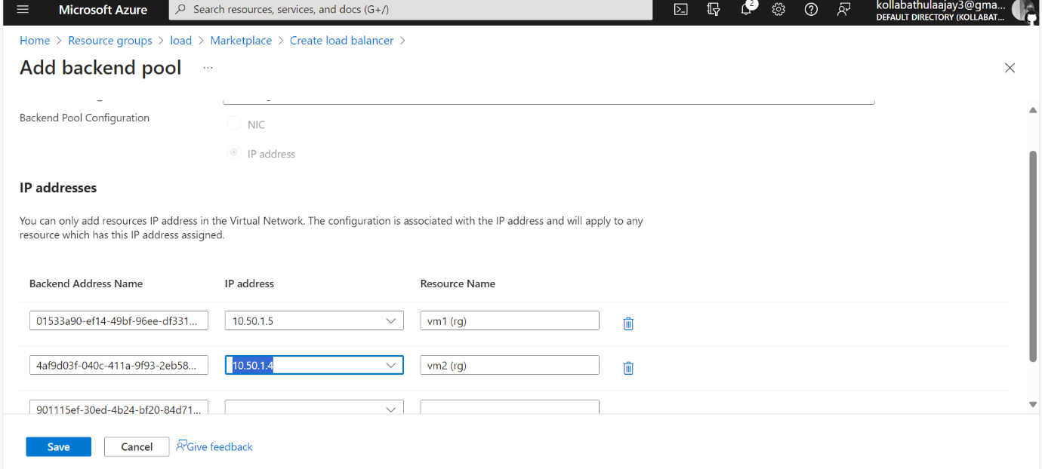

Next step :

Goto VM1 powershell run with this ip address for nginx

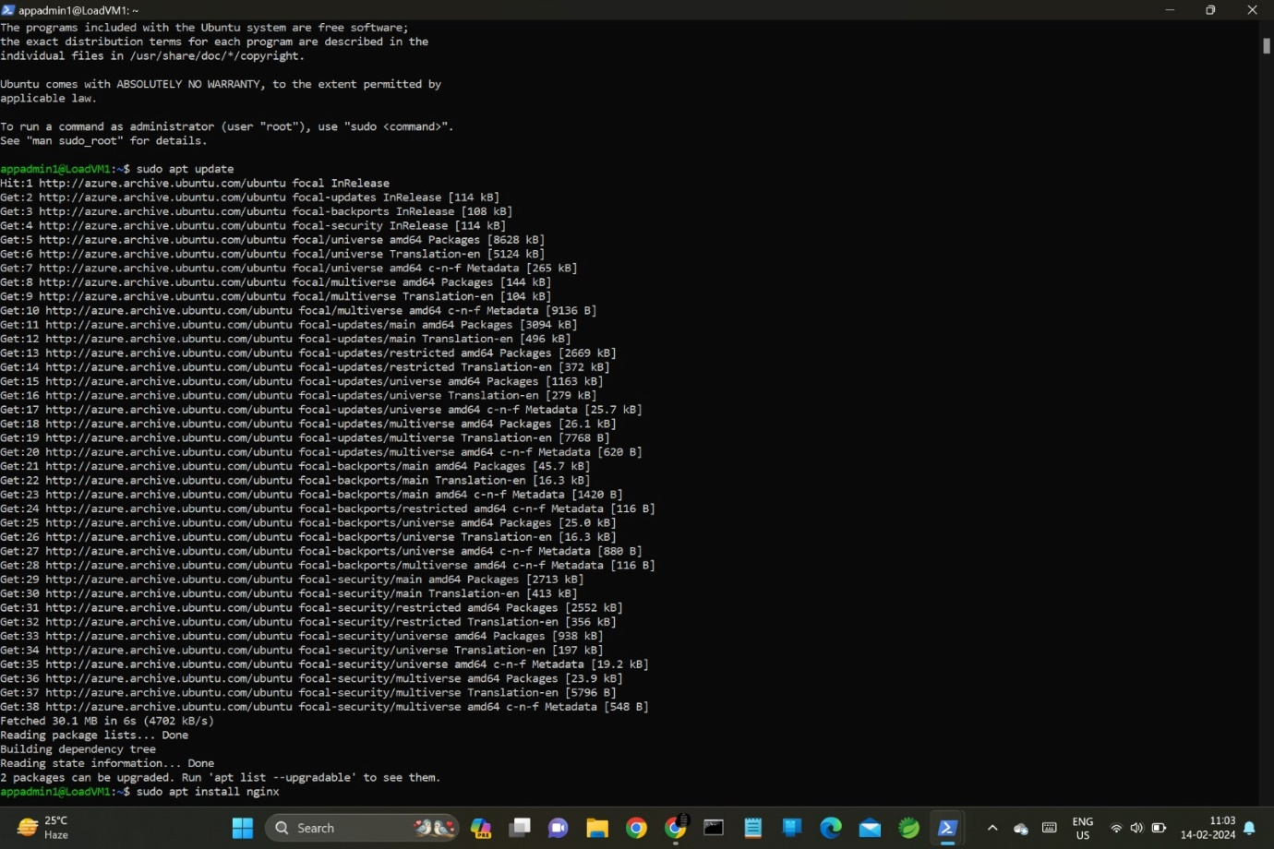

Goto VM2 powershell run with this ip address for UBNUTU

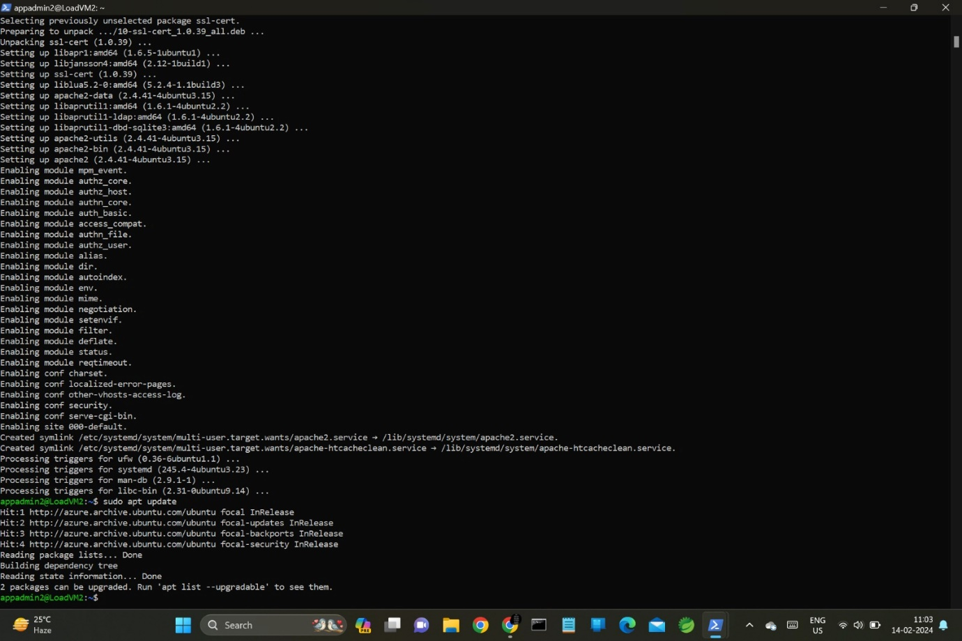

And add rules in load balancer

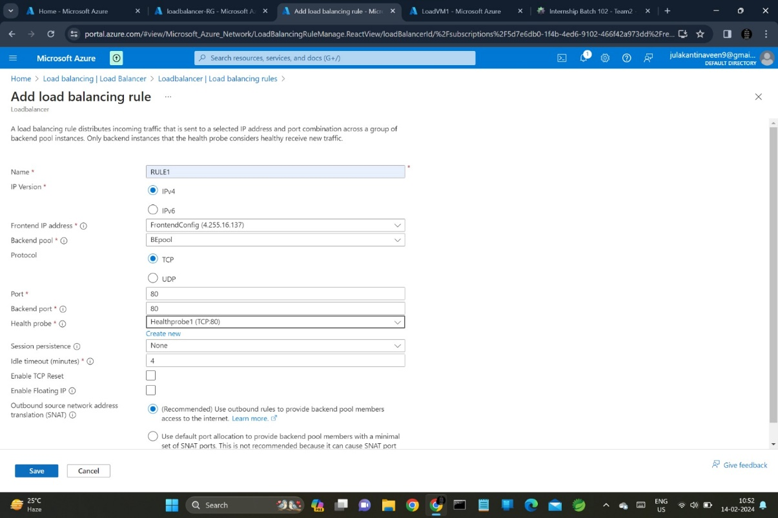

Select load balancer frontend ip address run in webserver

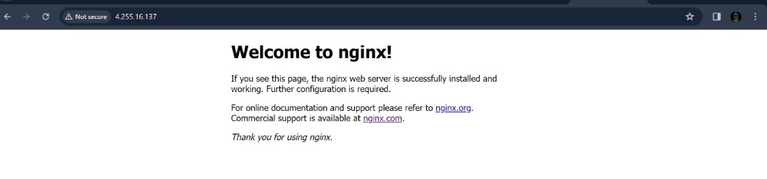

Try another ip address

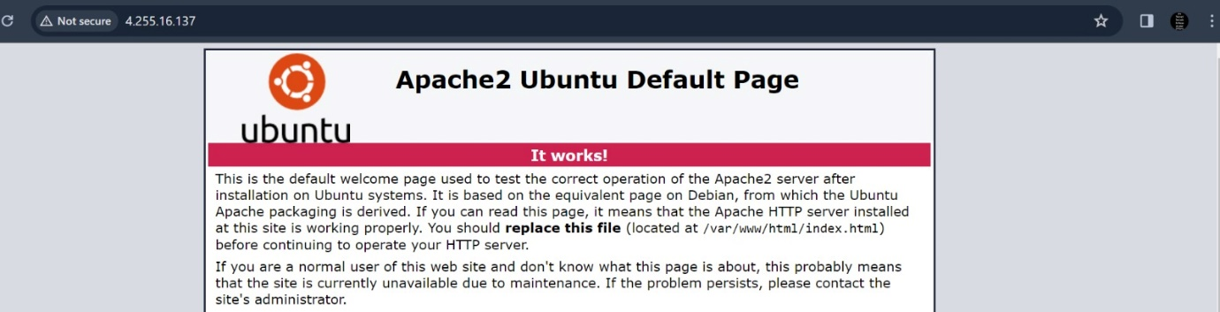

-Ajay Kollabathula