Create a virtual machine (VM) on

Microsoft Azure/AWS, configure it within a resource group and ensure basic

security measures are implemented.

**Azure:**

#### **Create a Resource Group**

1. Log in to the Azure portal.
2. Navigate to the "Resource groups" section.
3. Click on "Add" to create a new resource group.
4. Fill in the required details and select your preferred region.
5. Click "Review + create" and then "Create" to create the resource group

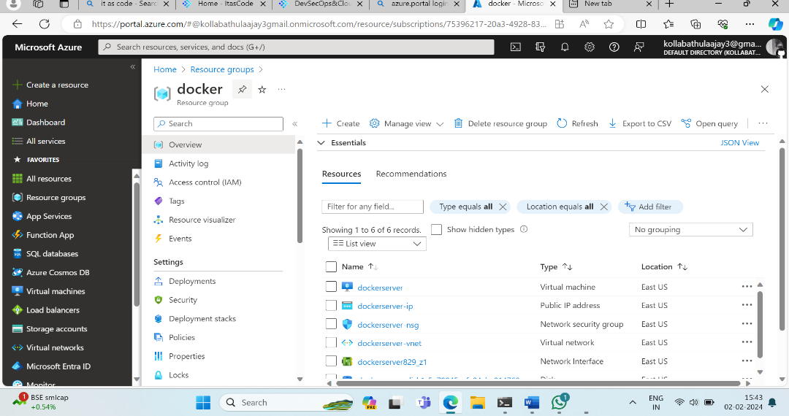

#### **Step 2: Create a Virtual Machine**

1. In the Azure portal, navigate to the resource group you created.
2. Click on "Add" to add a new resource.
3. Search for "Virtual machine" and select it.
4. Fill in the required details such as VM name, region, image, size, etc.
5. Configure the "Administrator account" and set up SSH or password authentication.
6. Configure networking settings, such as virtual network and subnet.
7. Click "Review + create" and then "Create" to deploy the virtual machine.

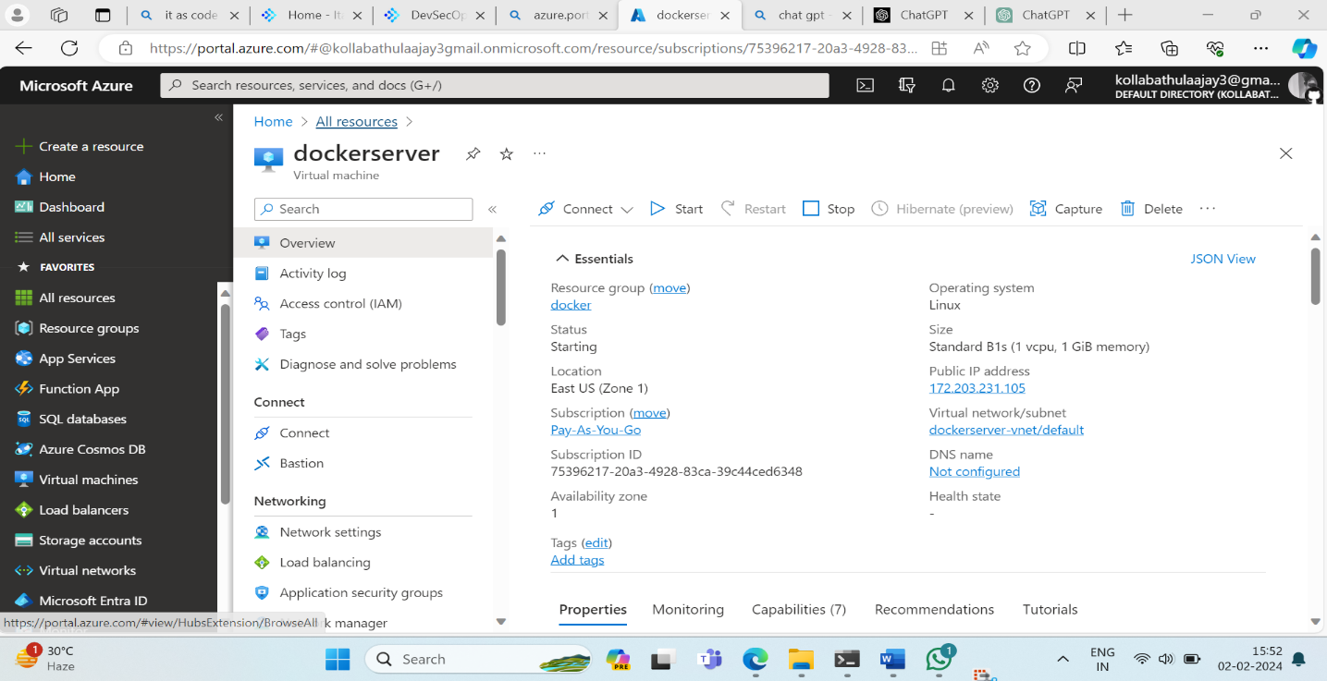

#### **Step 3: Basic Security Measures**

1. Network Security Group (NSG):
   * Associate an NSG with the virtual machine.
   * Define inbound and outbound rules to control traffic.
2. Azure Security Centre :
   * Enable Azure Security Centre for threat protection and security recommendations.
3. Update Management:
   * Configure Azure Update Management to keep the VM updated with the latest security patches.

-AJAY KOLLABATHULA