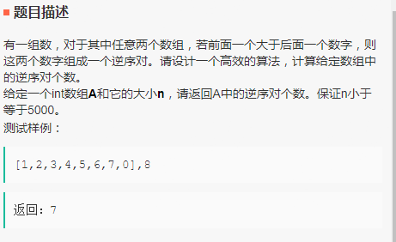

import java.util.\*;

public class AntiOrder {

public static int count(int[] A, int n) {

// write code here

int count = 0;

for(int i = 0;i< n-1 ;i++){

for(int j = i+1;j<n;j++){

if(A[i]>A[j]){

count++;

}

}

}

return count;

}

}