# Analysis

Analysis is the vital phase in software development process. It is the process of collecting requirements then analysing them to create proper and required system requirements for the project/software. Requirements comprises of functional and non-functional requirements and are collected from interaction with stakeholders and communication with users through tools like use cases, etc. Analysis also includes feasibility study of project to determine whether project is feasible economically, legally and so on.

Analysis is needed to capture client’s exact wants and needs from software project. It also helps in checking whether provided requirements are feasibly possible or not and if not help to understand what is needed rather than what they want.

## PEST Analysis

PEST analysis is the tool which is used to examine markets for particular product in a particular time with regards to multiple factors. It helps an organisation in better decision making and effective business strategies by studying various factors which are political, economic, social and technological which might influence product’s market directly or indirectly.

Factors impacting business environment to be analysed by PEST analysis are categorised into four parts:

1. Political

PEST analysis checks compatibility of business and products with government regulations or any related defined rules regarding tax guidelines, copyright and property law enforcement, social and environment policy, trade regulations, etc and any possible changes regarding them in near future. It helps an organisation determine whether there will be any impact in their business or product or not by political factors and act on it.

1. Economic

In PEST analysis, economic factors like current economy condition, exchange rates, unemployment rate, customer’s disposable income etc are considered. It helps in considering product cost, accessing of demand and expansion of business.

1. Social

With social factor, one can analyse socio-economic environment of business’s market to understand what customer need and want as well gauge potential market size. It includes study of demographics, population growth rate, age distribution, career attitude, etc that influences business environment of organisation.

1. Technological

With the rapid development ongoing in technology, customers are eager to adopt new technologies and this part of SWOT analysis involves study of factors related to technological advancements and its pace. It helps to determine organisation’s own required progress in technology and of its software product’s technology.

# Feasibility Study

Feasibility study is study for measuring completion success of a project from various standpoints. It is useful for knowing whether project is viable or not and identifying future potential problems that could occur in implementation of project.

Feasibility study has mainly five components.

1. Economic feasibility: It checks how much implementation of project costs and also how much it can return investment for organisation.

2. Technical feasibility: It projects how final product will be delivered including issues like manpower, business location and technology needed.

3. Schedule feasibility: It details the time limits to complete the project or deliver final product and also clarifies impact of late completion. Time is allocated before the start of project based on need.

4. Operational feasibility: This feasibility determines performance of product and whether it is operable or not. It checks how easy users find to interact with new system and need for training for operation if needed.

5. Legal feasibility: It determines whether legal regulations of government or region accepts new system or any possible hindrances with proper measures.

# 2.3 Requirement Analysis

Requirement analysis is one of the vital phases in software development process. It is required to correctly identify client’s requirements and expectations for the product.

## Functional Requirements

Functional Requirements are those what system needs to do.

|  |  |  |  |
| --- | --- | --- | --- |
| Function ID | Title | Description | Dependency |
| F1 | Registration | Registration of sales person | F1 |
| F2 | Admin Login | Log in of admin | F2 |
| F3 | Add Products | Addition of products in inventory by admin | F2 |
| F4 | Update/ Delete Products | Edit and remove of products by admin | F2 |
| F5 | Sales Person Login | Login by sales person for  POS | F1 |
| F6 | Products Inventory | View all products in inventory | F2, F5 |
| F7 | Sales Report | Report on sales transactions | F2, F5 |
| F8 | Refund Product | Refund of product on defect with cashback | F2, F5 |
| F9 | Purchase Product | Buy new product | F2 |
| F10 | Database | Database for recording all product details transactions |  |

Figure 1: Functional Requirements

## Non-Functional Requirements

Non-Functional Requirements are requirements which decide how system performs and its operation quality.

|  |  |  |
| --- | --- | --- |
| Non-Functional ID | Title | Description |
| NF1 | Reliability | Smooth operation and accurate outputs |
| NF2 | Availability | Available operational interface while needed |
| NF3 | Security | Restriction to unauthorised access |
| NF4 | Maintainability | Easy in maintenance |
| NF5 | Usability | User friendly interface and easy operation |

Figure 2: Non-functional requirements of DSMS

## MoSCoW Prioritization

MoSCoW is the technique to determine priorities of requirements/features for system in development process. It can be categorised in four types:

1. Must have
2. Should have
3. Could have
4. Won’t have

MoSCoW prioritization of functional and non-functional requirements of Departmental Store Management System is given below:

|  |  |  |  |
| --- | --- | --- | --- |
| S No. | Requirements | Type | MoSCoW Prioritization |
| 1 | Registration | Functional | Must have |
| 2 | Admin Login | Functional | Must have |
| 3 | Add products | Functional | Must have |
| 4 | Update/Delete products | Functional | Must have |
| 5 | Salesperson Login | Functional | Must have |
| 6 | Product Inventory | Functional | Should have |
| 7 | Sales report | Functional | Should have |
| 8 | Refund product | Functional | Could have |
| 9 | Purchase product | Functional | Must have |
| 10 | Database | Functional | Must have |
| 11 | Reliability | Non- Functional | Must have |
| 12 | Availability | Non- Functional | Should have |
| 13 | Security | Non- Functional | Must have |
| 14 | Maintenance | Non- Functional | Should have |
| 15 | Usability | Non- Functional | Should have |

Figure 3: MoSCoW prioritization of DSMS

Software Requirements Specification

Elements of Software Requirement Specification for DSMS are:

1. Documentation and help
2. Licensing and legal concerns
3. Technical, safety and quality standards
4. Operational concerns (error handling and backups)

## Use-Cases

Use Case Diagram is the graphical representation of interaction of user with system. It displays what action user(actor) performs on the system. It helps to identify and manage system requirements and determine its dynamic aspects.

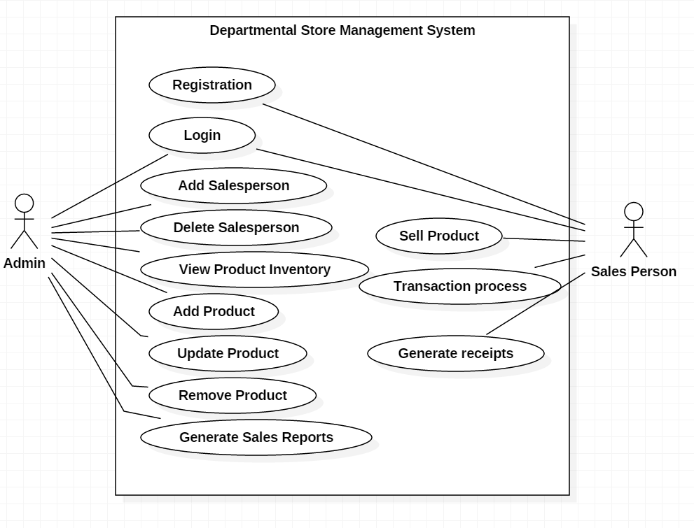

Figure 4: Use case Diagram of DSMS

## Natural Language Analysis

Natural Language Analysis is the process of identifying nouns as possible classes, adjectives as possible attributes and verbs as possible methods from the piece of descriptive text. From the scenario of this project, after analysing, following list of potential candidates are selected; nouns as classes and attributes, adjectives as attributes and verbs as methods after filtration process.

Filters:

* No duplicates
* No irrelevancies
* Eliminate candidate with higher level abstraction
* Eliminate out of scope candidates
* Amend ambiguities to meaningful ones

|  |  |  |
| --- | --- | --- |
| Classes | Attribute | Functions |
| Product | Name, quantity, cost, price | Add product  Update Product  Remove Product |
| Sales | Product name, quantity, product amount, description, invoice | Sell product  Generate bill  Generate sales report |
| User | username, password, user type | Login Users  Add salesperson  Remove salesperson |
| Customer | Name, address, amount, date, | Add customer  Manage sales log |

Figure 5: Potential classes and attributes after NLA

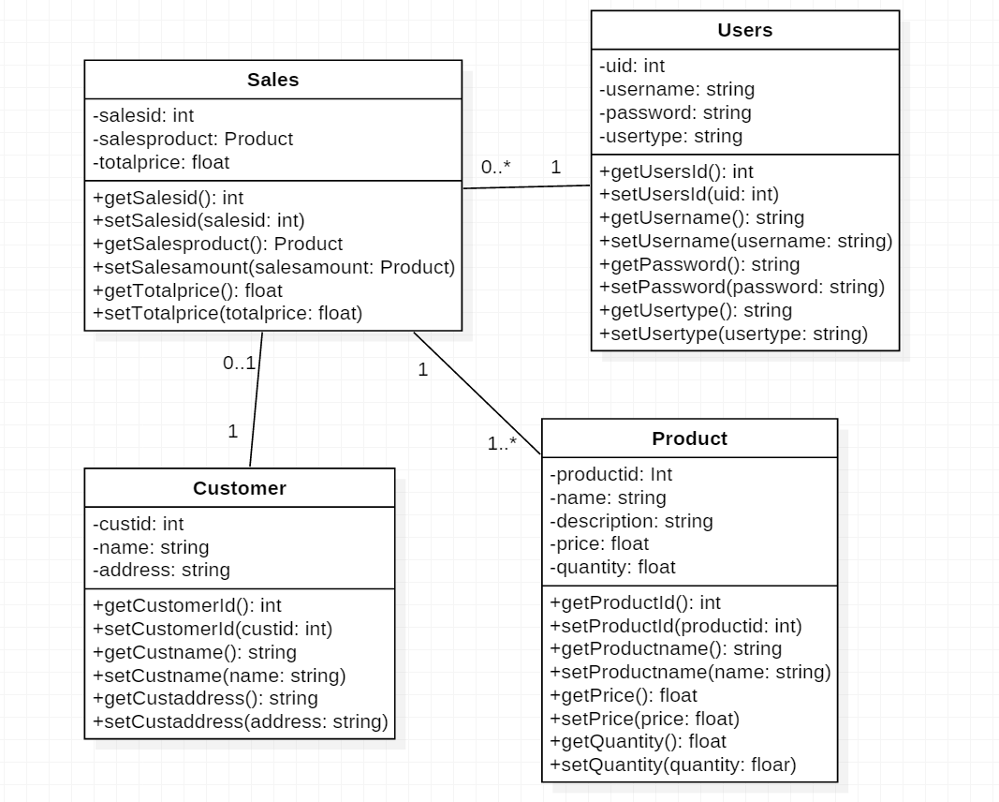

Figure 6: Class Diagram (DSMS)