Reproducible Research_Peer Assignment 1
ITguy666
2026-03-15
For this assignment, we will first download the data from a personal activity monitoring device that collects data at 5 minute intervals throughout the day. The data consists of two months of data from an anonymous individual collected during months of October and November 2012 and include the number of steps taken in 5 minute intervals each day.
The variables included in this dataset are:
- steps: Number of steps taking in a 5-minute interval (missing values are coded as NA)
- date: The date on which the measurement was taken in YYYY-MM-DD format
- interval: Identifier for the 5-minute interval in which measurement was taken
The dataset is stored in a comma-separated-value (CSV) file and there are a total of 17,568 observations in this dataset.
knitr::opts_chunk$set(echo = TRUE,warning = FALSE, message = FALSE)
##Loading libraries and preprocessing the activity data
library(ggplot2)
library(lubridate)
##
## Attaching package: 'lubridate'
## The following objects are masked from 'package:base':
##
## date, intersect, setdiff, union
library(dplyr)
##
## Attaching package: 'dplyr'
## The following objects are masked from 'package:stats':
##
## filter, lag
## The following objects are masked from 'package:base':
##
## intersect, setdiff, setequal, union
library(readxl)
#Define file name and url
url <- "https://d396qusza40orc.cloudfront.net/repdata%2Fdata%2Factivity.zip"
temp_zip <- tempfile(fileext=".zip")
#Download the file and unzip file
download.file(url,temp_zip,mode="wb")
file_list <- unzip(temp_zip,list=TRUE)
print(file_list) # To see file name
## Name Length Date
## 1 activity.csv 350829 2014-02-11 10:08:00
activitydata <- read.csv(unz(temp_zip,"activity.csv"))
unlink(temp_zip)
nrow(activitydata)
## [1] 17568
names(activitydata)
## [1] "steps" "date" "interval"
After downloading the data, we will next look at the first question in what is the mean total number of steps taken per day with the following analyses: 1. Calculate total number of steps taken per day 2. Make a histogram of the total number of steps taken each day 3. Calculate the mean and median of total number of steps taken per day
Solution: To tackle the above, we will first need to convert the date into a format that can be analysed using as.Date function. Following which, we will need to group the number of steps per day and sum up the data for each day. This can be done in creating another “totalsteps_perday” dataset using group_by date function and then pipe it to summarise using summarize function to sum up the steps taken in another variable within the dataset called “total_steps”. Latter will denote the total steps in a day and each row in the dataset is one day. We will also use the na.rm = TRUE to ignore missing values. Next, use the function hist() on totalsteps_perday$total_steps to create the histogram.
knitr::opts_chunk$set(echo = TRUE,warning = FALSE, message = FALSE)
#Convert Date format
activitydata$date <- as.Date(activitydata$date,format="%Y-%m-%d")
#Calculate the total steps per day by using group_by date and then use summarise to sum up the total steps for each day
totalsteps_perday <- activitydata %>%
group_by(date) %>% summarize(total_steps = sum(steps,na.rm=TRUE))
#Plot Histogram
hist(totalsteps_perday$total_steps,main="Total Steps Taken Each Day",
xlab="Steps",
col="steelblue",
breaks=20, na.rm=TRUE)
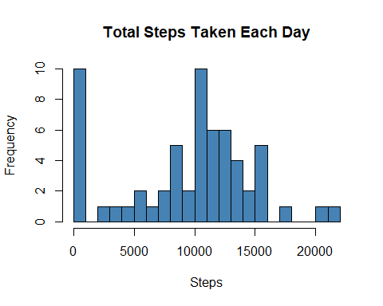
# Compute Mean and Median
mean_stepsperday <- mean(totalsteps_perday$total_steps,na.rm=TRUE)
median_stepsperday <- median(totalsteps_perday$total_steps,na.rm=TRUE)
print(mean_stepsperday)
## [1] 9354.23
print(median_stepsperday)
## [1] 10395
Next, we will study the data to derive the answers to the below: 1) What is the average daily activity pattern? 2) Make a time series plot of the 5-minute interval (x-axis) and the average number of steps taken, averaged across all days (y-axis) 3) Which 5-minute interval, on average across all the days in the dataset, contains the maximum number of steps?
Solution: To solve the above, we will also use the group_by and summarize functions to create a dataset “Average_daily_pattern” that groups by interval and then take the mean of the steps within the interval to create a new variable “avg_steps” for this. Similarly, remove NA values by setting na.rm = TRUE.Then plot interval and avg_steps in the “Average_daily_pattern” dataset.To calculate the maximum steps, we use the filter function to detect the datapoint whereby avg_steps is the max(avg_steps) and then come back with the corresponding interval which is 835.
knitr::opts_chunk$set(echo = TRUE,warning = FALSE, message = FALSE)
# Average steps per 5-minute interval
Average_daily_pattern <- activitydata %>%
group_by(interval) %>%
summarize(avg_steps = mean(steps,na.rm=TRUE))
#Time series plot
plot(Average_daily_pattern$interval,
Average_daily_pattern$avg_steps,
type = "l", col="red",iwd = 2, main = "Average Daily Activity Pattern By 5-minute Intervals",
xlab = "5-minute Interval",
ylab = "Average Steps")
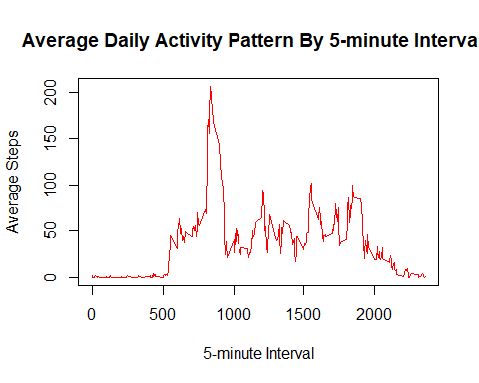
# Find 5-minute interval with maximum number of steps
max_interval <- Average_daily_pattern %>% filter(avg_steps==max(avg_steps))
print(max_interval$interval)
## [1] 835
Imputing missing values Note that there are a number of days/intervals where there are missing values (coded as NA). The presence of missing days may introduce bias into some calculations or summaries of the data.
- Calculate and report the total number of missing values in the dataset (i.e. the total number of rows with NAs)
- Devise a strategy for filling in all of the missing values in the dataset. For example, you could use the mean/median for that day, or the mean for that 5-minute interval, etc.
- Create a new dataset that is equal to the original dataset but with the missing data filled in.
- Make a histogram of the total number of steps taken each day and Calculate and report the mean and median total number of steps taken per day. Do these values differ from the estimates from the first part of the assignment? What is the impact of imputing missing data on the estimates of the total daily number of steps?
Solution: To resolve the above, we use sum(is.na) to count the total NAs. Following which, we will create a new variable “activity_imputed” that imputes the missing values by first joining the raw activity data with average daily pattern and then use mutate to create a new variable using ifelse that takes the value of “avg_steps” if the value is NA or missing. Following which, we remove the avg_step field from the dataset to keep it clean. With this dataset, we recompute the daily steps using group by and summarise functions. And then plot the histogram, mean and median.
knitr::opts_chunk$set(echo = TRUE,warning = FALSE, message = FALSE)
# Count total NAs
total_na <- sum(is.na(activitydata$steps))
paste0("The number of missing values are ",total_na," .")
## [1] "The number of missing values are 2304 ."
#Create a new dataset and fill NAs as average of steps
activity_imputed <- activitydata %>%
left_join(Average_daily_pattern, by="interval") %>%
mutate(steps = ifelse(is.na(steps),avg_steps,steps)) %>%
select (-avg_steps)
#Recompute total steps per day with imputed data
imputed_steps_per_day <- activity_imputed %>%
group_by(date) %>%
summarize(total_steps = sum(steps,na.rm=TRUE))
#Histogram for imputed data
hist(imputed_steps_per_day$total_steps,
main="Total Steps Per Day Using Imputed Data for NAs",
xlab = "Steps",
col = "lightgreen",
breaks = 20)
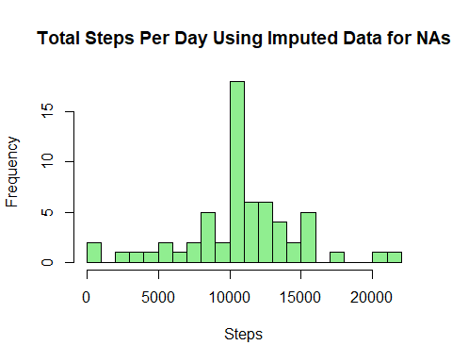
# Compute Mean and Median of imputed data
mean_imputed_stepsperday <-
mean(imputed_steps_per_day$total_steps,na.rm=TRUE)
median_imputed_stepsperday <-
median(imputed_steps_per_day$total_steps,na.rm=TRUE)
print(mean_imputed_stepsperday)
## [1] 10766.19
print(median_imputed_stepsperday)
## [1] 10766.19
Are there differences in activity patterns between weekdays and weekends? For this part the weekdays() function may be of some help here. Use the dataset with the filled-in missing values for this part.
- Create a new factor variable in the dataset with two levels – “weekday” and “weekend” indicating whether a given date is a weekday or weekend day.
- Make a panel plot containing a time series plot (i.e. type = “l”) of the 5-minute interval (x-axis) and the average number of steps taken, averaged across all weekday days or weekend days (y-axis). See the README file in the GitHub repository to see an example of what this plot should look like using simulated data.
Solution: To differentiate weekdays vs weekends, we use weekdays() and as.factor() functions in a new variable “day_type”. This “day_type” variable will be combined with “interval” variable to determine the breakdowns in the plotting of trend lines using ggplot.
knitr::opts_chunk$set(echo = TRUE,warning = FALSE, message = FALSE)
#Create factor for day type
Activity_imputed <- activity_imputed %>%
mutate(day_type = ifelse(weekdays(date) %in% c("Saturday","Sunday"),
"weekend","weekday"),
day_type = as.factor(day_type))
#Calculate average steps by interval and day_type
panel_data <- Activity_imputed %>%
group_by(interval,day_type) %>%
summarize(avg_steps = mean(steps))
#Panel plot using ggplot2
ggplot(panel_data,aes(x=interval,y=avg_steps,color=day_type))+
geom_line() +
facet_wrap(~day_type,ncol=1)+
labs(title="Comparison of Activity Patterns Between Weekday and Weekend",
x="Interval",y="Average Number of Steps")+
theme_bw()
