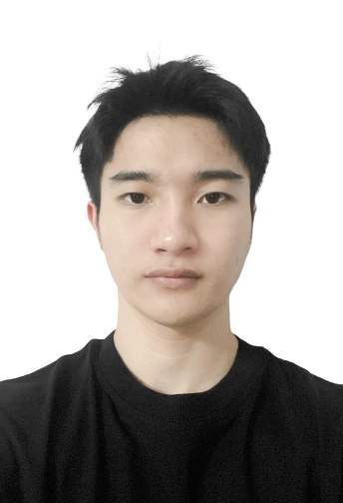

PHẠM TUẤN ANH

Developer

**Short-term Goals:**

Improve the skills required of a professional front-end and back-end programmer.

**Long-term Career Goals:**

In the future, My desire is to become a full-stack programmer.

[tuananh34.work@gmail.com](mailto:tuananh34.work@gmail.com) [0969023601](tel://0969023601/)

<https://fb.com/T.UA.N.A.N.H.3.4.1>

Minh Khai, Hai Bà Trưng, Hà Nội



30/04/2001

 Hải Dương

# Education

HANOI UNIVERSITY OF BUSINESS AND TECHNOLOGY

INFORMATION TECHNOLOGY – SOFTWARE ENGINEERING

**9/2019 - 8/2023**

GRADUATION GRADE: EXCELLENT – GPA: 3.6/4

Faculty: Information Technology

Major: Information Technology – Software Engineering

# EDUCATION

|  |  |
| --- | --- |
| **Level**: *1-4 Aware (Basic, need to practice more); 5-7 Knowledgeable (Intermediate, can use*  *it at work); 8-10 Proficient (Advanced, very good to use it at work)* | |
| HTML, CSS, SCSS, BEM, JavaScript, Vuejs, Reactjs, State management library, TailwindCSS, Bootstrap, Antd, Amchart, Echart,…. | Proficient, 8/10 |
| SQLite, Mysql, Postgresql, Mongodb. | Knowledgeable, 6/10 |
| Postman, Docker, Git, Gitlab, Github, Trello,.. | Proficient, 6/10 |
| Nodejs, ExpresJS. | Knowledgeable, 5/10 |

# WORK EXPERIENCE

|  |  |
| --- | --- |
| **From:** 09/2023 **To:** Present **Company:** VNCS GLOBAL **Position:** R&D | Research and explore open-source solutions for cybersecurity and information security.  Integrate Elasticsearch query calls to display desired data from returned results.  Coding, Design pattern.  Use Vue.js, Vuex, Quasar Framework.  Use ApexCharts, AmCharts, and ECharts to display data from Elasticsearch.  Search, design detailed UI/UX interfaces. |
| **From:** 11/2022 **To:** 5/2023 **Company:** IWANNA TECH **Position:** Intern | Designed and built UI/UX, reseach themes, HTML slicing.  Research solution, Coding, Design pattern.  Learned and utilized various tools and technologies: GitHub, Command line, Node.js, Docker,.. |

# PROJECTS

|  |  |
| --- | --- |
| **ChatAI** **Duration:** 6/2024 – Present **Client:** VNCS Product **Team Size:** 2 | **Description:** Handling user input data ( multilingual ) and returning desired results based on the Splunk AI Assistant API. **Responsibilities:**   * Building UI/UX * Integrate ChatGPT and Gemini, Splunk AI into the project. * Build the backend using Node.js and Express.js, RESTFul API, store the database using MongoDB and build Docker.   **Technologies Used:** Front-end: Vue.js, Vuex, Bootstrap, SCSS  Backend: Nodejs, ExpressJS, MongoDB |
| **Vsiem** **Duration:** 05/2023 – Present **Client:** VNCS Product **Team Size:** 4 | **Description:** Research and integrate licensed tools via API to build a SIEM system. Integrate Elasticsearch query API to display desired data from returned results. **Responsibilities:**   * Interface design * Script testing * Creating graphical interfaces for statistics * Feature development   **Technologies Used:** Frontend: Vue.js, AmCharts, ECharts, ApexCharts, Ant Design, BootstrapVue  Backend: Docker, PostgreSQL, Elasticsearch, etc. |
| **Web Mall** **Duration:** 03/2024 – Present **Client:** Private **Team Size:** 2 | **Description:** Building an e-commerce website, CRM, product management, and online store. **Responsibilities:**   * Frontend development using Vue.js. * Design detailed UI/UX interfaces , feature development.   **Technologies Used:** Frontend: Vue.js, Atn design vue, TailwindCss,… |
| **Web Nails** **Duration:** 12/2024 – 05/2024 **Client:** Private **Team Size:** 3 | **Description:** Build a nail salon management website. **Responsibilities:**   * Frontend development using React.js * Design detailed UI/UX interfaces , feature development.   **Technologies Used:** Frontend: React.js, HTML, CSS,… |