UNIT 1
SYLLABUS
- Computer System Overview-Basic Elements, Instruction Execution, Interrupts, Memory Hierarchy, Cache Memory, Direct Memory Access, Multiprocessor and Multicore Organization.
- Operating system overview-objectives and functions, Evolution of Operating System.
- Computer System Organization
- Operating System Structure and Operations- System Calls, System Programs, OS Generation and System Boot.

COMPUTER SYSTEM OVERVIEW

Computer is an electronic machine that accepts user input, process the data and outputs the desired result.
BASIC ELEMENTS
The basic elements of computer like processor, memory and input/output (I/O) components and modules are interconnected to achieve main function of computer. The four basic structural elements are:
- Processor:
  - often referred as Central Processing Unit
  - Controls operation of computer
  - performs data processing functions
- Main Memory
  - Also called as real/primary memory
  - Stores data and programs
  - volatile (contents of memory lost when system is shut down)
- I/O Modules
  - Moves data between computer and external environment
  - External environment- devices like disks(secondary memory), terminals, communication
equipments
- System Bus
  - Provides communication among processors, main memory and I/O modules

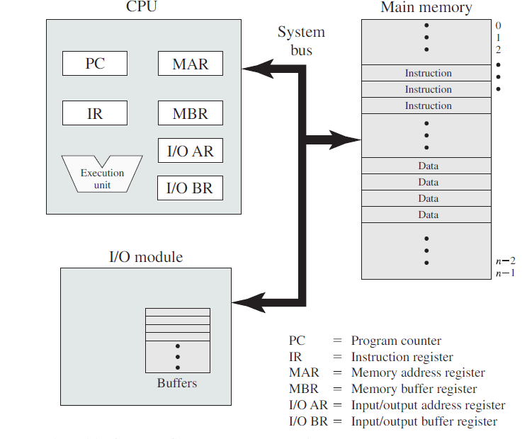

Figure 1.1 Computer Components-Top Level View

Figure 1.1 depicts the top level components of a computer. The processor exchanges data with the memory using two registers MAR(Memory Address Register-specifies memory address) and MBR (Memory Buffer Register-contains data). I/O AR specifies particular I/O device, I/O BR used to exchange data between processor and I/O device.

INSTRUCTION EXECUTION
- A program consists of set of instructions and is stored in memory, which is executed by the processor later.
- Processing required for single instruction is called as instruction cycle
- Processing of an instruction(instruction cycle) : 2 stages
  - fetch stage
  - execute stage
- Fetch stage:
  - At beginning of each instruction cycle processor fetches instruction from memory.
  - Program Counter(PC) holds address of next instruction to be fetched. PC incremented after every instruction fetch.

- Execute stage:
  - Fetched instruction is loaded into instruction register(IR).Instruction contains bits to specify action to be taken.
  - 4 categories of actions:
    - Processor-Memory: Data transferred from processor to memory or memory to processor
    - Processor-I/O: Data transferred to and from a peripheral device by transferring between processor and module
    - Data Processing: Processor may perform arithmetic/logic operations on data.
    - Control: An instruction can specify alteration in sequence of instruction execution.
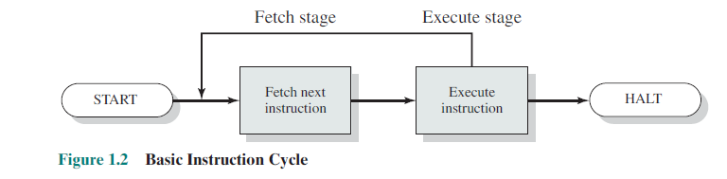
INTERRUPTS

- Interrupt is a signal emitted by hardware or software to the processor in-order alert the processor of higher priority event so that current instruction execution is interrupted.
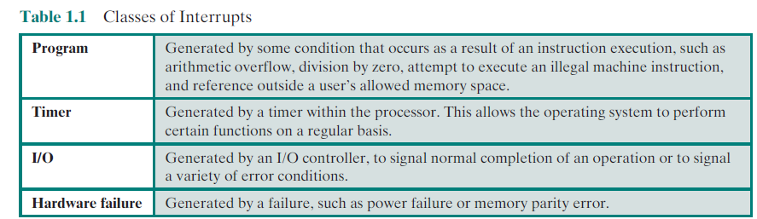
- Interrupts improve processor utilization.
- With the help of interrupts CPU can be engaged in executing other instructions while an I/O operation is in progress.
- When an external device is ready to accept data from processor, the I/O module for the external device sends an Interrupt Request signal to the processor
- The processor suspends current program, responds to the interrupt by branching off to a routine to service that particular I/O device known as Interrupt Handler
- After the interrupt processing is completed the suspended program is resumed/executed from the point where it was stopped.
- 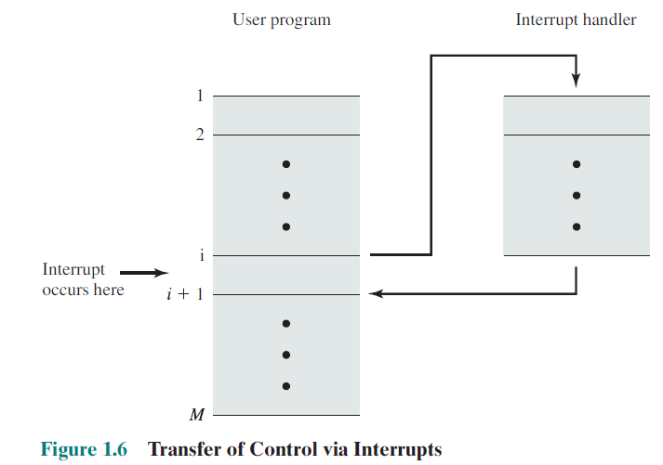
- To accommodate interrupts interrupt stage is added to the instruction cycle.
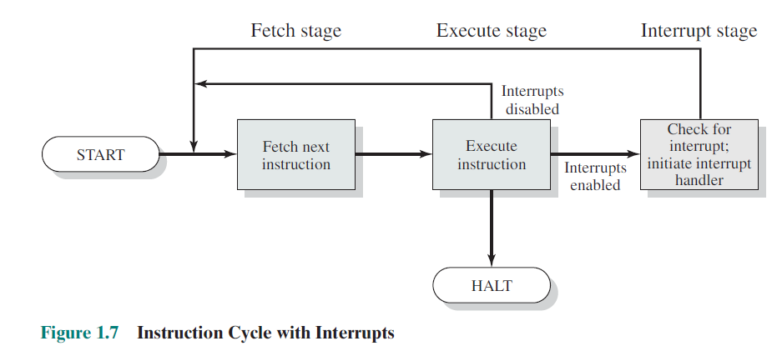
- In the interrupt stage processor checks if any interrupts have occurred (indicated by interrupt signal), if no interrupts processor proceeds to fetch stage else if interrupts are pending processor suspends current program and executes the interrupt handler routine.
Interrupt Processing
Following are the sequence of hardware events that occurs when an I/O device completes an I/O operation
- The device issues interrupt signal to the processor.
- The processor finishes execution of current instruction before responding to interrupt
- The processor tests for Interrupt Request, if present sends Acknowledgment signal to the device that issued the interrupt.
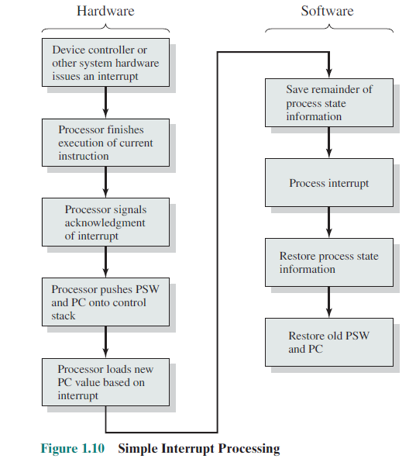
- Processor saves information (Program Status Word(PSW) + location of next instruction present in program Counter(PC) } in control stack
- Processor loads the PC with location of the interrupt handling routine that will respond to the interrupt
- The interrupt handler also saves the register contents and other status information of interrupted program in the stack
- The interrupt handler now processes the interrupt
- After the completion of interrupt processing , saved register values of interrupted program are retrieved from stack restored back to registers
- Finally the PSW and PC values are restored from the stack
Multiple Interrupts

- To manage multiple interrupts concept of disabled interrupts is used.
- Interrupts are disabled when other interrupt is executed. Later when the interrupt handler routine completes, interrupts are re-enabled before resuming the user program that was interrupted.
Traps
- A trap (or an exception) is a software-generated interrupt
- caused either by an error (for example, division by zero or invalid memory access)
- or by a specific request from a user program that an operating-system service be performed.

Interrupts | Traps
Signal emitted by hardware to the processor | Signal Emitted by a software or a user program
Instances when h/w interrupts generated are : completion of a DMA , I/O request etc | It is caused by an error (for example, division by zero or invalid memory access)  or by a specific request from a user program for an operating-system service
Hardware interrupts are asynchronous since they are not associated with a specific instruction or process. | Traps(software interrupts) are synchronous since they are associated with a specific instruction and process.

MEMORY HIERARCHY
- Memory is a storage place where various data, instructions, program, documents are stored. Memory hierarchy can be determined by following factors:
  - Access time
  - Frequency of access by processor
  - Capacity
  - Cost
- Access time is the time taken by CPU to retrieve data from memory
- Hit ratio H, fraction of memory accesses that are found in faster memory.
- Frequency of access/Memory references can further be simplified using Locality of Reference concept. Locality of reference makes use of the fact that loops and subroutines in programs access frequently small set of instructions that are either clustered or sequenced nearby the data accessed first. So such set of data are loaded into the fast memory for quick access and performance.
- Capacity is number of bytes that a memory can accommodate

Factors\Memory | Registers | Cache | Main Memory | Secondary Memory(disk&tape)
Access time | very less | lesser | high | highest
Cost | Costliest | Costlier | cheaper | cheapest
Capacity | very less | less | high | highest
Frequency of access | highest | higher | high | low

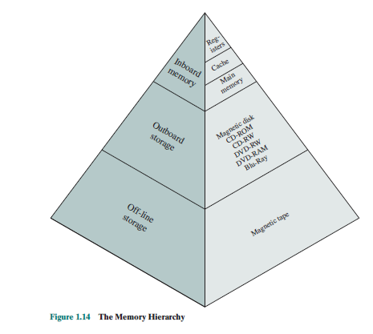

- Register
  - The register is a high speed storage memory present within CPU, therefore the access time is very fast in case of registers
  - It has less capacity, small in size and more expensive

- Cache
  - It’s a small fast storage placed between the CPU and Main memory.
  - Frequently accessed data are stored in cache to improve access of data and reduce the access time
  - Initially the CPU checks the cache for the data required to execute instruction, if present in cache its called as cache hit,if not present its called as cache miss and the CPU checks the main memory for the required data.
  - Cache can have various levels with the cache nearer to CPU having lowest capacity and fastest access.
- Main Memory
  - It has more capacity compared to cache.
  - There are two parts :Random Access Memory(RAM) and Read Only Memory (ROM).
  - RAM-volatile memory-data temporarily stored, programs are loaded before being executed in CPU
  - ROM-non volatile, stores important system programs
  - CPU checks main memory for required data, if not found then the data is searched in secondary memory.
  - Cheaper compared to the cache and registers.
- Secondary Memory
  - It’s the largest and slowest memory
  - Made of magnetic disks and tapes
  - It’s a non-volatile memory-data permanently stored
  - All back up data stored in secondary memory
  - The access time is high compared to other memories
  - Cheapest of all memories
Thus the smaller more expensive faster memories are supplemented by larger, cheaper and slower memories.

CACHE MEMORY
- A cache is a small high-speed storage space or temporary storage that stores most frequently needed used data.
- Motivation for cache: To improve memory access speed (match with CPU register speed)
- Main Principle: Locality of reference (principle of locality)- same value or related storage locations being frequently accessed
- Multi-level Caches: multi level caches are used to overcome the disadvantages of longer latency in single larger caches. Multi-level caches generally operate by checking the fastest, level 1 (L1) cache first; if it hits, the processor proceeds at high speed. If that smaller L1 cache misses, the next fastest cache (level 2, L2) is checked, and so on, before external memory is checked.
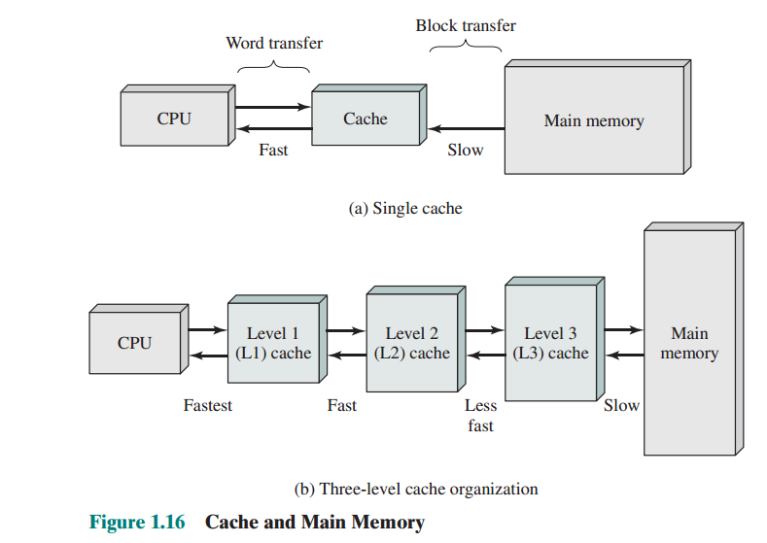

Cache Principles and Structure
Cache contains copy of portion of main memory
- When CPU tries to read a byte / word
  - Checks cache for the byte/word
  - If byte/word found in cache the its called as “Cache Hit”, the byte/word is transferred to CPU for processing
  - If data is not found in cache it is called as “Cache Miss”, then block of main memory (fixed number of bytes) is read into cache and transferred to CPU.
  - Locality of reference-when a block of data loaded in cache to satisfy a single memory reference, its probable that the other bytes/data in the block may be the future memory references.
  - Read Operation in Cache: processor generated the address of the word/data to be read (RA), if word present in cache delivered to processor else the word is checked in memory and block containing word loaded from memory to cache and delivered to processor.
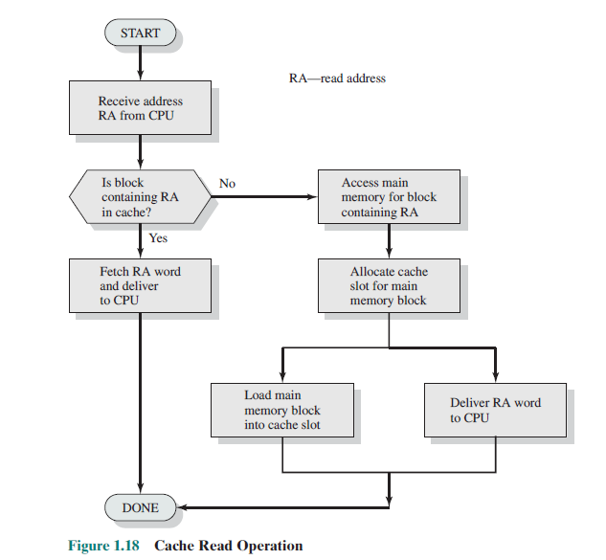
Cache/Main memory structure
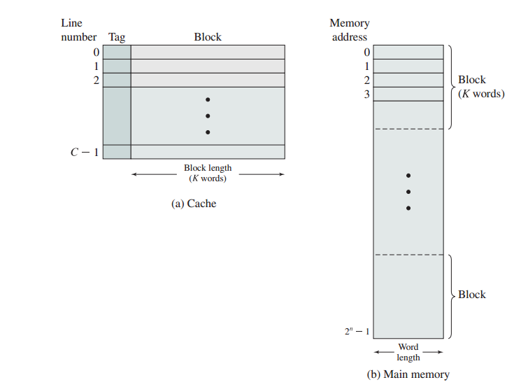
- Main memory➔0 to 2^{n} addressable words, memory has blocks of words
- Let each block of memory have k words
- Then number of blocks in main memory M=2^{n} / k
- Cache has C slots(also called lines) of K words each
- Slots( of cache) are mapped to blocks(of main memory)
- There are more blocks than slots
- So a slot cannot be permanently dedicated to a particular block
- Each slot has a tag to identify to which memory block it is linked

Cache Design

Key Elements in Cache design:
- Cache Size: small caches have significant performance
- Block Size: unit of data exchanged between cache and main memory
- Mapping Function: the mapping of cache location with main memory block
- Replacement Algorithm: When cache slots are full and new block is to be loaded into the cache, replacement algorithms remove slots from cache which may not be needed in future. Eg: Least Recently Used (LRU) algorithm
- Write Policy: whenever contents are written/updated in cache it is necessary that corresponding copy in main memory is also updated.

DIRECT MEMORY ACCESS

Introduction
3 techniques for handling I/O Operations
  - Programmed I/O:
  - Interrupt Driven
  - Direct Memory Access
Programmed I/O

- When processor executes I/O instruction it issues necessary commands to I/O module
- I/O module performs action requested
- I/O module set bits in I/O status register indicating the completion of the I/O operation
- But it does not alert processor
- Processor waits, idle until I/O operation over
- Processor checks the I/O status register periodically to know the completion of the I/O operation
- Disadvantage:
  - Long wait and idleness of processor
  - Delay in reception/transmission of data between I/O and processor
  - Interrogation on status periodically

Interrupt Driven
- Processor issues command to I/O module
- Processor does not wait, engages in other work
- But when the I/O module requires data from memory, processor intervention in required
- When I/O module finishes action triggers interrupt to processor
- More effective that programmed I/O
- Disadvantages
  - Dependency on processor for data transfer b/w memory & I/O module

Direct Memory Access
- DMA Completely takes care of I/O operation without processor intervention to read/write data from memory
- DMA function – may be present as a module in s/m bus or inbuilt in I/O module
- Advantage: Efficient technique to move large volumes of data.
- When I/O instruction occurs processor send DMA following info:
  - Whether to Read or Write the data
  - Address of I/O device
  - Starting Memory address of data to read/write
  - Number of words to read /write
- Processor after giving information to DMA engages in other jobs
- DMA is now responsible for the I/O operation.
- DMA transfers data to/from memory to I/O
- DMA sends interrupt to processor on completion of I/O operation
- Handshaking between the DMA controller and the I/O controller is performed via a pair of wires called DMA-request and DMA-acknowledge.

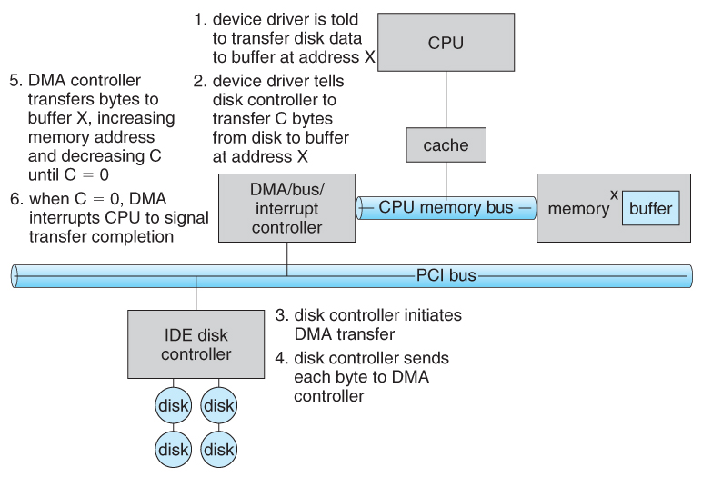

- DMA uses CPU-Memory bus for data transfer between I/O and main memory
- Processor cannot access bus during DMA transfer. Processor waits for bus, which is called as cycle stealing.
- Cycle Stealing : DMA grabs the machine cycles from the processor to directly access the memory to complete I/O operations
- Processor pauses for one bus cycle(not stopped)
- Disadvantage: Processor gets slower on DMA transfers
- Yet DMA more efficient for Multiple word -I/O transfer

MULTI-PROCESSORS
- Single entity or system having multiple CPU/processors
- Communicate with each other using shared memory
- Concept: Parallelism by replicating processors
- Motivation: Fast processing and high performance
Symmetric Multi Processors(SMP)
- SMP can be defined as Stand-alone s/m with following characteristics:
  - 2 or more processors with comparable compatibility
  - Processors share same main memory & I/O facilities which are interconnected by a bus.
  - Memory Access Time is approximately same for each processor
  - All processors share access to I/O devices through same or different channels
  - All processor can perform same functions
  - Integrated OS provides interaction b/w processors, schedule jobs, manage task, file and data elements
SMP-Organization
- Each processor has its own control unit, ALU, Registers and caches
- Each has access to shared memory & I/O via shared bus
- Processor communicate via
  - Messages & status info in Shared address spaces in main memory
  - Also exchange signals among them directly
  - Simultaneous access to separate blocks of memory
- Cache coherence be maintained in SMP: An update of a block in cache should be reflected in all copies of the block in other memories and caches
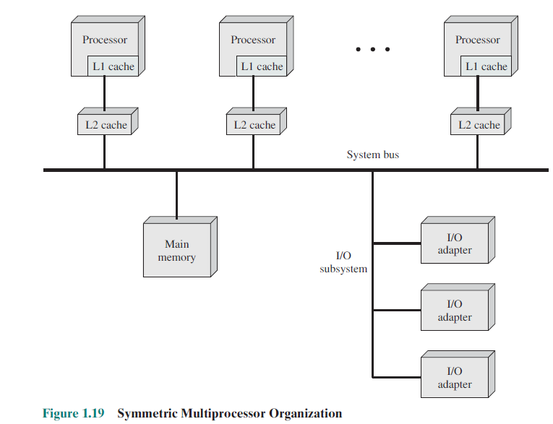

Advantages of SMP over Uniprocessor
- Performance-tasks shared and executed in parallel by many processors yield better performance than tasks done by a single processor
- Availability-failure of a single processor will not halt the machine
- Incremental growth-user can add additional processor and enhance performance
- Scaling-based on processors vendors can offer range of products with different price and characteristics.

MULTI-CORE ORGANIZATION

- Consists of 2 or more processors (cores) on a single piece of silicon(die) chip
- Also called as chip multiprocessor
- Each core consists of registers, ALU,CU,Caches etc
- Motivation:
    - Parallelism provide more performance
    - Increase miniaturization to improve processing speed
- Example: Intel Core i7
  - Four x86 processors
  - Dedicated L2 cache
  - Shared L3 cache
  - Pre-fetching data based on speculation (examines memory access patterns)
  - 2 forms of External Communication:
    - DDR3 Memory Controller
      - Interface b/w memory and chip
      - 3 channels each 8 bytes, total bus width=192 bits
      - Data rate up to 32 GB/s
    - QuickPath Interconnect(QPI)
      - Point to point electrical interconnect
      - High Speed communication among processors
      - Data rate 25.6 GB/s

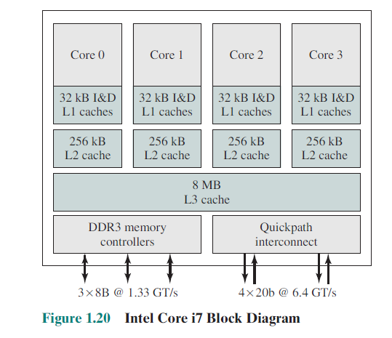
OPERATING SYSTEM OVERVIEW
- An operating system is a program that manages a computer’s hardware. Eg: Windows ,Unix
- Acts as an intermediary between the computer user and the computer hardware.
- It controls the application programs
Three main objectives of OS
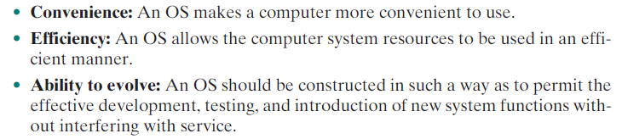
OS FUNCTIONS AND SERVICES
1)OS as a user/computer interface
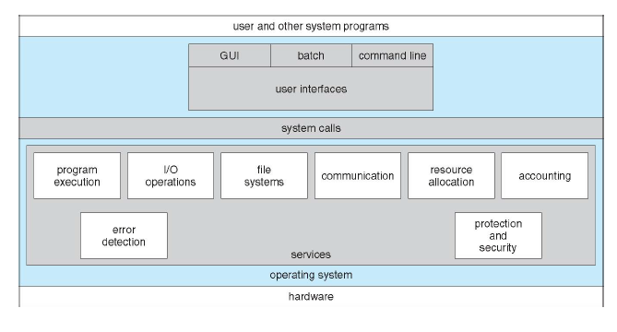
OS provides services in following areas
- Program Development
  - OS provides Application program development tools Eg:Editors, debuggers
- Program Execution
  - Data loading
  - File, Resource initialization
  - Scheduling
- Access to I/O
  - Each I/O device different
  - But OS provides uniform interface for users
- Controlled Access to Files
  - Manages Structure of file storage
  - Provide Protection mechanism
- System Access
  - Control of Shared systems /Resources
  - Protection from unauthorized users
  - Resource contention when two or more process needs a same resource
- Error Detection & Response
  - Handling H/w and s/w error Eg: memory error, division by zero
  - Response to errors
    - Terminate program
    - Retry
    - Report error to application
    - 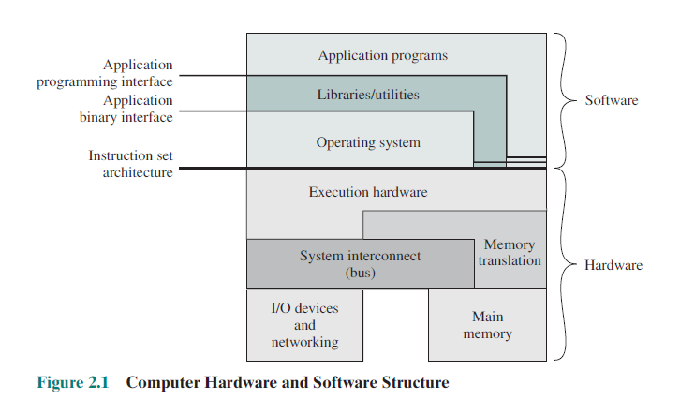
- Accounting
  - Collect resource statistics
  - Use response time to Monitor performance
  - To anticipate
    - Need for future enhancements
    - Tuning s/m for increased performnce
    - Billing purposes in multi-user s/m
- ISA (instruction set architecture)
• A well-defined hardware/software interface
• Defines set of machine language instruction that computer can follow
- Both application programs and system programs can access ISA directly
2 types
User ISA - accessed by application programs & Utilities
System ISA - for s/m resource management programs
- Application Binary Interface
  - Interface b/w application programs & OS
  - Defines standard for binary portability across programs
  - Defines s/m call interface to OS & H/w resources via user ISA
- Application Programming Interface
  - Helps user program to access h/w resources & services via User ISA and High Level Language library calls
  - System calls performed using libraries
  - Supports easy portability of s/w application

2) OS as a Resource Manager
(i) Storage/Memory Manager
OS manages the memory resources along with the memory management hardware in the processor
It controls the allocation and de-allocation of memory, which region of memory used/free etc
(ii)I/O Device Manager
OS also manages the I/O devices .It decides when an I/O device can be used by a program in execution and manages buffering, spooling and caching of data
(iii)CPU Scheduler
OS also manages the utilization of processor by the user programs, allocates processor time for each process
(iv) Mass Storage Manager
OS also manages the secondary storage-disk utilization and other functions like free space management, storage allocation and disk scheduling.

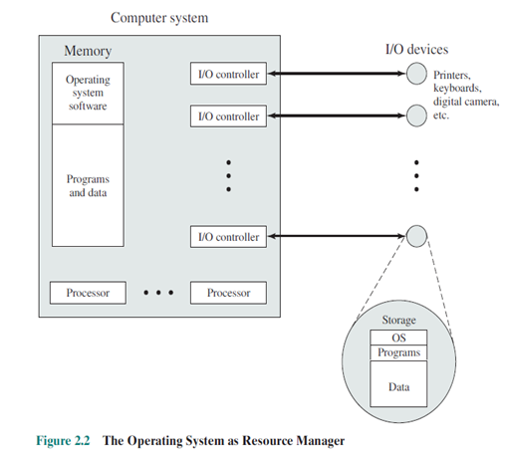
EVOLUTON OF OS
Serial Processing➔Simple Batch Systems ➔ Multi Programmed Batch Systems ➔Time Sharing systems

1. Serial Processing(1940-1950)
  - Earliest computers
  - Programmer directly interacted with h/w
  - No OS
  - I/Pà display lights, toggle switches, card reader
  - O/Pà printer
  - Programs are in machine code
  - If no error o/p will be printed on printer
  - If error program halted & indicated by lights
DISADVANTAGES
  - Scheduling of programs is very difficult
  - Setup Time to load & link- mounting/dismounting tapes is very time consuming
2. Simple Batch Systems
- Main PrincipleàBatch systems use software called MONITOR
  - Batches the jobs (programs) together
  - Executes job in sequence
  - Thus reduces idle time
- Motivation: to improve CPU Utilization
- First Batch OS developed on mid 1950s by General Motors on IBM 701
- IBM SYS, IBM OS for 7090/ 7094
- Monitor Point of view
  - Monitor Controls sequence of events
  - Part of monitor in main memory for execution is called as Resident monitor
  - Rest in utilities, routines required in beginning
  - Monitor reads job from i/p device
  - Places it in user program area
  - Pass control to job
  - Regains control after job completion
  - Reads next job
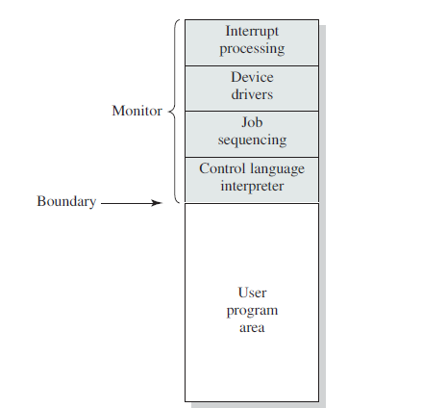
- Processor point of view
  - Processor executes monitor : that instructs to read job
  - User program executed until end/error, Next instruction fetched from monitor
  - 2 main actions
    - “Control passed to job” (fetch + execute user program)
    - “Control returned to monitor” (fetch +execute monitor program)
- Job control language (JCL)
  - Spl type of programming language that provides instructions to users
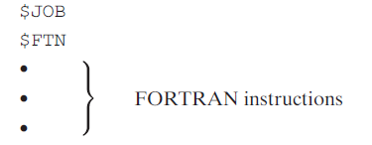
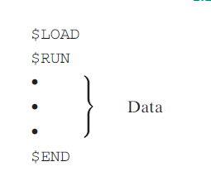
- Desired H/w features
  - Memory Protection
    - Prevent access of user program to alter monitor
  - Timer
    - Prevents single job monopolizing
  - Privileged Instruction
    - Executed only by monitor
    - Eg I/O instructions
  - Interrupts
    - Flexibility to transfer & regain control for OS
- 2 modes in system
  - User mode
    - User program executes
    - Protected memory areas cannot be accessed
  - Kernel mode
    - Monitor program executes
    - Protected areas can be accessed
- Disadvantages
  - Processor idle despite automatic job sequencing
  - I/O devices slow compared to processor
  - CPU waits till I/O operation over
3. Multi-programmed Batch Systems
- Multi-programming(Multi-tasking):
  - Processor can switch from one program execution to another before a program completion
  - The memory can be expanded to hold three or more jobs and switch among them while execution.
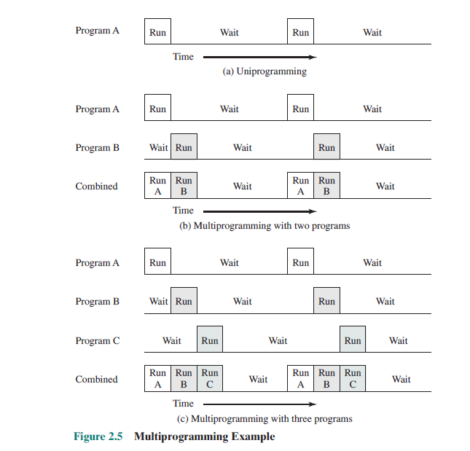
- Desirable h/w features
  - I/O Interrupts
  - DMA Access
- Disadvantages
  - More sophisticated than Uni-programming
  - Efficient Memory Management required
  - Efficient Job Scheduling algorithm required
In the above example we see that in Uniprogramming concept only one program can run at a time. There is a gap in execution of Program A while its performing some I/O operation, meawhile the processor remains idle.
In case of multiprogramming concept ,processor can switch execution of one program to another. Program A runs for a while and when it performs I/O operation, CPU rather than being idle takes up program B and starts executing it . Thus the waiting time or idleness of CPU is greatly reduced in multiprogramming.

4. Time Sharing Systems
- It’s a technique where multiprogramming can be used to handle multiple-interactive jobs, by sharing processor time among multiple users
- Interactive mode is essential. Multiple users access via terminals
- OS interleaves execution of user program in short burst of time. If n users each user will see 1/n computing capacity
- First Time Sharing OS is “COMPATIBLE TIME SHARING SYSTEM” (CTSS) by MIT
- CTSS ran with 32,000 36 bit words of memory.Resident monitor consumes 5000 words. Remaining 27,000 for user program
- Program always loaded at 5000th location
- At every 0.2 second clock interrupt is triggered. OS regains control and assigns processor to another user which is called as TIME SLICING
- To reduce disk traffic: write in disk only when another program overwrites it
Advantages
- Very Effective
- Simple, monitor size minimized
- No need for relocation techniques
- Minimized disk activity to be improved
- CTSS supported max of 32 users
Difficulties
  - Protection from interfering
  - Protection from unauthorized access
  - Contention of resources-printers, mass storage etc

COMPUTER SYSTEM ORGANIZATION
Computer-System Operation
- A modern general-purpose computer system consists of one or more CPUs and a number of device controllers connected through a common bus that provides access to shared memory (Figure 1.2).
- When system is powered up or rebooted, the bootstrap program must locate the operating-system kernel and load it into memory.
- Once the kernel is loaded and executing, it can start providing services to the system and its users. Some services are provided outside of the kernel, by system programs that are loaded into memory at boot time to become system processes, or system daemons that run the entire time the kernel is running.

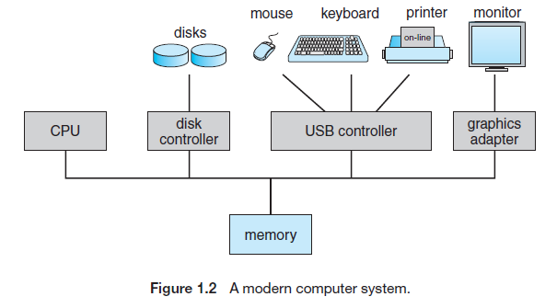
- On UNIX, the first system process is “init,” and it starts many other daemons.
- Once this phase is complete, the system is fully booted, and the system waits for some event to occur.
- The occurrence of an event is usually signaled by an interrupt from either the hardware or the software. Hardware may trigger an interrupt at any time by sending a signal to the CPU, usually by way of the system bus. Software may trigger an interrupt by executing a special operation called a system call
(also called a monitor call).
Storage Structure
- Computers run most of their programs from rewritable memory, called main memory (also called random-access memory,or RAM). Main memory commonly is implemented in a semiconductor technology called dynamic random-access memory (DRAM).
- Secondary storage is that it be able to hold large quantities of data permanently.The most common secondary-storage device is a magnetic disk, which provides storage for both programs and data. Most programs (system and application) are stored on a disk until they are loaded into memory. 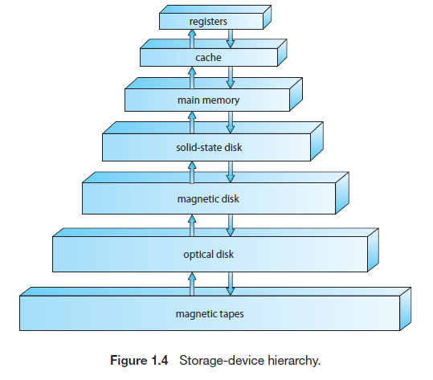

I/O Structure
- Each device controller is in charge of a specific type of device. Depending on the controller, more than one device may be attached. For instance, seven or more devices can be attached to the small computer-systems interface (SCSI) controller
- The device controller is responsible for moving the data between the peripheral devices that it controls and its local buffer storage.
- Operating systems have a device driver for each device controller. This device driver understands the device controller and provides the rest of the operating system with a uniform interface to the device.

COMPUTER-SYSTEM ARCHITECTURE
1.Single-Processor Systems
- On a singleprocessor system, there is one main CPU capable of executing a general-purpose instruction set, including instructions from user processes.
- All single processor systems have other special-purpose processors aswell, in the form of device-specific processors, such as disk, keyboard, and graphics controllers; or, on mainframes, they may come in the form of more general-purpose processors, such as I/O processors that move data rapidly among the components of the system.
2.Multiprocessor Systems
- Single entity or system having multiple CPU/processors
- Communicate with each other using shared memory
- Concept: Parallelism by replicating processors
- Motivation: Fast processing and high performance
- multiprocessor systems (also known as parallel systems or multicore systems) have two or more processors in close communication, sharing the computer bus and sometimes the clock, memory, and peripheral devices.
SMP-Organization
- Each processor has its own control unit, ALU, Registers and caches
- Each has access to shared memory & I/O via shared bus
- Processor communicate via
  - Messages & status info in Shared address spaces in main memory
  - Also exchange signals among them directly
  - Simultaneous access to separate blocks of memory
- Cache coherence be maintained in SMP: An update of a block in cache should be reflected in all copies of the block in other memories and caches

Advantages of SMP over Uniprocessor
- Performance-tasks shared and executed in parallel by many processors yield better performance than tasks done by a single processor
- Availability-failure of a single processor will not halt the machine
- Incremental growth-user can add additional processor and enhance performance
- Scaling-based on processors vendors can offer range of products with different price and characteristics.
- The ability to continue providing service proportional to the level of surviving hardware is called graceful degradation. Some systems go beyond graceful degradation and are called fault tolerant, because they can suffer a failure of any single component and still continue operation.

- The multiple-processor systems in use today are of two types.
    - Symmetric Multiprocessing
    - Asymmetric Multiprocessing
- Asymmetric multiprocessing: in which each processor is assigned a specific task. A boss processor controls the system; the other processors either look to the boss for instruction or have predefined tasks.
- Symmetric multiprocessing (SMP): in which each processor performs all tasks within the operating system. SMP means that all processors are peers; no boss–worker relationship exists between processors.
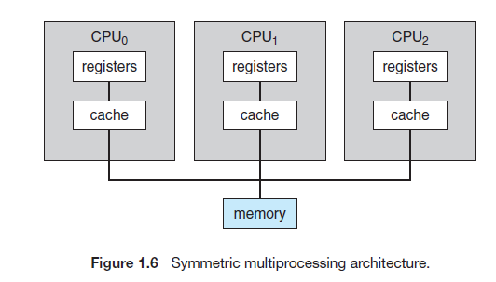
- Blade servers are a relatively recent development in which multiple processor boards, I/O boards, and networking boards are placed in the same chassis.
3. Multi-Core Organization

- Consists of 2 or more processors (cores) on a single piece of silicon(die) chip
- Also called as chip multiprocessor
- Each core consists of registers, ALU,CU,Caches etc
- More efficient than multiple chips with single cores because on-chip communication is faster than between-chip communication.
- Motivation:
    - Parallelism provide more performance
    - Increase miniaturization to improve processing speed
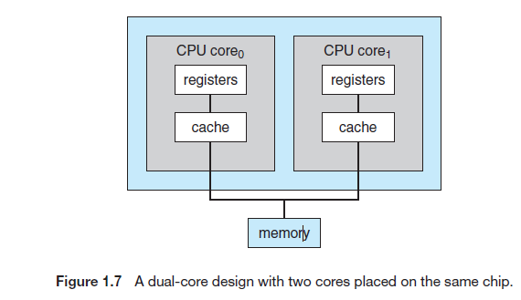
4. Clustered Systems
- It’s a type of multiprocessor system, which gathers together multiple CPUs to form a node. Collection of systems or nodes form clusters
- Each node may be a single processor system or a multicore system.
- They are loosely coupled, have shared storage
- Systems are linked via Local Area Network
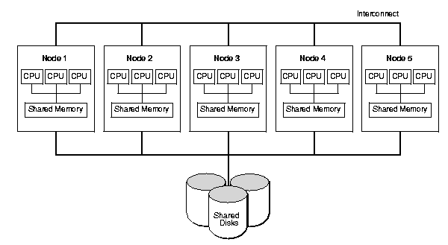
- Clustering is usually used to provide high-availability service—that is, service will continue even if one or more systems in the cluster fail.
- clusters can also be used to provide high-performance computing environments.
- Provides great parallelism
- Clustering can be structured asymmetrically or symmetrically.
- Asymmetric clustering, one machine is in hot-standby mode while the other is running the applications. The hot-standby host machine does nothing but monitor the active server. If that server fails, the hot-standby host becomes the active server.
- Symmetric clustering, two or more hosts are running applications and are monitoring each other. This structure is obviously more efficient, as it uses all of the available hardware. Other forms of clusters include parallel clusters and clustering over a wide-area network (WAN)
- Parallel clusters allow multiple hosts to access the same data on shared storage.
- Storage-area networks (SANs), which allow many systems to attach to a pool of storage. If the applications and their data are stored on the SAN, then the cluster software can assign the application to run on any host that is attached to the SAN.
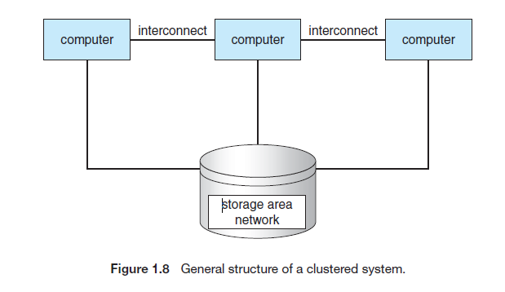
5. Distributed Systems
It’s a A collection of autonomous computers
a) linked by a network
b) using software to produce an integrated computing facility
c) do not share memory or a clock, instead, each processor has its own local memory.
The processors communicate with one another through various communication lines, such as high-speed buses or telephone lines. They are also called as loosely coupled systems.
The processors in a distributed system may vary in size and function. They may include small microprocessors, workstations, minicomputers, and large general-purpose computer systems. These processors are referred to by names, such as sites, nodes, computers.
Size is a distributed system
- Local Area Network (10's of hosts)
- Metropolitan Area Networks (100's of hosts)
- Wide Area Networks (internet) (1000's or 1,000,000's of hosts) 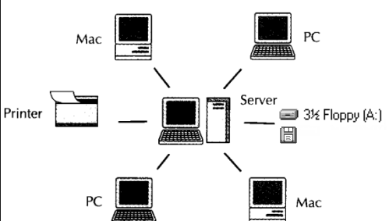
Benefits of Distributed Systems
- Resource sharing: If a number of different sites (with different capabilities) are connected to one another, then a user at one site may be able to use the resources available at another.
- Computation speedup: If a particular computation can be partitioned into a number of sub-computations that can run concurrently, then a distributed system may allow us to distribute the computation among the various sites to run that computation concurrently. If a particular site is currently overloaded with jobs, some of them may be moved to other, lightly loaded, sites. This movement of jobs is called load sharing.
- Reliability: If one site fails in a distributed system, the remaining sites can potentially continue operating.
- Communication: There are many instances in which programs need to exchange data with one another on one system. When many sites are connected to one another by a communication network, the processes at different sites have the opportunity to exchange
- information. Eg: Email communications

OPERATING-SYSTEM STRUCTURE
1.Simple Structure
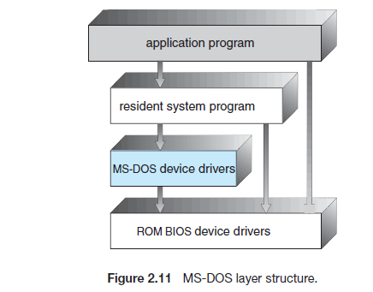
- Operating systems were started as small, simple, and limited systems.
- The interfaces and levels of functionality are not well separated.Application programs are able to access the basic I/O routines
- Such freedom leaves systems (eg-MS-DOS) vulnerable to errant (or malicious) programs, causing entire system crashes
- when user programs fail.
- UNIX consists of two separable parts: the kernel and the system programs. The kernel is further separated into a series of interfaces and device drivers, which have been added and expanded over the years as UNIX has evolved
- Advantage: simple design and Easy construction
- Disadvantage: difficult to debug, prone to frequent system failure
- Example MS-DOS , UNIX operating system.

2. Layered Approach
- With proper hardware support, operating systems can be broken into pieces that are smaller and more appropriate
- The operating system can then retain much greater control over the computer and over the applications that make use of that computer.
- Operating system is broken into a number of layers(levels). The bottom layer (layer 0) is the hardware; the highest (layer N) is the user interface. The mid layers mostly comprising the OS system and application programs This layering structure is depicted in Figure 2.13.
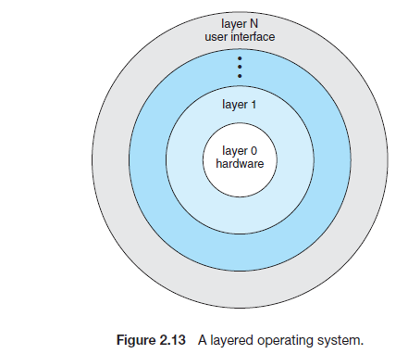

Advantage
- Simplicity of construction and debugging
- The first layer can be debugged without any concern for the rest of the system
- A layer does not need to know how these operations are implemented; it needs to know only what these operations do. Hence, each layer hides the existence of certain data structures, operations, and hardware-level layers.
Disadvantage
- Careful planning on design is necessary
- less efficient than other types. Each layer adds overhead to the system call. The net result is a system call that takes longer than does oneon a nonlayered system.
Example VAX/VMS, Multics

3. Microkernels
- Researchers at Carnegie Mellon University developed an operating system called Mach that modularized the kernel using the microkernel approach.
- Only essential Operating system functions like thread management, address space management, inter-process communication are built in kernel
- All nonessential components from the kernel are removed and implemented as system and user-level programs.
- The main function of the microkernel is to provide communication between the client program and the various services that are also running in user space.
- Communication is provided through message passing,
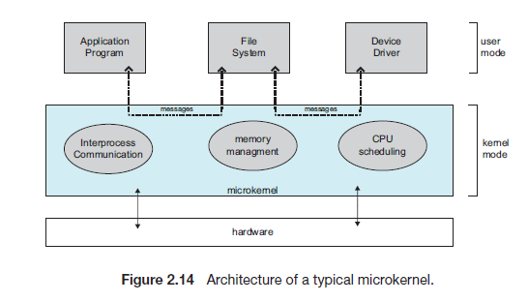
Advantage
- It makes extending the operating system easier.
- All new services are added to user space and consequently do not require modification of the kernel.
- Its easier to port from one hardware design to another.
- Provides more security and reliability, since most services are running as user process—rather than kernel process
- If a service fails, the rest of the operating system remains untouched
Disadvantage
The performance of microkernels can suffer due to increased system-function overhead.
Example: Mac OS X kernel (also known as Darwin) based onMach microkernel
4. Modules Approach
- The best current methodology for operating-system design involves using loadable kernel modules
- The kernel has a set of core components and links in additional services via modules, either at boot time or during run time. This type of design is common in modern implementations of UNIX, such as Solaris, Linux, and Mac OS X, as well as Windows.
- The idea of the design is for the kernel to provide core services while other services are implemented dynamically, as the kernel is running
- Linking services dynamically is preferable to adding new features directly to the kernel, which would require recompiling the kernel every time a change was made.
Advantages
- Has defined, protected interfaces;
- More flexible than a layered system
- More efficient, because modules do not need to invoke message passing in order to communicate.
Example:Solaris
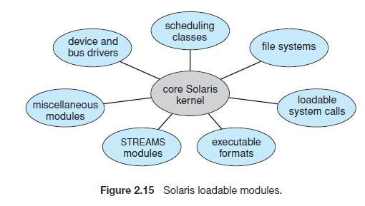
5. Hybrid Systems Approach
- Combine different structures, resulting in hybrid systems that address performance, security, and usability issues.
- Three hybrid systems: the Apple Mac OS X operating system and the two most prominent mobile operating systems—iOS and Android.
5.1 Mac OS X
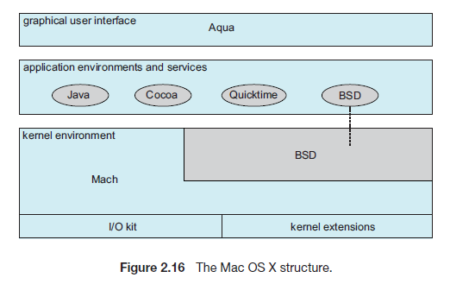
- It is a layered system.
- The top layers include the Aqua user interface(Figure 2.4) and a set of application environments and services.
- The Cocoa environment specifies an API for the Objective-C programming language, which is used for writing Mac OS X applications.
- Below these layers is the kernel environment, which consists primarily of the Mach microkernel and the BSD UNIX kernel. Mach provides memory management; support for remote procedure calls (RPCs) and interprocess communication (IPC) facilities, including message passing; and thread scheduling.
- The BSD component provides a BSD command-line interface, support for networkingand file systems, and an implementation of POSIX APIs, including Pthreads.
- The kernel environment provides an I/O kit for development of device drivers and dynamically loadable modules (whichMac OS X refers to as kernel extensions).

5.2 iOS
iOS is a mobile operating system designed by Apple to run its smartphone,
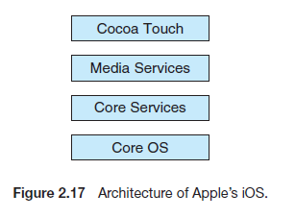
Cocoa Touch is an API for Objective-C that provides several frameworks for developing applications that run on iOS devices.
Cocoa Touch is that the latter provides support for hardware features unique to mobile devices, such as touch screens.
The media services layer provides services for graphics, audio, and video.

5.3 Android
The Android operating system was designed by the Open Handset Alliance (led primarily by Google) and was developed for Android smartphones and tablet computers.
Android runs on a variety of mobile platforms and is open-sourced,
Android is similar to iOS in that it is a layered stack of software
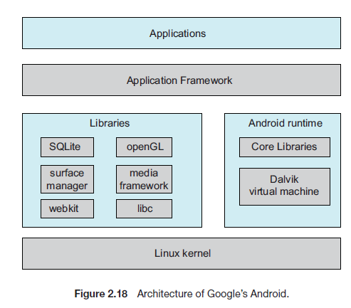
- At the bottom of this software stack is the Linux kernel. Linux is used primarily for process, memory, and device-driver support for hardware and has been expanded to include power management.
- The Android runtime environment includes a core set of libraries as well as the Dalvik virtual machine.
- The Dalvik virtual machine was designed for Android and is optimized for mobile devices with limited memory and
- CPU processing capabilities.
- Software designers for Android devices develop applications in the Java language.
- Google has also designed a separate Android API for Java development. The Java class files are first compiled to Java bytecode and then translated into an executable file that runs on the Dalvik virtual machine.
- The set of libraries available for Android applications includes frameworks for developing web browsers (webkit), database support (SQLite), and multimedia.
- The libc library is similar to the standard C library but is much smaller and has been designed for the slower CPUs that characterize mobile devices.

OPERATING SYSTEM OPERATIONS
1.Dual Mode Operation:
- To ensure proper operation, we must protect the operating system and all other programs and their data from any malfunctioning program. we need two separate modes of operation:
  - user mode
  - kernel mode( supervisor mode/ system mode/ privileged mode)
- A bit, called the mode bit, is added to the hardware of the computer to indicate the current mode: kernel (0) or user (1).
- With the mode bit, we are able to distinguish between an execution that is done on behalf of the operating system, and one that is done on behalf of the user.

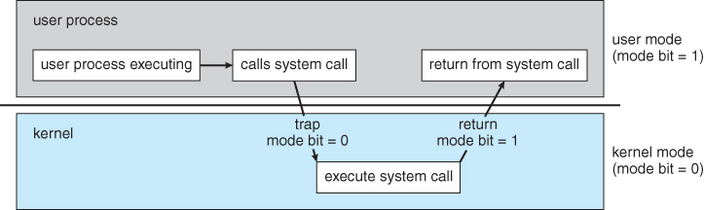
Transition from user to kernel mode
- At system boot time, the hardware starts in kernel mode. The operating system is then loaded, and starts user processes in user mode. Whenever a trap or interrupt occurs, the hardware switches from user mode to kernel mode(that is, changes the state of the mode bit to 0).
- Thus, whenever the operating system gains control of the computer, it is in kernel mode. The system always switches to user mode (by setting the mode bit to 1) before passing control to a user program.
- The dual mode of operation provides us with the means for protecting the operating system from errant users, and errant users from one another.
- This protection by designating some of the machine instructions that may cause harm as privileged instructions.
- The hardware allows privileged instructions to be executed in only kernel mode. If an attempt is made to execute a privileged instruction in user mode, the hardware does not execute the instruction, but rather treats the instruction as illegal and traps to the operating system.
- The lack of a hardware-supported dual mode can cause serious shortcomings in an operating system
- Example: More recent and advanced versions of the Intel CPU, such as the 80486, provide dual-mode operation. As a result, more recent operating systems, such as Microsoft Windows NT, and IBM OS/2,take advantage of this feature and provide greater protection for the operating system
2.Timer
- We must ensure that the operating system maintains control over the CPU.We cannot allow a user program to get stuck in an infinite loop or to fail to call system services and never return control to the operating system.
- To accomplish this goal, we can use a timer. A timer can be set to interrupt the computer after a specified period. The period may be fixed (for example, 1/60 second) or variable (for example, from 1 millisecond to 1 second).
- A variable timer is generally implemented by a fixed-rate clock and a counter. We can use the timer to prevent a user program from running too long.
- A simple technique is to initialize a counter with the amount of time that a program is allowed to run.
SYSTEM CALLS
Definition
- System calls- They are routines/codes that provide interface between programs and services made available by the OS
- They are routines written in C, C++, low level tasks in assembly language
- Even Simple programs heavily use OS by calling thousands of system calls per second
Working:
- User application is designed using functions available in application programming interface. These functions of API inturn invoke the system calls to avail operating system services
- For example, the Windows function CreateProcess() [used to create a new process] actually invokes the NTCreateProcess() system call in the Windows kernel.
- Most common APIs available to application programmers are the Windows API for Windows systems, the POSIX API for POSIX-based systems (which include virtually all versions of UNIX, Linux, and Mac OSX), and the Java API for programs that run on the Java virtual machine.
- For most programming languages, the run-time support system (a set of functions built into libraries included with a compiler) provides a system call interface that serves as the link to system calls in OS and the API functions.
- The system-call interface intercepts function calls in the API and invokes the necessary system calls within the operating system.
- A number is associated with each system call
- The system-call interface maintains a table indexed according to these numbers.
- The system call interface then invokes the intended system call in the operating-system kernel and returns the status of the system call and any return values.
- Programmer hidden from these details by API

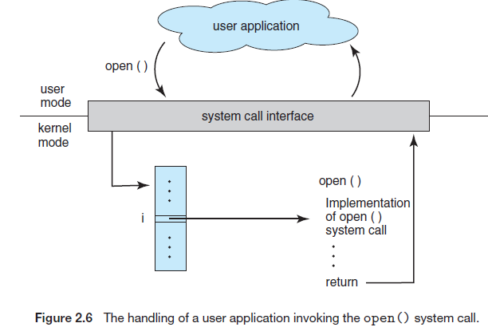
In this example the open() function in the user application on being used invokes the system call open() via the system call interface. open() system call after being implemented passes back the return values or status back to the open() function of user application

SYSTEM CALL IMPLEMENTATION WITH PARAMETER PASSING METHODS
Parameters are passed across system calls which serves as input arguments for operating system programs
Three general methods are used to pass parameters between a running program and the operating system
- Pass the parameters in registers
- Pass the parameters required for system call implementation using Registers where registers are high speed small storage present within the CPU.
- Registers are limited and cannot be used if there are more number of parameters
- Parameters stored in a block, or table, in memory
- In some cases, there may be more parameters than registers ,so a block of memory or table is used to store the parameters
- The address of block is passed in the registers.
- This approach taken by Linux and Solaris
- Very commonly used approach for parameter passing

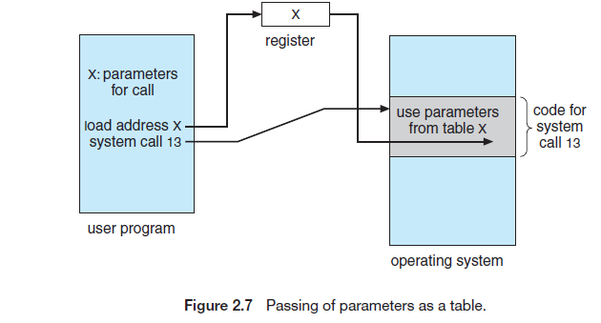
In the above In the figure we see system call 13 is implemented, its parameters are stored in a table whose address is X, address X passed in register. Through address the parameters from the table can be retrieved and used for implementation.
3) Parameters placed on stack by the operating system
- Parameters are placed, pushed, onto the stack by the program and popped off the stack by the operating system.
- Block and stack methods do not limit the number or length of parameters being passed which is good, but a bit slower than register access.

SYSTEM CALLS CLASSIFICATION/TYPES OF SYSTEM CALLS
System Calls can be classified into following categories
- Process Control
- File Manipulation
- Device Manipulation
- Information Maintenance
- Communications
- Protection
Process control System Calls
- end, abort
- load, execute
- create process, terminate process
- get process attributes, set process attributes
- wait for time
- wait event, signal event
- allocate and free memory
Significance: Using these system calls process can be created (CreateProcess()),loaded, aborted and allocated memory. Attributes and important details regarding a process can be obtained.
Having created new jobs or processes, we may need to wait for them to finish their execution. We may want to wait for a certain amount of time to pass (wait time()). More probably, we will want to wait for a specific event to occur (wait event()). The jobs or processes should then signal when that event has occurred (signal event()).
File management System Calls
  - create file, delete file
  - open, close
  - read, write, reposition
  - get file attributes, set file attributes
Significance: File management system calls are used to perform all basic operations concerning a file like file open, close, read, write and to obtain file attributes and details.
Device management System Calls
  - request device, release device
  - read, write, reposition
  - get device attributes, set device attributes
  - logically attach or detach devices
Significance: A program, as it is running, may need additional resources/devices like memory, tape drives, access to files, and so on. If the resources are available, they can be granted, and control can be returned to the user program; otherwise, the program will have to wait until sufficient resources are available. Such device request, connections and release can be instrumented using these system calls.
Information maintenance System Calls
  - get time or date, set time or date
  - get system data, set system data
  - get process, file, or device attributes
  - set process, file, or device attributes
Significance: Many system calls exist simply for the purpose of transferring information between the user program and the operating system. For example, most systems have a system call to return the current time and date, number of current users, the version number of the operating system, the amount of free memory or disk space, and so on.
Communication System Calls
- create, delete communication connection
- send, receive messages
- transfer status information
- attach or detach remote devices
Significance: Communication system calls are used to set up communication links, transfer messages and report transfer status. In the message-passing model, the communicating processes exchange messages with one another to transfer information
open() and close() calls provided by the file system or to specific open connection() and close connection() system call.
The source of the communication, known as the client, and the receiving daemon(background process), known as a server, then exchange messages by using read message() and write message() system calls. The close connection() call terminates the communication. In the shared-memory model, processes use shared memory create() and shared memory attach() system calls to create and gain access to regions of memory owned by other processes.
Protection System Calls
- set permission() and get permission(),
- allow user() and deny user() system calls
Significance:
It is used to manipulate the permission settings of resources such as files and disks.
To specify whether particular users can—or cannot—be allowed access to certain resources.
Protection provides a mechanism for controlling access to the resources provided by a computer system, in networking and the Internet, all computer systems, from servers to mobile handheld devices, must be concerned with protection.

SYSTEM PROGRAMS
- Also called as System Utilities
- Provide a convenient environment for program development and execution
- Some are user interfaces to s/m calls or bundle of useful s/m calls

Application Programs

System Programs

Operating System

Hardware
System programs can be divided into these categories:
- File Management
  - Programs to create, delete, print, copy, list, manipulate files and directories etc
- Status Information
  - Maintains and provides information on system Date, time, disk/memory space, logging, performance, debugging, registry
- File Modification
  - Text editorsècreate, modify and search file contents
- Programming language Support
  - Softwares like Compilers, assemblers, debuggers, interpreters for common programming languages (C,C++,Java)
- Program Loading & Execution
  - Programs of Absolute/relocatable loaders, linkage editors
- Communication
  - These programs provide Virtual connections, remote login, file transfer, web browsing, email communication
- Background Services
-They are constantly running programs Service/subs-systems/daemons (background processes)

OPERATING-SYSTEM GENERATION
- The process of configuring or generating a system for a specific computer site based on its purpose is known as System Generation SYSGEN
- The operating system is normally distributed on disk, on CD-ROM or DVD-ROM, or as an “ISO” image, which is a file in the format of a CD-ROM or DVD-ROM.
- SYSGEN program reads from a given file, or asks the operator of the system for information concerning the specific configuration of the hardware system
- Following are kinds of information must be determined by SYSGEN:
  - Type of CPU and options available in it
  - Format of the boot disk-sections, partitions
  - Memory Space available in the system
  - Reference memory locations to find the illegal address in the memory
  - Devices available in the system
  - Address of the device, Device interrupt number, Device type and model and specific characteristics of each device
  - Operating System options desired
  - Type of scheduling algorithm used
  - Number of buffers and their sizes
  - Maximum number of processes supported by the system etc

- Once this information is determined, it can be used in several ways.
- (1)Manual Approach: A system administrator can use it to modify a copy of the source code of the operating system. The operating system then is completely compiled. Data declarations, initializations, and constants, along with conditional compilation, produce an output-object version of the operating system that is tailored to the system described.
- (2)Modular Approach : Second option is creation of tables and the selection of modules from a precompiled library. These modules are linked together to form the generated operating system.
- (3)Tabular Approach: It is possible to construct a system that is completely table driven. All the code is always part of the system, and selection occurs at execution time, rather than at compile or link time. System generation involves simply creating the appropriate tables to describe the system.

SYSTEM BOOT
- The procedure of starting a computer by loading the kernel is known as booting the system.
- Bootstrap program or bootstrap loader is a small piece of code that locates the kernel, loads it into main memory, and starts its execution.
- PCs, use a two-step process in which a simple bootstrap loader fetches a more complex boot program from secondary disk, which in turn loads the kernel.
- GRUB is an example of an open-source bootstrap program for Linux systems.
- The bootstrap program can perform a variety of tasks:
  - Run diagnostics to determine the state of the machine.
  - If the diagnostics pass, the program can continue with the booting steps.
  - It initializes all aspects of the system, from CPU registers to device controllers and the contents of main memory.
  - Then it starts the operating system.
- Initial bootstrap is in the form of read-only memory (ROM), because the RAM is in an unknown state at system startup. ROM is convenient because it needs no initialization and cannot easily be infected by a computer virus.
- A problem with this approach is that changing the bootstrap code requires changing the ROM hardware chips. Some systems resolve this problem by using erasable programmable read-only memory (EPROM),
- Firmware: All forms of ROM, EPROM, Flash Memory are known as firmware, since their characteristics fall somewhere between those of hardware and those of software.
- A problem with firmware in general is that executing code there is slower than executing code in RAM. Some systems store the operating system in firmware and copy it to RAM for fast execution.
- Firmware is that it is relatively expensive, so only small amounts are available.
- Systems like Windows, Mac OS X, and UNIX) or for systems that change frequently, the bootstrap loader is stored in firmware, and the operating system is on disk(boot block).
- Boot Block: is a region of a hard disk that contains program to load entire operating system and begin execution. Mostly it is simple code (as it fits in a single disk block) and knows only the address on disk and length of the remainder of the bootstrap program.
- Boot Disk: A disk that has a boot partition is called a boot disk or system disk.
- After full bootstrap program has been loaded, it can traverse the file system to find the operating system kernel, load it into memory, and start its execution. It is only at this point that the system is said to be running.

VIRTUALIZATION
- Virtualization is a technology that allows operating systems to run as applications within other operating systems. . For example, an Apple laptop running Mac OS X (Host/Native OS) on the x86 CPU can run a Windows OS(Guest OS) to allow execution of Windows applications.
- Virtualization is one member of a class of software that also includes emulation. Emulation is used when the source CPU type is different from the target CPU type. For example, emulation facility called “Rosetta,” which allowed applications compiled for the IBM CPU to run on the Intel CPU.
- Virtualization Implementation
  - Difficult to implement – must provide an exact duplicate of underlying machine
  - Typically runs in user mode, creates virtual user mode and virtual kernel mode
  - Timing can be an issue – slower than real machine
  - Hardware support needed
  - More support-> better virtualization
- Para-virtualization
  - Presents guest with system similar but not identical to hardware
  - Guest must be modified to run on paravirtualized hardware
  - Guest can be an OS, or in the case of Solaris 10 applications running in containers

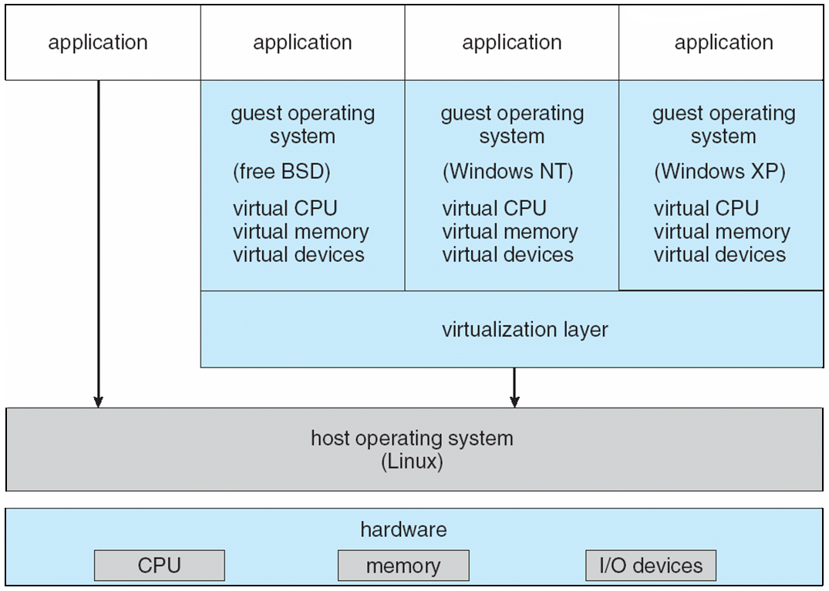
In this case we see that Linux OS is the actual host OS, yet by concept of virtualization we can run 3 guest OS : free BSD, Windows NT, Windows XP

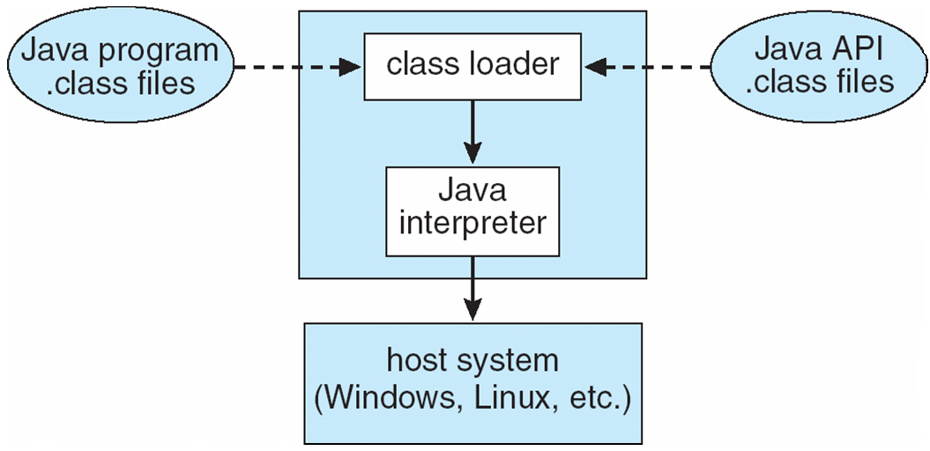
To execute java bytecodes java virtual machines (JVM) are used which makes it platform independent- thus java codes run on any OS – Windows, Linux etc

Virtual Machines
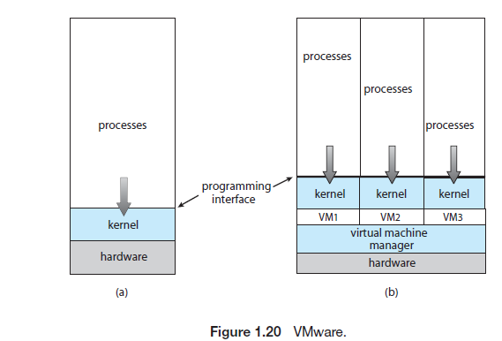
- A virtual machine takes the layered approach to its logical conclusion. It treats hardware and the operating system kernel as though they were all hardware.
- A virtual machine provides an interface identical to the underlying bare hardware.
- The operating system host creates the illusion that a process has its own processor and (virtual memory).
Each guest provided with a (virtual) copy of underlying computer
Virtual Machines History and Benefits
- First appeared commercially in IBM mainframes in 1972
- Fundamentally, multiple execution environments (different operating systems) can share the same hardware
- Protect from each other
- Some sharing of file can be permitted, controlled
- Commutate with each other, other physical systems via networking
- Useful for development, testing
- Consolidation of many low-resource use systems onto fewer busier systems
- “Open Virtual Machine Format”, standard format of virtual machines, allows a VM to run within many different virtual machine (host) platforms

- i.e. AMD provides “host” and “guest” modes

- That same concept can be extended to allow an entire operating system written for one platform to run on another..
- A common example of emulation occurs when a computer language is not compiled to native code but instead is either executed in its high-level form or translated to an intermediate form. This is known as interpretation.
- Some languages, such as BASIC, can be either compiled or interpreted.
- Java, in contrast, is always interpreted. Thus, we can run Java programs on “Java virtual machines,” but technically those virtual machines are Java emulators.
- Virtualization first came about on IBM mainframes as a method for multiple users to run tasks concurrently.
- Running multiple virtual machines allowed (and still allows) many users to run tasks on a system designed for a single user.
- Windows was the host operating system, and the VMware application was the virtual machine manager VMM. The VMM runs the guest operating systems, manages their resource use, and protects each guest from the others.
- On laptops and desktops, a VMM allows the user to install multiple operating systems for exploration or to run applications written for operating systems other than the native host. For example, an Apple laptop running Mac OS X on the x86 CPU can run a Windows guest to allow execution of Windows applications.
- Companies writing software for multiple operating systems can use virtualization to run all of those operating systems on a single physical server for development, testing, and debugging.
- Within data centers, virtualization has become a common method of executing and managing computing environments.
- Example for VMMs like VMware, ESX, and Citrix XenServer

