UNIT-2
Syllabus
- Processes-Process Concept, Process Scheduling, Operations on Processes, interprocess Communication;
- Threads- Overview, Multicore Programming, Multithreading Models; Windows 7 -Thread and SMP Management;
- Synchronization - Critical Section Problem, Mutex Locks, Semophores, Monitors;
- CPU Scheduling and Deadlocks.
1 PROCESSES
- Program: set of instructions(passive)
- Process is a program in execution(active)
- Program becomes process when its loaded in memory
- Its a unit of work in modern time sharing systems
- S/m (System) processes execute s/m code
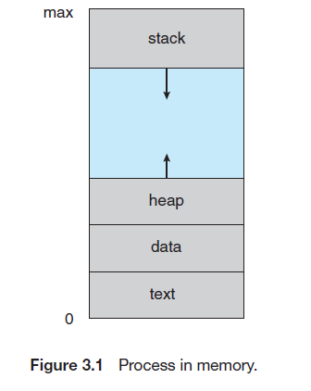
- User processes execute user code
- Process is known as text section
  - Includes current activity: program counter
  - Contents of processors registers
  - Has PROCESS STACK
    - Temporary data (func parameters, return addresses, local variables)
    - Data section (global variables)
  - Has heap : memory dynamically allocated at run time
  - Different instance of same application :separate process
- To load executable files:
  - Click on icon of exe file
  - Enter exe file name in command prompt
1.1 PROCESS STATE
As a process executes, it changes state. The state of a process is defined in part
by the current activity of that process. A process may be in one of the following
states:
5 states
- New. The process is being created.
- Running. Instructions are being executed.
- Waiting. The process is waiting for some event to occur (such as an I/O completion or reception of a signal).
- Ready. The process is waiting to be assigned to a processor.
Terminated. The process has finished execution
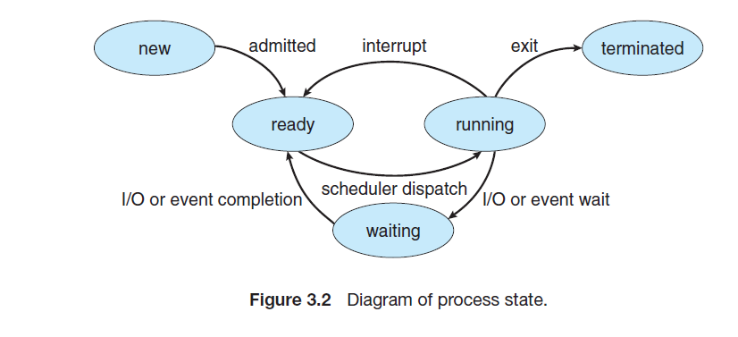
1.2 PROCESS CONTROL BLOCK
- Each process is represented in the operating system by a process control block
- (PCB)—also called a task control block.
Following are the contents of PCB
- Process state: The state may be new, ready, running, waiting, halted, and so on.
- Program counter: address of the next instruction for this process.
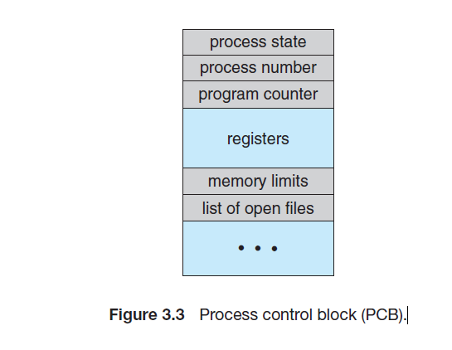
- CPU registers:
  - includes accumulators, index registers, stack pointers, and general-purpose registers
  - this state information must be saved when an interrupt occurs
- CPU-scheduling information: process priority, pointers to scheduling queues, and any other scheduling parameters.
- Memory-management information: value of the base and limit registers and the page tables, or the segment tables
- Accounting information: amount of CPU real time used, time limits, account numbers, job or process numbers etc.
- I/O status information: list of I/O devices allocated to the process, a list of open files, and so on.

In the diagram below we have Process P0 executing initially. On an interrupt /system call the control is transferred to OS after the save state(current state of P0) is saved in PCB0. Now P0 is made idle.
The OS now loads the state of process P1 from PCB1, thus P1 starts executing. Again on an interrupt, save state of P1 saved in PCB1 and reload state of P0 from PCB0 is loaded to resume the execution of P0

PCB Implementation
- The process control block in the Linux operating system is represented by
the C structure task_struct, which is found in the <linux/sched.h>
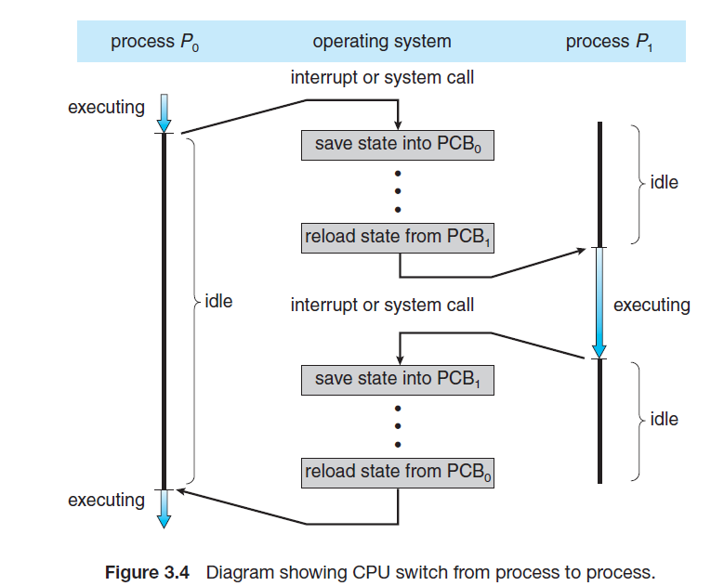

1.3 PROCESS SCHEDULING
- Process scheduling done to achieve :
  - Objective of multiprogramming: 100% CPU utilization
  - Objective of time sharing: switch the CPU among processes so frequently that users can interact with each program while it is running.
- process scheduler selects an available process for program execution on the CPU.

1.3.1 Scheduling Queues
- Job Queue: all processes in the system created are inserted in job queue initially.
- Ready Queue: has processes that are residing in main memory and are ready and waiting to execute
It is implemented using -
  - Linked list of PCBs of processes
  - Ready Queue header has pointer to first & last PCBs
  - Each PCB ptr field to next PCB
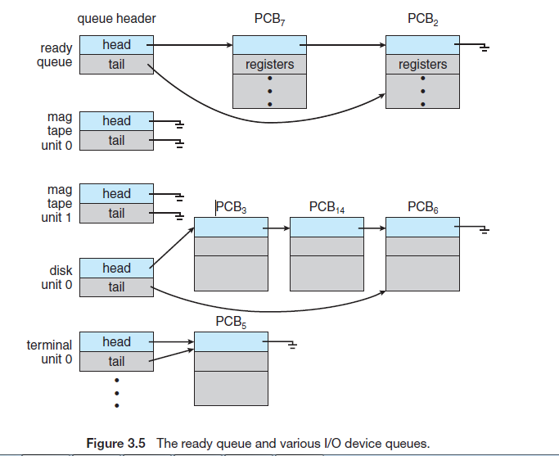
- Device queue: The list of processes waiting for a particular I/O device
  - Each device has its own device queue
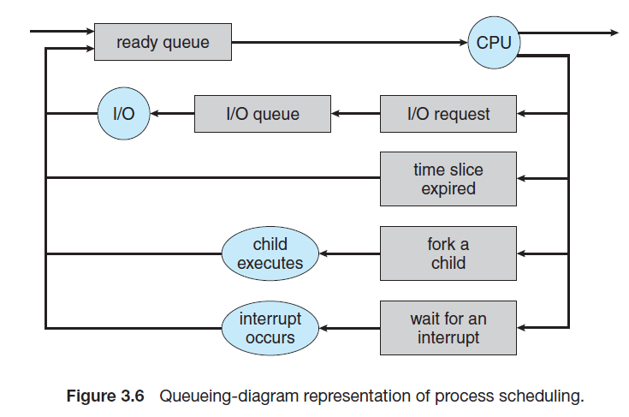
A common representation of process scheduling is a queueing diagram, such as that in Figure 3.6. Each rectangular box represents a queue. Two types of queues are present: the ready queue and a set of device queues.
The circles represent the resources that serve the queues, and the arrows indicate the flow of processes in the system. A new process is initially put in the ready queue. It waits there until it is selected for execution, or dispatched. Once the process is allocated the CPU and is executing, one of several events could occur:
• The process could issue an I/O request and then be placed in an I/O queue.
• The process could create a new child process and wait for the child’s termination.
• The process could be removed forcibly from the CPU, as a result of an interrupt, and be put back in the ready queue.
In the first two cases, the process eventually switches from the waiting state to the ready state and is then put back in the ready queue. A process continues this cycle until it terminates, at which time it is removed from all queues and has its PCB and resources deallocated

1.3.2.Schedulers
  - Selection of process done by Scheduler
  - Spooling (buffering processes) processes to mass storage device(disk) called as pool
  - Long term scheduler / Job Scheduler:
    - selects process from pool
    - Loads them in memory for execution
  - Short term Scheduler / CPU Scheduler:
    - Selects ready-to execute processes
    - Allocates them to CPU
Long Term Scheduler | Short term Scheduler
selcts processes from pool and schedules to main memory | Selects processes from main memory and schedules to CPU for execution
Selects process less frequently | Selects processes more frequently
Frequency of selection can be in minutes  (as new process creation takes time in minutes) | Frequency of selection should be in milliseconds (as CPU executes processes in milliseconds)

Degree of multi-programming= no of process in memory, controlled by Long term Scheduler
Stable degree of programming
Process Departure rate=Process Creation rate
Long term scheduler is invoked only when process leaves s/m(system)
- Long term should make CAREFUL SELECTION
- I/O bound process: more I/O operation, less computations
- CPU bound process: more computations, less I/O operations
- Good process mix ➔equal amount of I/Obound process & CPU bound process
In windows and unix no long term scheduler
- Mid term Scheduler
  - To reduce the degree of multiprogramming
  - Swap out partially finished process from memory and swap in later : SWAPPING
  - Its done to improve process mix / over-committed memory when memory requirements are high
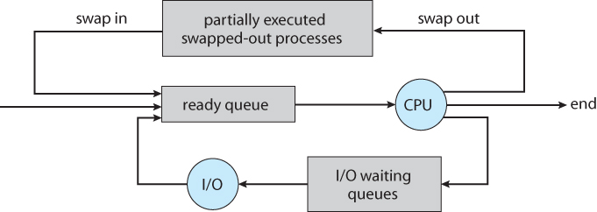

1.3.3.Context Switch
- Switching the CPU from one process to another process requires performing a state save of the current process and a state restore of new process. This task is known as a context switch
- States are saved and restored from corresponding PCBs
- Its a overhead. No useful work done while switching
- Switching speed depends on machine, memory speed
- Context switch can also be done using hardware support Eg: Sun UltraSPARC (ptr to current register set can switch processes), but id active processes more than registers then software switching is the option
1.4 OPERATIONS ON A PROCESS
- Process executed concurrently
- Dynamically deleted and created'
- Well defined mechanism required for
  - Process creation
  - Process deletion
1.4.1 Process Creation
- A process [parent process] can create new processes [child processes]
- Tree of processes are thus formed as shown in diagram below
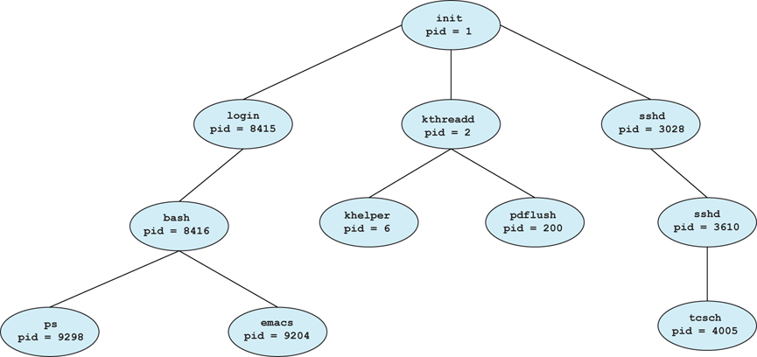
This Figure illustrates a typical process tree for the Linux operating system,showing the name of each process and its pid. (We use the term process rather loosely, as Linux prefers the term task instead.) The init process (which always has a pid of 1) serves as the root parent process for all user processes.
Once the system has booted, the init process can also create various user processes, such as a web or print server, an ssh server, and the like. In Figure 3.8, we see two children of init—kthreadd and sshd. The kthreadd process is responsible for creating additional processes that perform tasks on behalf of the kernel (in this situation, khelper and pdflush).
The sshd process is responsible for managing clients that connect to the system by using ssh (which is short for secure shell).
The login process is responsible for managing clients that directly log onto the system. In this example, a client has logged on and is using the bash shell, which has been assigned pid 8416.
Using the bash command-line interface, this user has created the process ps as well as the emacs editor.
Points on Child Process
- Created using fork() in LINUX / CreateProcess() in windows
- Need resources( memory, CPU time etc) to do tasks
- It obtains resources directly from OS or from parent resources
- Parent process share or partition resources
- Restricting child process to parent process prevents the overloading of system
- Parent process can pass inputs (initialization data) to child process
When a process creates a new process, two possibilities for execution exist:
1. The parent continues to execute concurrently with its children.
2. The parent waits until some or all of its children have terminated.

There are also two address-space possibilities for the new process:
1. The child process is a duplicate of the parent process (it has the same program and data as the parent).
2. The child process has a new program loaded into it.

#include <sys/types.h>
#include <stdio.h>
#include <unistd.h>
int main()
{
pid t pid;
/* fork a child process */
pid = fork();
if (pid < 0) { /* error occurred */
fprintf(stderr, "Fork Failed");
return 1; }
else if (pid == 0) { /* child process */
execlp("/bin/ls","ls",NULL);
}
else { /* parent process */
/* parent will wait for the child to complete */
wait(NULL);
printf("Child Complete");
}
return 0;}
Figure 3.9 Creating a separate process using the UNIX fork() system call.
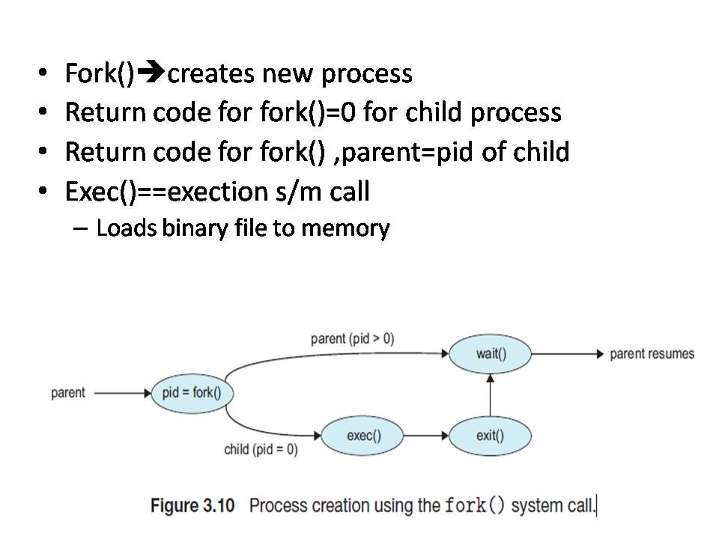
Process Creation in Windows
- Processes are created in the Windows API using the CreateProcess() function
fork() | CreateProcess()
It’s a function used to create processes in  UNIX | It’s a function used to create processes in  Windows
No parameters needed | 10 parameters has to be passed
the child process created with fork()  inherits a copy of the address space of its  parent | CreateProcess() function requires  specifying the address space of the child process.
#include <stdio.h>
#include <windows.h>
int main(VOID)
{
STARTUPINFO si;
PROCESS INFORMATION pi;
/* allocate memory */
ZeroMemory(&si, sizeof(si));
si.cb = sizeof(si);
ZeroMemory(&pi, sizeof(pi));
/* create child process */
if(!CreateProcess(NULL, "C:\\WINDOWS\\system32\\mspaint.exe", NULL, NULL, FALSE, 0, NULL, NULL, &si,&pi))
{
fprintf(stderr, "Create Process Failed");
return -1;
}
/* parent will wait for the child to complete */
WaitForSingleObject(pi.hProcess, INFINITE);
printf("Child Complete");
/* close handles */
CloseHandle(pi.hProcess);
CloseHandle(pi.hThread);
}
Figure 3.11 Creating a separate process using the Windows API.

The two parameters passed to the CreateProcess() function are instances of the STARTUPINFO and PROCESS INFORMATION structures. STARTUPINFO specifies many properties of the new process, such as window size and appearance and handles to standard input and output files.
The PROCESS INFORMATION structure contains a handle and the identifiers to the newly created process and its thread. We invoke the ZeroMemory() function to allocate memory for each of these structures before proceeding with CreateProcess().

1.4.2 Process Termination
- Process terminates after executing last statement
- Asks OS to delete it by invoking exit()
- Status returned to parent process
- Resources: physical memory, virtual memory, open files, I/O buffers deallocated by OS
- A process can terminate other process also via s/m call Eg: TerminateProcess() in Windows
A parent may terminate the execution of one of its children for following reasons:
• The child has exceeded its usage of some of the resources that it has been allocated. (To determine whether this has occurred, the parent must have a mechanism to inspect the state of its children.)
• The task assigned to the child is no longer required.
• The parent is exiting, and the operating system does not allow a child to continue if its parent terminates.[CASCADING TERMINATION]
- Process Table: Data structure that-records process info
- If a process has terminated, but its parent process has not invoked wait() then its called as ZOMBIE process. (the process exit status till then saved in process table)
- If parent process terminates without invoking wait() , then its child processes will become ORPHAN processes
- LINUX & UNIX uses init process to adopt the orphan processes by issuing wait() periodically
- so exit() status of orphan process can be collected , releasing process ID and entry in process table
1.5 INTER PROCESSOR COMMUNICATION
Introduction
A process is independent if it cannot affect or be affected by the other processes executing in the system. Any process that does not share data with any other process is independent.
A process is cooperating if it can affect or be affected by the other processes executing in the system.
There are several reasons for providing an environment that allows process cooperation:
• Information sharing: Since several users may be interested in the same piece of information (eg. shared file)
• Computation speedup: If we want a particular task to run faster, break it into subtasks, execute in parallel
• Modularity: to construct the system in a modular fashion, dividing the system functions into separate processes or threads
• Convenience: work on many tasks at the same time. eg: a user may be editing, listening to music, and compiling in parallel.
Cooperating processes require an interprocess communication (IPC) mechanism that will allow them to exchange data and information.
2 models of IPC
- Shared Memory
- Message Passing
1.5.1 Shared Memory Systems
- Interprocess communication using shared memory requires communicating processes to establish a region of shared memory.
- A shared-memory region resides in the address space of the process creating the shared-memory segment.
- Other processes that wish to communicate using this shared-memory segment must attach it to their address space.
- They can then exchange information by reading and writing data in the shared areas.
- The form of the data and the location are determined by these processes and are not under the operating system’s control. The processesare also responsible for ensuring that they are not writing to the same location simultaneously.
Eg: Producer Consumer problem
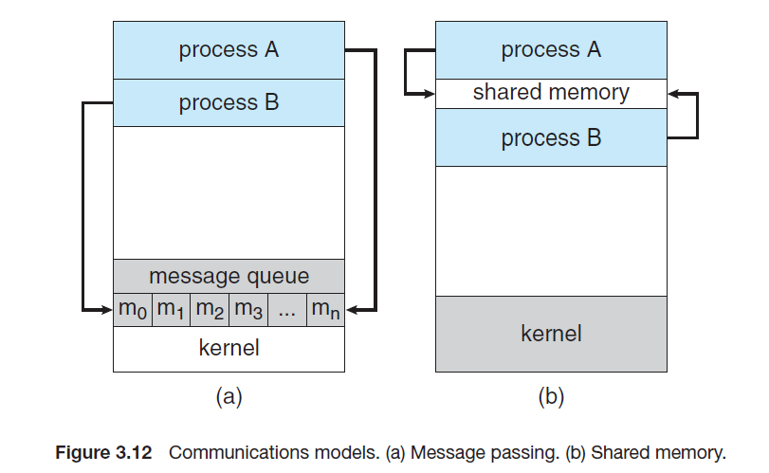
1.5.2 Message Passing
- Cooperating processes to communicate with each other via a message-passing facility.
- Message passing provides a mechanism to allow processes to communicate and to synchronize their actions without sharing the same address space.
- It is particularly useful in a distributed environment, where the communicating processes may reside on different computers connected by a network
- 2 operations
  - send(message)
  - receive(message)
- If processes P andQwant to communicate, theymust send messages to and receive messages from each other: a communication link must exist between them.
Here are several methods for logically implementing a link and the send()/receive() operations:
- Direct or indirect communication
- Synchronous or asynchronous communication
- Automatic or explicit buffering
1.5.2.1 Naming
Processes that want to communicate must have a way to refer to each other.
(i) Direct Communcation
Under direct communication, each process that wants to communicate must explicitly name the recipient or sender of the communication. In this scheme, the send() and receive() primitives are defined as:
• send(P, message)—Send a message to process P.
• receive(Q, message)—Receive a message from process Q.
A communication link in this scheme has the following properties:
• A link is established automatically between every pair of processes that want to communicate. The processes need to know only each other’s identity to communicate.
• A link is associated with exactly two processes.
• Between each pair of processes, there exists exactly one link.
This scheme exhibits symmetry in addressing; that is, both the sender process and the receiver process must name the other to communicate.
A variant of this scheme employs asymmetry in addressing. Here, only the sender names the recipient; the recipient is not required to name the sender, the send() and receive() primitives are defined as follows:
• send(P, message)—Send a message to process P.
• receive(id, message)—Receive a message from any process.
The variable id is set to the name of the process with which communication has taken place.
Disadvantage:
  - limited modularity of process
  - changing identity necessitates examination of process definitions
(ii) Indirect Communication
- the messages are sent to and received from mailboxes, or ports.
- A mailbox can be viewed abstractly as an object into which messages can be placed by processes and from which messages can be removed.
- Each mailbox has a unique identification.
The send() and receive() primitives are defined as follows:
• send(A, message)—Send a message to mailbox A.
• receive(A, message)—Receive a message from mailbox A.

In this scheme, a communication link has the following properties:
• A link is established between a pair of processes only if both members of the pair have a shared mailbox.
• A link may be associated with more than two processes.
• Between each pair of communicating processes, a number of different links may exist, with each link corresponding to one mailbox.
Mailbox ownership:
- A mailbox may be owned either by a process or by the operating system.
- When a process that owns a mailbox terminates, the mailbox disappears. Any process that subsequently sends a message to this mailbox must be notified that the mailbox no longer exists.
- a mailbox that is owned by the operating system has an existence of its own. It is independent and is not attached to any particular process.
The operating system then must provide a mechanism that allows a process to do the following:
• Create a new mailbox.
• Send and receive messages through the mailbox.
• Delete a mailbox

1.5.2.2 Synchronization
Message passing may be either blocking or nonblocking—also known as synchronous and asynchronous.
• Blocking send. The sending process is blocked until the message is received by the receiving process or by the mailbox.
• Nonblocking send. The sending process sends the message and resumes operation.
• Blocking receive. The receiver blocks until a message is available.
• Nonblocking receive. The receiver retrieves either a valid message or a null.
1.5.2.3 Buffering
Whether communication is direct or indirect, messages exchanged by communicating processes reside in a temporary queue. Basically, such queues can be implemented in three ways:
- Zero capacity. The queue has a maximum length of zero; thus, the link cannot have any messages waiting in it. In this case, the sender must block until the recipient receives the message.
• Bounded capacity. The queue has finite length n; thus, at most n messages can reside in it. If the queue is not full when a new message is sent, the message is placed in the queue and the sender can continue execution without
waiting.
The link’s capacity is finite.If the link is full, the sender must block until space is available in the queue.
• Unbounded capacity. The queue’s length is potentially infinite; thus, anynumber of messages can wait in it. The sender never blocks.
1.5.3 Examples of IPC Systems
POSIX systems: shared memory –use APIs like shmopen( ),shmget to use shared memory concept
MACH OS: uses message passing method using ports (mail boxes)
2.0 THREADS
A thread is a Light Weight Process and basic unit of CPU utilization, consisting of a program counter, a stack, and a set of registers, and a thread ID.
A process can be single threaded or multi threaded
Threads within a process can share resources, code and data of the process
It’s a flow of control within the process. A traditional (or heavyweight) process has a single thread of control. A multithreaded process contains several different flows of control within the same address space.

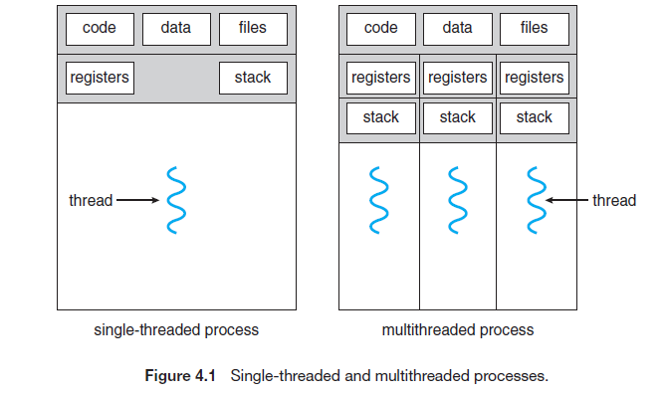

If a process has multiple threads of control, it can perform more than one task at a time. Figure 4.1 illustrates the difference between a traditional single-threaded process and a multithreaded process.
Motivation:
Most software applications that run on modern computers are multithreaded. An application typically is implemented as a separate process with several threads of control. Eg: A web browser might have one thread display images or text while another thread retrieves data from the network.
Benefits
The benefits of multithreaded programming can be broken down into four major categories:
1. Responsiveness: Multithreading an interactive application may allow a program to continue running even if part of it is blocked or is performing a lengthy operation, thereby increasing responsiveness to the user.
2. Resource sharing: Processes can only share resources through techniques such as shared memory and message passing. However, threads share the memory and the resources of the process to which they belong by default.
3. Economy: Allocating memory and resources for process creation is costly. Because threads share the resources of the process to which they belong, it is more economical to create and context-switch threads. In Solaris, for example, creating a process is about thirty times slower than is creating a thread, and context switching is about five times slower.
4. Scalability. The benefits of multithreading can be even greater in a multiprocessor architecture, where threads may be running in parallel on different processing cores.
2.1 MULTICORE PROGRAMMING

- Multicore/multi processor: to place multiple computing cores on a single chip or across the chip.
- Multithreaded programming provides a mechanism for more efficient use of these multiple computing cores and improved concurrency.

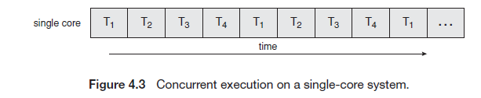
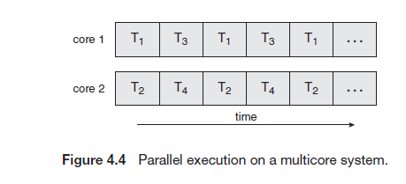
Consider an application with four threads. On a system with a single computing core, concurrency merely means that the execution of the threads will be interleaved over time (Figure 4.3), because the processing core is capable of executing only one thread at a time. On a system with multiple cores, however, concurrency means that the threads can run in parallel, because the system can assign a separate thread to each core (Figure 4.4).
Notice the distinction between parallelism and concurrency in this discussion. A system is parallel if it can perform more than one task simultaneously. In contrast, a concurrent system supports more than one task by allowing all the tasks to make progress. Thus, it is possible to have concurrency without parallelism.

Programming Challenges
Designers of operating systems must write scheduling algorithms that use multiple processing cores to allow the parallel execution.For application programmers, the challenge is to modify existing programs as well as design new programs that are multithreaded.
In general, five areas present challenges in programming for multicore systems:
1. Identifying tasks. This involves examining applications to find areas that can be divided into separate, concurrent tasks, so that they can be made to run parallel on cores.
2. Balance. While identifying tasks that can run in parallel, programmers must also ensure that the tasks perform equal work of equal value.
3. Data splitting. Just as applications are divided into separate tasks, the data accessed and manipulated by the tasks must be divided to run on separate cores.
4. Data dependency. The data accessed by the tasks must be examined for dependencies between two or more tasks. When one task depends on data from another, programmers must ensure that the execution of the tasks is synchronized to accommodate the data dependency.
5. Testing and debugging. Testing and debugging concurrent programs(as they have different execution paths) is inherently more difficult than testing and debugging single-threaded applications.
Types of Parallelism
two types of parallelism:
Data parallelism focuses on distributing subsets of the same data across multiple computing cores and performing the same operation on each core.
Task parallelism involves distributing not data but tasks (threads) across multiple computing cores.
In most instances, applications use a hybrid of these two strategies.

2.2 MULTI-THREADING MODELS
- Support for threads may be provided either at the user level, for user threads, or by the kernel, for kernel threads.
- User threads are supported above the kernel in the user space and are managed without kernel support. Mostly created and managed by the Thread Library (has API for all thread functionalities),
- Kernel threads are created in kernel space ,supported and managed directly by the operating system.
- A relationship must exist between user threads and kernel threads. three common ways of establishing such a relationship: the many-to-one model, the one-to-one model, and the many-to many model.

2.2.1 Many-to-One Model
The many-to-one model (Figure 4.5) maps many user-level threads to one kernel thread. Thread management is done by the thread library in user space, so it is efficient
If one user thread issues block system call then, kernel thread is blocked –which will hinder execution of other user threads. Because only one thread can access the kernel at a time,multiple threads are unable to run in parallel on multicore systems.
Advantage: Can create as many user threads. No overhead of creating many kernel threads
Disadvantage: Does not support parallelism
Example: Green threads—a thread library available for Solaris systems and adopted in early versions of Java—used the many-to-one model.
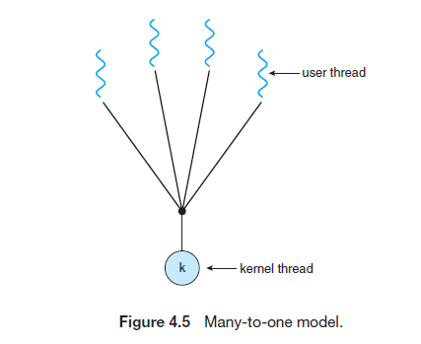
2.2.2 One-to-One Model
The one-to-one model (Figure 4.6) maps each user thread to a kernel thread. It more concurrency than the many-to-one model by allowing another thread to run when a thread makes a blocking system call.
Advantage: It also allows multiple threads to run in parallel on multiprocessors.
Disadvantage: The only drawback to this model is that creating a user thread requires creating the corresponding kernel thread. Because the overhead of creating kernel threads can burden the performance of an application, most implementations of this model restrict the number of threads supported by the system.
Example: Linux, along with the family of Windows operating systems, implement the one-to-one model.
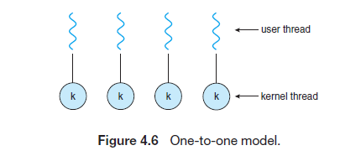
2.2.3 Many-to-Many Model
The many-to-many model (Figure 4.7) multiplexes many user-level threads to a smaller or equal number of kernel threads.
The many-to-many model suffers from neither of these shortcomings (unlike many-one/one-one): developers can create as many user threads as necessary, and the corresponding kernel threads can run in parallel on a multiprocessor.
When a thread performs a blocking system call, the kernel can schedule another thread for execution.
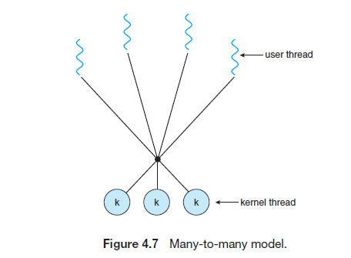
One variation on the many-to-many model still multiplexes many user level threads to a smaller or equal number of kernel threads but also allows a user-level thread to be bound to a kernel thread.
This variation is sometimes referred to as the two-level model (Figure 4.8). The Solaris operating system supported the two-level model in versions older than Solaris 9
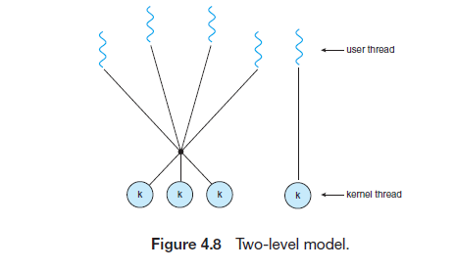
2.3 THREAD LIBRARIES
- Provides API for creating and managing threads
- 2 ways of thread library implementation:
  - Use kernel space(thread code+data structires)
  - Use user space
- POSIX PThread: kernel/user level library
- Windows Thread: kernel level
- Java Thread API: thread lib in host systems
PThreads
- Pthreads: POSIX standard
- Defines API for Thread creation and synchronization
- It’s a specification not implementation
- pthread_create() //pthread.h
- In UNIX,LINUX,Mac OS,
- No support in windows
Windows Threads
- Windows Thread Library
- Defines API for thread management in windows
- CreateThread() →method to create new threads
JAVA Threads
uses interface and methods to create threads
public interface Runnable
{
public abstract void run();
}
2.4 IMPLICIT THREADING
- Transfer of creation and management of threading from application developers to compilers and run-time libraries
- Approaches:
  - Thread Pools
  - OpenMP
  - Grand Central Dispatch
(i) Thread Pools
- To create a number of threads at process startup and place them into a pool, where they sit and wait for work.
- When a server receives a request, it awakens a thread from this pool
- If one is available—and passes it the request for service.
- Once the thread completes its service, returns to the pool and awaits more work.
- If the pool contains no available thread, the server waits until one becomes free.
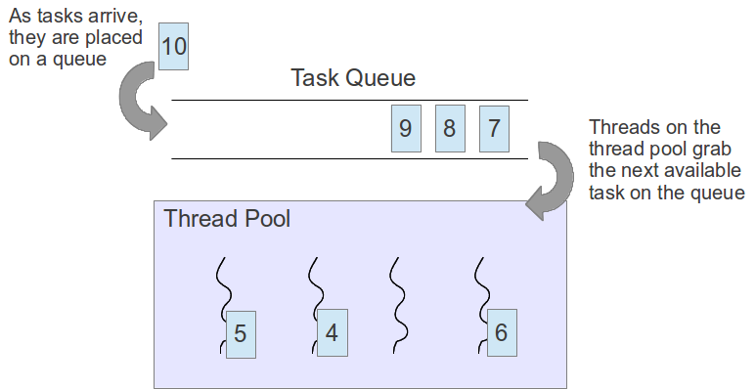
Benefits of thread pool
- On request , no need to create new Thread
- Limit on Thread creation
- Task Execution separated from Task creation- different running strategies can be used
(ii) OpenMP
- Its Compiler directive [#pragma omp parallel] and API for programs written in C,C++,Fortran
- Supports paralleled programming & shared memory
- OpenMP identifies parallel regions as blocks of code that may run in parallel.
- Application developers insert compiler directives into their code at parallel regions these directives instruct the OpenMP run-time library to execute the region in parallel.
#pragma omp parallel
for (i = 0; i < N; i++)
{
c[i] = a[i] + b[i];
}
(iii) Grand Central Dispatch
- Used in Apple,MacOS,iOS
- API & run time library in C to identify parallel code sections
- GCD identifies extensions to the C and C++ languages known as blocks.
- block represented as ˆ{ printf("I am a block"); }
- GCD Schedules blocks on Dispatch Queue
- 2 types of dispatch queue: Serial , Concurrent
- serial: removes only one process from queue, completes it & then removes next process from queue
- concurrent: removes set of process from queue and executes them in parallel
- Both FIFO order
2.5 THREADING ISSUES
(i)The fork() and exec() System Calls
UNIX systems have chosen to have two versions of fork(), one that duplicates all threads and another that duplicates only the thread that invoked the fork() system call. Which of the two versions of fork() to use depends on the application.
The exec() call will execute the thread. If exec() is called immediately after forking duplicating only the calling thread is appropriate.If, the separate process does not call exec() after forking, the separate process should duplicate all threads.
(ii) Signal Handling
A signal is used in UNIX systems to notify a process that a particular event has occurred. A signal may be handled by one of two possible handlers:
1. A default signal handler
2. A user-defined signal handler
Handling signals in single-threaded programs is straightforward: signals are always delivered to a process.
Delivering signals is more complicated in multithreaded programs,
In general, the following options exist:
1. Deliver the signal to the thread to which the signal applies.
2. Deliver the signal to every thread in the process.
3. Deliver the signal to certain threads in the process.
4. Assign a specific thread to receive all signals for the process.
(iii) Thread Cancellation
Thread cancellation involves terminating a thread before it has completed.
A thread that is to be canceled is often referred to as the target thread. Cancellation of a target thread may occur in two different scenarios:
1. Asynchronous cancellation. One thread immediately terminates the target thread.
2. Deferred cancellation. The target thread periodically checks whether it should terminate, allowing it an opportunity to terminate itself in an orderly fashion.
(iv) Thread Local Storage
Threads belonging to a process share the data of the process. But in some circumstances, each thread might need its own copy of certain data. We will call such data thread-local storage (or Thread Specific Data.)
(v) Scheduler Activations
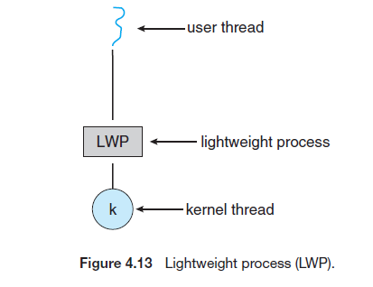
- Many systems implementing either the many-to-many or the two-level model place an intermediate data structure between the user and kernel threads. This data structure—typically known as a lightweight process, or LWP
- One scheme for communication between the user-thread library and the kernel is known as scheduler activation. It works as follows: The kernel provides an application with a set of virtual processors (LWPs), and the application can schedule user threads onto an available virtual processor.
- Furthermore, the kernel must inform an application about certain events. This procedure is known as an upcall. Upcalls are handled by the thread library with an upcall handler, and upcall handlers must run on a virtual processor.
WINDOWS7 -THREAD & SMP MANAGEMENT
Process Characteristics in WINDOWS
- PROCESSES implemented as OBJECTS
- Executable process can have 1 or more threads
- Process and threads have synchronization capabilities
- A process can create a new process or a copy of existing process
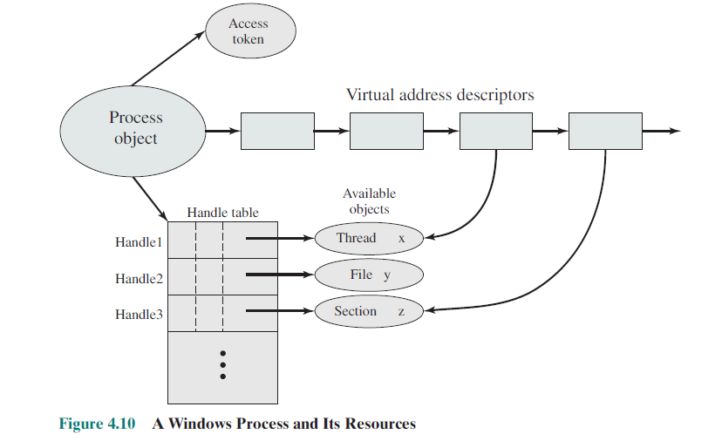
Every process has access token attached to it, which is assigned by system based on user logging in .Based on access tokens OS can grant or deny processes to perform operations and access resources

Process and threads are viewed as objects in Windows
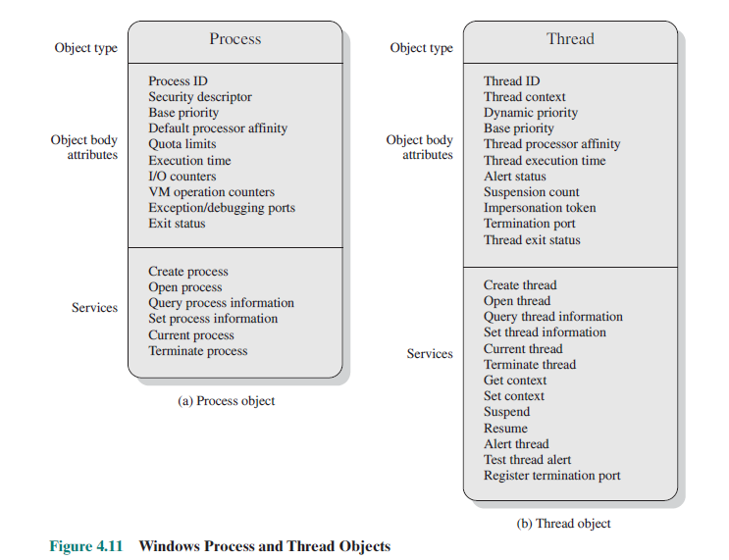
States of thread
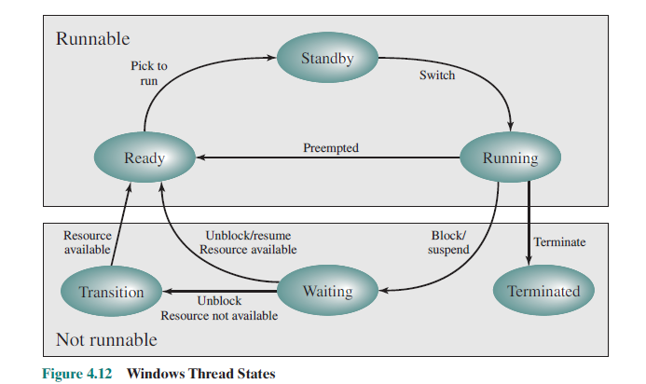
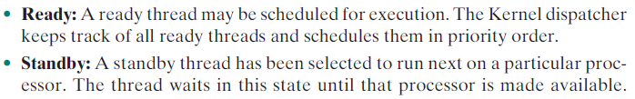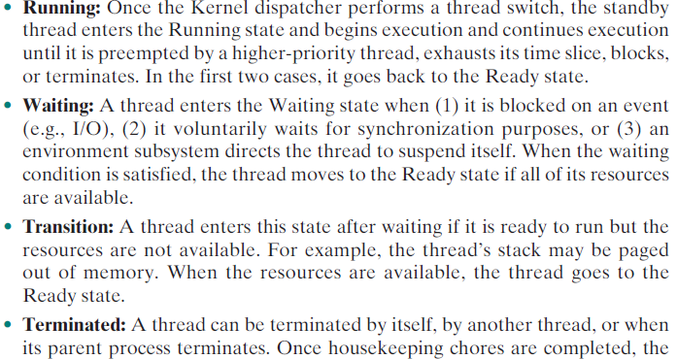

Support for os subsytems
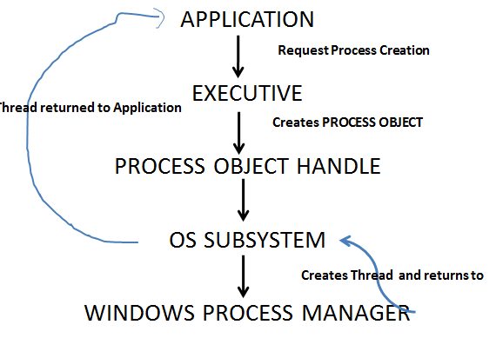
SMP support
- Threads of any process can run on any processor
- Kernel Dispatcher assigns next ready Thread to available CPU-thus CPUs utilized
- Kernel Dispatcher uses
  - Soft Affinity: assigns ready thread to CPU last assigned
  - Hard Affinity: restrict thread execution only in certain processors

SYNCHRONIZATION
Race Condition
A situation like this, where several processes access and manipulate the same data concurrently and the outcome of the execution depends on the particular order in which the access takes place, is called a race condition.
Process synchronization and coordination among cooperating processes is requires to avoid race conditions.
3.1 CRIITCAL SECTION PROBLEM
- Each process has segment of code : critical section (CS)
- It is used to accesses shared resources, change common variables, update tables , write file etc.
- No 2 processes can execute CS at same time, By this we can avoid race conditions
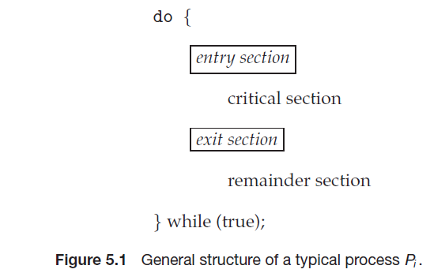
3 conditions to solve CS
- Mutual Exclusion :One process only can be in CS at a time
- Progress
If no process is executing in its critical section and some processes wish to enter their critical sections, then only those processes that are not executing in their remainder sections can participate in deciding which will enter its critical section next, and this selection cannot be postponed indefinitely
- Bounded Waiting:
There is a limit on number of times a process enters a critical section so that other process waiting for CS need not wait for long time
3.1.1 OS Based Approach to solve CS
- Preemptive kernels
  - preemption of process in kernel mode
  - Difficult to design
  - But preferred
  - Suitable for real time programming
- Non preemptive kernels
  - preemption of process in kernel mode not allowed
  - Free from race conditions
  - Less responsive
  - More waiting
3.1.2 Software based solution: Peterson’s Solution
- A classic software-based solution to the critical-section problem known as Peterson’s solution.
- Peterson’s solution is restricted to two processes that alternate execution between their critical sections and remainder sections.
- The processes are numbered P0 and P1. For convenience, when presenting Pi, we use Pj to denote the other process; that is, j equals 1 − i.
- Peterson’s solution requires the two processes to share two data items:
  - int turn;
  - boolean flag[2];
- The variable turn indicates whose turn it is to enter its critical section. That is, if turn == i, then process Pi is allowed to execute in its critical section.
- The flag array is used to indicate if a process is ready to enter its critical section. For example, if flag[i] is true, this value indicates that Pi is ready to enter its critical section.
We need to show that:
1. Mutual exclusion is preserved.
2. The progress requirement is satisfied.
3. The bounded-waiting requirement is met.
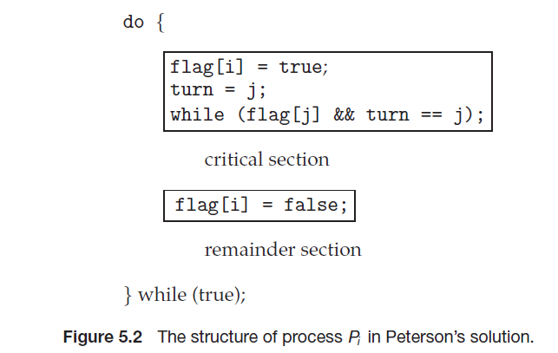

Explanation:
Proving Mutual Exclusion
To prove property 1, we note that each Pi enters its critical section only if either flag[j] == false or turn == i.
Also note that, value of turn can be either 0 or 1 but cannot be both.
Hence, one of the processes say, Pj must have successfully executed the while statement, whereas Pi had to execute at least one additional statement (“turn == j”).
However, at that time, flag[j] == true and turn == j, and this condition will persist as long as Pj is in its critical section; as a result, mutual exclusion is preserved.
Proving Progress and Bounded Waiting
To prove properties 2 and 3, we note that a process Pi can be prevented from entering the critical section only if it is stuck in the while loop with the condition flag[j] == true and turn == j; this loop is the only one possible.
Disadvantage: Peterson’s are not guaranteed to work on modern computer architectures

3.1.3 Synchronization Hardware
- Locks
- Test & Set Instruction
- Swap Instructions
Test & Set
- The important characteristic of this instruction is that it is executed atomically.
- If the machine supports the test and set() instruction, then we can implement mutual exclusion by declaring a boolean variable lock, initialized to false.
- When lock is true the process enters CS, once it completes its CS makes the lock value false so that other waiting process can enter their CS.
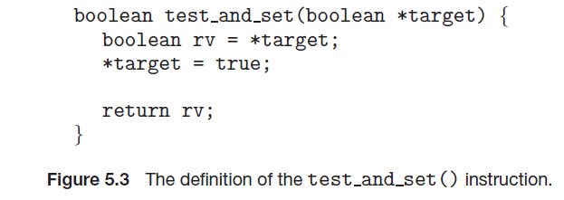
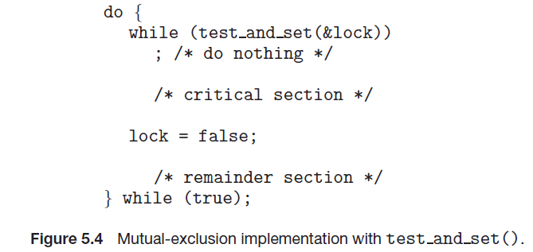
Compare & Swap
  - Like the TestAndSet ( ) instruction, it is executed atomically. If the machine supports the SwapO instruction, then mutual exclusion can be provided as follows. A global Boolean variable lock is declared and is initialized to false.
  - In addition, each process has a local Boolean variable key.
  - Using swap function a process can get its lock value true so that CS can be executed. When it finishes CS makes lock value false so its available for other waiting process

void Swap(boolean *a, boolean *b)
boolean temp = *a;
*a = *b;
*b = temp;
Figure 6.6 The definition of the Swap () instruction.

do { ,
key = TRUE;
while (key == TRUE)
Swap (&lock, &key) ,-
// critical section
lock = FALSE;
// remainder section
while (TRUE);
Figure6.7 Mutual-exclusion implementation with the Swap( ) instruction

3.2 MUTEX LOCKS
- H/W inaccessible to application programmers
- S/w tools used to solve CS
- Simplest s/w tool ==> MUTEX LOCK, locking mechanism that provides synchronization
- Mutex lock-->boolean variable indicating lock available or not
- We use the mutex lock to protect critical regions and thus prevent race conditions. That is, a process must acquire the lock before entering a critical section; it releases the lock when it exits the critical section.
- Use 2 functions
Acquire()
Release()
acquire()  {  while (!available)  ; /* busy wait */  available = false;;  } | release()  {  available = true;  }
- Disadvantage
    - Busy waiting-While waiting for CS, other process loop continuously, checking if the lock is available
- SpinLock (mutex)
    - Process spins waiting for lock to be available in a loop
    - Process is active but cannot perform any useful task check the loop condition repeatedly
    - Not preferred in uniprocessor
    - No context switch required
    - Preferred in multiprocessor (as lock held for short time)
3.3 SEMAPHORES
- It’s a Process synchronization tool that avoids race condition
- Semaphore S ==> integer variable ,
- Apart from initialization, semaphore variable S can be accessed only by 2 standard atomic operations wait() & signal()
- At a time only one process can modify semaphore
- definition of wait() is as follows:
wait(S)
{
while (S<=0)
; // busy wait
S--;
}

The definition of signal() is as follows:
signal(S)
{
S++;
}
- A process waiting for CS executes wait(), process completing CS executes signal()
- When one process modifies the semaphore value, no other process can simultaneously modify that same semaphore value. Process that wants to enter CS executes wait(S), if S value is greater than zero then the process enters CS ,else process waits. Process leaving CS will execute signal() operation where S value is incremented.
- Semaphore Usage : 2 types
- Counting Semaphore
  - Has values of Range 0-n
  - Control access to finite resource instances
  - Process wants a resource -->wait() ,count--
  - Process releases a resource -->signal(), count ++
  - Count=0 all resources used
- Binary Semaphore (like mutex locks)
  - has values 0 or 1
Semaphore Implementation
- To overcome busy waiting- BLOCK process waiting for CS
- Waiting queue of semaphore is used to queue such process, process moves to waiting state
- After signal(), wake up the process, process moves from waiting -->ready state
- process moved to Ready queue-where its scheduled by CPU scheduler
New structure of semaphore
typedef struct
{
int value;
struct process *list;
}semaphore;

Wait() semaphore operation can be defined as
wait(semaphore *S)
{
S->value--;
if (S->value < 0)
{
add this process to S->list;
block();
}
}
Signal() semaphore operation can be defined as
signal(semaphore *S)
{
S->value++;
if (S->value <= 0)
{
remove a process P from S->list;
wakeup(P);
}}

- Wait() and signal() to be performed atomically
- In uniprocessor ,disable interrupts
- In multiprocessor,
    - disabling interrupts difficult
  - Use compare&swap() or spinlocks
- Disadvantage of Semaphore: timing error , deadlock, starvation.

Deadlocks and Starvation
- on implementation of a semaphore with a waiting queue two or more processes are waiting indefinitely for an event can be caused only by one of the waiting processes :DEADLOCK
- STARVATION: indefinite waiting of process

Priority Inversion
- problematic scenario in scheduling
- in which a high priority task is indirectly preempted by a medium priority task
- "inverting" the relative priorities of the two tasks.
Example Consider 3 process with priorities L<M<H. L priority process accessing resource R, process with priority H requires resource R and waits for L to finish. Suppose process with priority M becomes runnable ,preempting process L. Indirectly, a process with a lower priority—process M—has affected how long process H must wait for L to relinquish resource R.
Solution: PRIORITY INHERITANCE PROTOCOL : all processes that are accessing resources needed by a higher-priority process inherit the higher priority until they are finished with the resources in question.

Classic Synchronization Problems
1.Dining Philosopher

Consider five philosophers who spend their lives thinking, hungry and eating. The philosophers share a circular table surrounded by five chairs, each belonging to one philosopher. In the center of the table is a bowl of rice, and the table is laid with five single chopsticks (Figure 5.13). When a philosopher thinks, she does not interact with her colleagues. From time to time, a philosopher gets hungry and tries to pick up the two chopsticks that are closest to her (the chopsticks that are between her and her left and right neighbors). A philosopher may pick up only one chopstick at a time. Obviously, she cannot pick up a chopstick that is already in the hand of a neighbor. When a hungry philosopher has both her chopsticks at the same time, she eats without releasing the chopsticks. When she is finished eating, she puts down both chopsticks and starts thinking again. The dining-philosophers problem is considered a classic synchronization problem
2.Reader Writer
Suppose that a database is to be shared among several concurrent processes. Some of these processes may want only to read the database, whereas others may want to update (that is, to read and write) the database. We distinguish between these two types of processes by referring to the former as readers and to the latter as writers. Obviously, if two readers access the shared data simultaneously, no adverse effects will result. However, if a writer and some other process (either a reader or a writer) access the database simultaneously, chaos may ensue. To ensure that these difficulties do not arise, we require that the writers have exclusive access to the shared database while writing to the database. This synchronization problem is referred to as the readers–writers problem.
3.Bounded Buffer Problem /Producer Consumer Problem
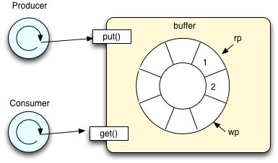
The producer–consumer problem (also known as the bounded-buffer problem) is a classic example of a multi-process synchronization problem. The problem describes two processes, the producer and the consumer, who share a common, fixed-size buffer used as a queue. The producer's job is to generate a piece of data, put it into the buffer and start again. At the same time, the consumer is consuming the data (i.e., removing it from the buffer) one piece at a time. The problem is to make sure that the producer won't try to add data into the buffer if it's full and that the consumer won't try to remove data from an empty buffer.
The solution for the producer is to either go to sleep or discard data if the buffer is full. The next time the consumer removes an item from the buffer, it notifies the producer, who starts to fill the buffer again. In the same way, the consumer can go to sleep if it finds the buffer to be empty. The next time the producer puts data into the buffer, it wakes up the sleeping consumer. The solution can be reached by means of inter-process communication, typically using semaphores. An inadequate solution could result in a deadlock where both processes are waiting to be awakened.
3.4 MONITORS
The operating system must provide the means to guard against timing errors, and several language constructs have been proposed to deal with these problems. Various types of errors can be generated easily when programmers use semaphores incorrectly to solve the critical-section problem.
To deal with such errors, researchers have developed high-level language constructs. One such fundamental high-level synchronization construct is the monitor type
A monitor type is an Abstract Data Type that includes a set of programmer defined operations that are provided with mutual exclusion within the monitor. The monitor construct ensures that only one process at a time is active within the monitor
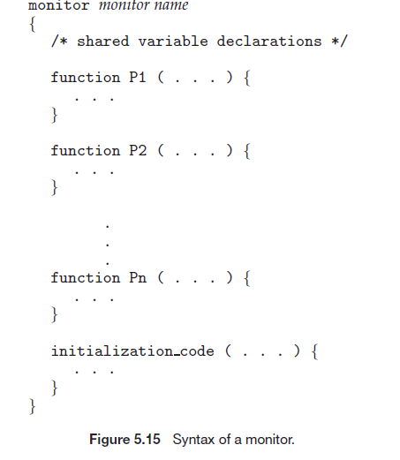
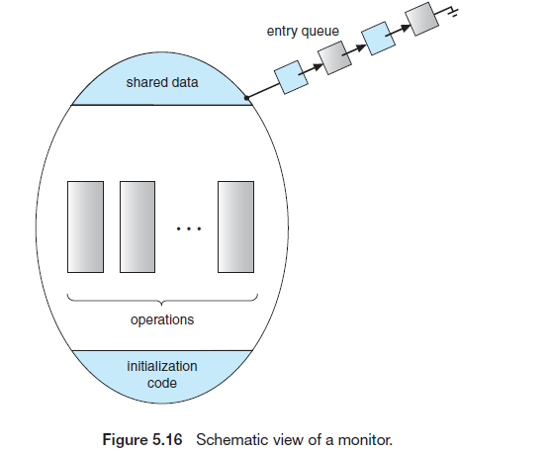
A condition variable provides a method by which a monitor function can block its execution until it is signaled to continue A programmer who needs to write a tailor-made synchronization scheme can define one or more variables of type “condition”.
condition x, y;
The only operations that can be invoked on a condition variable are wait() and signal(). The operation x.wait(); means that the process invoking this operation is suspended (waits) until another process invokes x.signal();
The x.signal() operation resumes exactly one suspended process. If no process is suspended, then the signal() operation has no effect; that is, the state of x is the same as if the operation had never been executed
To avoid, completed process P (which invoked signal operation) and waiting/suspended process Q (which invoked wait operation) from being active simultaneously within monitor, two possibilities exist:
1. Signal and wait. P either waits until Q leaves the monitor or waits for another condition.
2. Signal and continue. Q either waits until P leaves the monitor or wait for another condition.

3.4.1 Dining-Philosophers Solution Using Monitors
Monitor concepts by presenting a deadlock-free solution to the dining-philosophers problem. This solution imposes the restriction that a philosopher may pick up her chopsticks only if both of them are available.
To code this solution, we need to distinguish among three states in which we may find a philosopher. For this purpose, we introduce the following data structure:

enum {THINKING, HUNGRY, EATING} state[5];
Philosopher i can set the variable state[i] = EATING only if her two neighbors are not eating: (state[(i+4) % 5] != EATING) and(state[(i+1) % 5] != EATING).

monitor DiningPhilosophers
{
enum {THINKING, HUNGRY, EATING} state[5];
condition self[5];
void pickup(int i)
{
state[i] = HUNGRY;
test(i);
if (state[i] != EATING)
self[i].wait();
}
void putdown(int i)
{
state[i] = THINKING;
test((i + 4) % 5);
test((i + 1) % 5);
}
void test(int i)
{
if ((state[(i + 4) % 5] != EATING) &&(state[i] == HUNGRY) &&(state[(i + 1) % 5] != EATING))
{
state[i] = EATING;
self[i].signal();
}
}
initialization code()
{
for (int i = 0; i < 5; i++)
state[i] = THINKING;
}
}
Figure 5.18 A monitor solution to the dining-philosopher problem.
We also need to declare condition self[5];This allows philosopher i to delay herself when she is hungry but is unable to obtain the chopsticks she needs.
The distribution of the chopsticks is controlled by the monitor DiningPhilosophers,
Each philosopher, before starting to eat, must invoke the operation pickup(). This act may result in the suspension of the philosopher process.
After the successful completion of the operation, the philosopher may eat. Following this, the philosopher invokes the putdown() operation.
Thus, philosopher i must invoke the operations pickup() and putdown() in the following sequence:
DiningPhilosophers.pickup(i);
...
eat
...
DiningPhilosophers.putdown(i);
It is easy to show that this solution ensures that no two neighbors are eating simultaneously and that no deadlocks will occur.

3.4.2 Resuming Processes within a Monitor
If several processes are suspended on condition x, and an x.signal() operation is executed by some process, conditional construct can be used to choose one among many suspended processes. This construct has the form
x.wait(c);
where c is an integer expression that is evaluated when the wait() operation is executed.
The value of c, which is called a priority number, is then stored with the name of the process that is suspended. When x.signal() is executed, the process with the smallest priority number is resumed next.

3.4.3 Implementing a Monitor Using Semaphores
We now consider a possible implementation of the monitor mechanism using semaphores. For each monitor, a semaphore mutex (initialized to 1) is provided. A process must execute wait(mutex) before entering the monitor and must execute signal(mutex) after leaving the monitor.
Since a signaling process must wait until the resumed process either leaves or waits, an additional semaphore, next, is introduced, initialized to 0. The signaling processes can use next to suspend themselves.
An integer variable next_count is also provided to count the number of processes suspended on next. Thus, each external function F is replaced by
wait(mutex);
...
body of F
...
if (next_count > 0)
signal(next);
else
signal(mutex);
Thus Mutual exclusion within a monitor is ensured.

A semaphore can be implemented using the following monitor code:
monitor semaphore
{
int value = 0;
condition c;
semaphore increment()
{
value++;
c.signal();
}
semaphore decrement() {
while (value == 0)
c.wait();
value--;
}
}
A monitor could be implemented using a semaphore in the following manner. Each condition variable is represented by a queue of threads waiting for the condition.
Each thread has a semaphore associated with its queue entry. When a thread performs a wait operation, it creates a new semaphore (initialized to zero), appends the semaphore to the queue associated with the condition variable, and performs a blocking semaphore decrement operation on the newly created semaphore.
When a thread performs a signal on a condition variable, the first process in the queue is awakened by performing an increment on the corresponding semaphore.
4.0 CPU SCHEDULING
Basic Terminologies
1. CPU–I/O Burst Cycle
CPU Burst cycle – cycle of CPU execution
I/O Burst cycle – cycle of I/O execution
process execution consists of a cycle of CPU execution and I/O wait, alternating between these two states
2. CPU Scheduler
short-term scheduler/ CPU scheduler selects a process from the processes in memory that are ready to execute and allocates the CPU to that process.
3. Preemptive Scheduling
CPU-scheduling decisions may take place under the following four circumstances:
1. When a process switches from the running state to the waiting state (for example, as the result of an I/O request or an invocation of wait() for the termination of a child process)
2. When a process switches from the running state to the ready state (for example, when an interrupt occurs)
3. When a process switches from the waiting state to the ready state (for example, at completion of I/O)
4. When a process terminates
When scheduling takes place only under circumstances 1 and 4, we say that the scheduling scheme is nonpreemptive or cooperative. Otherwise, it is preemptive
4.Dispatcher
The dispatcher is the module that gives control of the CPUto the process selected by the short-term scheduler. This function involves the following:
• Switching context
• Switching to user mode
• Jumping to the proper location in the user program to restart that program
The time it takes for the dispatcher to stop one process and start another running is known as the dispatch latency.

5.Gantt chart
Gantt chart, which is a bar chart that illustrates a particular schedule, including the start and finish times of each of
the participating processes

4.1 Scheduling Criteria
- CPU utilization. To keep the CPU as busy as possible.
• Throughput. The number of processes that are completed per time unit, called throughput.
• Turnaround time. The interval from the time of submission of a process to the time of completion is the turnaround time. Turnaround time is the sum of the periods spent waiting to get into memory, waiting in the ready queue, executing on the CPU, and doing I/O.
• Waiting time. Amount of time that a process spends waiting in the ready queue. Waiting time is the sum of the periods spent waiting in the ready queue.
• Response time. The time from the submission of a request until the first response is produced.

4.2 SCHEDULING ALGORITHMS

4.2.1 First-Come, First-Served Scheduling (FCFS)
The process that requests the CPU first is allocated the CPU first.
When a process enters the ready queue, its PCB is linked onto the tail of the queue. When the CPU is free, it is allocated tothe process at the head of the queue. The running process is then removed from the queue.
Process Burst Time
P1 24
P2 3
P3 3
If the processes arrive in the order P1, P2, P3, and are served in FCFS order,we get the result shown in the following Gantt chart, which is a bar chart that illustrates a particular schedule, including the start and finish times of each of the participating processes:
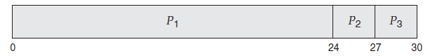
The waiting time is 0 milliseconds for process P1, 24 milliseconds for process P2, and 27 milliseconds for process P3. Thus, the average waiting time is (0+ 24 + 27)/3 = 17 milliseconds.
Disadvantage: short process waits for long time if its predecessor processes are long processes

convoy effect
As all the other processes wait for the one big process to get off the CPU. This effect results in lower CPU and device utilization than might be possible if the shorter processes were allowed to go first.

4.2.2 Shortest-Job-First Scheduling (SJF)
This algorithm associates with each process the length of the process’s next CPU burst. When the CPU is available, it is assigned to the process that has the smallest next CPU burst.
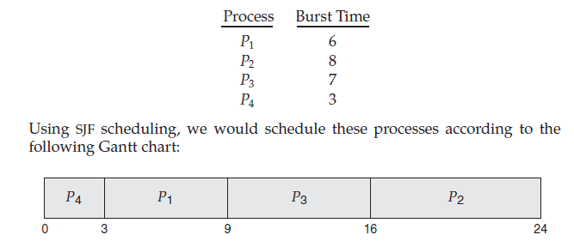
The waiting time is 3 milliseconds for process P1, 16 milliseconds for process P2, 9 milliseconds for process P3, and 0 milliseconds for process P4. Thus, the average waiting time is (3 + 16 + 9 + 0)/4 = 7 milliseconds.
If we were using the FCFS scheduling scheme, the average waiting time would be 10.25 milliseconds.
Disadvantage: there is no way to know the length of the next CPU burst.
The next CPU burst is generally predicted as an exponential average of the measured lengths of previous CPU bursts. We can define the exponential average with the following formula. Let tn be the length of the nth CPU burst,
and let Ʈn+1 be our predicted value for the next CPU burst. Then, for α, 0 ≤α ≤ 1, define
Ʈ_{n+1}= α t_{n}+(1- α)Ʈ_{n}
The value of tn contains our most recent information, while Ʈ_{n} stores the past history.

4.2.3 Priority Scheduling
The SJF algorithm is a special case of the general priority-scheduling algorithm.
A priority is associated with each process, and the CPU is allocated to the process with the highest priority.
Equal-priority processes are scheduled in FCFS order
As an example, consider the following set of processes, assumed to have arrived at time 0 in the order P1, P2, · · ·, P5, with the length of the CPU burst given in milliseconds:
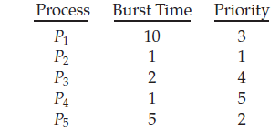
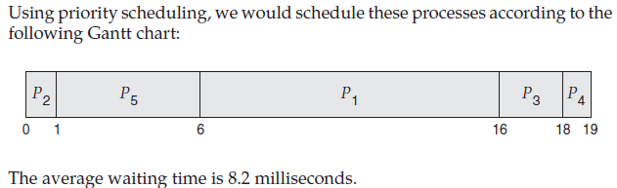
Disadvantage: indefinite blocking, or starvation.
A solution to the problem of indefinite blockage of low-priority processes is aging. Aging involves gradually increasing the priority of processes that wait in the system for a long time.
4.2.4 Round-Robin Scheduling
The round-robin (RR) scheduling algorithm is designed especially for timesharing systems. It is similar to FCFS scheduling, but preemption is added to enable the system to switch between processes. A small unit of time, called a time quantum or time slice (usually 10-100ms), is defined.
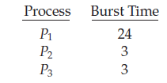
slice time=4ms
Gantt Chart
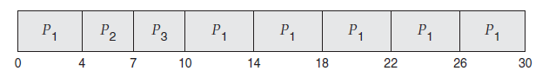
Let’s calculate the average waiting time for this schedule. P1 waits for 6 milliseconds (10 - 4), P2 waits for 4 milliseconds, and P3 waits for 7 milliseconds. Thus, the average waiting time is 17/3 = 5.66 milliseconds.

4.2.5 Multilevel Queue Scheduling
A multilevel queue scheduling algorithm partitions the ready queue into several separate queues (Figure 6.6).
The processes are permanently assigned to one queue, generally based on some property of the process, such as memory size, process priority, or process type.
Each queue has its own scheduling algorithm. For example, separate queues might be used for foreground and background processes.The foreground queue might be scheduled by an RR algorithm, while the background queue is scheduled by an FCFS algorithm.
In addition, there must be scheduling among the queues, which is commonly implemented as fixed-priority preemptive schedulingFor example, the foreground queue may have absolute priority over the background queue. Let’s look at an example of a multilevel queue scheduling algorithm with five queues, listed below in order of priority:
1. System processes
2. Interactive processes
3. Interactive editing processes
4. Batch processes
5. Student processes
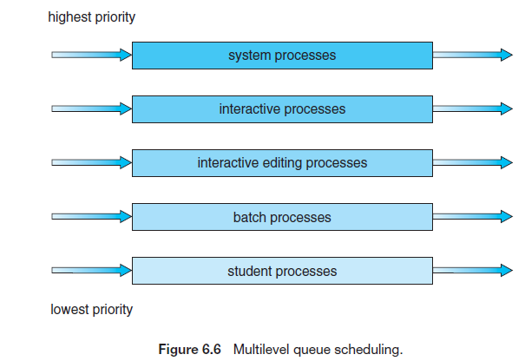
Disadvantage: processes cannot move between queues
4.2.6 Multilevel Feedback Queue Scheduling
Allows a process to move between queues. The idea is to separate processes according to the characteristics of their CPU bursts.
If a process uses too much CPU time, it will be moved to a lower-priority queue. This scheme leaves I/O-bound and interactive processes in the higher-priority queues.
In addition, a process that waits too long in a lower-priority queue may be moved to a higher-priority queue. This form of aging prevents starvation.
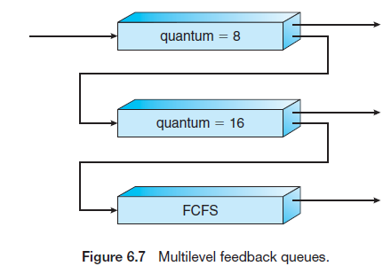
For example, consider a multilevel feedback queue scheduler with three queues, numbered from 0 to 2. The scheduler first executes all processes in queue 0. Only when queue 0 is empty will it execute processes in queue 1. Similarly, processes in queue 2 will be executed only if queues 0 and 1 are empty.
A process entering the ready queue is put in queue 0. A process in queue 0 is given a time quantum of 8 milliseconds. If it does not finish within this time, it is moved to the tail of queue 1.
If queue 0 is empty, the process at the head of queue 1 is given a quantum of 16 milliseconds. If it does not complete, it is preempted and is put into queue 2. Processes in queue 2 are run on an FCFS basis but are run only when queues 0 and 1 are empty.
In general, a multilevel feedback queue scheduler is defined by the following parameters:
• The number of queues
• The scheduling algorithm for each queue
• The method used to determine when to upgrade a process to a higher priority queue
• The method used to determine when to demote a process to a lower priority queue
• The method used to determine which queue a process will enter when that process needs service
Disadvantage: most complex algorithm, since defining the best scheduler requires some means by which to select values for all the parameters.

5.0 DEADLOCKS
A deadlocked state occurs when two or more processes are waiting indefinitely for an event that can be caused only by one of the waiting processes.
System Model
- System: Process & Resources
- Resources:
  - Printer, DVD Drives, Scanner etc
  - CPU
  - Memory
- Instance of resources – number of resources
- Utilization of resource by process
  - Request for resource
  - Use resource
  - Release the resource

Necessary Conditions for deadlock
- Mutual Exclusion
  - Only one process can use resource at a time
- Hold & Wait
  - Process holds atleast one resource & waits for another resource
- No Preemption
  - Resource cannot be preempted. Resources released only after a process finishes its execution
- Circular Wait
  - A set {P0, P1, ..., Pn} of waiting processes must exist such that P0 is waiting for a resource held by P1, P1 is waiting for a resource held by P2, ..., Pn−1 is waiting for a resource held by Pn, and Pn is waiting
for a resource held by P0.

Resource Allocation Graph (SYSTEM RESOURCE ALLOCATION GRAPH)
  - It’s a directed graph
  - used to describes deadlocks
  - Has set of vertices V
    - Process P={P1,P2,,,Pn}
    - Resources R={R1,R2,,,,Rm}
  - Has set of edges E
    - Request Edge

    - Assignment Edge

◦ R = {R1, R2, R3, R4}
◦ E = {P1 → R1, P2 → R3, R1 → P2, R2 → P2, R2 → P1, R3 → P3}
• Resource instances:
◦ One instance of resource type R1
◦ Two instances of resource type R2
◦ One instance of resource type R3
◦ Three instances of resource type R4
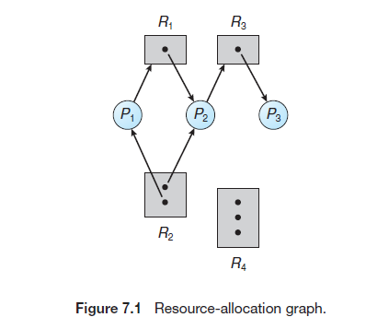

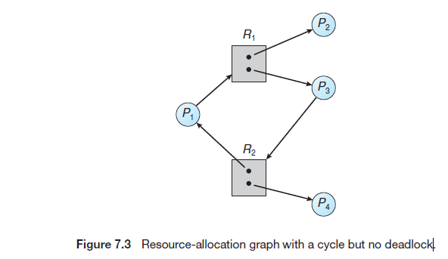

Methods for Handling Deadlocks
- Deadlock Prevention
  - Ensure necessary conditions never occur
- Deadlock Avoidance
  - Maintain requests, resource, allocation info
- Deadlock Detection
  - Detect deadlock and recover system
5.1 Deadlock Prevention
- Mutual Exclusion:
  - Sharable resources can be avoided from mutual exclusion . Eg Many processes can read a file at a time
  - Minimize non sharable resources (Eg.Printer) as they have to be mutually exclusive
- Hold & Wait
  - When a process requests resources, it should not hold another resource
  - 2 protocols
    - Process before execution ,Request all resources at beginning and then should start processing
    - Process should request resource, gain it, release and then only can request next resource
- No Preemption
Method 1
  - a process holding some resources ;
  - requesting for another resource not available immediately;
  - all resources of that process preempted
  - Preempted resources given to other waiting process
  - This process restarted after it regains all old resources + gets new resources requested
Method 2
- Process request resources
- Check availability, if true allocate to it
- If not check whether requested process held by some other waiting process
- Preempt desired resources from waiting process
- If resource not available/held by a non-waiting process then process must wait
Eg: Applied to CPU registers, memory space (states saved and restored)
- Circular Wait
  - Total ordering of resource types
  - Process request resources in increasing order of enumeration
  - 2 protocols
    - A process has resource R_{i} ,can request R_{j} iff
      - F(R_{j} )>F(R_{i})
Example: process holding tape drive can request for disk drive or printer, but process holding printer cannot request for tape drive or disk drive
    - A process requesting R_{i} must release R_{j} when
      - F(R_{j} ) ≥ F(R_{i} )
Example: process holding printer can request for tape drive, only after releasing printer

- Total Ordering of 3 resources: F(tape drive) = 1, F(disk drive) = 5, F(printer) = 12

5.2 Deadlock avoidance
- Avoid deadlock based on Prior Information on : resources available, allocated, future requests, releases etc
- Deadlock Avoidance algo checks Resource Allocation State dynamically to ensure no circular wait
- Resource Allocation State: defined by
  - Number of resources available
  - Number of allocated resources
  - Maximum demand of process
Safe State
- A state is safe if the system can allocate all resources requested by all processes ( up to their stated maximums ) without entering a deadlock state
- a system is in a safe state only if there exists a safe sequence.
- A safe state is not a deadlocked state.
- Not all unsafe states are deadlocks
- An unsafe state may lead to a deadlock.
- A deadlocked state is an unsafe state.

safe sequence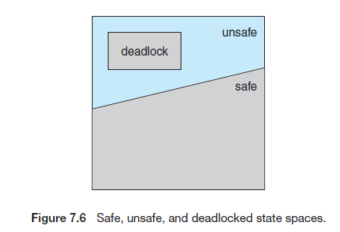
- A sequence of processes
- <P1, P2, ..., Pn> is a safe sequence for the current allocation state if,
- for each Pi , the resources requested by Pi can be satisfied by the currently available resources + the resources held by all Pj, with j < i. (i.e Pj is a predessor process of Pi)
- consider a system with twelve magnetic tape drives
- At time t₀ s/m in safe state <P₁,P₀,P₂>
- At time t₁ if P₂ requests 1 more tape drive s/m can go to unsafe state èdeadlock
- To avoid deadlock ensure s/m is in SAFE STATE!
5.2.1 Resource Allocation Graph Algorithm
- A claim edge Pi - -> Rj indicates that process Pi may request resource Rj at some time in the future
- resources must be claimed a priori in the system (before process execution)
- Check for safety by using a cycle-detection algorithm.
- An algorithm for detecting a cycle in this graph requires an order of n² operations where n = the number of processes in the system.
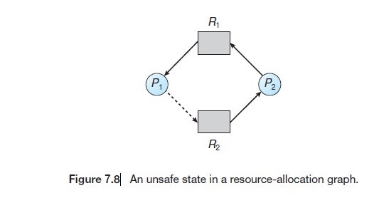
Drawback: Not applicable to multiple instances of resource type

5.2.2 Bankers Algorithm
- Can detect deadlocks in a s/m of multiple instances of resource type
- A new process enters the system it must declare the MAXIMUM number of instances of each resource type it needs
- This number may not exceed the total number of resources AVAILABLE in the system.
- When a user requests a set of resources, determine whether the allocation - safe state.
- If so, the resources are allocated; otherwise, the process must wait enough resources.
Data structures for Bankers
- Available: A vector of length m indicates the number of available resources of each type. Available[j] =k
• Max: An n × m matrix defines the maximum demand of each process Max[i][j].nàno of process màno of resources
• Allocation: An n × m matrix defines the number of resources of each type currently allocated to each process. Allocation[i][j]
• Need: An n × m matrix indicates the remaining resource need of each process.
Need[i][j] = Max[i][j]− Allocation[i][j].

5.2.2.1 Safety Algorithm
- Let Work and Finish be vectors of length m and n, respectively. Initialize
1. Work = Available and Finish[i] = false for i = 0, 1, ..., n − 1.
2. Find an index i such that both
a. Finish[i] == false
b. Need_{i} ≤Work, If no such i exists, go to step 4.
3. Work =Work + Allocation_{i}
Finish[i] = true Go to step 2.
4. If Finish[i] == true for all i, then the system is in a safe state.
- This algorithm may require an order of m × n2 operations to determine whether a state is safe.
5.2.2.2 Resource-Request Algorithm
When a request for resources is made by process Pi , the following actions are taken:
1. If Request_{i} ≤Needi , go to step 2. Otherwise, raise an error condition, since the process has exceeded its maximum claim.
2. If Request_{i} ≤ Available, go to step 3. Otherwise, Pi must wait, since the resources are not available.
3. Have the system pretend to have allocated the requested resources to process Pi by modifying the state as follows:
Available = Available–Request_{i} ;
Allocation_{i} = Allocationi + Request_{i} ;
Need_{i} = Need_{i} –Request_{i} ;
If Resource allocation leaves safe state then Pi is allocated the resources
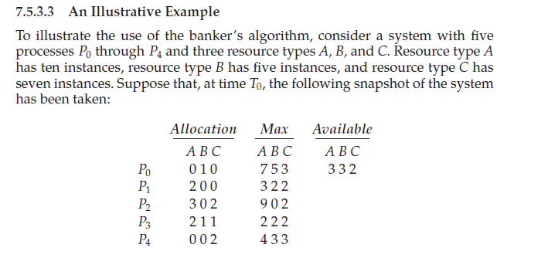
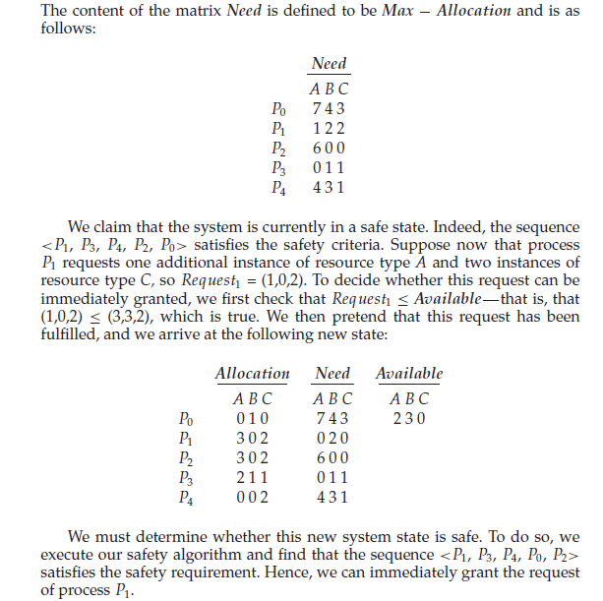
5.3 Dead Lock Detection
If a system does not employ either a deadlock-prevention or a deadlock avoidance algorithm, then a deadlock situation may occur. In this environment, the system may provide:
• An algorithm that examines the state of the system to determine whether a deadlock has occurred
• An algorithm to recover from the deadlock

5.3.1Single Instance of Each Resource Type
If all resources have only a single instance, then we can define a deadlock detection algorithm that uses a variant of the resource-allocation graph, called a wait-for graph.
We obtain this graph from the resource-allocation graph by removing the resource nodes and collapsing the appropriate edges. An edge Pi → Pj exists in a wait-for graph if and only if the corresponding resource allocation
graph contains two edges Pi → Rq and Rq → Pj for some resource Rq .
A deadlock exists in the system if and only if the wait-for graph contains a cycle. To detect deadlocks, the system needs to maintain the wait for graph and periodically invoke an algorithm that searches for a cycle in the graph.
An algorithm to detect a cycle in a graph requires an order of n² operations, where n is the number of vertices in the graph.

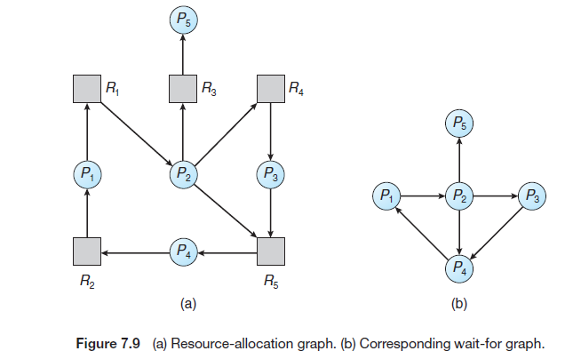
Disadvantage: The wait-for graph scheme is not applicable to a resource-allocation system with multiple instances of each resource type
5.3.2 Several Instances of a Resource Type
Detection algorithm that is applicable to a system of multiple instances of resource type. The algorithm employs several time-varying data structures
• Available. Avector of lengthmindicates the number of available resources of each type.
• Allocation. An n × m matrix defines the number of resources of each type currently allocated to each process.
• Request. An n × m matrix indicates the current request of each process. If Request[i][j] equals k, then process Pi is requesting k more instances of resource type Rj .

Deadlock detection Algorithm
1. Let Work and Finish be vectors of length m and n, respectively. Initialize Work = Available. For i = 0, 1, ..., n–1, if Allocationi _= 0, then Finish[i] = false. Otherwise, Finish[i] = true.
2. Find an index i such that both
a. Finish[i] == false
b. Requesti ≤Work
If no such i exists, go to step 4.
3. Work =Work + Allocationi
Finish[i] = true
Go to step 2.
4. If Finish[i] ==false for some i, 0≤i<n, then the system is in a deadlocked state. Moreover, if Finish[i] == false, then process Pi is deadlocked.
This algorithm requires an order of m × n² operations to detect whether the system is in a deadlocked state.

Detection-Algorithm Usage
- Invoking the deadlock-detection algorithm for every resource request will incur considerable overhead in computation time.
- A less expensive alternative is simply to invoke the algorithm at defined intervals—for example, once per hour or whenever CPU utilization drops below 40 percent.
- Deadlocks occur only when some process makes a request that cannot be granted immediately
5.4 Deadlock Recovery
Deadlock recovery makes possible steps to recover a system from a deadlock. There are two options for breaking a deadlock
5.4.1 Process Termination
To eliminate deadlocks by aborting a process, we use one of two methods. In both methods, the system reclaims all resources allocated to the terminated processes.
• Abort all deadlocked processes. This method clearly will break the deadlock cycle, but at great expense. The deadlocked processes may have computed for a long time, and the results of these partial computations must be discarded and probably will have to be recomputed later.
• Abort one process at a time until the deadlock cycle is eliminated. This method incurs considerable overhead, since after each process is aborted, a deadlock-detection algorithm must be invoked to determine whether any processes are still deadlocked.

5.4.2 Resource Preemption
To eliminate deadlocks using resource preemption, we successively preempt some resources from processes and give these resources to other processes until the deadlock cycle is broken.
If preemption is required to deal with deadlocks, then three issues need to be addressed:
1. Selecting a victim. Select a process to be preempted with minimum cost. Cost factors may include such parameters as the number of resources a deadlocked process is holding and the amount of time the process has thus far consumed.
2. Rollback. We must roll back the preempted process to some safe state and restart it from that state. Since, in general, it is difficult to determine what a safe state is, the simplest solution is a total rollback: abort the process and then restart it.
Disadvantage: this method requires the system to keep more information about the state of all running processes.
3. Starvation. ensure that resources will not always be preempted from the same process

