* **Home Page**

On Clicking on Home on the left

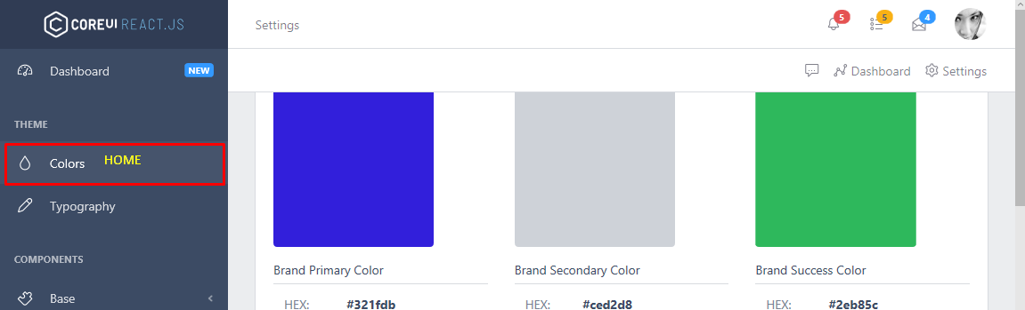

**Acceptance Criteria:**

1. **When I click on Home on the Left, We can have a welcome Message(Optional)**
2. **A Counter Which will display Counts, We can have 4 different counter will be named later.**
3. **And 2 Boxes One Displying the Hosting Services and another Recent Ticket. (No Logic needed Just Dummy DATA), as shown in the below design.**

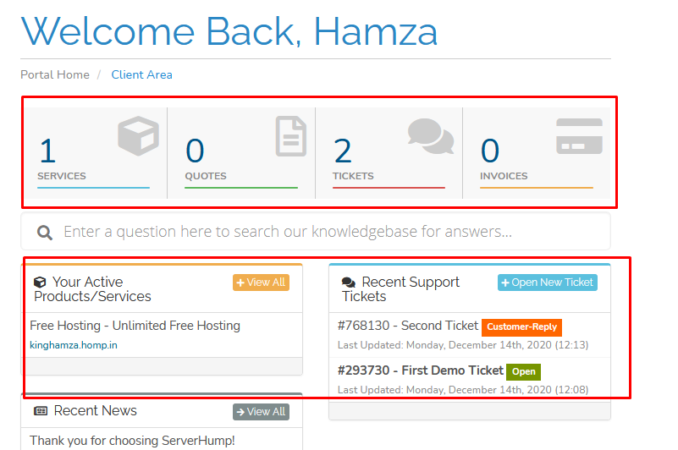

* **Tickets**

On Clicking on Support or Tickets

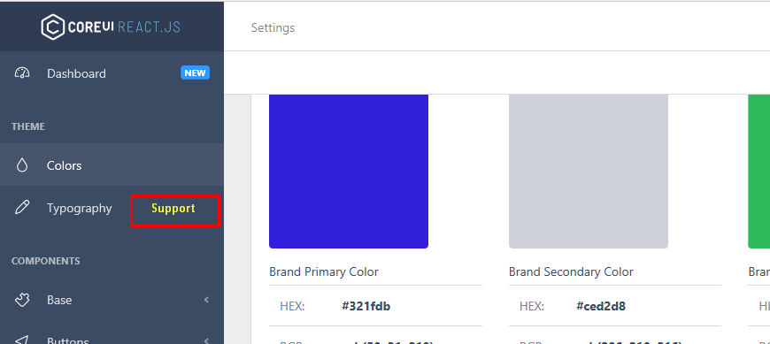

**Acceptance Criteria (No Need to Code Any Logic Data will come from API Calls, So on Button Click Just Console Log the Input data of all text boxes, Load Dummy Data in Grid View)**

1. **When I click on Support or Ticket on the Left PaneI get a list of List of Tickets Submitted in Grid view Format.**
   * + - 1. **There should be a button on top right corner like Create New, keep all the current fields and also add Attachment field (as its in your current design).**

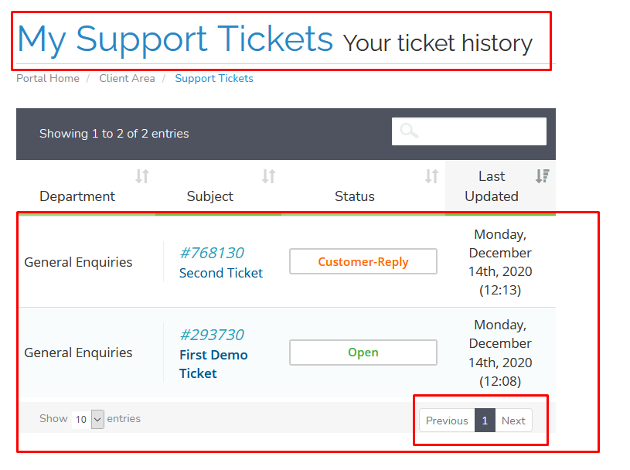

1. **Now On Clicking the ticket, Ticket Id be passed to the next page where reply will be loaded (Pass an Dummy ID )**

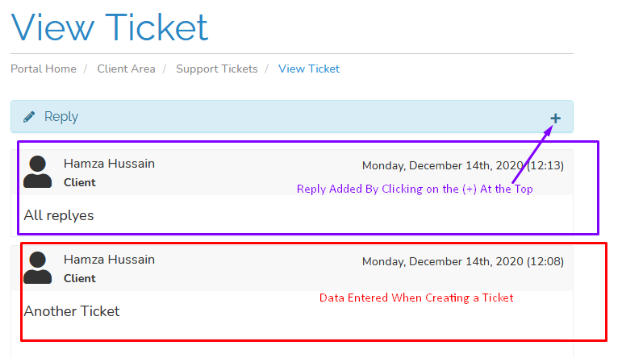

1. **On Clicking on Reply (here +) a reply Entry Box is created on clicking on submit all the details are console logged and Editable field is gone.**

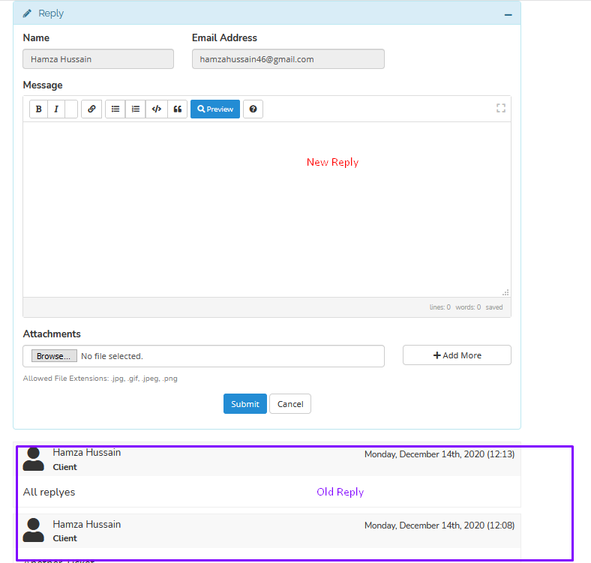

* **Hosting**

**One the Left Navigation we have Hosting which has sub menu like View Account and Create a New Account.**

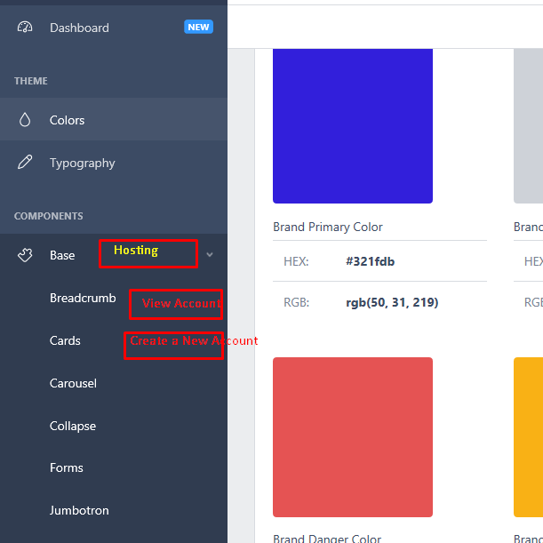

**View Accounts**

**On clicking View Account it should Show List of Account   Add Dummy data (Will use API to fetch it) but keep it with PageNation**

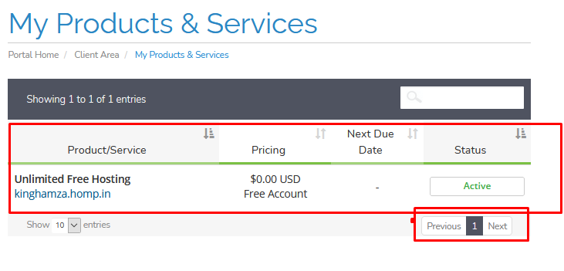

**On Clicking on the Above List it will send Account Id which will load the below (Keep the Below Data some Dummy Data)**

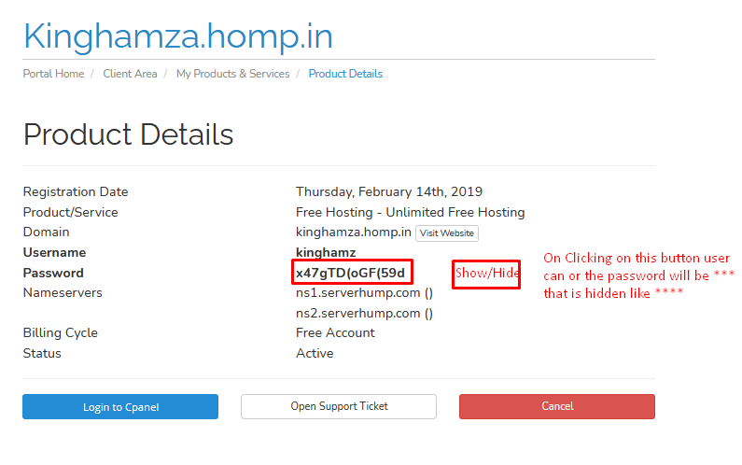

**One Clicking on the above button data all the data in the page should be console Logged. (For the API to do the necessary Task)**

**Create a New Account**

**This is the second submenu in Hosting on left Tab.**

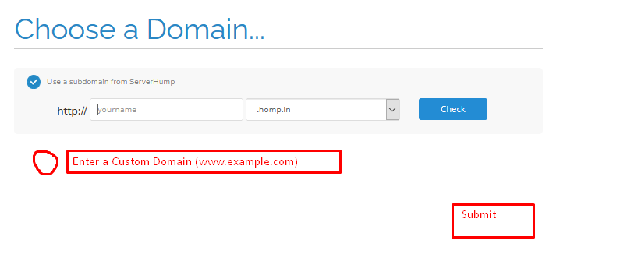

**On Clicking on submit or Check Console Log the Radio button Selection and data in the text box. Will be used by API to create an Account**