TREAT Accrual Report

October 28, 2016

* TREAT-001 -- Observational
* TREAT-002 -- IU Obeticholic Acid
* TREAT-003 -- VCU Immuron
* TREAT-008 -- Cohort Dose Escalation Study

## TREAT 001 -- Observational

|  |  |  |  |
| --- | --- | --- | --- |
| Site | Cases | Controls | Total |
| IU | 67 | 62 | 129 |
| Mayo | 71 | 80 | 151 |
| VCU | 68 | 21 | 89 |
| Total by Arm | 206 | 163 | 369 |

### TREAT 001 -- Accrual by Month (All Sites - Cases)

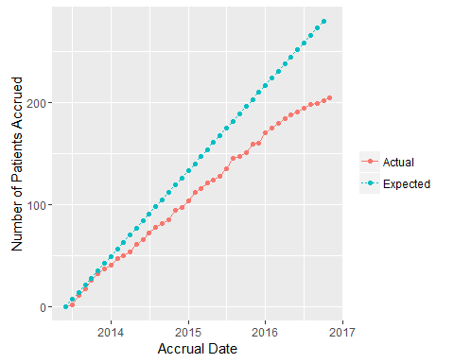

### TREAT 001 -- Accrual by Month (All Sites - Controls)

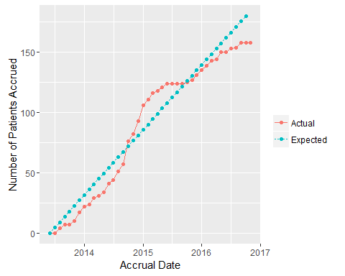

## TREAT 002 -- IU Obeticholic Acid

|  |  |
| --- | --- |
| Site | Accrued |
| IU | 4 |
| Mayo | 9 |
| VCU | 3 |
| Total | 16 |

### TREAT 002 -- Accrual by Month (All Sites)

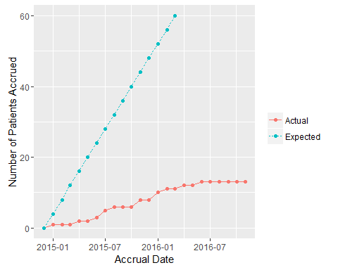

## TREAT 003 -- VCU Immuron

|  |  |
| --- | --- |
| Site | Accrued |
| IU | 9 |
| Mayo | 3 |
| VCU | 19 |
| Total | 31 |

### TREAT 003 -- Accrual by Month (All Sites)

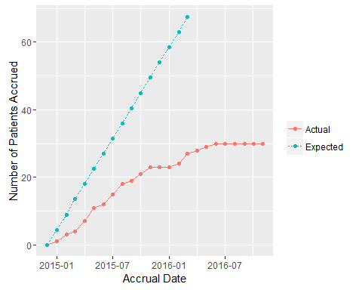

## TREAT 008 -- Cohort Dose Escalation Study

|  |  |
| --- | --- |
| Site | Accrued |
| IU | 0 |
| Mayo | 4 |
| VCU | 0 |
| Total | 4 |

### TREAT 008 -- Accrual by Month (All Sites)

