STUDENT PERFORMANCE MONITORING SYSTEM

**Project Report**

**Section: 1**

**Faculty Name: Ms. Sadita Ahmed**

|  |  |
| --- | --- |
| NAME | ID |
| Md. Golam Quaiyum | **1530281** |
| Sheikh Anandee Hasan | **1730700** |
| Shibriat Hossain | **1831099** |

Table of Contents

STUDENT PERFORMANCE MONITORING SYSTEM 1

Chapter 1: Introduction 3

Section 1.1: Background of the Organization 3

Section 1.2: Background of the Project 3

Section 1.3: Objectives of the Project 3

Section 1.4: Scope of the Project 4

Chapter 2: Requirement Analysis 5

Section 2.1: Rich Picture (as is) 5

Section 2.2: Processes along with six system elements (AS-IS): 6

Section 2.3: Process Diagram (As Is) 17

Section 2.4: Problem anylysis 22

Section 2.5: Rich Picture (TO-BE): 27

Section 2.6: Processes Along with Six ELEMENTS (TO-BE): 28

Section 2.7: Process Diagram (TO-BE) 36

ChAPTER 3: Logical System Design 39

Section 3.1: Business Rule 39

Chapter 1: Introduction

Section 1.1: Background of the Organization

Independent University, Bangladesh (IUB) is one of the leading private university in Bangladesh. It was established in 1993. It focuses explicitly on Research and Global partnerships. Main mission of IUBs is to achieve the goals of higher education and of sustainable economic growth in the country through a two-way relationship between community and university. Its goals are to produce graduates of international standards within the local environment, with knowledge and relevant skills so that it can provide leadership in enterprise, public service and welfare, encourage and support useful research, create knowledge, and provide further learning opportunities.

Currently IUB have six academic schools:

* School of Business
* School of Engineering and Computer Science
* School of Environmental Sciences and Management
* School of Liberal Arts and Social Sciences
* School of Life Sciences
* School of Public Health

IUB is rapidly expanding its portfolio and is in the process of introducing Architecture and Biotechnology. The University curriculum and course of study are progressively revised and adjusted based on their relevance to national needs and the global market demand. [1]

Section 1.2: Background of the Project

The Student Performance Monitoring System helps assessing necessary information to help students, faculties, administrators, and policy makers. It can be used to evaluate, and analysis the CO’s and mapped PLOs achieved by a student for his/her enrolled courses. It will also help to analyse the enrolment process and student progress for faculties, deans, heads, and VC.

Section 1.3: Objectives of the Project

* To analyse the enrolment procedure and enrolment status of a student.
* To help the higher authorities such as VC, Dean or department head to understand and assess student progress.
* To provide insight into what students are learning in relation to the big ideas of the courses and the program they aim to complete.
* To automate the process of monitoring student performance so as to reduce the manual processing involved in it.
* To analyse how student populations are learning inside of their programs so that the departments can focus more strategically on equity and success.

Section 1.4: Scope of the Project

Using the basis of the existing system, we must update the system so that it is more user friendly and more helpful and more effective than it is now. The proposed system would provide us automatic insights on the enrolment trends, evaluate a student progress and store the record of a student’s achieved CO and PLO’s. The instructors, VC, dean, or department heads can also analyse and check a student’s progress of any course or program’s overall status. As most of the tasks mentioned above are done manually this day, it will be very helpful for the students, faculties, deans, or heads. We tried to implement this project for IUB, but it can be also used by UGC in the upcoming days with some updates and modification to get notified about all the universities.

Chapter 2: Requirement Analysis

Section 2.1: Rich Picture (as is)

Figure : Rich Picture (AS-IS)

Section 2.2: Processes along with six system elements (AS-IS):

|  |  |  |  |  |  |  |
| --- | --- | --- | --- | --- | --- | --- |
| Process Name | Human | Non-Computing Hardware | Computing Hardware | Software | Database | Network & Communications |
| 1) User Account Creation | *User:*  Provides information  depending on their specific role such as- name, personal information, degree program etc to the admin by registration process and HR  *Admin:* 1) Create user account on IRAS  2) Collect information such as- student name, address,date of birth,contact number, degree program enrollment etc  3) Collect faculty information from HR  4) Admin provides user ID and password for each individual user type. For example: - student, faculty. | Pen & Paper  User provides all the necessary documents for account creation. | User data is collected and stored in a Computer | Microsoft Office - All the data are  Recorded using this software | All the data are stored in a specific location | 1) Internet is used to associate with IRAS to input account information  2) User’s interface and website pages are served using internet access. |
| 2) Student enrolment record | *Student:*  1) Enrolls in a certain Degree program.  2) Provides enrollment data to the register office  Register Office:  1) Collects the enrolment data from the student   2) Keeps a copy of the data and forwards the data regarding student enrollment in a certain degree program on a specific semester to the specific departments  *Departments:*  1) Receives the total number of student enrollment on a specific semester from the register office. | Pen and paper: Students may use provide the  enrolment information manually | Computer is used for collecting the data, making, and storing the record | Data may be recorded is MS excel | 1) Register office collects the data and stores in database  2) Data is kept in Department records | The Internet is used for collecting the data and the Department can receive the data by email. |
| 3) Student Assessment Records | Student:  Submit project work and  assignments. Gives exams for each of the course taken in a specific semester  Instructor:  1) Take quizzes and exams and assign project work and  assignments throughout the semester to the students.  2) Records assessment  data of each student throughout the semester for every exams and assignments  3) Calculate total marks of  quizzes, assignments and midterm and final exams and convert the marks to assign final grades to each student of specific courses according to the marks distribution provided.  4) Upload student’s final grades on IRAS and also send them to the Department  *Department:*  1) Receives assessment record from instructor and sends a copy to the register office | Pen and Papers  are used to record assessment marks | Computer Is used to create soft copies of the data | Microsoft Excel - Assessments are recorded in the excel sheet.  Upload students’ final grades into IRAS | Student grade information are stored in the IRAS database  Documents are stored in department storage | *Internet:* The Internet is used to communicate with IRAS to store final grades of students |
| 4) Create OBE Marksheet & Course Assessment Report | *Instructor:  1*) Evaluate marks achieved by the students for each question and other assessment mapped to CO. Thus calculate the total marks received for each CO.  2) Calculates CO percentages. If greater than or equal to 40% CO’s then it is considered to be achieved, a student passes that certain CO otherwise fails. Record the information in the OBE marksheet 3) The corresponding CO’s are mapped against PLO’s and PLO achievements are recorded. 4) Make Course Assessment Report using Course Outline, Course Content and CO5)Submits OBE marksheet and assessment report to the department  *Department:* 1) Receives the OBE Marksheet and Course Assessment Report from the instructor  2) Stores the documents  3) Forwards the OBE marksheet, Course Assessment Report and others to the Registrar’s Office.   *Registrar’s Office:*   Stores the OBE Marksheet and Course Assessment Reports | Pen and paper: OBE marksheet stored in hardcopy. Additional markings may be made to further separate between students | Computer is to make softcopies of the OBE Marksheet and Course Assessment Reports.   Printer is used to print hardcopies of final versions  of the OBE Marksheets and Course Assessment Reports. | Instructors use automated excel sheets to calculate the student’s success/ failure in achieving PLOs.   MS word is used to make assessment report | Records of students’ assessment data and final grades will be saved in the department storage  OBE Marksheets, Course Assessment Reports and other documents submitted by the department is stored in register office storage | Internet:  Google Sheets may be used for processing the OBE assessment data spreadsheet. |
| 5) Analysis of Student Performance trends by instructor | *Instructor:*  1) Request the department to provide the OBE Marksheets,  of a specific semester. To check the performance trend of a student from past semester  2) Analyses the documents one by one  *Department:* Provides the document request by the instructor | Paper  To print hard copies of the marksheet | Printer   Faculty may print hard copies of the marksheet  Computer The documents  are recorded By using the computer | Microsoft Office:  1) Faculty uses  automated excel.  sheets to calculate.  the student’s  success/ failure in achieving PLOs. | Store and access data related to student assessments in the form of PDF, DOC, XLSX files etc. | Internet: Submission and Request Can be send via email |
| 6) Overall Performance trend inspection | *Instructor:*   1)Submits student assessment record and OBE marksheet to department  *Department:*  2)Receives the OBE mark sheets and assessment report from the Instructor, records them   3) Sends a copy to the Register office.  *Register office :* 1) Receives OBE marksheet, student assessment report form all the departments  2)Collect all documents together and submit them to the education ministry.  *Ministry of Education:*  1)Requests register office to provide documents to check student performance trend   2)Receives the documents and analyses them one by one | *Paper:*  For Printing Hard copies of the reports | *Computer:*  To generate reports  *Printer:*  To print hard copies of the reports to send them to their respective Department. | *Microsoft Office:*  Used to make reports using Microsoft word and excel | 1) Retrieves Data from IRAS  2) Store and access data related to the reports in the form of PDF, DOC, XLSX files etc. | *Internet:*  Needed to access the web to send a copy of the reports as emails to their respective users |
| 7) Mapping of PLO’s & CO’s | *Ministry of education:* 1) Provides PLO to Higher authority  *Higher Authority:*  1) Request to provide PLO and curriculum  2) Receives the curriculum and PLOs under the OBE model for each program from the education ministry.  3)Sends the new curriculum and PLOs to the Department  *Department:* 1) Receives the curriculum and PLOs  2) Provides Curriculum and PLO to the instructors to design CO and assessment data  *Faculty:*  1) Receives the course curriculum and PLO   2)Maps COs to specific questions of mid term, final exam questions and project work from the given PLOs . | *Pen & Paper:*  May be used to collect information and also make reports as per request by Higher Authority, departments or faculties | *Computer:*  Needed to store the updated information  *Printer:*  May be used to print hard copies of the reports | *Microsoft Office:*  Instructor updates mapped CO in the excel sheet.  Maps question using Microsoft Word and Excel | Store and access data related to the PLOs and COs in the form of PDF, DOC, XLSX files etc. | *Internet:*  Needed to access the web to send emails to their respective users |

Section 2.3: Process Diagram (As Is)

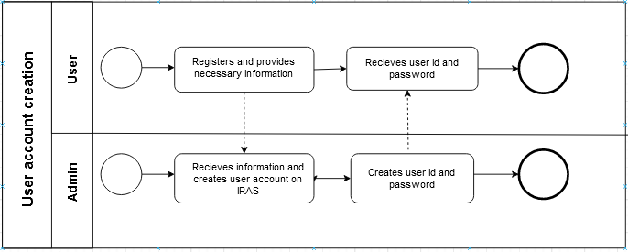

Figure : Process Diagram for User Account Creation

Figure : Process Diagram for Student Enrollment Records

Figure : Process Diagram for Student Assessment Records

Figure : Process Diagram for Generating OBE Marksheet and course assessment records.

Figure : Process Diagram for Analysis of Students Performance trend by instructor

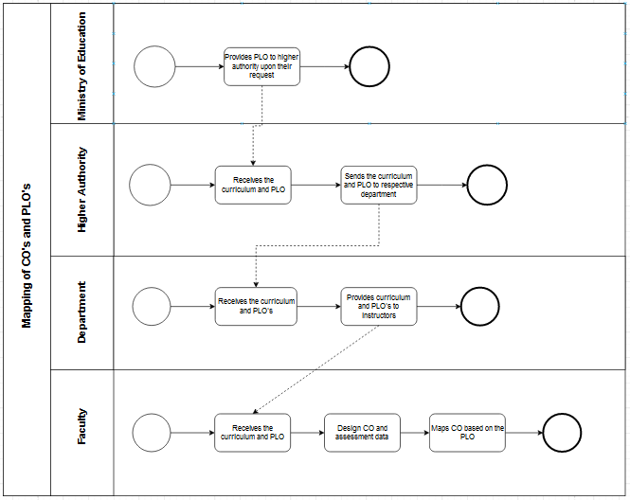

Figure 7: Process Diagram for Mapping of COs and PLOs

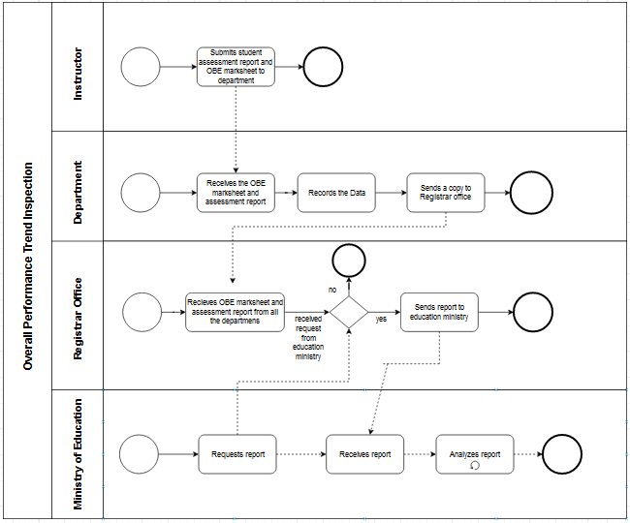

Figure : Process Diagram for Overall Performance trend inspection

Section 2.4: Problem anylysis

|  |  |  |  |  |
| --- | --- | --- | --- | --- |
| Process Name | Stakeholders | Concerns | Analysis | Solution Proposed |
| **1)** Student  enrollment record | Register office  Department | 1. Register office collects the enrollment data from students on a specific semester and keeps a record  Forwards copies of the record to different departments. 2. Departments receive the student enrollment data on a specific semester from the register office. | 1. Forwarding the enrollment records to different departments is an inefficient process. 2. Departments have to receive the data regarding student enrollment from the register office not directly from IRAS. 3. If a higher authority or department wants to compare the enrollment data with another department, they have to analyses the records on their own. | 1) In our SPMS,the register office will only input the data of the total number of student enrollment and the SPMS will automatically produce different graphical representation of the data which will show different comparison trends, e.g school-wise, department-wise, etc. Departments and Higher Authority will have direct access to the report. |
| **2)**Record of Student Assessment | Instructor | For instructor evaluation of total marks achieved for each CO and calculation of total percentage of CO one by one can have a high chance of manual error.  Submitting hardcopy and  softcopy of OBE Marksheet  and Course Assessment  Report to the Registrar's  Office or Department  Office is a time consumption process  and delays or loss of  information and important data.  After receiving the documents from Instructors , storing them can be an insufficient process and hard work to manage. | Collecting all the data regarding student assessment and keeping record and finding the trend will extremely hard and lengthy process , chances of manual errors are high and the process will be inefficient   For departments storing the documents received from the instructor can be a difficult process to manage Keeping track of all the soft copies and hard copies will take lots of time and it is a disorganised process | Faculty can input the  student assessment information directly into SPMS and it will generate a proper report which can be viewed by the higher authority and departments etc |
| **3)**Create OBE Marksheet & Course Assessment Report | Instructor Department Register Office | Instructor manually creates OBE marksheet and assessment report by using excel,  In the existing system there is no proper representation of assessment report  Submitting the OBE marksheet and assessment documents to the department is a time consuming process ,there’s high risk of losing or misplacing the data | Instructors calculates the marks and manually inputs the data in excel sheets which can cause manual error while formatting the columns and the risk of misplacings and losing the file is file | Instructors will input data regarding student assessment and SPMS will automatically generate OBE marksheet and generate an assessment report as the table of mapped CO and PLO are already in the SPMS which will show the percentage of students with achieved COs and not achieved CO’s in a graphical representation.  Department can have a direct access to the system to check the assessment report |
| **4)** Analysis of Student Performance trends by Instructor | Instructor | To check a students previous  records faculty have to request the department to provide marksheet Of a specific semester  Faculty have to search for the record one by one manually from several documents  . | Collecting marksheet from department and  analysing the student performance trend one by one  manually is a difficult and time consuming process. Department might delay to provide the desired document to the Instructor | In our SPMS, Instructor can directly search the desired document and it will show the result no need to ask the department for any document |
| **5)** Overall Performance trend inspection | 1.Instructor  2. Department  3.Higher Authority  4. Ministry of education | Instructor will submit the data regarding student assessment , OBE marksheet to the respective departments Departments will forward the documents to the register office The Ministry of Education and higher Authority will have to request the register office to view for a regular inspection and analyze the documents one by one manually. | Collecting documents from different departments and  Combining all the data containing multiple categories for submitting to the education ministry will be a hard working process and time consuming.   The Ministry of education will have to receive documents from the register office not directly from IRAS. Analyzing the report one by one and making decision based on that is a difficult process | In our SPMS, the Instructor will only input the student assessment record; it will automatically produce different graphical representations of the data which will show different overall performance trends, e.g school-wise, department-wise, CGPA-wise etc. The Ministry of education will have direct access to the system. |
| **6)** Mapping of PLO’s & CO’s | Ministry of education  Higher authority Department  Instructor | Ministry of education provides PLO and curriculum to the higher authority as per request.     Department receives the PLO and curriculum from higher authority and forwards it to the instructor     Instructor mappes the new CO’s according to the curriculum and PLO received from the department. Mapping CO and PLO to specific questions and upload in the excel sheet has a risk of manual error | Higher Authority have to request and wait for the ministry to provide curriculum and PLO there is a risk of losing the mail/hard copy sent by the ministry  Higher Authority have to send the PLO and curriculum to every departments, misplacement and miscommunication can occur in this process   Departments have to forward the PLO and curriculum to every instructor. Instructors have to wait for the department to send documents. Delay and problems occur in this process | Ministry of education can directly provide PLO into SPMS  Instructor can receive the PLO directly from the SPMS   Instructor can upload mapped CO to specific questions of specific exams taken as a table on directly the SPMS system Which will can be used to produce Assessment report and marksheets |

Section 2.5: Rich Picture (TO-BE):

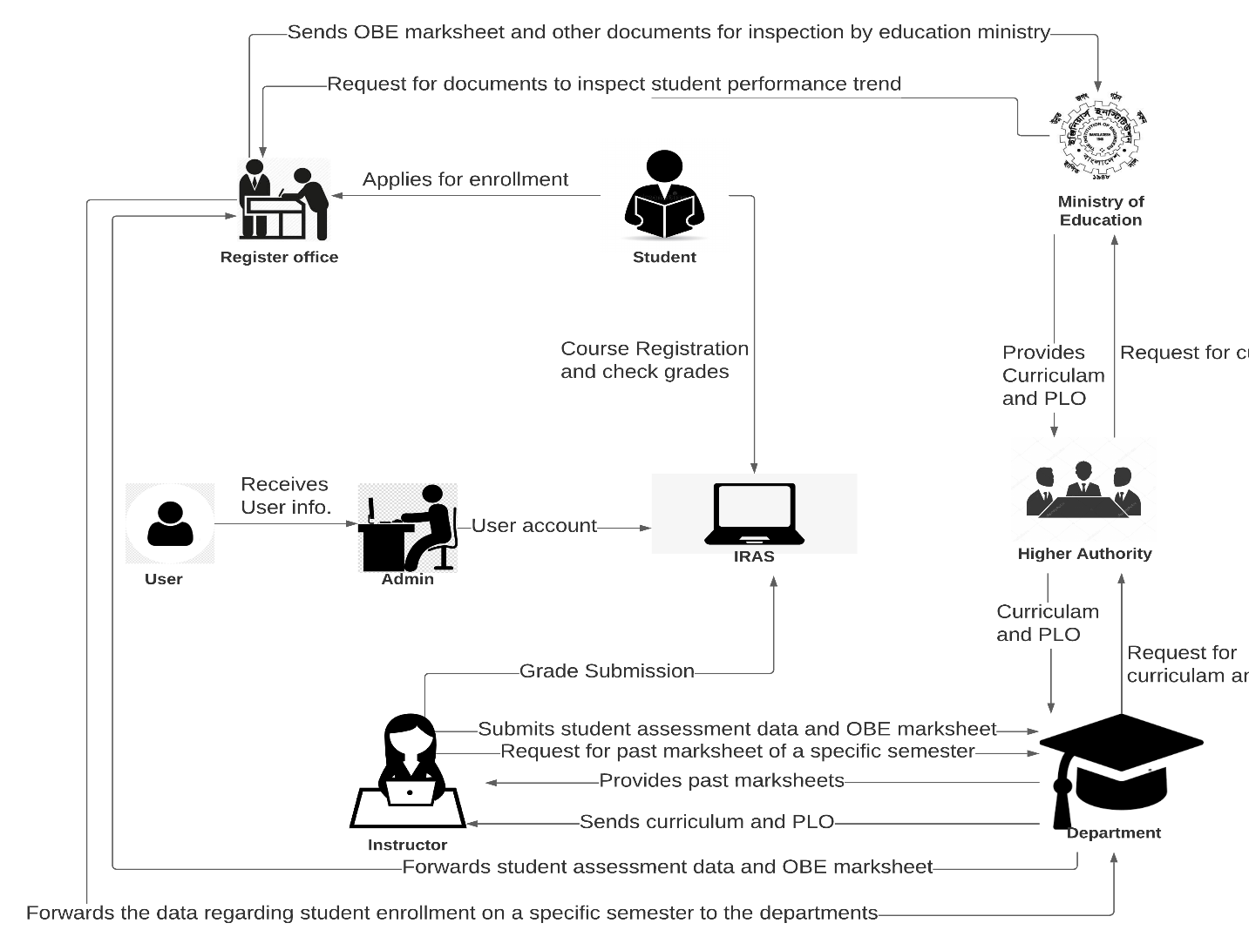

Figure : Rich Picture (TO-BE)

Section 2.6: Processes Along with Six ELEMENTS (TO-BE):

|  |  |  |  |  |  |  |
| --- | --- | --- | --- | --- | --- | --- |
| Process Name | Human | Non-Computing Hardware | Computing Hardware | Software | Database | Network & Communications |
| 1) Student enrolment record | *Student:*  1) Enrolls in a certain Degree program.  2) Provides enrollment data to the register office  Register Office:  1) Collects the enrolment data from the student   2) Keeps a copy of the data and inputs the data regarding student enrollment in a certain degree program on a specific semester in the SPMS.  Higher Authority:  Login to SPMS to view the student enrollment comparison report. | Pen and paper: Students may use provide the  enrolment information manually | Computer / laptop:    1) Register office will collect, store and input the data by using a computer.  2) Users will use the computer to view the report.     Database Server: Used by the register office and SPMS to store data.  Networking Devices (Router, Switch, Bridge, Hub):   Used to Provide and store enrollment information and to access SPMS | SPMS:  Register office provides data to the software and the SPM software uses the information to automatically produce different graphical representations of the data which will show different comparison trends, e.g school-wise, department-wise, etc. | 1) Register office collects the data and may store it in excel files.  2) Student enrollment information will be stored in SPMS database | The Internet is used to access SPMS as it is a web-based application |
| 2) Student Assessment Records | Instructor:  1) Login to SPMS via email and password  2) Click on the “Data Entry” button. A list courses taken by the instructor on a specific semester will appear  3) choose a specific course Input the marks and Input the marks for the students and save the data.  4) Here, the instructor can also view the data in a tabulated form. | Pen and Papers  Are used by the students to give exams and submit assignments | Computer is used to access and input marks into SPMS | SPMS are used by the instructor to record the assessment | All the assessment achieved by students are stored in the SPMS database | *Internet:* SPMS is web based it must be connected with internet |
| 3) Create OBE Marksheet & Course Assessment Report | *Instructor:* Generate OBE marksheet and Assessment report by using SPMS1)Login into SPMS  2) Select the “Student Performance Report” button on the dashboard. Mapped CO of every course taken by the instructor will appear and then specify the scope of the data.  3) Check the percentage of students with achieved COs and not achieved CO’s in a graphical representation.  *Student:*  1) Logins to SPMS  2) Clicks “Performance Report” tab and selects the desired course from the list of courses  3) Views OBE Marksheet in the browser and checks if CO is achieved or not. Export the data if required.  *Higher Authority:*  1) Login to SPMS Dashboard.  2) View different performance trends, searchable by year, courses, faculty, etc. | None | Computer is used to access the SPMS | Marksheets and reports are automatically by using SPMS | SPMS PLO and CO achieved by students in every course are stored in SPMS database and the report are generated and saved in SPMS | *Internet* SPMS must be connected with internet |
| 4) Analysis of Student Performance trends by Instructor | Instructor:  1) Logins to SPMS  2) Select “Student performance report “ button and list will appear choose desired course check the OBE Marksheet of a specific course to view a student’s past performance/overall course performance. | Paper  To print hard copies of the marksheet | Printer   Faculty may print hard copies of the marksheet  Computer The documents  are recorded By using the computer | MS excel Instructor will login to SPMS and enter the marksheet id and semester name | All the neccesary documents are stored in SPMS database | Internet: Submission and Request Can be send via email |
| 5) Overall Performance trend inspection | *Instructor:*  Enters student assessment record and OBE marksheet.into SPMS. *Higher Authority:*  Logins to SPMS to directly choose “student performance trend” option on the service tab check School-wise, department-wise, etc. report  *Ministry of Education:*  Logins to SPMS to directly choose “student performance trend” option on the service tab check School-wise, department-wise, etc. report | *Paper:*  For Printing Hard copies of the reports | *Computer:*  To generate reports  *Printer:*  To print hard copies of the reports to send them to their respective Department | *Microsoft Office:*  Can be used to make excel files to upload to the SPMS | *SPMS:*  SPMS accesses the database and creates graphical representation of the data showing different trends. | *Internet:*  Needed to access the web to send a copy of the reports as emails to their respective users |
| 6) Mapping of PLO’s & CO’s | *Ministry of Education:*  1) Login to the system and uploads the curriculum and PLOs under the OBE model for each program directly to the SPMS  *Instructor:*  1) Checks the course curriculum and PLO, reviews them and updates the new maped COs from the PLOs to SPMS | None | *Computer:*  Needed to enter the informations  directly to SPMS | *SPMS*  Ministry of Education and Instructor can login into the system and add information directly to SPMS | All the related information are stored in SPMS database | *Internet:*  Needed to access the web to search the data |

Section 2.7: Process Diagram (TO-BE)

Figure : Process Diagram for Student Enrolment Records

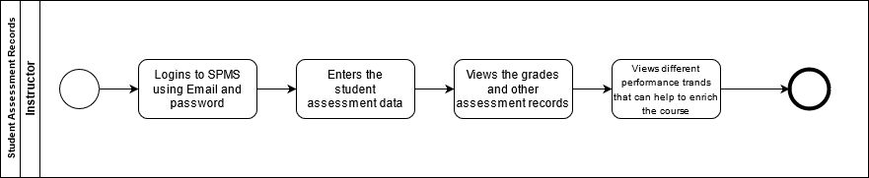

Figure : Process Diagram for Student Assessment Records

Figure : Process Diagram for Creating OBE Marksheet and assessment records.

Figure :Process Diagram for Analysis of Student Performance Trends

Figure 14: Process Diagram for Overall Performance Trend inspection.

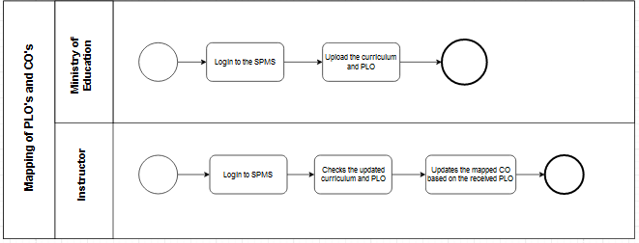

Figure : Process diagram for Mapping of PLOs and COs

ChAPTER 3: Logical System Design

Section 3.1: Business Rule

We are building a software which will increase efficiency in monitoring the student performance trend and analyse data regarding student enrolment for a university.   
Users can login via userID and password to the system. In a university a student gets enrolled under a specific Degree Program. Each Degree Program belongs to a department and the related departments are kept under schools. Courses are taught by instructors, departments are run  by higher authorities ( schools, department heads, school heads ). A student will have a studentID, first name, last name, date of birth gender, phone number, departmentID, degreeprogramID . A department has departmentID, name and Higher AuthorityID. Enrolment has enrollmentID, studentID. Degree Programs will have degreeProgramID,  degreeprogramname, departmentID. Instructors will have instrutorID, name, email, departmentID etc. They can have access to the courses and courses will have courseID, course name, degreeprogramID.  
  
In our SPMS all data regarding student enrolment, student performance trend, PLO and CO are stored. Register office input the student enrolment data to the system. SPMS will generate a enrolment comparison report, (school,department,degree program wise).The Instructor will update the student assessment details and CO for each course to the SPMS, for the system to generate a student performance trend report (school-wise, department-wise, degree program-wise, Instructor-wise, course-wise).The Ministry of Education has direct access to the system. They can view the student performance trend report and update the PLO, Instructor can map and update the CO according to the PLO. The student can view their student assessment details and Higher authority and department can view the enrolment comparison report.

Section 3.2: ERD

Figure : ERD