LAB 01: Message Queue + JWT

- Chạy docker compose cho RabbitMQ

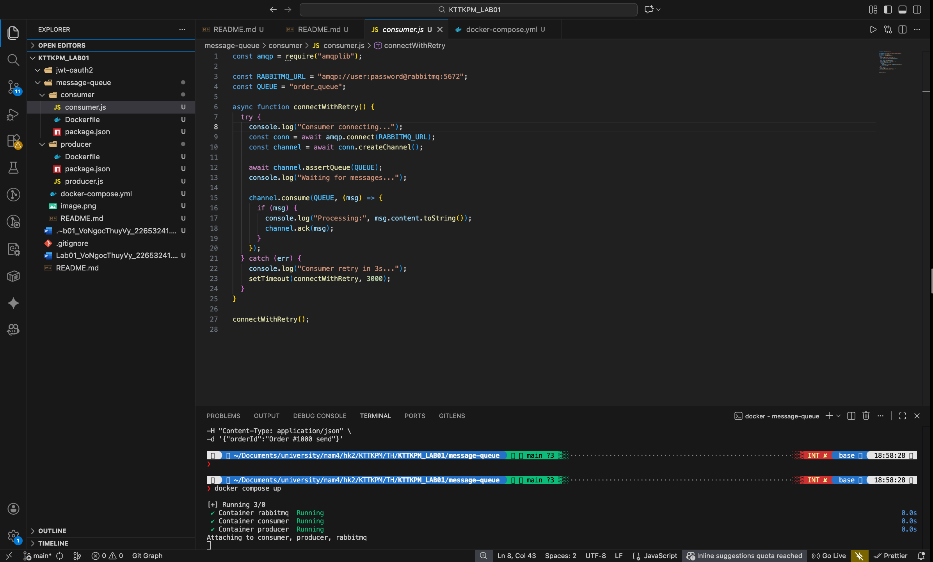
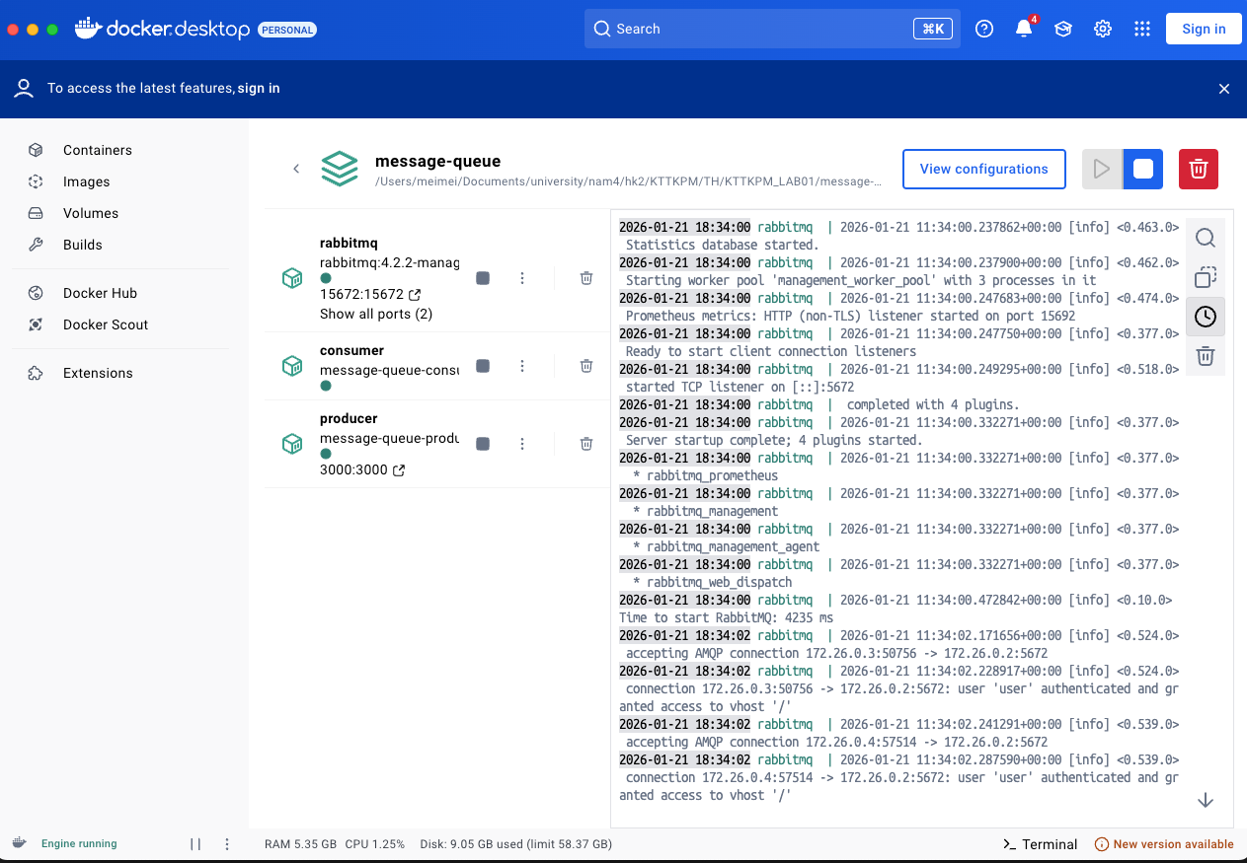

- Chạy test api /register

