Issues in 1.05 (Fall 2016) Pre-Release

## ISSUES

### pdb2pfo

### Large molecules

#### BNS_TIMEOUT

Seen in

salt_found = MarkSaltChargeGroups( pCG, at,

num_atoms, s_group_info, t_group_info, c_group_info, pBNS, pBD );

Option /W !!!

#### Re-numbering leads to different InChI’s

pdb2pfo

Diff. in tetrahedral stereo

InChIKey=VVDXAGDESGSJPE-YMVCPGOQSA-A

InChI=… ;5-,6+,8+;…

InChIKey=VVDXAGDESGSJPE-LJSOXLLGSA-A

InChI=… ;5-,6+,8+**,26-**;…

pdb4ged

diff. in moveable H layer

InChIKey=ZEGUMSOBLUXXCJ-QVCVEFAUSA-K

InChI=… ;/h41-48,60-65,74-81,111-114,120-121,131,137-149,154-163,170,178-186,195-215,237-248,**312-314**,377-380,382-385H, …

InChIKey=VHWVYMKJPNGXPQ-QVCVEFAUSA-K

InChI = … /h41-48,60-65,74-81,111-114,120-121,131,137-149,154-163,170,178-186,195-215,237-248,**312-313**,377-380,382-385H,…

Renumbering – tests 2 (may 2016, addon)

Total shuffled (<=1 min single0run) : 4402 (of total 17334 (of which V3000 are 7565))

No problems detected

### Polymers

### Support for large molecules (experimental)

…

TODO: Finalize.

TODO: Add description.

#### Testing

Describe PDB experiments!!

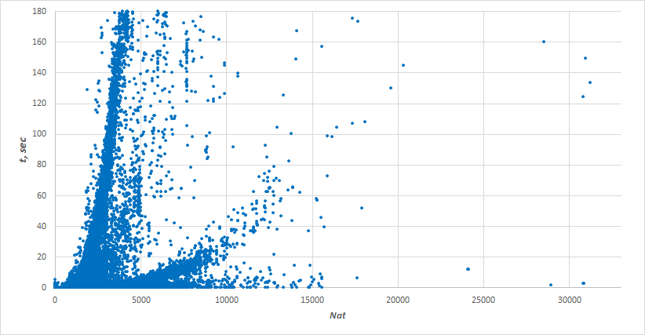

Xeon E3-1245V2 3.4 GHz machine, single-threaded execution, 64-bit Linux OS (Ubuntu 14.04 LTS).

Timeout for individual molecule set to 180 sec.

Total molecules examined: 118607

InChI successfully calcd.: 115983

Stopped by 180-sec timeout: 2624

**Known issues**