INDIANA UNIVERSITY SOUTHEAST

**From**: Chad Wilson  
 Conner Mayfield  
 Harris Chaudhary

**Project for P445**

**Project Management System**

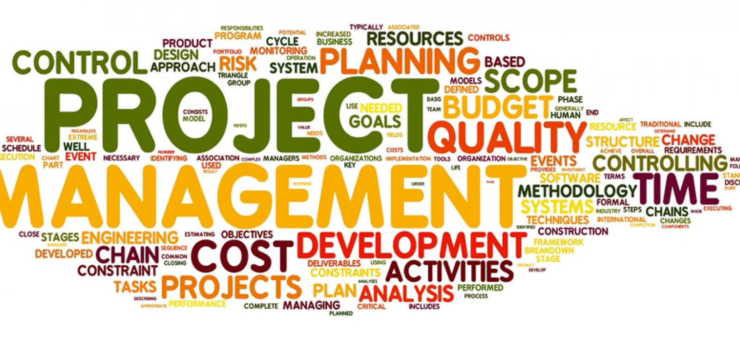

**Date Submitted: 9/28/2021**

**Introduction** – Project management systems are developed for companies to have a better access over projects. Such systems can make it an ease for companies to assign and better manage projects. Each project has its own kinks and quirks which needs to be foreseen by a manager. Our Project management system will have different levels of roles. Managers will be able to have admin access which means there will be an admin page where projects can be created or closed. Projects will have feedback fields where employee can share their ideas and reports.   
This system will allow managers and employees to understand their roles and assignments better. Each project has its own unique goals it needs to reach and with no clear instructions or task described, team can lose sight. This system can help with ton of different projects under different managers.

**Purpose** – Project management system has several purposes as it helps a company in many ways. Before evaluating the purpose of this system, we should consider companies who might not have this system. With no project management system, every process can be a cluster and have no definite goal. When a project is introduced, it is introduced with goals, tasks, due dates, expectations, feedback and with no system, employees can lose sight and focus. Employees may not completely understand their assignments or in general just be confused about the whole project. Project management system can provide companies with compatibility of records. Once an employee is assigned a task, it will be easy for them and managers to track his progress. This will allow him to never lose sight and always know where he needs to progress. Giving feedback will be a lot easier as such system allows you to leave feedback and suggestions to improve upon.

**Definitions** – Application –   
Status – Each project will have progression bar from it will be estimated if projects are in pre-development or post-development.  
Title – Each project will be given a name.  
Detailed Description – Project will summaries of them which will explain what the project is about.  
Requestor – This will explain who requested specific items.  
Department – This will be selected before a project is started to identify for who the project is being developed.  
RequestDT – This will show a requested database.  
DevTimeSpent – This will showcase any notes added in by developer. It can be notes, text, or date.  
Impact if not implemented – Text with max 225-character length which will indicate warning for not completing a specific task.  
ValueCategory – This will display time saved in a task, compliance issues and dollars recovered.   
MinutesTimeSaved – Numeric field that displays how much time is saved doing one task.  
Frequency – This displays how many times a process occurs on daily, weekly, monthly, or annual basis.   
TTS – This will display how much time is saved.   
AnnualCostSaved – This will display annual cost saved will a special numeric value.

**System overview** – Project management system will be a web-based software where it will be its own software of a sort.

1. Application dropdowns
2. Naming each project and task
3. Able to change status of each project
4. Selecting department
5. Recording of time spent by employees and managers
6. Feedback field

Overview of system above can land us a perfect project management system.

**References** –

*Project Management System: Definition & Features*. ProofHub. (2020, November 17). Retrieved September 27, 2021, from https://www.proofhub.com/articles/project-management-system.

*Take online courses. earn college credit. Research Schools, Degrees & Careers*. Study.com | Take Online Courses. Earn College Credit. Research Schools, Degrees & Careers. (n.d.). Retrieved September 27, 2021, from https://study.com/academy/lesson/project-management-system-definition-example.html.

Anne-Mai Aadamsoo. (2010). WEB BASED PROJECT MANAGEMENT SYSTEM.

**Overall Description** – Project management systems are designed to help improve projects of a companies. It helps to organize cluster of tasks and deadlines into simple format where each task or deadline is laid out. Further in this document we will dive deep into nitty gritty stuff of our software where we explain user interference for users.

The product perspective is how all of this will work for the consumer. This is a tracking program that will allow the user to see how long, what project are they working on, what is the longest time that they have spent on the project, who did what on each project, and what team has requested the greatest number of projects. Plus, there will be very more of what they need to be done.

**Break down of individual contributions:**

Chad: I will be dealing with most of the user characteristics, the constraints, assumptions, and dependencies. I will also deal with all the memory constraints. I will also deal with all the documents for the projects and sprints.

Harris: Will be dealing with all the operations and the side adaptation requirements, will also be dealing with all the memory constraints and with the communication interfaces. Also, will help with the documentation.

Conner: Will be dealing with the System Interfaces, Hardware interfaces, Software interface, and User interface. Conner will be dealing with most of the web-based application and that connects them together.

***Specific requirements***

**External interface requirements**

External interface requirements include the user, other software & hardware system our software system might interact with. So to start off, the user will grant an administrator portal if they are a manager or have administrative privileges. All users are granted access to the regular software system page/portal as well. Our software system will interact and interface with other software systems, hardware systems, and Databases so that once deployed it can fully function in the real world.

**Functional requirements**

Functional requirements include the Angular web application framework, front end programming languages, backend programming languages, servers, and databases. All these components coming together will build our project and make it fully functional.

**Performance requirements**

* Fields with Definitions
* Admin Pages to Manage Content
* Project Enhancements (The team back log)
* Project Closed
* Reports

**Design constraints**

The design constraints of this software project were crafted by our Sponsor. The design constraints include physical requirements, performance requirements, software development standards, and software quality assurance standards.

**Standards Compliance**

Our software system will obey by the Standards Compliance and all its guidelines.

**Logical database requirement**

The logical database requirement for this software system is for it to be connected to an employee database. The reason for this is that the fields that will be used in this software system require employee's data or information to be populated. At first this software system can be connected to a local database but after testing is done with local or created data, the product will be ready for deployment this software system should be connected to the companies databases.

**Software System attributes**

* + - Reliability - This software system will have premium reliability due to the amount of testing and review that will be performed on this software.
    - Availability - This product will be available everyone who has an internet connection and is allowed access to this product. This product will be available on Desktop, Laptops, and phones since it is a web application.
    - Security - The security of this software system is top tier. An admin portal page will be built so that only admins can fully control or modify the system and no one else.
    - Maintainability – There should not be too much Maintenance for this software system. Other than database updates that the sponsor will handle on their since it will be their employee database that might have confidential information. So maintenance of this software system would mainly be database related updates.
    - Portability - Since this is a web application that a user can access from a laptop, desktop PC, and mobile means the portability of this software is good.

**Other requirements**

No other requirements are required at this moment.

**Key personnel for this project are:**

Chad: the team leader who also is making a giant list of all our functions and characteristics. I will also oversee all the documentation of the projects and speaking with the sponsor.

Harris: will be teaming up with Conner and getting all the angular and web base set up so we can have a running version of our program. Will also be doing some of the documentation.

Conner: will be the main programmer and he will be getting all the web-based items set up and connecting everything together.

Hollie: The sponsor. She is the employee at Humana that has given us the project and she has been speaking with Chad a lot about the specifics of the data and types.