INDIANA UNIVERSITY SOUTHEAST

**From**: Chad Wilson  
 Conner Mayfield  
 Harris Chaudhary

**Project for P445**

**Project Management System**

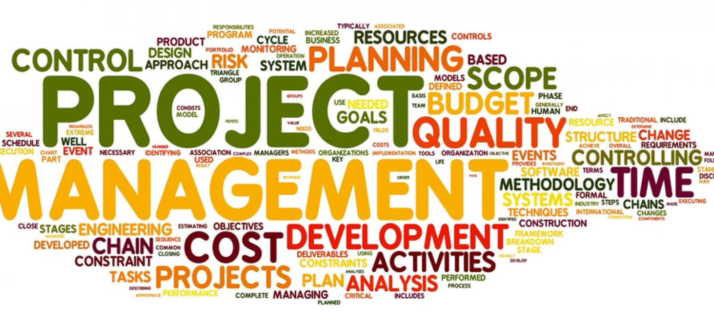

**Date Submitted: 10/15/21**

**Overview:** This project will be used by Humana that will allow them to have a log of who does what on each individual system and project that they have. This will mainly be used by the software development team there that will allow them to log into the program depending on their status that will decide what they can and cannot do. Most of the functionally will come from the software dev team to add in what they did to each project with a specific amount of time that they have. It will allow the project manager to see who has completed and what their team has done over the given specific amount of time or even what has happened in the total lifetime of the project.

**Subsystem decomposition:**

**Hardware/software mapping:** The hardware will be assigned to the software by having it inside of the main database and hardware code of all of the storage on their computers. They will all have the main code on their computers as well, if they do not have it or do not download it then they will not be able to use it.

**Persistent data management:** we will have many data functions and many different variables that will be persistent. Almost all of our data that we will use is inserted and entered by the user. Most of the data will be strings and floats so they will be able to take many different types of constraints and different types of parameters. They will all be allowed to be accessed at any point in time as long as the user is permitted as well.

**Access control and security:** We will have 4 main types of users. They will be Admin, Developer, search user, and view only. Within each of those users they will all have their own types of functions that they can do. The admin has access to everything and do whatever they want to do. The admin will be the only person who can add and take away projects, close projects/mark as complete, give people admin access, and have their own page that has all the specific files for admins. The Developer will have access to all the databases and files but will only be able to write to them and will only be able to add in their specific time and description of what they did. They will also be able to change the names of databases and documents and be able to give priority to a project. Search user will only be able to look and see what has been done and what has been requested. They cannot adjust the projects, but they can leave in notes and ask questions directly to a specific person. They can also request that something be added or even add in a comment. The view only can only see what’s going on. They can still request a project for them, but cannot do anything else other than view information that is allowed to be seen set by the admin.

There will be a login in system that will the user to login and be able to do items that they are assigned to do. If they do not login, they will not be able to do anything. The ultimate goal will be to have them do a 2-factor authentication that will either send an email or just ask them a security question, but we are going to go with just the username and password for now.

**Global software control:** Describe the control flow (e.g. procedural, event-driven, threaded). Procedural control flows should be described using activity diagrams. Event-driven flows are best described using sequence and state diagrams (use UML diagram standards). -Diagram: Diagram

**Boundary conditions:** The system will start up running a website that will be stored in the main database there. It will be initialized by someone either running the program or going to the website. It will be closed by someone logging off or someone stopping their version of the program. It will respond with errors by saying what the error is and giving them a big screen that says you must do this before you can continue. It will deal with exceptions based off a list that will be set based off of the user. It will have to be maintained biweekly or even weekly just to take sure that everyone’s login works and to make sure all of the databases are still connected properly. All you will need to do to change your computer is to rerun the program and log back in. Since all of the information is already in databases they will just be adding items to them from our program so no issues with bulk dumping.

**Examples of the component types:**

* Use Cases - First, the user will sign into the software system using the login system that admins and normal users have access to. Both admins and normal users will have access to the same portal, however admins will have access to certain features. In the portal there will be a table or calendar like feature where admins and normal users can add information regarding a project, track a project, adjust due dates, etc.
* Functions- In our program there will be many functions that will include items such as user authority and adding items to the database. Our program will have many functions but all items in our program will be controlled by a function.
* Triggers – We will be implementing all of the triggers into our program. There will be time triggers when an item is over a specific number of days or hours without an update. State triggers will be used when specific items need to have a change of state inside of them. Such as the time function might need be to a time zone base. We will have transaction triggers whenever someone wants to add something to the database, delete something from the database, or even insert something at a specific spot.
* Data Stores – Any data that is not being used inside of them program will be at rest but will also be on standby at any time.
* Data Flows - The flow of data on our application will be from the frontend-> backend-> database. API’s will help transfer this data between the frontend, backend, and database and connect everything together.
* Data Elements – It will be the data entered by the user of our program that is in the change between the database and the entrance of the code.
* Processors – Our processors are the people who will be using the programs computers and the main servers and databases used throughout Humana.
* Data Storage - The way data will be stored in this application is going to be through a database. At first while the development of the application is in progress, we will be using mockup or local databases for testing, debugging, etc. However, when this application is ready for deployment Humana’s engineers, or our team will connect the application to a real employee/user SQL database.
* Data Connections – They will be databases for us. Everything that we will need are going to be inside of the databases.
* Actors/External Entities – They will be the users of our website that will allow them to change what they are entering inside of the database.

**Break down of individual contributions:**

Chad: will be dealing all the documentation and getting all of the project management organized. Will also deal with everything that involves users and processes. Also, I will be dealing with most of the user characteristics, the constraints, assumptions, and dependencies. I will also deal with all the memory constraints

Harris: Will oversee helping conner and myself by helping conner code and by helping me do some of the documentation. Will be dealing with all the operations and the side adaptation requirements, will also be dealing with all the memory constraints and with the communication interfaces

Conner: Will be dealing with the System Interfaces, Hardware interfaces, Software interface, and User interface. Conner will be dealing with most of the web-based application and that connects them together. He will also be dealing with all of the data connection between databases and our program.

**Key personnel for this project are:**

Chad: the team leader who also is making a giant list of all our functions and characteristics. I will also oversee all the documentation of the projects and speaking with the sponsor.

Harris: will be teaming up with Conner and getting all the angular and web base set up so we can have a running version of our program. Will also be doing some of the documentation.

Conner: will be the main programmer and he will be getting all the web-based items set up and connecting everything together.

Hollie: The sponsor. She is the employee at Humana that has given us the project and she has been speaking with Chad a lot about the specifics of the data and types.