INDIANA UNIVERSITY SOUTHEAST

**From**: Chad Wilson  
 Conner Mayfield  
 Harris Chaudhary

**Project for P445**

**Open Source Software Selection Report**

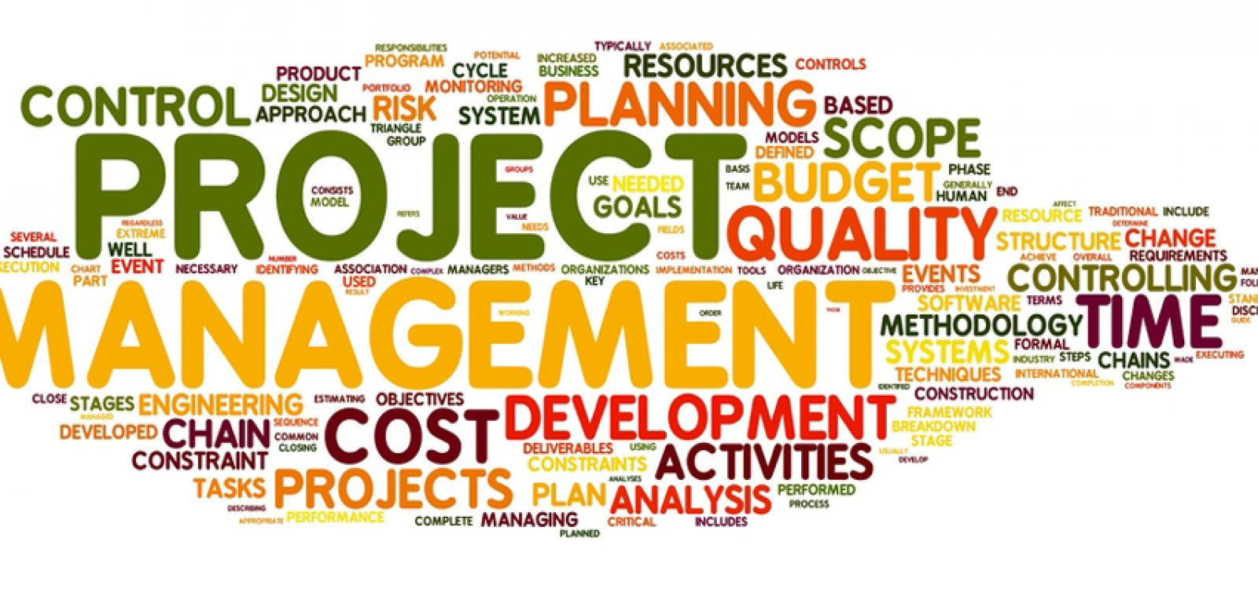

**Date Submitted: 10/31/21**

**Overview:** This project will be used by Humana that will allow them to have a log of who does what on each individual system and project that they have. This will mainly be used by the software development team there that will allow them to log into the program depending on their status that will decide what they can and cannot do. Most of the functionally will come from the software dev team to add in what they did to each project with a specific amount of time that they have. It will allow the project manager to see who has completed and what their team has done over the given specific amount of time or even what has happened in the total lifetime of the project.

**10 questions to ask for the project**

1. The open-source part of our project is not really going to be up to us. This will not be public knowledge after we give it to Humana, but for the mean time it will be because it fits the requirements right now. The requirements can use, be able to study, be able to redistribute, and to improve. Right now, we are able to improve it, be able to study it, be able to use it, and be able to redistribute it. We currently own the code, but when we give it to Humana, they will have it in their private database that only they have access to. Currently it is open to the public via GitHub, but that will be made private when it comes to the end of the project.
2. The strength of the community is strong. Humana is an enormous company with many teams of developers/engineers. So, if any bugs or errors arise within the software their teams will be able to respond quickly and fix them. Secondly, Conner, Chad, and Harris are the team developing this software so three eyes looking at the code will help ensure that no major errors or bugs make it into production/deployment.
3. The project will be very easy to use between all of the users. Everyone will have their own login and there will be a page that will show them what they can and can’t do. The program will be very easy to use to everyone since it is almost click and type while the backend of the code does 75% of the work.
4. We’re in the part of the process where our team has already agreed to terms & conditions with company. Asking for commercial support in the midst of things just doesn’t seem to benefit neither of the parties. However, if we had laid our working capacity before agreeing to terms, answer might’ve been different then what it is at the current state. As Commercial support is something businesses offer on daily basis for projects to meet business requirement, we would’ve gotten the commercial support before agreeing to terms and conditions. As this project is our client’s requirement, we can acquire a commercial support
5. The quality assurance processes that exist are unit testing. Unit testing is essential in debugging code, resolving future problems, and making sure all instances of bad code will be resolved before the software is deployed to a sponsor or client. After the software is handed to the sponsor, they might preform unit testing of their own and also perform routine quality assurance patches/updates monthly, quality or yearly.
6. The documentation will be very detailed and will be very organized since it will be made by the programmers and the people who help create the program. There will be a very big documentation that shows who can do what and what each different type of user can do. There will be a document that will show what all of the variables will do and what are named and what they control. There will also be a page that will show them what the login page is and what everyone’s login information is as well. Lastly there will be a page that gives a demonstration of what the login and what the main system looks like.
7. The admin dashboard/portal allows for easy customization of the entire system. Admins can change everything within the software. Also, the source code of this project will be given to our sponsor so their developers/engineers can customize, tweak, and change the software as much as they want. Finally, our team will leave plenty of comments throughout the code so that it is easy to read and everyone knows what each line of code is doing
8. Project is governed very loosely up until we launch our first prototype for the company and testers. Once the testers and company have the software in hand to explore, Initial testing will give us some solid feedback to work on bugs or features and moving forward from that point on, software will be governed. In a team, it’s never really easy to influence a software development as there maybe many conflicts or different ideas clashing. Our team was given a specific set of data and we need to use that data/requirement to build our project. You can influence a feature’s design at best but can’t change its direction as to what it does and to what extent
9. As I mentioned in my previous answer, we’ve been given a specific set of data and we’re using that to develop our project. There might be some conflicts in resources we have at our disposal that might limit some features in our project but it’ll be very close to what was required. We plan to follow the directions of the company that were provided to us. Project could lack some features as it may exceed what we can build but everything seems to be simple to develop.
10. Security patches will depend on how the testing goes. The way we will develop it, our software will only require a few security patches if necessary. We’re fetching information from a certified company not a database from web which would’ve increased our changes of security threats.

**Break down of individual contributions:**

Chad: will be dealing all the documentation and getting all of the project management organized. Will also deal with everything that involves users and processes. Also, I will be dealing with most of the user characteristics, the constraints, assumptions, and dependencies. I will also deal with all the memory constraints

Harris: Will oversee helping conner and myself by helping conner code and by helping me do some of the documentation. Will be dealing with all the operations and the side adaptation requirements, will also be dealing with all the memory constraints and with the communication interfaces

Conner: Will be dealing with the System Interfaces, Hardware interfaces, Software interface, and User interface. Conner will be dealing with most of the web-based application and that connects them together. He will also be dealing with all of the data connection between databases and our program.

**Key personnel for this project are:**

Chad: the team leader who also is making a giant list of all our functions and characteristics. I will also oversee all the documentation of the projects and speaking with the sponsor.

Harris: will be teaming up with Conner and getting all the angular and web base set up so we can have a running version of our program. Will also be doing some of the documentation.

Conner: will be the main programmer and he will be getting all the web-based items set up and connecting everything together.

Hollie: The sponsor. She is the employee at Humana that has given us the project and she has been speaking with Chad a lot about the specifics of the data and types.