|  |  |
| --- | --- |
|  | Software Detailed Design |
|  |  |
|  | Bryce Winnecke, Drew Yellina, Jakob Markland  [Course title] |

**Data Design**

So, we will have two different types of users, admins, and members the admins will be able to see different views of the website that the members will not be able to see. They will be able to pull up a search component that will allow them to search the database for different members in case they need to contact them in any way or need to pull any information about that user. New users will be able to fill out a form and submit it for review and it will send the admin an email saying that someone is interested in becoming a member.

**Architecture Design**

There will be different tabs like information, user info, join the club, gallery, calendar, and contact info. For each of these tabs there will be different routes for each of these pages that will come up the same headings that will still display the same tabs at the top along with the headings and just display new information in the general view. Members will not be able to see tabs that admins will be able to see like being able to search for members through the database or being able to see the forms that new members submit to join the club. If you are not a member you will still be able to see the same views that members will be able to see the only people that will be logging in are the admins to be able to manage the website and members.

**Interface Design**

The information tab will display information like the address and different information of the ranking members of the club and who is in charge and so on. The user info tab will show the users information that we have on file like phone number, email, etc. The join the club tab will allow the user to input their information and submit the form and a notification will be sent to the admins and after they review their application they will have to go into the club to be sworn in and pay their dues. The gallery tab will have pictures of what the club looks like on the inside and the outside of the club for new users to be able to see what the business has to offer. The calendar tab will have two different views one that shows what events they have coming up in the coming weeks and another to show what events their will be in the future. The contact info tab will show different ways to get in contact with the people who oversee the club for any questions or concerns related to the business.

**Procedural Design**

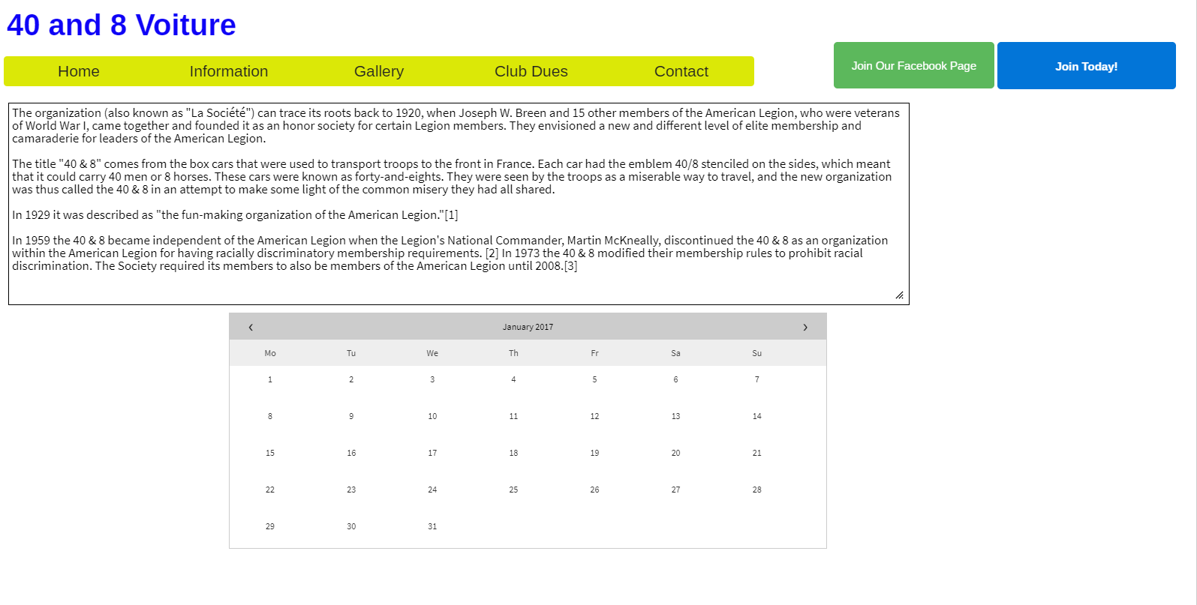

**Individual Contributions**

**Drew Yellina – Team Lead**

Contributed to the Data Design and Procedural Graphic

**Jakob Markland - Developer**

Contributed to Architecture design

**Bryce Winnecke – Developer**

Contributed to interface design