|  |  |
| --- | --- |
|  | Software Architecture Specification |
|  |  |
|  | Bryce Winnecke, Drew Yellina, Jakob Markland |

**Software Architecture Specification**

**Overview**

We will be designing a website for the 40&8 club and it will be hosted using Digital Ocean and Angular. We will be hosting the data for users and members using MongoDB. This will make it easier for people to apply for membership, enter raffles, or find more information about the organization.

**Subsystem Decomposition**

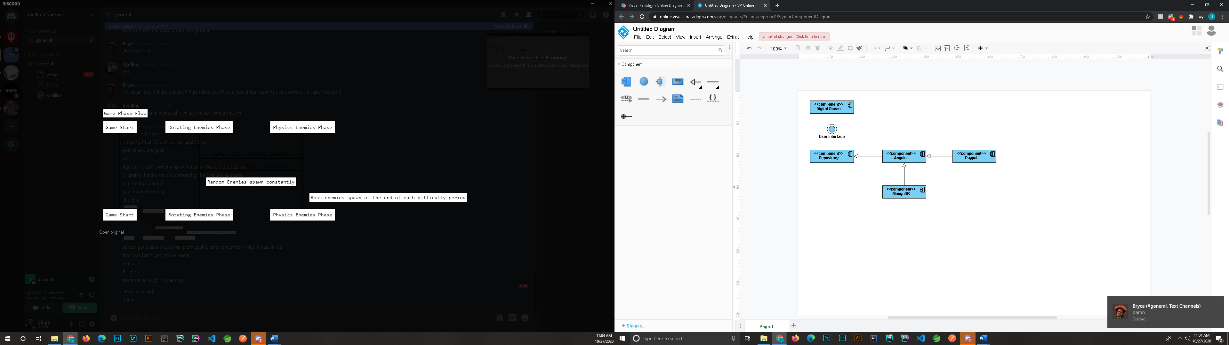

**Digital Ocean**

Digital Ocean will host the website from our Repository. As the repository is updated, Digital Ocean will redeploy automatically to the latest changes. This can be accessed remotely by anyone with access to the repository.

**Repository**

Our repository will be hosted onto GitHub. This will allow anyone with access to the repository to make changes to the website and access this remotely. Allowing anyone to access the source code remotely will make it easier in the future for maintaining and updating any new changes quickly and efficiently.

**Angular**

Our User Interface will be built using the Angular Library. This will contain HTML, TypeScript, and CSS. This will allow us to quickly and effectively deliver a professional looking Enterprise Grade website. The Angular library contains components that will allow us to quickly add HTML components with many dynamic elements. Any parts of the User Interface that is displayed using Data that is stored will come from a database.

**MongoDB**

Our data will be hosted on a database using MongoDB. This will allow us to quickly add new members and get important user information. This will also allow the UI to dynamically operate according to what a user wants to know or for a developer to quickly get information.

**PayPal**

Members will be paying for membership via PayPal. We will be using this to make transactions much more simply for them and allow anyone to apply for membership anywhere. This will also make it convenient for members without cash to enter raffles via credit card payment through PayPal.

**Hardware & Software Mapping**

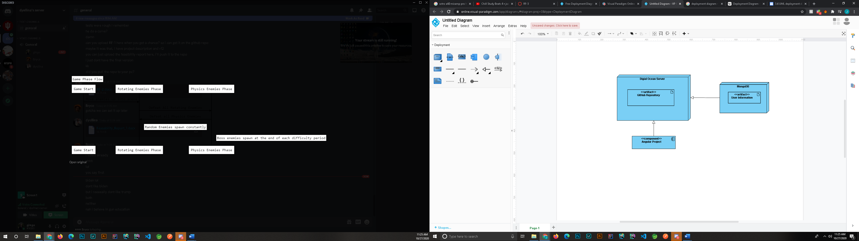

**Persistent Data Management**

**Database Design**

|  |
| --- |
| **Users** |
| **Name** |
| **Email** |
| **Phone Number** |
| **Address** |
| **City** |
| **State** |
| **Zip Code** |
| **Date Joined** |
| **Last Payment** |

**Access Control**

**User**

A user will have the ability to go in and update their Name, Email, Phone Number, Address, City, State, and Zip Code. This is so if a user has any of that information change in the future, they can quickly go in and change it.

**Administrator**

An administrator will have the ability to go in and update any of this information in the database. This will allow for quick update of any user’s information that does not want to update their information on their own.

**Global Software Control**

**Boundary Conditions**

The system will be able to be started, initialized, and shutdown remotely by anyone with access to the Digital Ocean server. This server, if any errors are found or exceptions are caught, it will display them within the console in Digital Ocean. This will allow the developer easy access to what the issue is. The only efforts I would see necessary as far as upkeep would be upgrading Angular Versions. When a new version of Angular is deployed a developer or someone who has the knowledge how, would go in and upgrade the angular project in the repository. This would then be deployed to the Digital Ocean server once a pull request has been completed. I would not see any issue with us having to migrate servers ever. This is because all our content will be hosted on the Cloud.

**Individual Contributions**

**Drew Yellina – Team Lead**

Contributed to the Overview and the Global Software Control

**Jakob Markland - Developer**

Contributed to Hardware and Software Mapping, Access Control, and Boundary Conditions

**Bryce Winnecke – Developer**

Contributed to Subsystem Decomposition and Persistent Data Management

**Key Personnel Information**

Meeting with sponsor at 5:30 on 10/30/2020 to discuss further information.