Test Summary Report

Contents

1. Purpose 2

2. Application Overview 2

3. Testing Scope 2

4. Metrics 3

5. Types of testing performed 3

6. Test Environment & Tools 4

7. Lessons Learnt 4

8. Recommendations 4

9. Best Practices 5

10. Exit Criteria 5

11. Conclusion/Sign Off 5

# Purpose

This document explains the various activities performed as part of testing of the No Kill Louisville website implemented by team NoKill.

# Application Overview

The No Kill Louisville website is intended for use by the volunteers and customers of the No Kill Louisville pet food bank. The new site allows the food bank customers to register, submit documentation, and schedule appointments online. The No Kill administrators and volunteers can access customer information that is stored in the database, manage customer appointments, and record outgoing donations. The new system also includes a customer mobile check-in system which will send check-in information to a tablet located inside the distribution center

# Testing Scope

**a) In Scope**

* Pages display complete and accurate information
* Customers can check-in on mobile devices
* Security is monitored and regularly updated
* UI is responsive and easy to use
* Site functions on most popular web browsers and mobile devices
* Admins can upload and edit client information/events/shop items **b) Out of Scope**
* Payment methods will need to be setup by the client

**c) Items not tested**

• Currently, database testing is incomplete.

# Metrics

**d) No. of test cases planned vs executed**

|  |  |  |  |
| --- | --- | --- | --- |
| **Test cases planned** | **Test cases**  **executed** | **TCs Pass** | **Tcs Failed** |
| 26 | 22 | 22 | 0 |

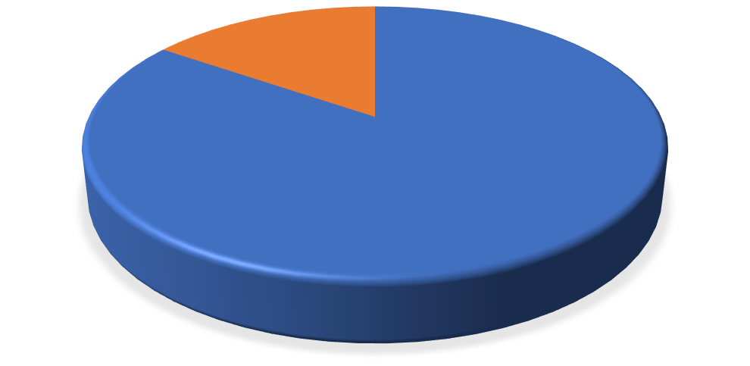

**Executed**

**,**

**85**

**%**

**Planned**

**,**

**15**

**%**

**TC PLANNED VS EXECUTED**

**d) No. of test cases passed/failed**

All tests were repeated until passed.

# Types of testing performed

1. **Security Testing**

• This testing was done to ensure that security is up-to-date and will be automatically updated during the site’s lifetime through WordPress

1. **System Integration Testing** 
   * This testing was done to verify the entire application works as per the requirements.
   * Critical business scenarios were tested to make sure important functionalities in the application works as intended without any errors.
2. **Regression Testing** 
   * Regression testing was performed each time a new feature was added to the site.
   * Regression Testing is being performed continuously during development
   * This testing ensures that existing functionalities work after defect fix and new enhancements are added to the existing application.
   * Test cases for new functionalities are added to the existing test cases and executed.

# Test Environment & Tools

Application URL: <https://capstonenokill.com/>

Most testing was performed through the application, with some tests being done on individual local instances.

# Lessons Learnt

Building an application for the use of a real-world client demands thorough testing. The team had to consider all levels of tech literacy and make decisions that would accommodate the client and their customers. Since the website will not be maintained by the implementation team in the future, we had to ensure that all possible vulnerabilities and defects were corrected.

# Recommendations

* Admin should keep all plugins up to date to ensure site continues to function well.
* Admin should train volunteers in proper use of the site dashboard to ensure that new defects are not introduced.

# Best Practices

* Testing plugins in a local environment before implementing in the live site provided a safe way to explore different alternatives.
* Allowing useful plugins to auto update ensured that we are working with current tools.
* Deleting unused plugins and keeping security rules updated ensured that the site’s security is tight.

# Exit Criteria

1. All test cases should be executed – **Yes**
2. All defects in Critical, Major, Medium severity should be verified and closed – **Yes**.
3. Any open defects in trivial severity – **Action plan prepared with expected dates of closure.**

# Conclusion/Sign Off

As the exit criteria was met and satisfied as mentioned in Section 10, this application is

suggested to ‘Go Live’ by the testing/development team. Further testing will be required during the client hand-off to confirm that all requirements have been satisfied.

Submitted by: Amanda Schneider, Jon Clements, Jeffery Becker