Ben Szabo, Kham Mangar, Walker Bolen

E-Commerce Website

***CHICKEN DIPPERS***

2. Proposed software architecture

**1.1. Overview:**

The product is an online store built for Kham Mangar’s sister. Their aunts and uncle have been sewing handmade masks and sending them to Kham’s sister to sell. This will enable her to have her own online storefront getting her product out in the world with ease. E-commerce is the buying and selling of goods and services over the internet. E-commerce can be a substitute for brick-and-mortar stores, though some businesses choose to maintain both. Almost anything can be purchased through e-commerce today. This will be an HTML and CSS site hosted by Azure with custom domain.

**1.2. Subsystem decomposition** – Identify the subsystems and the responsibilities of each. You should use component diagrams.

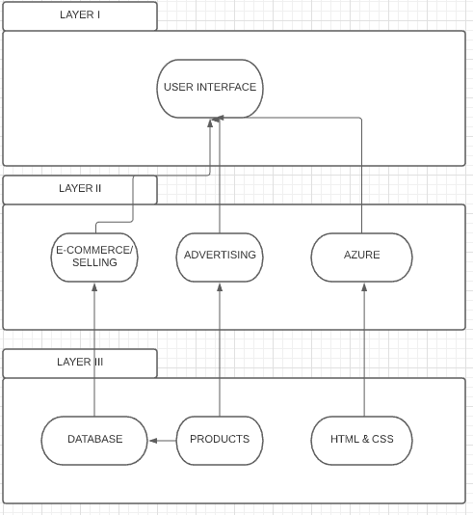

**1.3. Hardware/software mapping** – How will subsystems be assigned to hardware? You should use deployment diagrams.

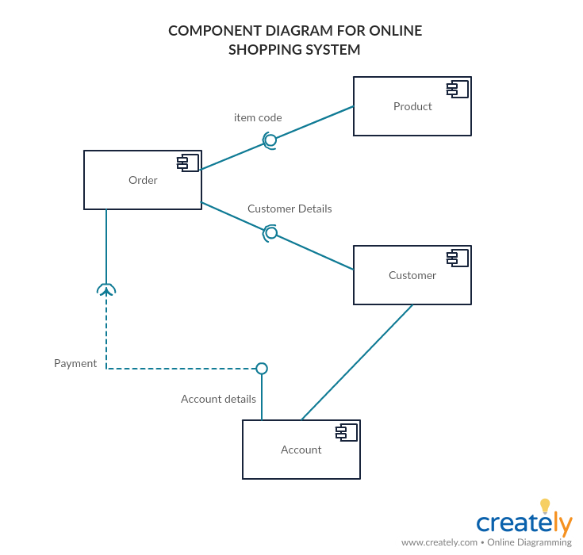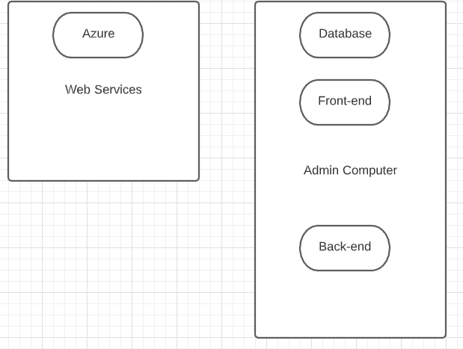

**1.4. Persistent data management** – **Identify the data which will be persistent. Describe the file system or database to be used, including a complete database design.**

Persistent data will be store’s inventory including image, price, and description. It will all be stored in a single mongoDB table coexisting with a table to store specified user items for cart and checkout.

**1.5. Access control and security – For each different actor (user, system administrator, etc.) describe the operations they will be enabled to use. Describe authentication and security provisions.**

Users will be able to browse items and add to cart, followed by checking out with PayPal, which has its own security set up.

System admin will simply be able to control inventory and webpage items secured by the codes repository.

**1.6. Global software control** – Describe the control flow (e.g. procedural, event-driven, threaded). Procedural control flows should be described using activity diagrams. Event-driven flows are best described using sequence and state diagrams (use UML diagram standards).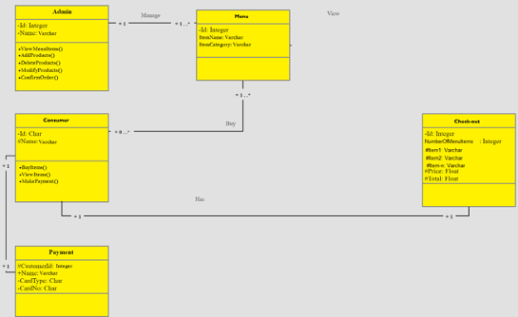

**1.7. Boundary conditions** – describe how the system will be started up, initialized and shut down. How will it respond to errors and exceptions? Any daily/weekly/monthly/yearly efforts necessary? All organizations buy new computers every 3-4 years, how to migrate to new server? Be able to bulk dump all data to file and bulk load all data from same file.

The system will be running in the web hosting service and the customer will be able to get started by going to the website. It will be optional to login once you land on the page but login will be required in the checkout process or you can checkout as a guest. The users will be initialized once they login and shut down once they logout or after a period of time. It will handle errors by giving the related http status code. Mitigation would be easy since the admin would have their user account and be able to login using that.

Regardless of the techniques being used, we can say that any system can be said to be

composed of nine basic component types:

- Use Cases

- Functions

- Triggers

- Data Stores

- Data Flows

- Data Elements

- Processors

- Data Storage

- Data Connections

- Actors/External Entities

3. Breakdown of Individual Contributions

· Team Lead: Kham Mangar

· Front-end Programmers: Ben Szabo and Kham Mangar

· Back-end programmers: Walker Bowen and Kham Mangar

· Functions researcher: Everyone

· Docs: Everyone

· Information Gathering: Kham Mangar

4. Key Personnel Information:

· Each person is putting in at least 3-4+ hours a week working on the reports and attending our scheduled meeting on Sundays. We are using Sundays because it is the time that everyone is available to meet. During these meetings, we sit and talk about the reports due and work our way through brainstorming ideas. This is were we discuss what needs to be done in the following week to report in the next meeting.

· Biographies:

o **Ben Szabo:** Computer Science Major working for UPS as a CO-OP and waiting tables at a Japanese restaurant. At UPS I mainly write test automation using java and selenium as well as citrus. The tests I’ve written cover anything from UI to API testing for blackbox as well as end to end testing. I’m going to be moving to application development within UPS to work on a middleware application that resolves communication issues between other applications.

o **Kham Mangar:** I am a Bhutnese Refugee and now a U.S citizen, hopefully graduating this spring of 2021. I am currently looking for intership/co-op/part-time work related to computer science field. I am also interested in serving my community through the IT sector in the national guard. Also want to further my education.

o **Walker Bolen:** I am currently going to school and working full time at American Commercial Barge Line. I work on the ServiceDesk and training to transition to the Microsoft PowerBi team here shortly. I have interest in working in databases and working with the general people. If theres something new and cool to learn I hop on it. I wish I had more freetime to broaden my knowledge but at this point work and school is where I learn new skills.