Ben Szabo, Kham Mangar, Walker Bolen

E-Commerce Website

***CHICKEN DIPPERS***

2. **Data Design**- **Walker**

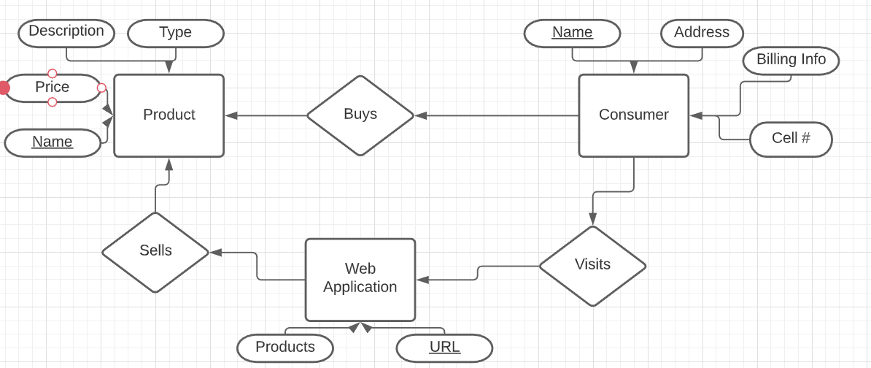

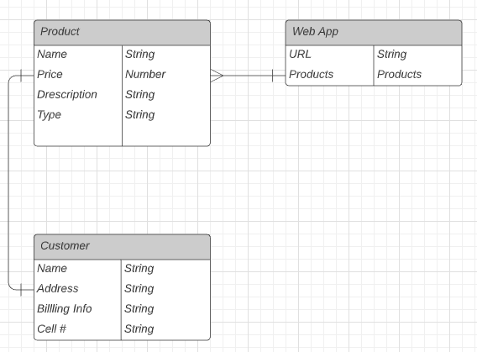

3. Architecture Design-

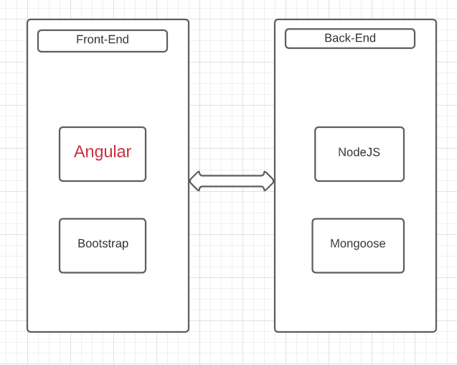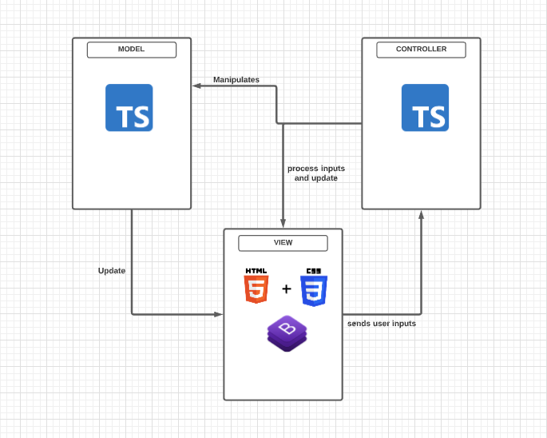

4. Interface Design-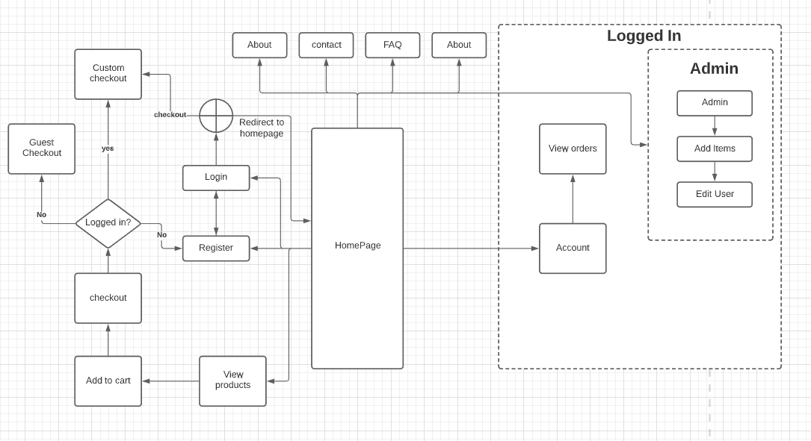

5. Procedural Design-

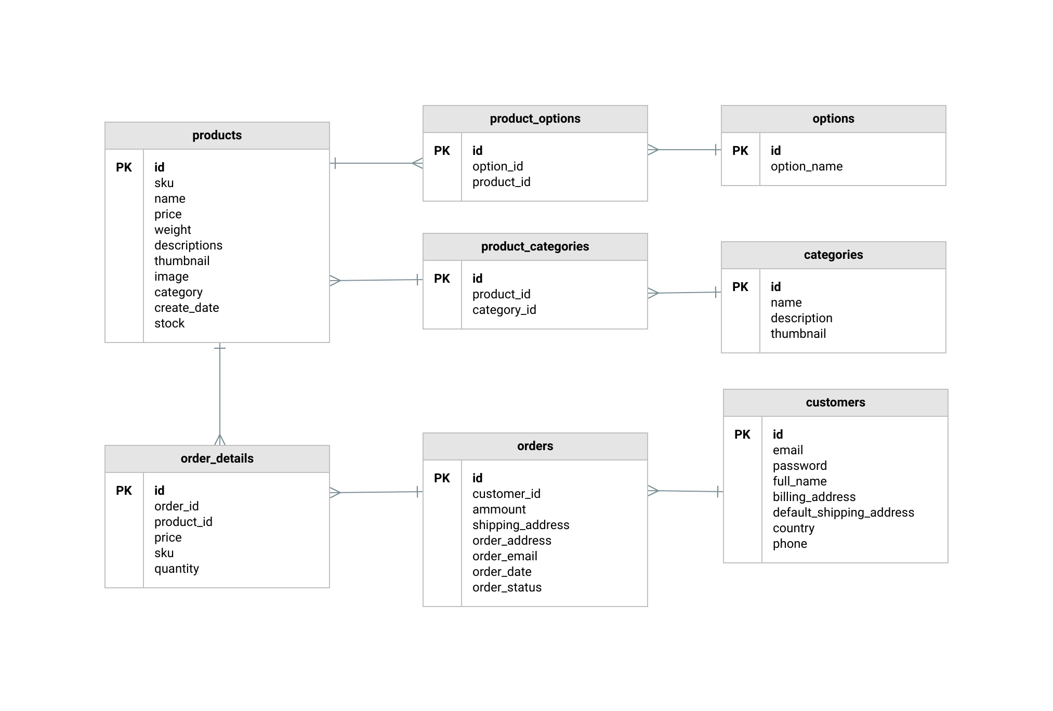

6.  **Breakdown of Individual Contributions**

· Team Lead: Kham Mangar

· Front-end Programmers: Ben Szabo and Kham Mangar

· Back-end programmers: Walker Bowen and Kham Mangar

. Database: Walker Bolen

· Functions researcher: Everyone

· Docs: Everyone

· Information Gathering: Kham Mangar

7. **Key Personnel Information:**

· Each person is putting in at least 3-4+ hours a week working on the reports and attending our scheduled meeting on Sundays. We are using Sundays because it is the time that everyone is available to meet. During these meetings, we sit and talk about the reports due and work our way through brainstorming ideas. This is where we discuss what needs to be done in the following week to report in the next meeting.

· Biographies:

o **Ben Szabo:** Computer Science Major working for UPS as a CO-OP and waiting tables at a Japanese restaurant. At UPS I mainly write test automation using java and Selenium as well as Citrus with Spring Boot. The tests I’ve written cover anything from UI to API testing for blackbox as well as end to end testing. I’m going to be moving to application development within UPS to work on a middleware application that resolves communication issues between other applications.

o **Kham Mangar:** I am a Bhutnese Refugee and now a U.S citizen, hopefully graduating this spring of 2021. I am currently looking for internship/co-op/part-time work related to the computer science field. I am also interested in serving my community through the IT sector in the national guard. Also want to further my education.

o **Walker Bolen:** I am currently going to school and working full time at American Commercial Barge Line. I work on the ServiceDesk and training to transition to the Microsoft PowerBi team here shortly. I have interest in working in databases and working with the general people. If there's something new and cool to learn I hop on it. I wish I had more freetime to broaden my knowledge but at this point work and school is where I learn new skills.