**Feasibility Report**

You should provide a feasibility report in the following format:

1. **Product:** A general statement of the product; give a brief description of what the proposed system will do, highlighting where the proposed system meets the specified business requirements of the organization.

The product is an online store built for Kham Mangar’s sister. Their aunts and uncle have been sewing handmade masks and sending them to Kham’s sister to sell. This will enable her to have her own online storefront getting her product out in the world with ease. It also gives us students an option to use as a template for our own online store in order to make money in these trying times.

1. **Technical Feasibility:** Will the proposed system perform to the required specification? Outline technical systems options you propose to use, which will give a technical solution satisfying the requirements and constraints of the system, as outlined in the terms of reference.

The main required specification falls under payment. Being able to implement the shopping cart and having a secure checkout is whats required for any online business. This online store will have the support of PayPal which will perform a safe and secure checkout option for customers, allowing them to use their PayPal account for quick and easy payment or even simple credit card payments. For the chosen items to stay in the shopping cart for the customer, we will either use browser sessions if using CSS and HTML, or even google sheets if an Angular application seems more feasible.

1. **Social Feasibility:** Consideration of whether the proposed system would prove acceptable to the people who would be affected by its introduction. Describe the effect on users from the introduction of the new system; consider whether there will be a need for retraining the workforce. Will there be a need for relocation of some of the workforce? Will some jobs become deskilled? Will the current workforce be able to perform effectively any new tasks introduced by the proposed system? Describe how you propose to ensure user co-operation before changes are introduced.

The proposed system is something that is already used every day by almost everyone. Especially with COVID going on, people will easily feel more safe choosing an online store option rather than in person. Providing masks that help prevent the spread of the virus is another thing to add in regards to helping people feel safe, which has already been proven to be accepted by many. With online stores like Amazon, there will be no need for restrain, relocation, or even job deskilling of the current workforce as things are already greatly affected and pivoted to fit and work with the abundance of today’s online retailers. We will aim at emphasizing handmade and family-owned which will help ensure user co-operation.

1. **Economic Feasibility:** Consider the cost/benefits of the proposed system. Detail the costs that will be incurred by the organization adopting the new system; consider development costs and running costs. Detail benefits that the new system will bring, direct economic benefits such as reduced costs, and indirect benefits, such as improved management information and better customer service. Illustrate the cost/benefit of the new system by applying a suitable cost/benefit analysis method such as the payback method.

On average it cost around $200 to build a website with an ongoing cost of around $50 per month to maintain it. 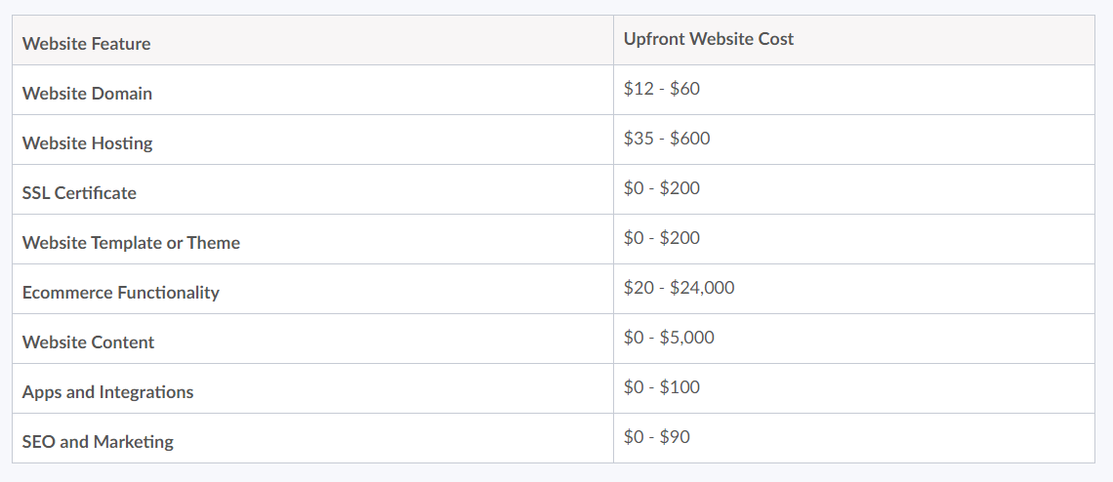

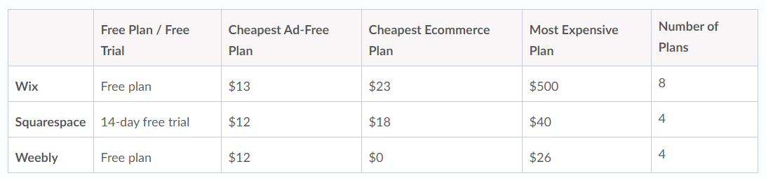

6

12

The benefit of the new system will be that we will not have to pay monthly subscription for building our website. Instead we can use our framework or template to create e-comerce website for others if we do freelance job or work doing it.

It will take us 2 semester to get this project done which is about 10 months. To run the website for 10 months at the cheapest price would be $12 *10 = ($120) + Hosting. After the 10 months is up we only have to pay for hosting and SSL which range from $2.75(blue hosting) - $60(Digital ocen GP droplet)

1. **Market Research:** A comprehensive market research identifying a need for the product. Detail all market research you carried out, listing sources of information. Justify any conclusions you have drawn from your research. Identify the potential customer base for your product, together with evidence of customer need for the product. Describe how you propose to compete with similar products on the market.

According to the articles below I concluded that because 89% of U.S adults use internet, having an online website will increase customer base. Also because of the pandemeic people have relized that it’s more efficient to go virtual than brick and mortar to decrease costs. The customer base for our product is someone that is environmental frendily and supports the small business and community, and as well as want a high quality one of a kind product. Right now we are focusing on face mask but we will go into more fashion clothing like pants, upper garment, coats, etc.. we will be more Eco-friendly than our counter parts because we are smaller than Amazon and use less footprint than them. The customer needs are to find a good quality product and a brand they can trust on. We will compete with similar products on the market by marketing and spreading the word out in the community.

<https://www.bluecorona.com/blog/do-i-need-a-website/>

<https://www.wsj.com/articles/coronavirus-pandemic-widens-divide-between-online-traditional-businesses-11585733402>

<https://www.washingtonpost.com/technology/2020/06/22/small-business-tech-pandemic/>

<https://www.uschamber.com/co/good-company/launch-pad/how-local-stores-are-moving-to-selling-online>

<https://www.mic.com/p/amazons-carbon-footprint-goes-beyond-shipping-millions-of-prime-packages-18739965>

1. **Alternative Solution:** Consideration of alternative solutions should be documented. At least two alternative business or technical systems options should be considered. Detail the differences between these options and the proposed system. Justify your choice of the proposed system and the reasons for rejecting the alternative options.
   1. Alternative solutions would be to sell more than just masks and clothing iteams such as other crafty items.This site could be utilized for the storefront for anything that is legal to sell. Another business idea would be to sell services instead of products. We could use this site to sell our services to make websites. These differ from our proposed idea because Kham’s sister will be using the site to sell masks and some clothing items made by family. These alternative ideas are different in a lot of ways but can utilize the site the same way.
2. **Project Risks:** To have success in managing a software project, the project manager needs to understand the nature of software risks, which can be defined as uncertain events or conditions that, if they occurs, can have a negative effect on a project outcome. List and discuss some the risks associated with this project.
   1. At this point, all of th **Security and Privacy:** The main issue that could come about with this project would be the secureness of the payments. Using Paypal is a safe option due to its built in security but if users want the products and don’t have Paypal they will be up the creek without a paddle.Protecting peoples credit card information is the most important part of the whole website. People need to trust that their information is safe.
   2. **Changing of products:** Depending on integration of the site, if the sponsor wants to change the products all the time it could be a hassell.
   3. **Reliability:** We need to make sure that the site can handle multiple orders coming in at the same time so it doesn’t not break anything
   4. **Infringment on trademarks or patents:** Make sure products made and sold do not infringe on any trademarks or patents. Such as logos and other designs

e planning (personnel and time frame) for the project has been done and if the feasibility study has shown that the project is likely to succeed within its constraints, then it only remains for us to start the requirements analysis and thus proceed with the project.