**MOCK TEST 02**

**LISTENING**

**PART 1 : QUESTIONS 1-10**

**Questions 1-7**

*Complete the form below.*

*Write****NO MORE THAN THREE WORDS AND/OR A NUMBER****for each answer.*

|  |  |
| --- | --- |
| **Details of Order** | |
| Party Host | **Example:** Customer's ***oldest daughter*** |
| Occasion | 18th birthday |
| Number of Guests Invited | **1** |
| Customer Budget | **2**  £800 |
| Marquee Size | **3** X 9 metres |
| **4**  Cost | £450 |
| **5** | £150 |
| Lighting Cost | approximately ₤**6** |
| Number of Guests | seated 30 / standing 50 |
| Furniture Cost | per table £4.00 / per chair £3.00 |
| Dates Marquee Required | Set-up date **7**   To be taken down on June 7th |

**Questions 8-10**

*Complete the form below.*

*Write****NO MORE THAN TWO WORDS AND/OR A NUMBER****for each answer.*

|  |  |
| --- | --- |
| **Customer Details** | |
| **Name** | **8** |
| **Postcode** | **9** |
| **Contact Number** | **10** |

**PART 2 : QUESTIONS 11-20**

**Questions 11-15**

*Label the map below of a typical medieval castle.*

*Write the correct letter,****A-G****, next to****questions 11-15****.*

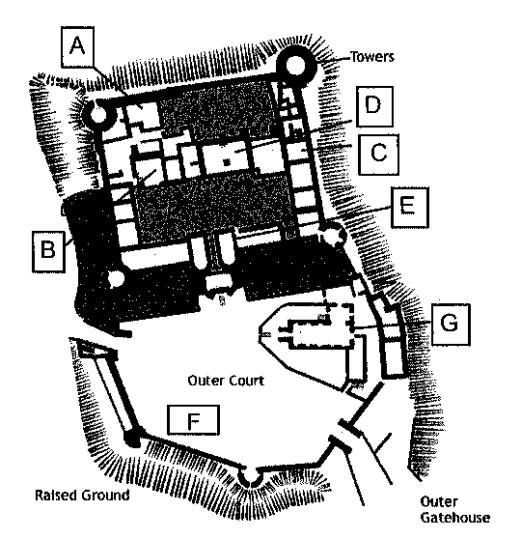

**11**  Chapel

**12**  Great Hall

**13**  Great Chambers

**14**  Bakehouse

**15**  Stables

**Questions 16-20**

*Choose the correct letter,****A, B****or****C.***

**16**

Medieval castles

* **A** shared a common design.
* **B** were each unique.
* **C** had the same methods of fortification in common.

**17**

The early medieval Keep served as

* **A** a prison and fortified tower.
* **B** a fortified tower and living area.
* **C** a fortified entrance to the inner castle area.

**18**

In later medieval castles, the Keep

* **A** evolved into a set of different buildings.
* **B** was used purely for accommodation.
* **C** played a less significant role in the castle's domestic life.

**19**

Underground dungeons were built in response to

* **A** a shift in the medieval belief system.
* **B** the Keep being no longer used for prisoners.
* **C** a call for harsher treatment of prisoners.

**20**

The least effective line of defence was

* **A** the portcullis.
* **B** the drawbridge.
* **C** the barbican.

**PART 3 : QUESTIONS 21-30**

**Questions 21-25**

*Choose the correct letter,****A, B****or****C.***

**21**

Julie and Dave thought the lecture

* **A** gave a new insight into Shakespeare's style.
* **B** offered a thought-provoking view on Shakespeare and his work.
* **C** explained Shakespeare's belief in ghosts.

**22**

Hamlet was a play

* **A** which reflected popular belief in the supernatural.
* **B** that recorded historical events.
* **C** seemingly in conflict with accepted beliefs.

**23**

In the time of James I

* **A** a belief in ghosts was not tolerated.
* **B** more people believed in ghosts.
* **C** certain religious beliefs were not acceptable.

**24**

Shakespeare introduced ghosts into plays

* **A** because he believed in a spirit world.
* **B** as a theatrical device.
* **C** to provoke religious debate.

**25**

Shakespeare's audience would probably have

* **A** secretly approved of a supernatural content in plays.
* **B** shown approval for plays with a supernatural content.
* **C** disapproved of the inclusion of ghosts in plays.

**Questions 26-30**

What does Julie say about the following subjects?

*Write the correct letter,****A, B****or****C****, next to****questions 26-30****.*

|  |  |
| --- | --- |
| **A** | cornful, dismissive |
| **B** | open-minded |
| **C** | believing |

**26**  witches / astrology

**27**  ghosts

**28**  UFOs/aliens

**29**  premonitions

**30**  telepathy

**PART 4 : QUESTIONS 31-40**

**Questions 31-35**

*Complete the notes below.*

*Write****NO MORE THAN THREE WORDS****for each answer.*

|  |
| --- |
| Darwin is credited with having **31**  popular beliefs about Man's creation. However, Alfred Russell Wallace simultaneously came up with an **32**  to Darwin. Unfortunately for Wallace, Darwin seems to have been given the **33**  for the theory of evolution. Darwin's theory **34** , upsetting the religious authorities of his time. Today, it is often accepted that Man is a product **35**  and not spontaneous creation. |

**Questions 36-40**

*Complete the sentences below.*

*Write****NO MORE THAN TWO WORDS****for each answer.*

The absence of a **36**  might be seen by some to discredit Darwin's theory.

Finding an evolutionary bridge between Man and ape would provide undeniable **37**  the theory of evolution.

When **38**  of the Piltdown Man was first unearthed in 1908, it seemed Darwin's theory was no longer in doubt.

In fact, the hoax proved **39**  that scientists and the Press alike believed in its validity.

After 40 years, Piltdown Man **40**  as being no more than a fake.