**ACL004 LISTENING**

**Part 1**

**Questions 1-8**

*Fill in the details missing from the quotation form below.*

*Write****NO MORE THAN TWO WORDS AND/OR A NUMBER****for each answer.*

|  |
| --- |
| **MONTERRAY SHIPPING**  *Customer Quotation Form* |
| Destination Country: ***Canada****(Example)*  Name: Marco   Collection Address: 25   Town: Grimsby  Postcode:   https://ieltsonlinetests.com/sites/default/files/2019-04/Upgrade%20ielts%20test%201%20-%203-9.jpg  Size of Container:  Height:   Length:   Width:   Contents:  television    sofa bed    Total Estimated Value: £5,000 |

**Questions 9-10**

*Choose the correct letter,****A, B****or****C.***

**9. How is Marco going to pay the cost of shipping?**

**A**using his parents’ credit card

**B**his sister’s bank account will be debited directly

**C**by charging it to his sister’s credit card

**10. What type of visa will Marco have when he enters Canada?**

**A**a 12-month work-sponsored visa

**B**a 60-day working-holiday visa

**C**a visa that expires after one year

**Part 2**

**Questions 11-18**

*Label the map below with the names of the different areas of the zoo.*

*Write****NO MORE THAN THREE WORDS****for each answer.*

*You need****NOT****write the word ' enclosure' on your labels, the name of the animal itself is sufficient.*

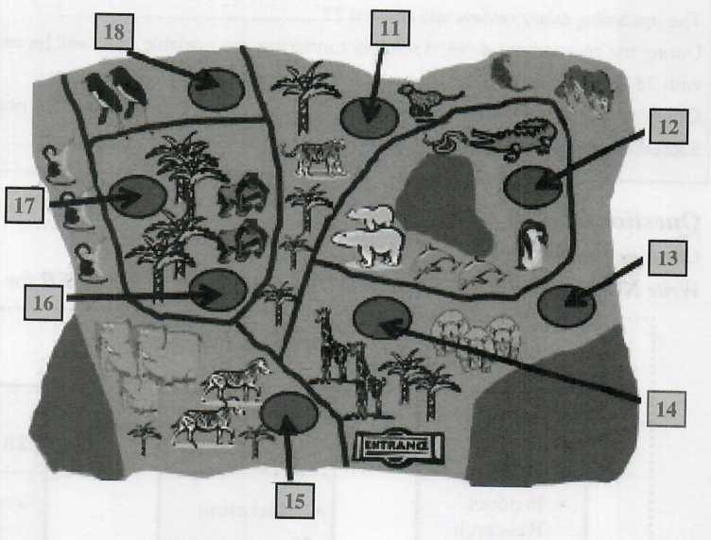

















**Questions 19-20**

*Choose the correct letter,****A, B****or****C.***

**19. What is not covered by the voucher?**

**A**train ride

**B**meal

**C**drink

**20. Which of the following statements is accurate?**

**A**Tour group members can receive 20% off purchases under £40.

**B**Season tickets are being offered at a discount of 20%.

**C**A 10% discount is offered on purchases below £40 in value.

**Part 3**

**Questions 21-25**

*Complete the sentences below.*

*Write****NO MORE THAN TWO WORDS AND/OR A NUMBER****for each answer.*

There will be no  only voluntary ones.

The upcoming salary review will reward 

During the recruitment drive, if suitable candidates are available, they will be recruited internally in accordance with 

Opportunities to get  will be arising in the not-too-distant future.

Successful candidates will have shown that they can manage  effectively.

**Questions 26-28**

*Complete the chart below.*

*Write****NO MORE THAN THREE WORDS AND/OR A NUMBER****for each answer.*

|  |  |  |  |  |
| --- | --- | --- | --- | --- |
| **Project Phases** | | | | |
| **Weeks 1-3** | long-arrow-right.png | **Weeks** | long-arrow-right.png | **Weeks** |
| - Product Research  - Prototype Testing | - Maketing   - Testing on Market Sample | - Product Launch |

**Questions 29-30**

*Complete the table below.*

*Write****NO MORE THAN TWO WORDS****for each answer.*

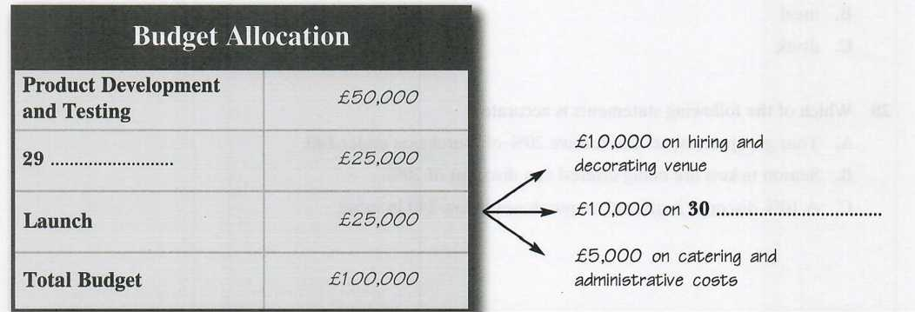





## Part 4

#### Questions 31-40

Answer the following questions.

Write ***NO MORE THAN THREE WORDS AND/OR A NUMBER*** for each answer.

- A bird’s three basic needs are the need for water, the  and the need for food.

- Cement Bowl’s Maximum Depth: 

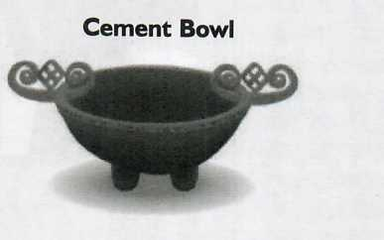

- Birds are prevented from accessing their natural food supply during winter when an ice- or frost-crust forms 

- If you start feeding birds from late autumn onwards, they will become accustomed to locating food in a  in your garden.

- If you don’t want to attract the unwanted attention of rodents, then your feeder should only be accessible from a 

- Suet is an advantageous bird food because not only is it nourishing, but it also doesn’t  during very cold spells.

- If boiled eggs or potatoes are used as  these should be finely chopped.

- Birdhouses should be painted a dull colour so that they blend in with their 

- Birds of the same  do not like to nest in close proximity to one another.

- Birdhouses are usually occupied from early  each year.

**ANSSWERS**

**Part 1: Question 1 - 10**

* **1**Cebrianatori
* **2**Grimsby Place
* **3**GB86BY
* **4**2 metres
* **5**3 metres
* **6**1.5 metre
* **7**home computer/fridge-freezer
* **8**fridge-freezer/home computer
* **9**C
* **10**C

**Part 2: Question 11 - 20**

* **11**Lion
* **12**Seal Pool
* **13**Arctic fox
* **14**Hippo
* **15**Petting Zoo
* **16**African hunting dog
* **17**Panda
* **18**Birds of prey
* **19**B
* **20**C

**Part 3: Question 21 - 30**

* **21**compulsory redundancies
* **22**top performers
* **23**company policy
* **24**a promotion/promoted
* **25**other members
* **26**4-6
* **27**Strategy
* **28**7-8
* **29**Marketing
* **30**promotional work

**Part 4: Question 31 - 40**

* **31**need for safety
* **32**6.5 centimetres
* **33**over the ground
* **34**certain spot
* **35**raised landing area
* **36**freeze
* **37**bird feed
* **38**surroundings
* **39**species
* **40**spring