**LISTENING**

**SECTION 1 : QUESTIONS 1-10**

**Questions 1-4**

*Choose the correct letter****A, B****or****C.***

**Example**

When will the New Year Party be held?

**A. December 29th**  
B. December 30th  
C. December 31st

**1**

The best place for holding the party is _______________

* **A** restaurant.
* **B** common room.
* **C** stadium.

**2**

How much does everyone should pay?

* **A** £15
* **B** £50
* **C** £15.50

**3**

How many days should they choose menu in advance?

* **A** a week
* **B** three days
* **C** seven working days

**4**

How much deposit should they pay in advance?

* **A** £70
* **B** £80
* **C** £90

**Questions 5-10**

*Complete the notes below.*

*Write****NO MORE THAN TWO WORDS****for each answer.*

|  |  |
| --- | --- |
| **ORDER MENU** | |
| **Appetizer** | Fruit juice  **5** |
| **6** | Roast dinner |
| **Vegetables** | Vegetable salad: carrot, tomato, patato, corn,  **7** , lettuce, cucumber |
| **8** | **9**   Mango pudding |
| **Drinks** | Coffee, **10** , Cola |

**SECTION 2 : QUESTIONS 11-20**

**Questions 11-13**

*Complete the notes below.*

*Write****NO MORE THAN TWO WORDS AND/OR A NUMBER****for each answer.*

|  |  |
| --- | --- |
| Registration time: | 9:00 a.m. 4:00 p.m. Monday – Friday  **11**  Saturday |
| Registration position: | Main Building, **12** |
| Bring: | **13**  and passport photo |

**Questions 14-17**

*Complete the notes below.*

*Write****NO MORE THAN TWO WORDS****for each answer.*

|  |
| --- |
| **COMPUTER CENTRE RULES**  Opening hour: 9:00 a.m.-11:00 p.m.  No **14**  and noise in Computer Centre  Students can put their bags in **15**   No occupying a locker for 3 days  Computers can be **16**  3 days in advance  Students can use **17**  and printer. |

**Questions 18-20**

*Label the map below.*

*Write the correct letter,****A-E****, next to questions****18-20.***

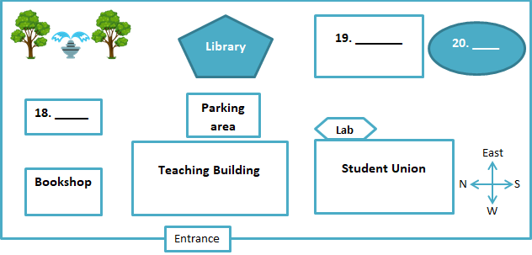

|  |  |
| --- | --- |
| **A** | Bookshop |
| **B** | Gym |
| **C** | Canteen |
| **D** | Parking lot |
| **E** | Computer Centre |

**18** 

**19** 

**20** 

**SECTION 3 : QUESTIONS 21-30**

**Questions 21-26**

*Complete the notes below.*

*Write****NO MORE THAN TWO WORDS AND/OR A NUMBER****for each answer.*

**Dissertation Requirements**

|  |  |
| --- | --- |
| Word limitation: | **21**  words |
|  | not includes **22**  and contents |
| Deadline for dissertation | **23** |
| Check list of | **24** |
| Tutorial time: | 1 :00 p.m – 2:00 p.m |
|  | on Tuesday **25**  on Friday |
| Printed by | **26** |

**Questions 27-30**

What’s the dissertation timetable ?

*Write the correct letter,****A-F****, next to questions****27-30.***

|  |  |
| --- | --- |
| **A** | Do research |
| **B** | Choose topic |
| **C** | Discuss with other peers |
| **D** | do a survey |
| **E** | Proof-reading |
| **F** | Write up work |

**27** 

References

Draft plan

**28** 

**29** 

**30** 

Hand in work

**SECTION 4 : QUESTIONS 31-40**

**Questions 31-40**

*Complete the notes below.*

*Write****NO MORE THAN THREE WORDS AND/OR A NUMBER****for each answer.*

|  |
| --- |
| The driest continent is **31**   The Australia is about **32**  times larger than Britain.  Three main structural features of Australia:  The Great Western Plateau The Central Eastern Lowlands  The **33**   The hottest month of Australia is **34**   The flag of Australia indicates its historical relationship with **35**   English is Australia’s official language just by **36**  not by law.  **37**  of Australian are migrants.  Australian employees have paid annual leave; sick leave and **38**   Australia’s own history and culture are mainly affected by the **39**   The Australian government carried a **40**  policy to finance arts. |

**LISTENING ANSWERS  
Answer Keys:**

* **1**B
* **2**A
* **3**C
* **4**A
* **5**Tomato soup
* **6**Main Course
* **7**Pea, onion
* **8**Dessert
* **9**Chocolate cake
* **10**Sprite
* **11**9:00 a.m.-12:00 a.m./9:00 a.m. to 12:00 a.m./9 a.m. to 12 a.m./9 a.m. -12 a.m.
* **12**Room 214
* **13**Student Card
* **14**smoking
* **15**(student) locker
* **16**reserve
* **17**photocopier
* **18**B
* **19**E
* **20**C
* **21**20,000
* **22**acknowledgement
* **23**30th July
* **24**tutor arrangements
* **25**2:00 p.m.-3:00 p.m/2:00 p.m. to 3:00 p.m./2 p.m. to 3 p.m.
* **26**laser printer
* **27**B
* **28**A
* **29**F
* **30**E
* **31**Antarctica
* **32**25
* **33**Eastern Highlands
* **34**January
* **35**Britain
* **36**usage
* **37**1/4 / 25 percent
* **38**long-service leave
* **39**Asian neighbours/Asian neighbors
* **40**tax deduction