**GTL001**

**IELTS LISTENING**

**PART 1 : QUESTIONS 1-10**

**Question 1**

*Circle the correct letter****A-C.***

***EXAMPLE***

What time is it now as Jenny is talking to the agent?

A 11:00

B 11:30

***C 12:00***

**1**

Jenny’s journey began in ...

* **A** London.
* **B** Singapore.
* **C** Hong Kong.

**Questions 2-4**

*Complete the form.*

*Write****NO MORE THAN THREE WORDS****for each answer.*

|  |  |
| --- | --- |
| **Lost luggage CLAIM FORM** | |
| **Name:** | Jenny Lee |
| **Address:** | **2**  St., Riverside |
| **Telephone number:** | **3** |
| **Arrived on:** | Flight QA 392 |
| **Connecting from:** | Flight **4** |

**Questions 5-7**

*Circle the correct letter****A-C.***

**5**

Which of the drawings resembles Jenny’s bag?

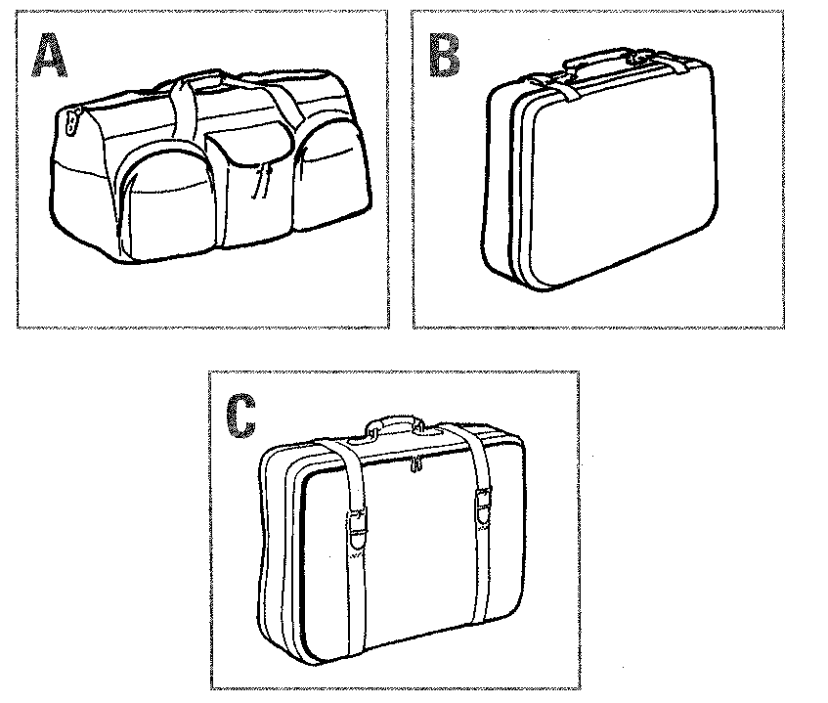

* **A** A
* **B** B
* **C** C

**6**

Which extra feature does Jenny identify?

* **A** black colour
* **B** wheels
* **C** a metal handle

**7**

What time should Jenny’s bag arrive?

* **A** 5:50 pm
* **B** 6:10 pm
* **C** 7:50 pm

**Question 8**

*Write****NO MORE THAN TWO WORDS****for the answer.*

When Jenny picks up the bag, she has to **8**  in person.

**Questions 9-10**

*Name****TWO****things that the agent advises Jenny to bring.*

**9** 

**10** 

**PART 2 : QUESTIONS 11-20**

**Questions 11-12**

*Complete the notice below.*

*Write****NO MORE THAN THREE WORDS OR A NUMBER****for each answer.*

|  |
| --- |
| **ATS Ticketing** |
| Box Office Hours (Regency Theatre):  Mon - Thurs: **11**   Firday, Saturday: 10 am - 8 pm  Internet Address: **12** |

**Questions 13-15**

*Indicate the number (****1-4****) to press for information on each of the following.*

***Example Answer***

***Tennis 1***

**13**  Symphony Orchestra

**14**  Classical Ballet

**15**  Formula One Grand Prix

**Questions 16-20**

*Fill in the information about Formula One Grand Prix Tickets.*

|  |
| --- |
| **FORMULA ONE GRAND PRIX TICKETS** |
| Dates: **16**   Ticket prices:  Saturday (concession rate) **17**   Grandstand ticket (4 days) **18**   Gate opening time Saturday and Sunday: **19**   Booking fee per ticket: **20** |

**PART 3 : QUESTIONS 21-30**

**Questions 21-23**

*Match the 3 speakers (****21-23****) with the background information below (****A-G****).*

**21**  Anna

**22**  Veronica

**23**  Chris

|  |  |
| --- | --- |
|  | COMMITTEE MEMBERS’ BACKGROUND AND EXPERIENCE |
| **A** | has done film reviews |
| **B** | currently in third year |
| **C** | gaining course credit for festival project |
| **D** | has made films |
| **E** | enrolled in Media Studies |
| **F** | works as a journalist |
| **G** | has film club experience |

**Question 24**

*Circle the correct letter****A-C.***

**24**

The total number of films in the festival each year is ...

* **A** five
* **B** three
* **C** twelve

**Questions 25-28**

*Circle the correct letter****A-C.***

**25**

Who chooses the films for the festival?

* **A** the committee members
* **B** the international Students’ Society
* **C** independent distributors

**26**

During the intermission, who is interviewed on camera?

* **A** journalism students
* **B** members of the audience
* **C** the organising committee

**27**

Of the films shown in the festival, ...

* **A** none is in English.
* **B** most are dubbed.
* **C** many have subtitles.

**28**

The festival did not make a profit last year because of ...

* **A** poor weather.
* **B** high price of admission.
* **C** lack of publicity.

**Questions 29-30**

*Complete the following using****NO MORE THAN THREE WORDS.***

|  |  |
| --- | --- |
| **INTERNATIONAL FILM FESTIVAL**  **Planning Overview** | |
| **Task:** | **To be completed by:** |
| • **29** | 1 March |
| • obtain sponsorship and advertising | 15 March |
| • **30** | 31 March |
| • print and distribute posters | April |

**PART 4 : QUESTIONS 31-40**

**Questions 31-34**

*Complete the summary using****NO MORE THAN ONE WORD****for each answer.*

|  |
| --- |
| **Construction of a reed bed**  • Rectangular hole 1 metre deep lined with **31**   • System of perforated tubing embedded in gravel  • **32**  planted in bed  https://ieltsonlinetests.com/sites/default/files/2019-01/ielts%20on%20track%20test%201-4-8.png  **Process**  • Sewage flows **33**  from tank into reed bed.  • Oxygen from reeds combines with bacteria to reduce waste to elements.  • Water is **34**  then released. |

**Questions 35-38**

*Complete the notes below.*

*Write****NO MORE THAN THREE WORDS****for each answer.*

|  |
| --- |
| **Environmental benefits of reed beds** |
| • produce good quality **35**  for farming use  • provide a **36**  for birds and animals  **Advantages over conventional system**  • lower **37**  costs  • 10% cheaper installation  • less maintenance  • efficiency **38**  with time |

**Questions 39-40**

*Write****NO MORE THAN ONE WORD****for each answer.*

Name **ONE**group which has opposed the introduction of reed bed technology.

**39** 

Give **ONE**concern about reed bed systems raised by students in the question period.

**40** 

**Answer Keys:**

* **1**C
* **2**533 East/E 67(th)
* **3**93014269
* **4**CX/Cathay Pacific 912
* **5**C
* **6**B
* **7**A
* **8**clear customs
* **9**passport/key/ticket
* **10**baggage claim number
* **11**10 (am) to 5 (pm)
* **12**www.ATSTIX.com
* **13**3
* **14**4
* **15**2
* **16**10th-14th
* **17**$35
* **18**$299
* **19**7:30 am
* **20**$2,50
* **21**G
* **22**A
* **23**C
* **24**C
* **25**A
* **26**B
* **27**B
* **28**A
* **29**select films
* **30**design program
* **31**clay/plastic
* **32**reeds
* **33**underground
* **34**tested
* **35**compost/soil
* **36**(healthy, natural) home/habitat
* **37**labour/labor
* **38**increases
* **39**unions/manufacturers
* **40**efficiency/winter/cold/weather/mosquitoes