**ACR006 – ACADEMIC READING**

**READING PASSAGE 1**

*You should spend about 20 minutes on* ***Questions 1-13****, which are based on Reading Passage 1 below.*

**The Secret Schizoid**

It is psychiatrist Ralph Klein who was credited with first coining the phrase ‘secret schizoid’. Unlike the overtly schizoid or schizotypal individual who is characterised by aloofness, coldness and indifference, the secret schizoid may present himself as an engaging and interactive individual according to Klein. Thus, Klein argues, there are not one but two distinct schizoid personality types: the overt schizoid and the covert schizoid.

Covert schizoids are difficult, on first glance, to identify. They have erected a convincing defensive barrier of social assuredness, engaging with the external reality, superficially at least. This engagement might, to the casual onlooker, appear quite normal. However, if quizzed about their behaviour, covert schizoids will probably reveal that they are still, on a deeper level, withdrawn from the real world. Their outward persona should be viewed, therefore, as little more than an act; the actual personality only being revealed in a safe place within the confines of the schizoids’ own mind; in other words, only ever known to the schizoids themselves.

The covert schizoid, as Fairbairn identified as long ago as 1940, is capable of ‘schizoid exhibitionism’; covert schizoids can appear to express a lot of feeling and make impressive social contacts without revealing anything of great significance about themselves. In effect, they disown the ‘character’ they play in public - the very credible front they put up -preserving their real personality intact. What the schizoids fear most is the consequences of emotional intimacy, so by erecting an invisible barrier between their public persona and their real self, the schizoids can avoid ever having to confront this fear and yet lead a relatively active and inclusive lifestyle.

Is the secret schizoid schizophrenic? Certainly not. Though the two fall within the realms of the same family of illnesses, the schizophrenic personality disorder is far more destructive. Whereas schizoids can, depending on the severity of their affliction, function fairly normally and even form relationships with others (based on intellectual, physical, familial, occupational or recreational, but most certainly not emotional, activities), and have a relatively fair grasp of reality, schizophrenics are plagued by hallucinations, delusions and disorganised thinking, all of which are likely to affect their functional capacity in a very negative way. It is true, however, that a family background of schizophrenia leaves one more vulnerable to or likely to develop a schizoid or schizotypal personality.

The causes of schizoid personality disorder are not clear, but it is theorised that an absence of parental affection and attention during early childhood may encourage the defensive tendencies and fear of intimacy that schizoids exhibit. It is also hypothesised that so-called secret schizoids are highly intelligent and have learned to develop their act as an effective coping mechanism which allows them to have the superficial relationships they so often crave without compromising that which they hold most valuable - their privacy.

One of the most damaging aspects of life as a secret schizoid can be what is termed 'depersonalisation’, namely, the loss of one’s sense of identity and individuality. Without the feedback which may be gleaned from real interpersonal relationships, schizoids’ perception of self may become skewed, or worse, they may begin to lose all self-perception. Effectively, this leaves the individuals feeling a deep sense of emptiness. Their emotional needs continue to go unfulfilled despite the fact that, on the face of it, the secret schizoids are leading an active and engaging lifestyle. The schizoids begin to question who or what they are and, tragically, yearn for the emotional attachment needed to confirm or reaffirm their perceptions of self an emotional attachment that they are incapable of seeking.

The public perception of the schizoid is misinformed at best. Just because they suffer from the illness does not mean secret schizoids are apathetic, dispassionate or indifferent. In actual fact, the schizoids can experience very strong emotions, but do so in both the comfort and discomfort of their own mind; the comfort of not feeling emotionally violated and the discomfort of not being able to share one’s inner fears with another person in order to alleviate them. Schizoids are often extremely sensitive people and their defensive front exists for the sole purpose of protecting themselves from criticism with which they are incapable of coping.

#### **Questions 1-7**

Complete the sentences below.

Choose ***NO MORE THAN THREE WORDS*** from the passage for each answer.

|  |
| --- |
| Whereas a typical schizoid might behave in an aloof or indifferent manner, the secret schizoid tends to appear, superficially at least, a very person, and one who is capable of interacting very successfully with those around him.  The secret schizoid appears socially assured, but this is only a very good , put up to make it seem as if he is in tune with what is going on in the real world, whilst at the same time protecting him from it.  The way the secret schizoid behaves in public is only ; the outside world never gets a glimpse of his real self, which remains hidden.  As they are unwilling to try to overcome their innate fear of emotional intimacy, schizoids who wish to lead a full and inclusive life must develop a separate , and create an invisible barrier between this and their private self.  Schizoids differ from schizophrenics in that they have a fairly decent understanding of and are not inclined to suffer from the same incapacitating symptoms, like hallucinations, delusions and disorganised thinking, that schizophrenics do.  A history of schizophrenia in the family leaves a person more to developing schizoid tendencies.  Although it is not known what causes schizoid personality disorder, some suggest a lack of during the first few years of life is partly to blame. |

#### **Questions 8-13**

Do the following statements agree with the information given in Reading Passage 1?

Write

|  |  |  |
| --- | --- | --- |
| **YES.** | if the statement agrees with the views of the writer |  |
| **NO.** | if the statement contradicts the views of the writer |  |
| **NOT GIVEN.** | if it is impossible to say what the writer thinks about this |  |

**8……………….**

People with schizoid personality disorder seem to be much more ‘normal’ than they actually are.

**9…………………**

Often, emotional attachment to another person is exactly what schizoids need to help them form a better picture of who they are; unfortunately, they are not capable of developing this.

**10…………………..**

The way schizoids are popularly perceived is fairly accurate.

**11…………………**

Most secret schizoids tend to be cold and unemotional people behind their public persona.

**12…………………**

Schizoids often put up a front as they are very sensitive and easily hurt.

**13…………………**

Schizoids in general have a higher than average level of intelligence.

# READING PASSAGE 2

You should spend about 20 minutes on ***Questions 14-26***, which are based on Passage 2 below.

## Fortunes of the Maori People

The islands of New Zealand, or Aotearoa, as its first inhabitants named them, first became populated at some point not long before 1300 AD. The indigenous people of New Zealand, known by the name they gave themselves - the Maori - are descendant from eastern Polynesia, whence they came in several waves. They formed a tribal society based on Polynesian social customs and organisation, but, over time, would develop a unique language and culture all of their own, complete with a rich mythology, distinctive crafts and performing arts, in splendid isolation from the rest of the world.

Europeans did not arrive in New Zealand until the beginning of the 17th century, and although their coming did not immediately bring the great change one might have assumed (in fact, the islanders and the Europeans lived fairly harmoniously together for some years, trading, and sharing knowledge and customs), it would, ultimately, usher in enormous upheaval. Over the years, the Maori began to adopt the settlers' ways, and many aspects of indigenous culture were compromised as a result.

It was following the signing of the Treaty of Waitangi in 1840, which gave Britain a mandate to govern New Zealand and bestowed the rights of subjects of the British monarch on the Maori, that the rumblings of discontent began in earnest.

At first, what was being disputed was the exact terms of the treaty. The translation presented to the Maori in their native tongue had a number of discrepancies in it compared to the English version. Crucially, there was no mention of a total surrender of power and control to the British monarch, so it is highly unlikely that the Maori actually agreed with or consented to what they were signing when they put pen to paper on the anglicised version.

This, and the fact that only about one-third of the Maori tribes had actually signed off on the treaty, led to the first dispute, which soon turned bloody. Inevitably, the British forces, with their superior fire power, would prevail in the ensuing conflict. The conflict itself, though, did not take a harsh toll on either side in terms of fatalities. What really decimated the Maori population was disease. The Maori were not biologically equipped for the diseases they would contract as a result of contact with the settlers. They did not have sufficient natural immunity to combat flu and measles, which, it is estimated, together killed anywhere between ten and fifty percent of the population. Other illnesses such as typhoid, scarlet fever and whooping cough also took their toll.

The Maori population went into serious decline from the mid-1800s right up until the start of the 20th century when it began to stage a revival of sorts, thanks in part to efforts by the government of New Zealand, motivated by a desire to make amends for previous wrongdoing, to help the Maori return to prosperity. The 20th century saw a renaissance of Maori culture and a recovery of the population, which is continuing into the new millennium.

By 2015, an estimated 660,000 New Zealanders could claim direct Maori descent - roughly fifteen percent of the total population. Maori, the language, is spoken, to some extent, by about a quarter of this group, or four percent of the total population of New Zealand, and the Maori people are active in all aspects of domestic affairs. Maori words have become part of the lexicon of the local vernacular, New Zealand English, and many towns and regions across the country are known by their traditional Maori names.

That said, the Maori people still face some serious challenges today; challenges chiefly of a socio-economic nature. The Maori have a lower life expectancy, inferior earning power, higher crime levels and more health problems than all the other ethnic groups on the islands. They are also serial underachievers educationally. However, steps are being taken to redress the balance and improve the prospects of Maori youths going forward. One area in which they have excelled, and something which has come to almost symbolise the Maori's great sense of pride and warrior tradition, is the game of rugby. The Maori Haka has become synonymous with the All Blacks, New Zealand's national rugby team. This traditional Maori dance is now showcased around the world in performances by the international rugby players, which precede all games they play in.

#### **Questions 14-24**

Complete the timeline diagram below.

Write ***NO MORE THAN THREE WORDS*** from the passage for each answer.

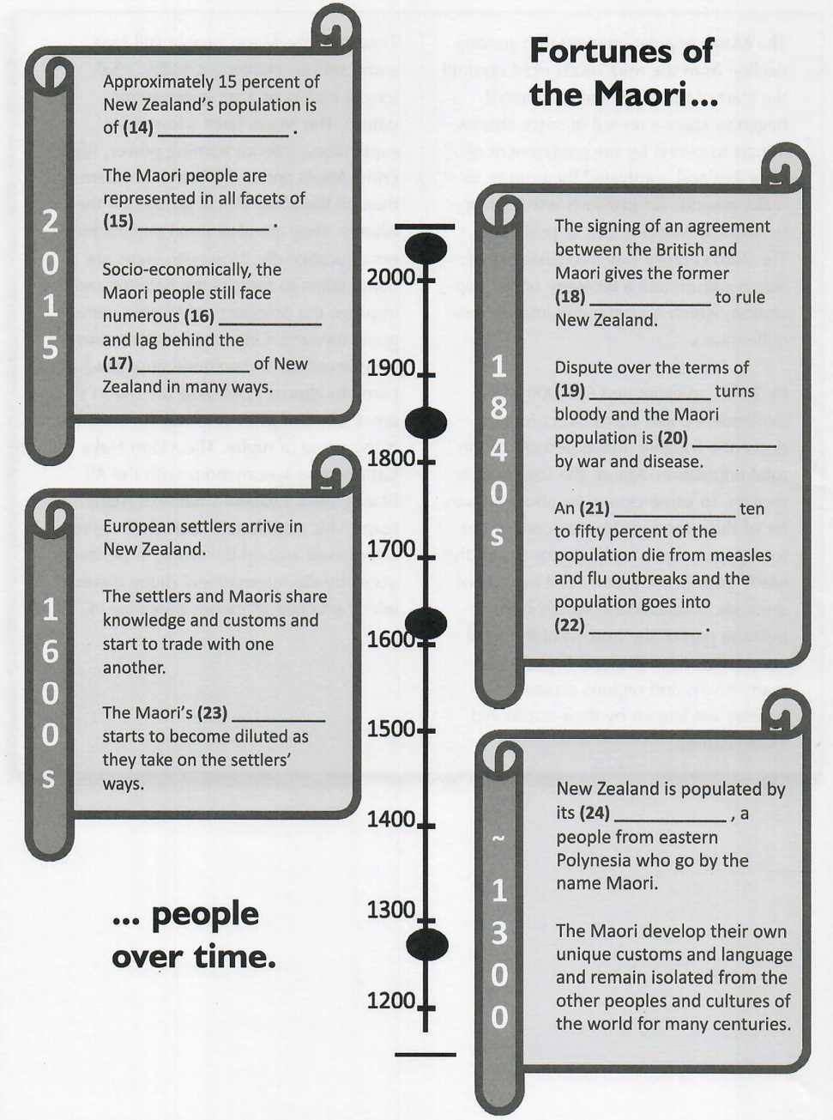























#### **Questions 25-26**

There are ***two*** correct answers.

Choose ***two*** letters from ***A, B, C, D*** and ***E.***

The Maori people today

A derive pride from their association with a national sport.

B speak their indigenous language about four percent of the time.

C are statistically the least prosperous community in New Zealand.

D perform their traditional dances at special Maori events which take place all over the world.

E are still known by their traditional Maori names.

# READING PASSAGE 3

You should spend about 20 minutes on ***Questions 27-40***, which are based on Reading Passage 3 below.

## The Kuiper Belt

Located in a region of the Solar System beyond the planets (from 30 AU at Neptune’s orbit to circa 55 AU from the Sun), the Kuiper Belt, or Edgeworth-Kuiper Belt I as many scientists prefer to call it, is similar to an asteroid belt though far greater in size, being 20 times as wide and potentially 200 times as massive. Like asteroid I belts, the Kuiper is composed of small celestial bodies, the scattered remnants - the leftover junk if you like - from the formation of the Solar System, but unlike asteroid belts whose objects are largely composed of rock and metal, the Kuiper’s objects consist of what are termed ‘frozen volatiles’: methane, ammonia and water in ice form, for example. Another significant differentiating factor between the Kuiper and asteroid belts is the presence in the former of at least four dwarf planets, the most well-known of which is Pluto, which, until 2006, was actually classed as a planet in its own right. The belt has also previously been home to other large objects such as Saturn’s moon Phoebe and Neptune’s Triton, which originated in the region before coming under the influence of the gravitational forces of their respective planets.

Though the existence of a phenomenon like the belt had been hypothesised for some time, its existence wasn’t officially confirmed until 1992, since when over one thousand Kuiper Belt objects (KBOs) have been officially observed. On the basis of what we know about the region, it is speculated that the actual number of KBOs measuring over 100km in diameter is far in excess of the 1000 objects already confirmed and closer to a figure in the region of 70,000. Initially, it was speculated that the Kuiper region was responsible for the appearance of most periodic comets (comets whose orbit lasts less than 200 years), but studies conducted in the mid-90s appear to contradict this assumption and cast the Kuiper region as one which is dynamically stable and, thus, not the repository of periodic comets it was originally assumed to be. Instead, the true source of periodic comets is now thought to be in the farther regions of the Solar System outside of the Kuiper Belt in an area referred to as the scattered disc, thought to have been created by the outward motion of Neptune several billion years ago. Scattered-disc objects are KBO-like bodies with orbits which take them as far as 100 AU from the Sun, far beyond the 50 AU boundary of the Kuiper Belt itself.

Pluto Is the largest-known Kuiper Belt object and also the tenth most massive body observed directly orbiting the Sun. It was reclassified a dwarf planet after it was discovered to be more similar compositionally to KBOs than the major planets, being comprised of rock and Ice. Its orbital period is also identical to that of another group of KBOs, referred to as plutinos in its honor. Alongside Pluto, a further three dwarf planets have now been observed within the Kuiper Belt, and these are collectively referred to as plutoids: another patent tribute to the former planet.

The Kuiper’s close proximity to Neptune has a profound effect on its structure due to the consequent orbital resonance (gravitational influence) at work on it. Neptune’s gravity destabilises the orbits of objects lying within certain regions of the Kuiper, doing one of two things: either sending them farther out into the scattered disc region of interstellar space, or into the linear Solar System. For this reason, the Kuiper is characterised by a series of pronounced gaps in its current layout, similar to the gaps present in the asteroid belt on which gravitational forces are also constantly at work.

The classical belt is the region of the Kuiper between 42-48 AU. Here the gravitational influence of Neptune is negligible, so KBOs can exist in their original orbits, largely unaffected. This region accounts for about two-thirds of all KBOs observed to date. Within the classical belt are two distinct populations of KBO defined by their differing orbits. The ‘dynamically cold’ population has orbits which are nearly circular, much as planets do. The ‘dynamically hot' population is characterised by more pronounced elliptical orbits. Not only are the populations at odds in their orbits, they are also compositionally distinct. The cold population has a red hue not evident in the hot population (the names cold and hot are not in any way indicative of temperature). It is thought that the hot population therefore formed in a different region near Jupiter before being ejected outward by movements among the gas giants, whereas the cold formed roughly where it is still situated, just outside of the orbital range of Neptune.

#### **Questions 27-32**

Complete the diagram below.

Write ***NO MORE THAN THREE WORDS*** from the passage for each answer.

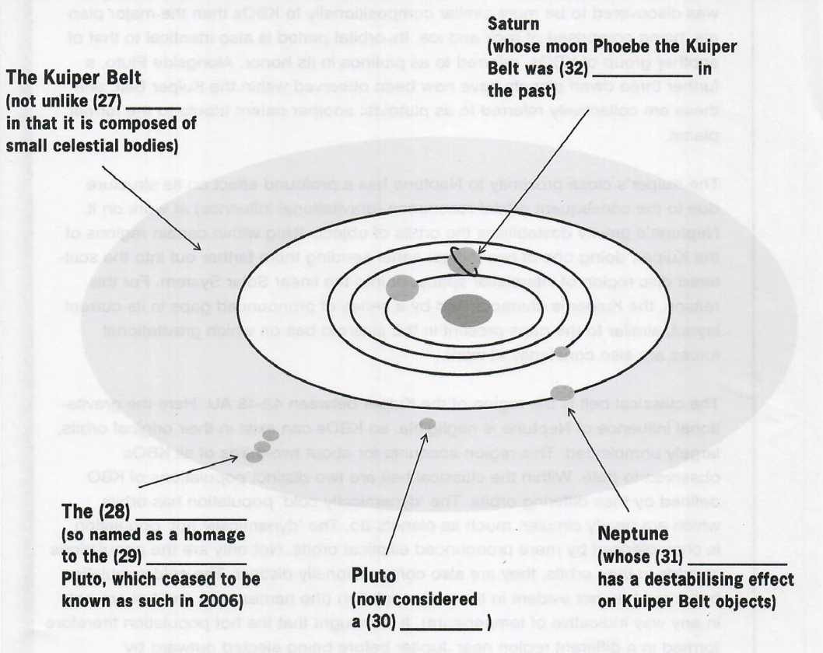













#### **Questions 33-38**

Complete the notes below.

Write ***NO MORE THAN THREE WORDS*** from the passage for each answer.

|  |
| --- |
| **IMPORTANT FACTS ABOUT THE KUIPER BELT** |
| - Located in part of the Solar System which is beyond the planets  - Wider and much more than asteroid belts  - Comprised of small celestial bodies  - KBOs dissimilar to asteroids compositionally - composed of frozen volatiles rather than  - Contains four known dwarf planets  - Existence of dwarf planets is another distinguishing feature between it and  - Though toexist for many years, presence of belt only confirmed in 1992  - Now an estimated 70,000 KBOs in existence  - Contrary to initial theories, not responsible for the majority of which are now believed to come from further out in the Solar System  - Pluto is the largest KBO and tenth most massive object in orbit around the Sun.  - A further three dwarf planets have been identified.  - Neptune’s influence has affected the of the Kuiper Belt, producing a series of pronounced gaps therein. |

#### **Questions 39-40**

Complete the chart below.

Write ***NO MORE THAN THREE WORDS*** from the passage for each answer.

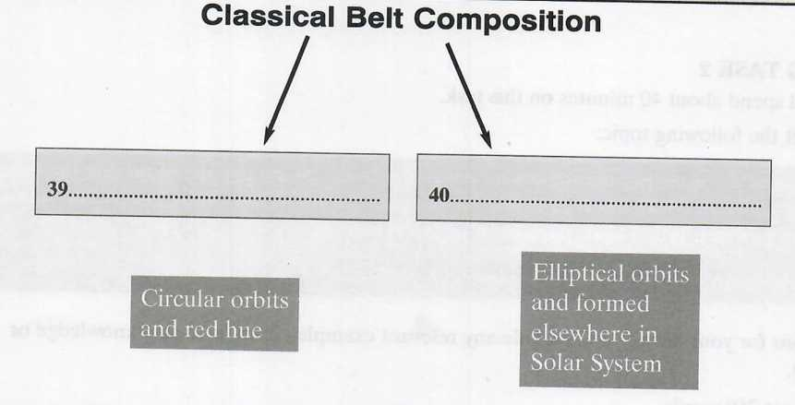





**Answer Keys:**

###### Part 1: Question 1 - 13

1 engaging

2 defensive barrier

3 an act

4 public persona

5 reality

6 vulnerable

7 parental affection/parental attention

8 YES

9 YES

10 NO

11 NO

12 YES

13 NOT GIVEN

###### Part 2: Question 14 - 26

14 Maori descent

15 domestic affairs

16 challenges

17 other ethnic groups

18 a mandate

19 the treaty

20 decimated

21 estimated

22 serious decline

23 indigenous culture

24 first inhabitants

25 26 A,C

###### Part 3: Question 27 - 40

27 an asteroid belt

28 plutoids

29 former planet

30 dwarf planet

31 gravitational influence/orbital resonance/gravity

32 home to

33 massive

34 rock and metal

35 asteroid belts

36 hypothesised

37 periodic comets

38 orbits of objects

39 (dynamically) cold population

40 (dynamically) hot population