# ACR008 – ACADEMIC READING

# READING PASSAGE 1

You should spend about 20 minutes on ***Questions 1-13***, which are based on Reading Passage 1 below.

## The Liquid-Propellant Rocket and Alternatives

A liquid-propellant rocket is a rocket whose engine uses propellants in liquid form to power it. The reasonably high density of liquids makes them a desirable form of engine power as the volume of propellant tanks used to hold them can be relatively low. Lightweight pumps can also be used to pump the liquid propellant from the tanks into the engine, which means the propellant can be kept under low pressure. Both these factors, smaller tanks and lighter pumps, are advantageous as they effectively lower the rocket’s mass ratio.

One of the most common types of liquid-propellant rocket is the bipropellant rocket. Bipropellant rockets generally have two tanks: the topmost one which contains liquid fuel, and a second, typically slightly larger tank, containing a liquid oxidiser such as liquid hydrogen or a hydrocarbon fuel, liquid oxygen combination. The fuel tank and the oxidiser are connected to the combustion chamber by pumps. It is within the chamber that the fuel and oxidiser react and combust. This chamber, in turn, connects to the nozzle through which spent fuel is expelled, generating sufficient thrust to get the rocket airborne.

Liquid-propellant rockets are preferred to other types primarily because they have a higher energy content, thus generating more thrust. Tankage efficiency is another important factor. Liquid propellant will typically have a density similar to water and require only modest pressure to prevent vapourisation from occurring. This combination of high density and low pressure permits a very lightweight tank. Gasses, on the other hand, are not nearly as dense and require more pressure to be applied in order to keep them stored within the tank, meaning heavier tankage must be used, which results in a higher rocket’s mass ratio.

Other advantages of liquid-propellant rockets include the fact that they can be reused for several flights, as happened many times in the Space Shuttle programme operated by NASA, and the ability to shut down and reignite such rockets multiple times if necessary. That said, the use of liquid propellants has been associated with a number of issues. One such issue is termed slosh (the movement of a liquid inside another object already undergoing motion). Slosh can lead to loss of control of the vehicle and it can also confuse computerised guidance systems, which are not equipped to account for the random path disturbances it can cause. Another major drawback of this kind of rocket is the functional complexity of the liquid-propellant mechanism, which operates high speed moving parts at very high temperatures. This can be a recipe for disaster, as it increases the probability of something going wrong.

The pumps used to pump the liquid propellants, though lightweight, are also very hard to design, and this is another bone of contention with proponents of other forms of rocket propellant. These turbopumps, as they are known, can suffer serious failures, such as overspeeding or shedding when operated at high speed.

Essentially, liquid-propellant rockets must be fine-tuned and they operate with a very small margin for error. They are, therefore, very high-maintenance, taking into consideration build, design, storage and flight logistics. However, if the logistical complications can be overcome, the reward is a highly effective, precise instrument that is relatively lightweight and can be reused more than once - a huge plus point when the expense of building a new rocket is factored in.

Solid-fuel rockets have been in existence much longer, and their main advantage over the liquid-propellant rocket is their long storage life. Solid-fuel rockets can be stored indefinitely and can then be readied for redeployment and operation in a relatively short space of time. They are also less volatile and for that reason can be transported more easily from place to place. This explains the military’s preference for solid-fuel rockets when it comes to its missile cache.

On the other hand, while NASA does deploy solid-fuel rockets in the initial stages of a space shuttle launch, primarily for their superior initial thrust, it relies on liquid-propellant rockets in the latter stages as these rockets provide thrust for longer periods.

In an attempt to capture the best aspects of both rocket types - solid and liquid (gas, realistically, being far too volatile) -hybrid rocket models have recently emerged. These are mechanically and functionally simpler machines, as they require one, not two, liquid tank. They are also superior from a safety perspective as they can be loaded onsite, so they are effectively transported in a benign state and do not represent a hazard in transit (this type of hazard is a major drawback of conventional rockets). At present, it is mainly space science agencies that are researching the potential of hybrid rockets

#### **Questions 1-5**

Label the diagram below.

Choose ***FIVE*** answers from the box and write the correct letter, ***A-G***, next to questions ***1-5***.

|  |  |  |
| --- | --- | --- |
| **A.** | Nozzle |  |
| **B.** | Liquid Oxidiser |  |
| **C.** | Combustion Chamber |  |
| **D.** | Pump |  |
| **E.** | Fuel |  |
| **F.** | Hydrogen Gas |  |
| **G.** | Thrust |  |

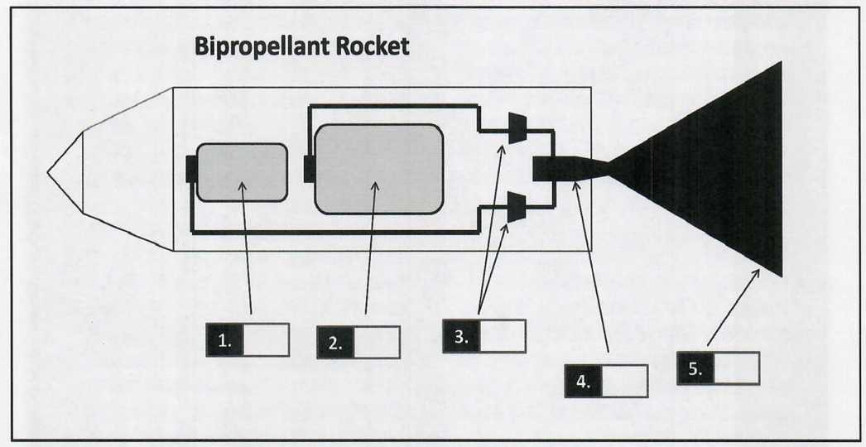

**1………….**

**2………………..**

**3……………….**

**4…………….**

**5………………..**

#### **Questions 6-10**

Complete the notes below using ***NO MORE THAN THREE WORDS*** from the passage for each answer.

|  |
| --- |
| The Liquid-Propellant Rocket: The Pros and Cons |
| PROS: - It generates more thrust as a result of  - Use of a more lightweight tank helps keep the rocket’s low compared to, say, gas-propellant rockets.  - The rocket can be used more than once and allows the controller to the rocket again several times after it has been shut down. CONS: - Liquid fuels inside tanks often suffer from slosh, which can adversely affect , and, in some cases, lead to a loss of control of the rocket.  - Functional complexity of the rocket mechanism increases the likelihood of in flight.  - Pumps are hard to design and prone to failure. |

#### **Questions 11-13**

Complete the summary below.

Use ***NO MORE THAN THREE WORDS*** from the passage for each answer.

|  |
| --- |
| Solid-Fuel Rockets |
| Solid-fuel rockets have been around much longer than liquid-propellant ones. They are also renowned for having a superior and, not only can they be stored indefinitely, once required for operational purposes, they can be operational again in a very short space of time, hence why they have always been the favoured type of rocket. Solid-fuel rockets also have , which is why NASA uses them in the initial stages of launching a space shuttle. |

# READING PASSAGE 2

You should spend about 20 minutes on ***Questions 14-26***, which are based on Reading Passage 2 below.

## Education Cuts Counterproductive to Long-Term Goals

In the latest so-called league table of universities around the world, Irish institutes have performed comparatively poorly, with only one of the 'big three' making progress in the right direction through the rankings. Arguably Ireland's most prestigious university, Trinity College Dublin registered a sharp fall and has now gone from being just outside the top 50 in the world, placed in position 52 last year, to 65th twelve months later. University College Dublin fared even worse in the World University Rankings, and now lies in 134th place, some 20 places worse off than it was last year. The only good news, and it was hardly something to write home about, came by way of University College Cork's modest rise from 184th to 181 st place.

University presidents were quick to blame cutbacks for the slippage and have criticised the government for taking funding out of third-level education, claiming that this will undermine our reputation as a very well-educated workforce in the long term and damage the prospects for a meaningful economic recovery over the next ten to fifteen years for this debt-ridden country.

UCD president Hugh Brady was quick to highlight the futility of Irish universities' attempts to compete with their British and American counterparts. Brady points out that UK universities now charge undergraduate students on average €10,000 per annum. In America, the cost of university education can be even more excessive.

Here in Ireland, third-level education is still free, but there are calls for fees to be reintroduced, otherwise this years' slide down the rankings is likely to be repeated again in 12 months' time.

Another option open to Irish universities is to gain more of a foothold in the market for attracting foreign students. Tapping deeper into the global education market would prove very lucrative and, as funding continues to be pulled out of third-level education by the government, this is now seen as crucial for the future in this country. However, the Irish universities' poor performance in the rankings is a double-edged sword; not only is it harming their international reputation, but in doing so, it is also making it more difficult to attract foreign fee-paying students for enrolment in years to come. And yet, without the funding such students provide, Irish universities will continue to plot a downward course in the rankings. It is a vicious circle.

Ironically, in making it harder for local universities to compete on the global stage by cutting funding, the government is undermining its own policy agenda, which is to attract double the number of foreign students each year by 2018. The economics of this policy are sound; Ireland currently attracts around 26,000 foreign students per annum. Each international student spends an average of €20,000 in fees and expenses, so it is clear to see how doubling the number would provide a massive boost for the economy and much-needed funding for the universities themselves.

Moreover, in the long run, as these well-educated and highly skilled international students would hopefully depart Ireland with a positive impression of the country, they would open up new trading and investment opportunities as they returned home to their native countries. This is obviously a very sensible government policy, which makes the government's decision to divert funding away from education all the more short-sighted and counterproductive.

As for the calls to reintroduce university fees, these have been met with understandable anger from both parent and student groups. The Students' Association of Ireland has threatened to organise a huge protest march, should it get even the slightest hint that there is some support in government circles for this proposal. Union president, Michael Carmody, promises to bring the city centre to a complete standstill and cause widespread disruption to business and services if the government approves any plans for the reintroduction of fees. 'We will not take this lying down', he said. 'Ireland is not a classist society and we are very proud of that. Everyone has an equal opportunity to attend third-level courses no matter how well-off their parents are or what their background is. If we allow fees to be reintroduced, university will become the preserve of an elite few; either that or, as is the case in Britain, students will be burdened with huge debts for the rest of their lives. No. We will not stand idly by and let this happen.

#### **Questions 14-18**

Choose the correct letter, ***A, B, C*** or ***D.***

14. The top three Irish universities

A all performed very disappointingly in the global university league tables.

B ranked the same or worse in this year’s World University Rankings than the previous year.

C in the World University Rankings are all ranked outside of the top 50.

D in the World University Rankings, from highest to lowest, are Trinity College, University College Cork and University College Dublin.

15. What do those in charge of Irish universities attribute their performance in the rankings to?

A a build-up of debt in the country

B a slippage in standards of teaching in third-level education

C a reduction in the amount of third-level funding being made available by the government

D Ireland’s poor reputation for educating its workforce

16. Why does Hugh Brady think it is pointless for Irish universities to try to compete with prestigious British and American ones?

A People would not be willing to pay as much in fees to attend an Irish university as they would to attend a British or American one.

B Not only are Irish universities facing funding cuts, but they are not allowed to charge fees, unlike their British and American counterparts.

C Ireland’s performance in the university rankings has been a big blow to its reputation in the field of third-level education.

D Fees are soon going to be reintroduced in Ireland, putting Irish universities under a significant burden of debt.

17. What can Irish universities do to source more funding, with the exception of introducing fees?

A lobby the government and call on it to change its funding policy

B attract more fee-paying domestic students

C entice more students from abroad to study the courses they offer

D develop a better understanding of the global education market

18. Why is Ireland’s performance in the global rankings ‘a double-edged sword’?

A because it damages the reputation of Irish university both domestically and internationally

B because the universities damaged reputation abroad also means fewer fee-paying international students will be prepared to enrol, making their financial situation even worse

C because Irish universities cannot attract foreign investment in their facilities if their reputation is undermined by their poor performance in the global rankings

D because Irish students will look to be educated abroad at more reputable universities as fee-paying foreign students if their own third-level institutes are inadequate

#### **Questions 19-22**

Do the following statements agree with the views of the writer given in Reading Passage 2?

Write

|  |  |  |
| --- | --- | --- |
| **YES.** | if the statement agrees with the views of the writer |  |
| **NO.** | if the statement contradicts the views of the writer |  |
| **NOT GIVEN.** | if it is impossible to say what the writer thinks about this |  |

**19………………**

The government’s decision to cut funding to universities is going to prove counterproductive to its own goals.

**20……………….**

The government’s target of attracting an average of more than 50,000 foreign students each year by 2018 is an unsound policy.

**21………………**

Despite the fact that parents and children are unhappy about it, the call for student fees to be reintroduced is to be welcomed.

**22……………….**

The protest march, were it to go ahead, would attract a large number of participants; such is the anger among students.

#### **Questions 23-26**

Complete each sentence with the correct ending, ***A-F,*** below.

|  |  |  |
| --- | --- | --- |
| **A.** | cautiously optimistic about the effect a reintroduction of fees would have. |  |
| **B.** | believes Ireland's system, unlike the UK's, burdens students with too much debt. |  |
| **C.** | believes Ireland has a system of third-level education which is, at present, not elitist. |  |
| **D.** | were Ireland to introduce student fees, either students from poor families would be debt-burdened or they would be prevented from getting a third-level education at all. |  |
| **E.** | a reflection of the frustration felt by parent and student groups generally at the prospect of a reintroduction of fees. |  |
| **F.** | determined to react strongly in the face of any moves to reintroduce student fees. |  |

**23…………..**

Michael Carmody, head of the Students’ Union, is

**24……………**

The head of the Students’ Union

**25……………**

According to Michael Carmody,

**26……………**

Michael Carmody’s anger is

# READING PASSAGE 3

You should spend about 20 minutes on ***Questions 27-40***, which are based on Reading Passage 3 below.

## Is paradise forever lost?

**A**

These days, it has almost become a cliche - the notion of travelling on a shoestring is far too common for the liking of the free spirited hippie types who started the craze off. And, besides, with the cost of travel having plummeted in recent years, it no longer entails enduring the kinds of hardships experienced by the budget travellers of yesteryear. And, in some ways, this has taken the enjoyment out of the experience of ‘roughing it’ as you travel around the world in search of new and ever more unique experiences. Why? Because there aren’t that many new and unique experiences left. Once everyone started doing it, this whole globe-trotting idea started to look a lot less attractive. It was supposed to be for a select few adventurers daring enough to take the dusty roads less trodden. But those roads are now crowded highways of overexcited youths trying desperately to make their holiday adventures special. There is something very artificial about the whole experience. Part of the reason people used to go backpacking to the ends of the earth was to, well, escape the maddening crowd, not join it. Is there nowhere that is safe anymore? Is there no escape from the masses?

**B**

Rex, 25, from Kensington, dropped out of Engineering in his second year at Oxford to travel the world. An idealist and romantic, Rex had become disillusioned with life in the big smoke, having lived in London for most of his 25 years, and decided it was time to branch out. His parents were understandably distraught to learn of his decision to quit university, but they gave him their full support once it was clear this was the only thing that would make him happy. So Rex started down the by now well-documented road to Asia and the Far East. At first brimming with enthusiasm, his passion for the journey soon dried up when Rex realised things were not exactly as he had imagined they would be. No matter where he went, a dedicated army of foreigners like himself would follow; there was no escaping them, and so, Rex felt, the experience of local culture was very artificial, almost deliberately extreme to impress the eager eyes of his mainly American travel buddies.

**C**

Having almost given up on ever finding the authentic experience, Rex prepared to come home. You can hear it from the horse’s mouth from here: ‘I got this deal with a stopover in Greece on route back to London, so I figured I might as well spend a few days there if for no other reason than to avoid having to face the music from my parents when I arrived home. I’d heard the Ionian islands were nice, but horribly overcrowded. Still I thought: “What’s the point of fighting it? Everywhere’s crowded.”

So, a couple of days later, I found myself in Corfu on a beautiful spring day in March. It was 25 degrees outside; the sky was clear and the sea a picture-postcard turquoise. Surprisingly, there weren’t that many tourists on the island either. Suddenly my spirits got high. That first evening, I dined in the old town on some exquisite local fare at a small, family-owned taverna where the owner - a chubby, middle-aged man of very good nature - proceeded to introduce me (his only customer) to the rest of his family one-by-one, then sat down and chatted by my side in his broken English for the rest of the night.’

**D**

‘I told him where I was going next and the man’s eyes beamed. Kefalonia, he explained, was where he had grown up. Indeed, his village was only a mile or two from the hostel where I would be staying. It was settled then; I would stay with his brother Nikos, who would give me a “royal” tour of the island, instead. Nikos, it turned out, was every bit as helpful as his older brother, and, somehow, by accident, I found myself spending the next two months in the company of his family as they showed me from one part of Kefalonia to the next, exploring land and sea, caves and rivers, waterfalls and lakes, forests and mountains. This was real; Nikos was real; his wife and children were real; their hospitality was real and Kefalonia was real. The turtles I swam with were real; it was just me and Nikos’ daughter Eliza who’d chanced upon them by accident in the fishing boat. There were no crowds to spoil this moment; everything was real. One evening, as I sat looking out onto the sunset, totally relaxed and at home on my little island paradise, a bus came bumping up the uneven road that led to the beach. Then, within minutes, there were 20 or 30 bodies on my beach, throwing balls, kicking sand, drinking beer, lighting fires... “Summer has arrived”, I thought. And with it, I made a hasty retreat back to London. It occurred to me then, that, even in the most commercialised of tourist destinations like the Greek Islands, if you know what to look for, where to look and, more importantly, when, you can still find paradise, if only for a few moments.’

**E**

Rex’s story is a reminder to keep searching until you find what you are looking for. Rex found his paradise in the most unlikely of places. Greece has a reputation for attracting hoards of package-holiday goers. It is a place where beaches are overflowing with deckchairs and sunbeds and the stench of commercialism from June to September each year. But, as Rex found out, for the rest of the year it transforms into something magical, or, at least, a small part of it - a quiet, peaceful, little gem of an island on the shores of the Ionian Sea, does. Keep searching!

#### **Questions 27-31**

***Reading Passage 3*** has five paragraphs, ***A-E***.

Choose the correct heading for each paragraph from the list of headings (***i-viii***) below.

**27……….**

Paragraph A

**28…………**

Paragraph B

**29…………..**

Paragraph C

**30…………..**

Paragraph D

**31………….**

Paragraph E

|  |  |  |
| --- | --- | --- |
| **i.** | The mood is lifted at last |  |
| **ii.** | Reality bites for peace-seeking traveller |  |
| **iii.** | Backpackers no longer breaking new ground |  |
| **iv.** | Paradise found at last but disturbed by new arrivals |  |
| **v.** | Making friends from America |  |
| **vi.** | Arrival of royalty causes a stir |  |
| **vii.** | Restaurant owner opens his home to weary traveller |  |
| **viii.** | Never give up on finding what you're looking for |  |

#### **Questions 32-37**

Complete the flow-chart below.

Write ***NO MORE THAN TWO WORDS*** from the passage for each answer.

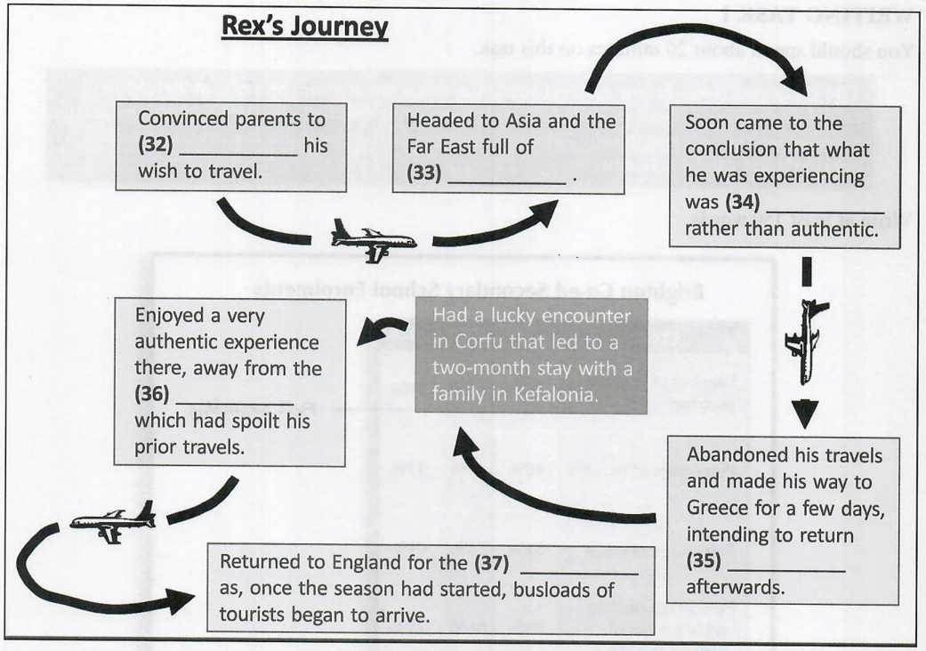













#### **Questions 38-40**

Choose the correct letter, ***A, B, C*** or ***D.***

38. Why did Rex want to go to Greece for a few days?

A in order to escape the crowds of holidaymakers

B he had to choose between Greece and England and preferred Greece

C he wanted to put off having to go home

D the weather in March in Greece is typically very pleasant

39. What did Rex originally intend to do in Greece?

A stay in Corfu for a few days before departing for England

B visit Corfu and then Kefalonia, and stay in a hostel there

C visit Corfu and then stay with Nikos and his family in Kefalonia

D spend a few days cruising around the Ionian Sea

40. What message is the writer trying to put across?

A People should not expect to find everywhere they travel up to the standard they expect.

B Though you might not think so, Greece is a better holiday destination than parts of Asia and the Far East.

C It is almost impossible to find a holiday destination which is quiet, peaceful and private these days.

D People should not give up on the idea of finding their ideal holiday destination, and, if they keep looking, they might find it where they least expected to.

**Answer Keys:**

###### Part 1: Question 1 - 13

1 E

2 B

3 D

4 C

5 A

6 higher energy content

7 mass ratio

8 reignite

9 computerised guidance systems

10 something going wrong

11 storage life

12 military's

13 superior initial thrust

###### Part 2: Question 14 - 26

14 C

15 C

16 B

17 C

18 B

19 YES

20 NO

21 NO

22 NOT GIVEN

23 F

24 C

25 D

26 E

###### Part 3: Question 27 - 40

27 iii

28 ii

29 i

30 iv

31 viii

32 support

33 enthusiasm

34 artificial

35 to London

36 crowds

37 summer

38 C

39 B

40 D