### ACW005 – WRITING TASK I

You should spend about **20 minutes** on this task.

The chart below gives information about the journey to school by children aged 11 to 16 in the UK in a year. Summarise the information by selecting and reporting the main features, and make comparisons where relevant.

You should write **at least 150 words.**

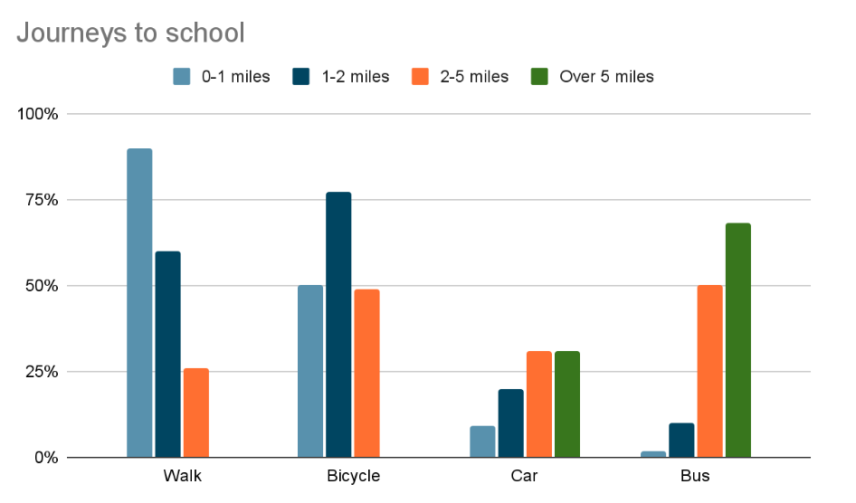

### ACW005 – WRITING TASK II

You should spend about **40** minutes on this task.

**Many people around the world use social media to keep in touch with other people and get the news. Do you think the advantages of this development outweigh the disadvantages?**

You should write at least **250** words