### ACW006 – WRITING TASK I

You should spend about **20 minutes** on this task.

The chart below shows the percentage of a drug company’s total sales, by region, from 2002 to 2006.Summarise the information by selecting and reporting the main features, and make comparisons where relevant

You should write **at least 150 words.**

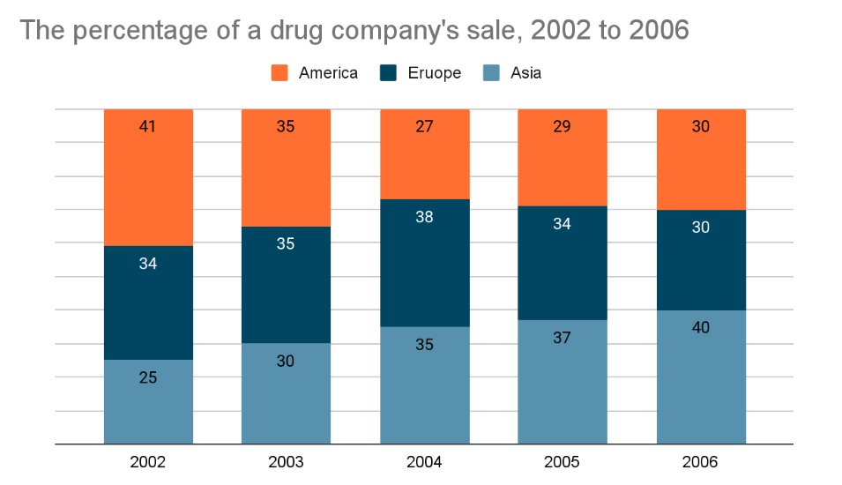

### ACW006 – WRITING TASK II

You should spend about **40** minutes on this task.

**Parents are putting a lot of pressure on their children to succeed. What are the reasons for this? Is it a positive or negative development?**

You should write at least **250** words