### ACW007 – WRITING TASK I

You should spend about **20 minutes** on this task.

**The diagram gives information about the process of making carbonated drinks.**

Summarise the information by selecting and report in the main features, and make comparisons where relevant.

You should write **at least 150 words.**

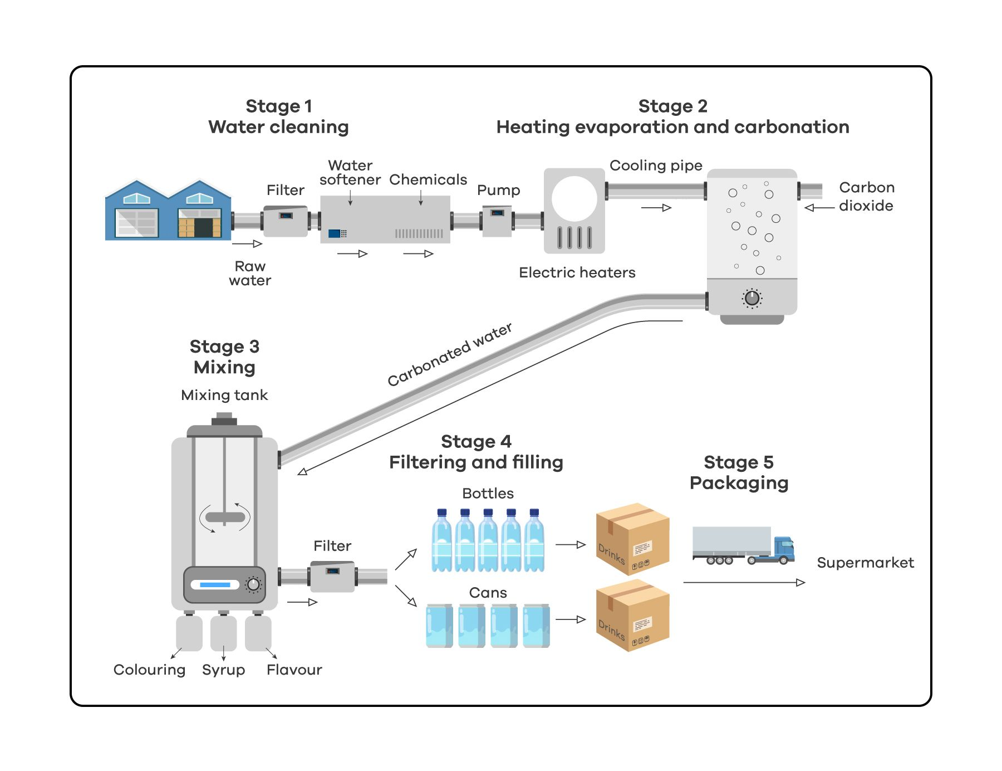

### ACW007 – WRITING TASK II

You should spend about **40** minutes on this task.

**By punishing murderer with the death penalty, society it also guilty of committing murder. Therefore, life in prison it a better punishment for murderers.**

**To what extent do you agree or disagree with this statement?**

You should write at least **250** words