### ACW008 – WRITING TASK I

You should spend about **20 minutes** on this task.

**The chart below shows the percentage of their food budget the average family spent on restaurant meals in different years. The graph shows the number of meals eaten in fast food restaurants and sit-down restaurants.**

Summarize the information by selecting and reporting the main features, and make comparisons where relevant.

You should write **at least 150 words.**

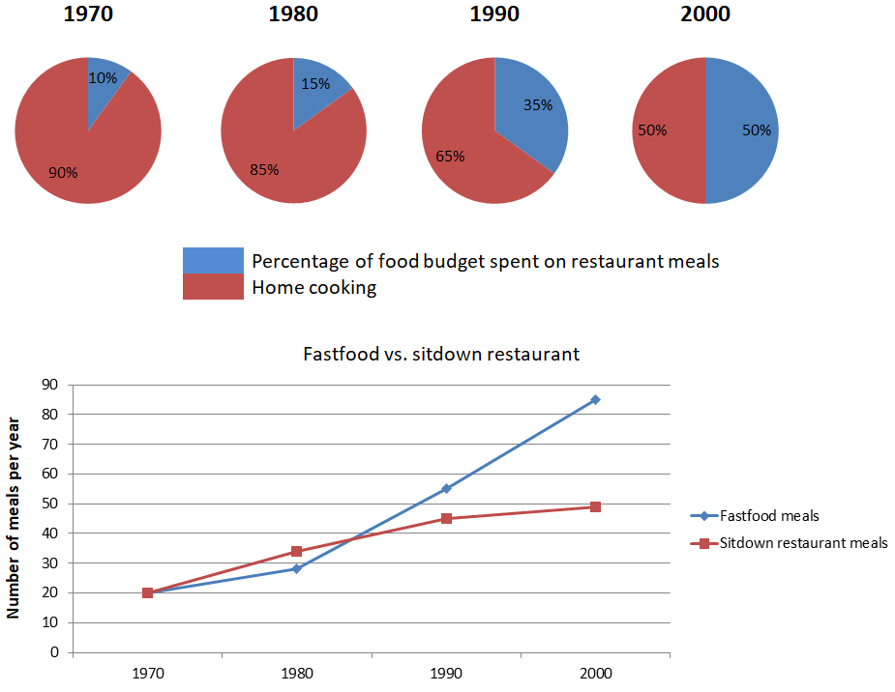

### ACW008 – WRITING TASK II

You should spend about **40** minutes on this task.

**Some people feel that manufacturers and supermarkets have the responsibility to reduce the amount of packaging of goods. Others argue that customers should avoid buying goods with a lot of packaging. Discuss both views and give your opinion.**

You should write at least **250** words