### ACADEMIC WRITING TASK I

You should spend about **20 minutes** on this task.

The chart below shows the number of international applicants to the universities of one European country.

Summarize the information by selecting and reporting the main features, and make comparisons where relevant.

You should write **at least 150 words.**

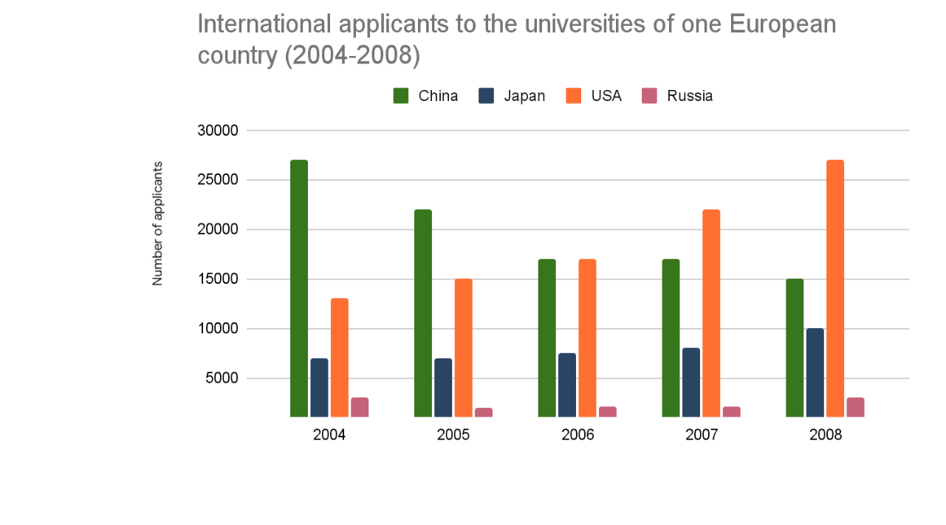

### ACADEMIC WRITING TASK II

**Duration: 40 minutes**

**Many people think modern communication technology is having some negative effects on social relationships. Do you agree or disagree?**

You should write at least **250** words