Create folder to contain git repo which hold project files
Shell → git init
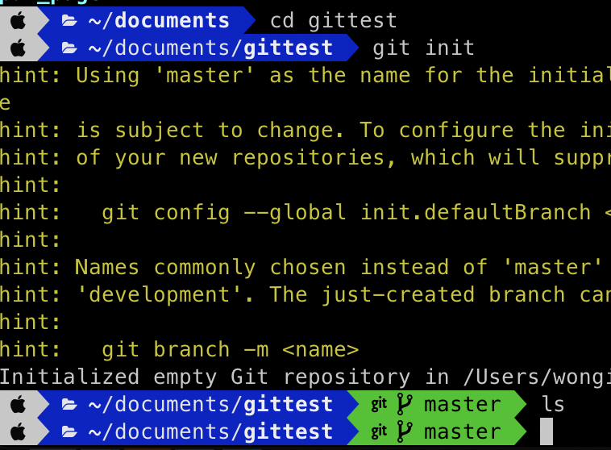

create file hello.txt in gittest folder
Shell → git status → checking the content of gittest
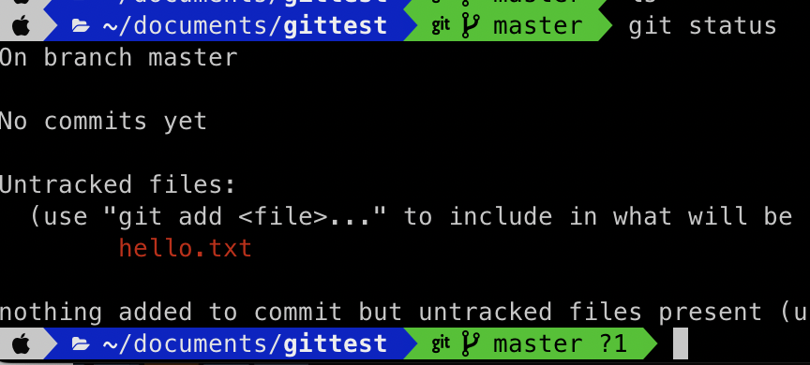

Shell → git add → change the file be trackable

Shell → git commit → save file
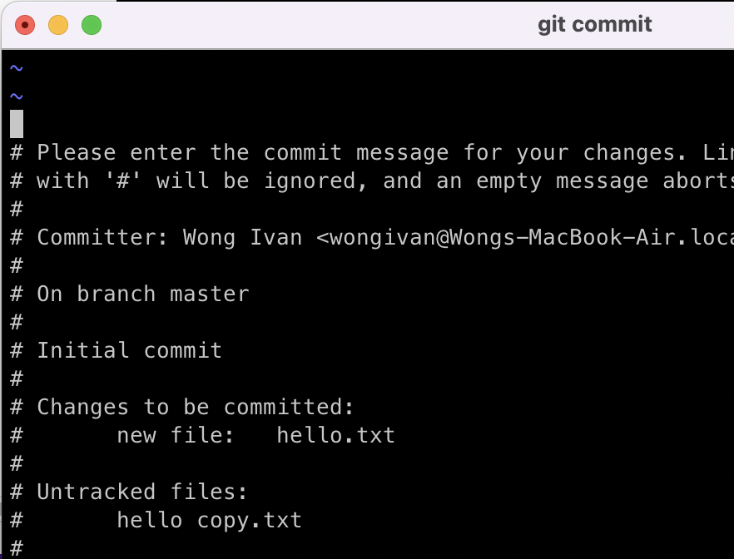

now it is under vim mode
exit vim → esc, shift z, shift z
shell → git commit -m
shell → git log → look committed file
press q to exit git log

shell → git add . → make all file trackable

shell → git commit -m “second commit”

Uploading file to github

login gibhub

create new repository

link github with your pc

copy path in github
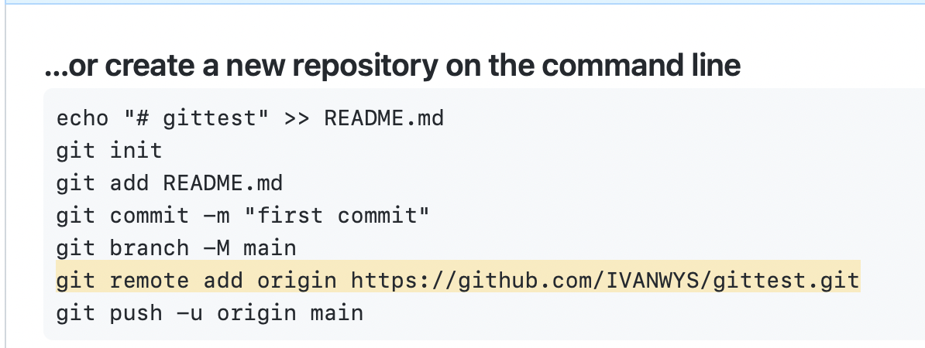

shell →

shell → git remote → git remote show “origin”
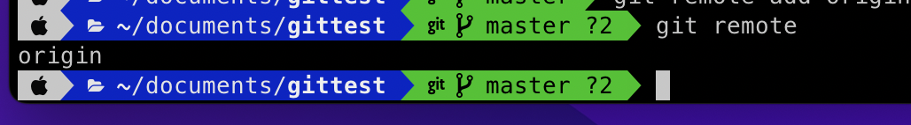

shell → git push-u origin master → used to push file to github
