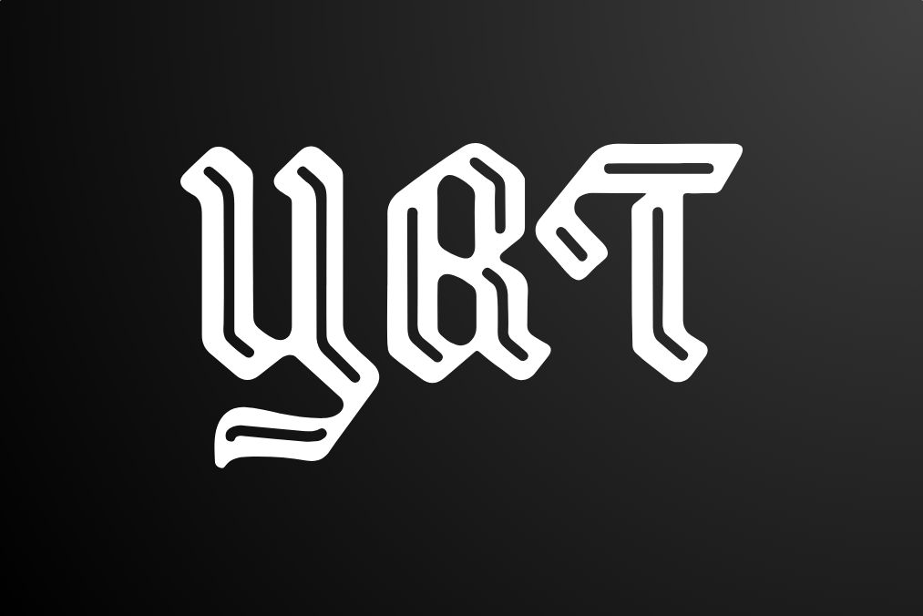

Table of Contents

Team members 3

Introduction 3

Summary 3

Ways of realization 4

Task for completion 4

Conclusion 4

Algorithmic scheme 3

Digitalization of the game

# Team members

|  |  |
| --- | --- |
| № | Roles in the team |
| 1 | Ivan Andreev – Scrum Trainer |
| 2 | Boyan Kiovtorov – Backend Developer |
| 3 | Dimitur Dimov – Frontend Developer |
| 4 | Dobril Peev – Python Developer |

# Introduction

|  |  |
| --- | --- |
| № | Introduction |
| 1 | **What is the product?**  The product is used for educational purposes. It is about digital will. |
| 2 | **How can you access it?**  You can read about our collaborative work on GitHub and access our project’s repository files. |
| 3 | **What about communication?**  We communicated through Teams due to its helpful functions like screen sharing and text channels. The team was well connected and the work was efficient. |
| 4 | **What programs were used?**  We used GitHub for file management and collaborative work, Visual Studio Code for code editing, MS Teams for communication, MS PowerPoint for our presentation, MS Word for the documentation, MS Excel for our QA documentation, C++ , Qt Maker and Python to make the app. |

# Summary

## Ways of realization

|  |  |
| --- | --- |
| № | How did we do it? |
| 1 | **Task Distribution**  The Tasks were distributed based on the skillset of everyone. We also notified each other when a commit was made so everyone can stay up to date with the collaborative work. This way our team was as productive as possible. |
| 2 | **Task Completion**  Every day we held a meeting to track the development of the app and help each other progress further. We also resolved issues and shared ideas. |
| 3 | **Deadlines**  In these meetings we also discussed time management, how specific parts were coming along, what everyone had done in their specified time and what things should be completed in the near future. |

WORK PLAN

## Tasks for Completion

|  |  |
| --- | --- |
| № | Task Breakdown |
| 1 | **Creating the main menu** |
| 2 | **Making the logo of the app** |
| 3 | **Creating the design of the app** |
| 4 | **Fixing database lag issue** |
| 5 | **Making login UI** |
| 6 | **Making transaction history page** |
| 7 | **Adding git ignore** |
| 8 | **Designing and implementing crypto page UI** |
| 9 | **Connecting Python code to Azure database** |
| 10 | **Making account-management (Log In/ Register form)** |
| 11 | **Making building system compatible with all platforms (Windows , macOs, Linux)** |
| 12 | **Detecting heir of user** |
| 13 | **Making “create transaction” page UI** |
| 14 | **Making transaction history page** |
| 15 | **Refactoring code formatting and organization** |
| 16 | **Creating README** |
| 17 | **Creating the QA Documentation** |
| 18 | **Documentation** |
| 19 | **Presentation** |

## Conclusion

In conclusion, this project helped us improve our skills in working as a team. We learned to how to bare with every obstacle and be patient with the process.