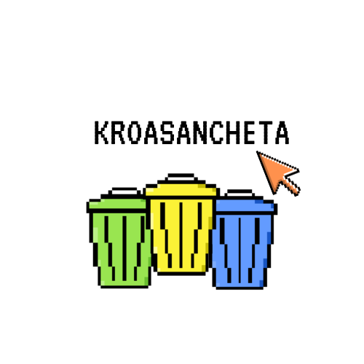Project documentation

Table of Contents

Resume 3

Team 4

Was it difficult? 5

What did we use? 6

Game model 7

# Resume

**Aim**

To influence people and help them understand how necessary it is to keep the planet clean.

**Realization**

After forming our team, we discussed our ideas and decided to make a game that would educate adults and children about the importance of recycling. After that we decided to use SFML for developing the game. Our choice of SFML was based on its ease of use and its ability to make the game more accessible for a younger audience.

**Result & Future improvements**

We are extremely satisfied with the final product, but we may add levels in the future in order to engage more young minds. The game will become more complex as a result, which will increase interest in it.

# Team

* + Ivo Badalov (Scrum trainer)

[IVBadalov21@codingburgas.bg](mailto:IVBadalov21@codingburgas.bg)

* + Martin Belchev (Backend developer)

[MDBelchev21@codingburgas.bg](mailto:MDBelchev21@codingburgas.bg)

* + Simeon Syarov (Backend developer)

[SMSyarov21@codingburgas.bg](mailto:SMSyarov21@codingburgas.bg)

* + Kristina Zheleva (Frontend developer)

[KMZheleva21@codingburgas.bg](mailto:KMZheleva21@codingburgas.bg)

* + Petya Stoyanova (Mentor)

[PGStoyanova20@codingburgas.bg](mailto:PGStoyanova20@codingburgas.bg)

# Was it difficult?

|  |
| --- |
| Difficulties: |
| 1/10 – not difficult \ 10/10 – very difficult |

|  |  |
| --- | --- |
| Communication | 3/10 |
| Code | **4/10** |
| Teamwork | **5/10** |
| Role distribution | **2/10** |

# What did we use?

1. Teams
2. Discord
3. Aseprite
4. GitHub
5. SFML
6. Excel
7. Visual studio
8. Word
9. Power point

# Game model