**Demo App: Booking Meeting Room**

* Purpose: Research Android.
* Function: Build an app for booking meeting room in IVC, on Android framework.
* Account for Login Screen Email: [tinbui@ivc.com](mailto:tinbui@ivc.com) Password: 123456

**This is tutorial for my Demo App**

* Login screen

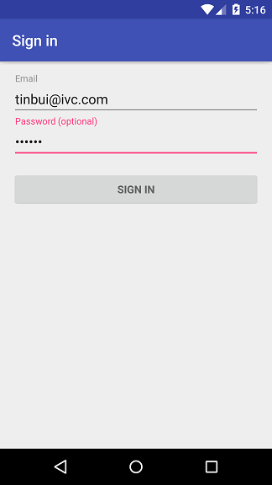

* Here is Information screen, showing information of user

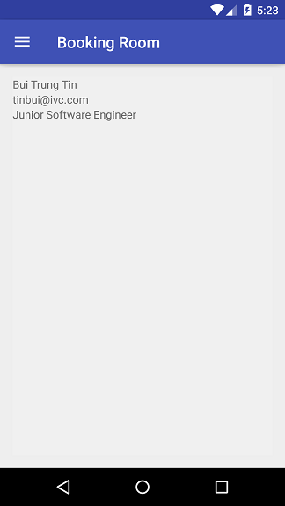

* Navigate other screen

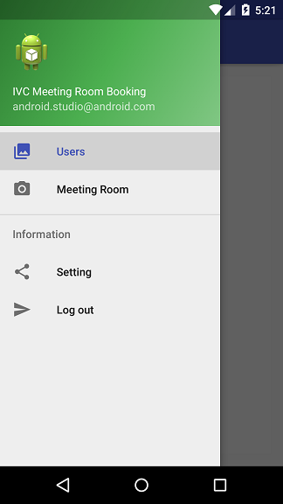

Users: To call Information Screen

Meeting Room: To call Meeting room list screen

Logout: To finish session of user

Setting: Do not thing

* Meeting room list screen

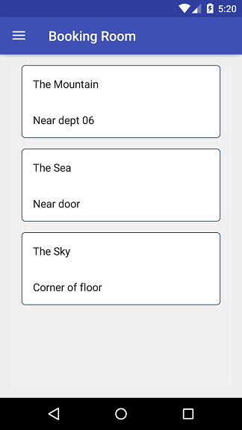

* Booking room

Fill information via click these TextView then click Register Button to book.

