**Demo App: To Do List**

* Purpose: Research Qt.
* Function: Build application that records the user's task list, on Qt framework.
* My application is only build on windows and mac os x.

**This is tutorial for my Demo App**

* **Main screen**

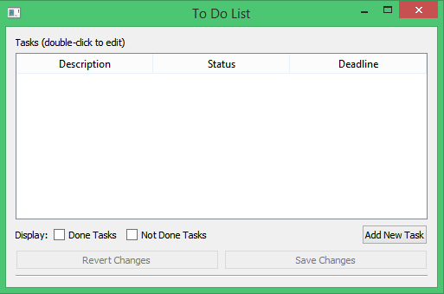

* 1. *Click Add* ***New Task***
* **Choose date and write new task**

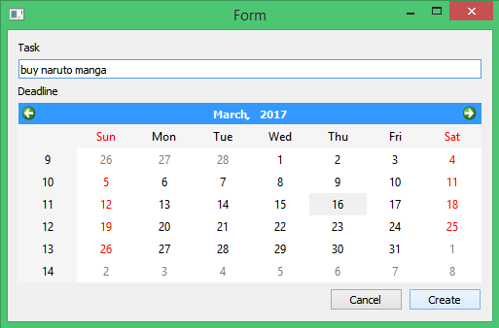

*1.2 click* ***Create***

* **Your task list show on main screen, double click to change**

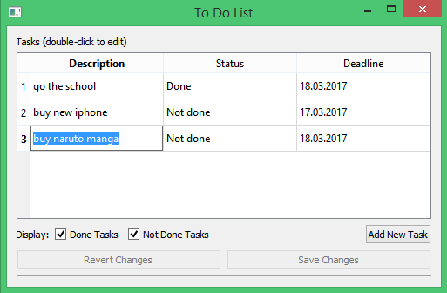

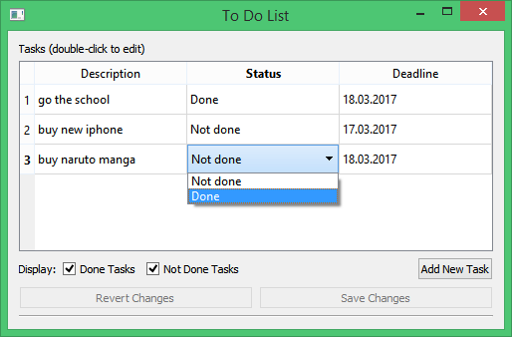

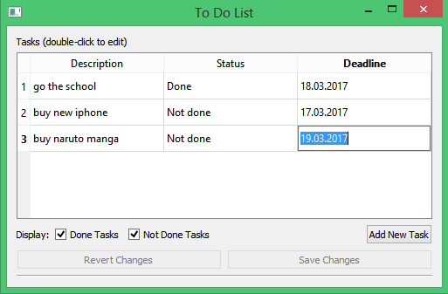

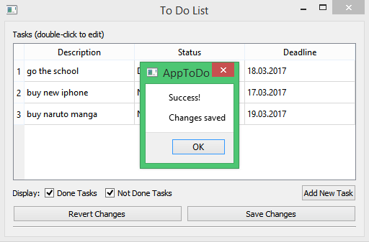

*1.3 Double click to edit and click Save Changes*

* **Revert data**

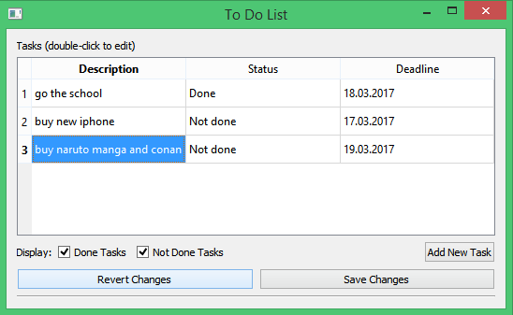

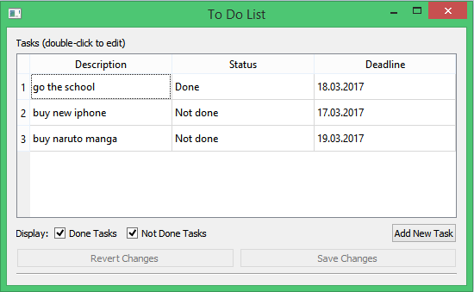

*1.4. After edit, you don’t want to change, click to revert, all data will rollback*

* **Filter tasks Done or Not Done**

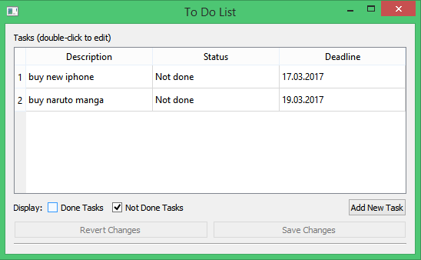

1.5. Click check box Done Task will hidden all done tasks.