IoMate

(Internet of Maritime Things)

An overview of AIS:
- Introduction:
AIS was developed to provide automatic reporting between ships and to shore, which contributes to the safety of navigation and facilitates traffic management by exchanging information such as identity, position, time, course and speed, autonomously and continuously.

- What is AIS:
AIS stands for Automatic Identification System, which is a technology used in the maritime industry to identify and track the location of ships, boats, and other vessels. This information is used to improve maritime safety and efficiency, prevent collisions, and aid in search and rescue operations.
It is also a communications system using 4 worldwide channels in the VHF maritime mobile band, for the exchange of navigation data.
There are numerous AIS device, known as stations, which are identified by a unique Maritime Mobile Service Identity (MMSI) and use an international open standard to communicate.
AIS stations are designed to operate autonomously (without interaction by ship or shore personnel) and may also be instructed to transmit in a different manner. AIS enables the automatic exchange of shipboard information from vessel sensors (dynamic data), as well as manually entered static and voyage related data between one vessel and another and between a vessel and a shore station.
AIS has been mandated as a shipboard carriage requirement for vessels under the
revised Chapter V of the International Convention for the Safety of Life at Sea, 1974
(as amended) (SOLAS 74) section 19 2.4. in addition, AIS is required domestically on non-SOLAS vessels by some administrations.
The development of AIS has expanded to include devices such as AIS for Aids to Navigation (AIS AtoN), AIS on search and rescue aircraft and AIS search and rescue transmitter (AIS-SART).

- Advantages:
- Information exchange between vessels within VHF range of each other, increasing
situational awareness;
- Information exchange between a vessel and a shore station, such as a VTS, to improve
traffic management in congested waterways;
- Automatic reporting in areas of mandatory and voluntary reporting;
- Exchange of safety related information between vessels, and between vessels and
shore station(s)

- Features:
1. Identification of vessels: AIS allows for the identification of vessels by transmitting and receiving vessel-specific information such as name, call sign, MMSI number, type, and size.
2. Real-time tracking: AIS provides real-time tracking of vessel movements, including their speed, course, and position.
3. Collision avoidance: AIS enhances safety at sea by providing vessel operators with information about the location and movement of other vessels in the area, helping them to avoid collisions.
4. Communication: AIS enables vessels to communicate with each other, shore stations, and other vessels using VHF radio.
5. Information exchange: AIS allows vessels to exchange important information such as weather conditions, navigational warnings, and other safety-related information.
6. Integration with other systems: AIS can be integrated with other systems such as radar, electronic charting, and automatic steering systems to provide a more comprehensive view of vessel movements.
7. Regulatory compliance: AIS is required by law for many vessels and is mandated by international regulations such as SOLAS (Safety of Life at Sea) and the IMO (International Maritime Organization).

- Purpose of AIS:
The AIS improves the safety of navigation and protection of the environment by assisting in the effective navigation of ships and the operation of VTS, by satisfying the following functional requirements:
1. in a ship‐to‐ship mode for collision avoidance;
2. as a means for littoral States to obtain information about a ship and its cargo;
3. as a VTS tool, i.e. ship‐to‐shore (traffic management).
AIS provides for increased situational awareness which enables effective response to emergencies such as search and rescue (SAR) as well as environmental pollution. Additionally, AIS can provide data to identify trends or improvements to provision to enhance navigational safety.
It is important to be aware that not all ships are required to carry AIS and that it is permissible for the AIS to be switched off if the master believes that the continual operation of AIS might compromise the safety or security of his/ her ship or if security incidents are imminent.
A vessel must inform the competent authority if it switches off its AIS whilst in a mandatory reporting area.

- Application of AIS:
- Vessel identification, heading, course over ground (COG) and speed over ground (SOG)
- Improved vessel tracking (no target swap);
- Wider geographical coverage;
- Greater positional accuracy, dependent on the position input sensor;
- Information in radar shadow area ('sees' around bends and behind islands);
- Near real time maneuvering data;
- No loss of targets in sea, rain and snow clutter.
- Display traffic on electronic navigational chart and radar display;
- Provide information to VTS centers;
- Monitor shipping routes including mandatory and recommended routes;
- Enable trend analysis of AIS data (number and sizes of different types of ships; use of
routing measures);
- Provide data for risk analysis;
- Provide data for long term planning;
- Provide data for marine accident investigation;
- Improve the effectiveness and efficiency of planning, management and maintenance
of waterways including the provision of Aids‐to‐Navigation.

- Requirements:
The requirements of AIS (Automatic Identification System) vary depending on the type of vessel and the regulatory framework in which it operates. However, the following are some general requirements of AIS:
1. Vessel Identification: Each vessel must have a unique Maritime Mobile Service Identity (MMSI) number, which is used to identify the vessel on the AIS network.
2. AIS Transceiver: Every vessel subject to AIS regulations must be equipped with a properly installed AIS transceiver that meets international standards.
3. Data Transmission: The AIS transceiver must transmit data including the vessel's identity, position, course, and speed at regular intervals.
4. VHF Radio: The AIS transceiver must be integrated with the vessel's VHF radio system to enable communication with other vessels and shore stations.
5. Power Supply: The AIS transceiver must be connected to a reliable power supply, either the vessel's main power supply or an independent power source.
6. Maintenance: The AIS system must be maintained and tested regularly to ensure proper functioning and compliance with regulations.
7. Compliance: Vessels subject to AIS regulations must comply with all applicable international, national, and local regulations.
These requirements help ensure that AIS is used effectively and efficiently to enhance safety and communication in the maritime industry.

- Block diagram:
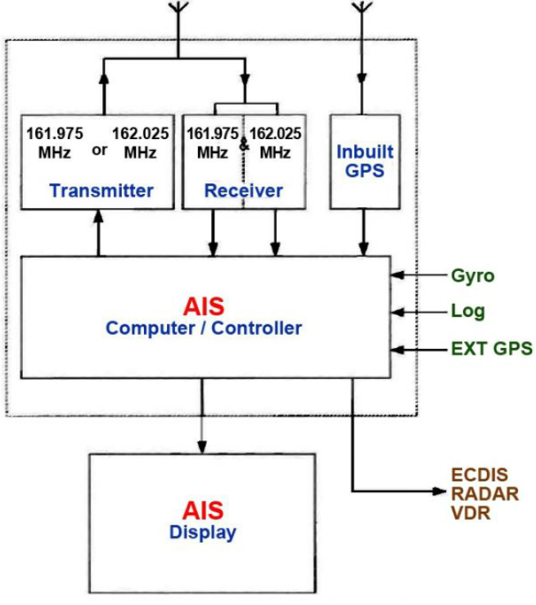

- How does AIS operate:
AIS stations communicate using a time-division multiple access (TDMA) communications scheme. Which means that the data link used is divided into a number of equal time slots which hold a set amount of data and are synchronized using GPS time. The primary methods by which AIS devices access the link (as detailed in ITU-R) are:
1. Self-organized (SOTDMA) is the basic access method for mobile stations. Stations preannounce when they are going to transmit and plan their transmissions based on slot use information collected from other stations in order to prevent slot collisions (two stations picking the same slot to transmit their data packet).
2. Random access (RATDMA)7 is used by AIS stations to access the link for unscheduled transmissions.
3. Fixed access (FATDMA)8 is used by AIS stations that have a requirement to transmit data at predetermined intervals, and involves the reservation of particular slots for their exclusive use.
4. Carrier Sense (CSTDMA) - known a ‘polite’ behavior is used by some mobile stations which can access the link only when they find a unused slot. These stations must listen to the beginning of a slot to detect occupancy and are therefore limited to a single slot transmission.
Land AIS networks rely upon communication towers, referred to as Base Stations that manage the network in a similar manner to telephone ‘cell’ towers. What makes AIS unique and very different from a mobile telephone network is the ability to ‘self-organize’. Simply, each AIS station is its own cell tower so its cell, or coverage area, moves with it. This is possible because the network is continuously self-organizing around the user, thus reducing the likelihood of ‘dropped call’.

- Protocol for data transmission:
AIS uses TDMA protocol, this is the method used to communicate amongst stations, using pre-defined messages which are exchanged between stations via four designed VHF frequencies.
The protocols, frequencies and the messages together are defined as the VHF data link (VDL). The VDL is similar to an internet email service where international compatibility s assured by a strict protocol, whatever the content of the message might be.
for AIS1 and AIS2, each minute of time (known as the ‘frame’) on each designed frequency is divided into 2250 slots, giving a total of 4500 for the two frequencies. Each frame of 2250 slots are repeated every minute. To ensure all units are synchronized, every AIS station contains a global navigation satellite system receiver (GNSS – GPS) which provides universal time coordinated (UTC) as a timing reference. If GNSS timing is lost, synchronization is provided by other mobile units or AIS base stations in the area.
Although AIS relies on GPS for timing it may also obtain its position reference from an external source. Any interference or loss of the GNSS signal will impact AIS data.

- Data exchange:
In addition to TDMA, AIS stations also use internationally adopted maritime digital interfaces and data sentences to exchange data amongst other devices, systems or networks. These facilities (the display and use of AIS information) on board the vessel and ashore, which enables the use of AIS to meet specific needs. On board the vessel the AIS provides data to the radar.
The data exchange using AIS is based on well-defined messages, occupying between 1 and 5 consecutive time slots.
the table below demonstrates the standard AIS messages:
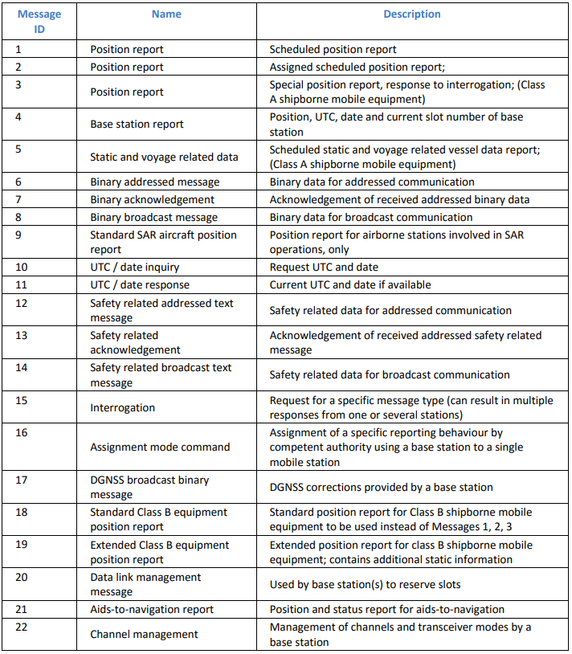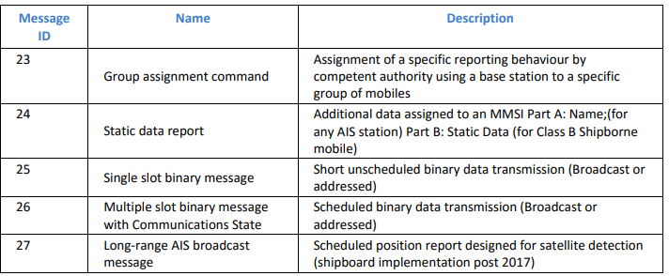
- Class A:
class A equipment complies with the IMO AIS performance standards. Important static ship-related information entered into the AIS memory are identity(i.e. name, call sign, MMSI), length and beam, type of ship and the location of the position-fixing antenna. Subsequent changes to these data require password access.

- Class B:
Class B are compatible with class A and are fully compliant with ITU requirements but report less frequently and at a lower power than class A.
There are two different variants of class B stations, with different access methods (self-organized TDMA and carrier-sense TDMA). Class B shipborne AIS stations are typically installed on non-SOLAS work craft and pleasure craft. Class B units are not user configurable. Because of this, the units must be configures by the manufacturer or their representative prior to use.

- AIS-SART:
a Search And Rescue Transponder (AIS-SART) is used in the final stages of the execution of a search to respond to the ‘locating’ element of the Global Maritime Distress and Safety System (GMDSS). An AIS-SART is capable of transmitting messages that indicate the position and safety information of a unit in distress and is compatible with existing AIS installations. The station will transmit a safety related text message containing ‘SART ACTIVE’ during an emergency and ‘SART TEST’ when under test.

References:
https://www.marineinsight.com/marine-safety/what-is-search-and-rescue-transponder-sart/
https://knowledgeofsea.com/automatic-identification-system/
https://marinacaspian.com/2018/10/%D8%B3%DB%8C%D8%B3%D8%AA%D9%85-ais/#:~:text=%D8%B3%DB%8C%D8%B3%D8%AA%D9%85%20%D8%B4%D9%86%D8%A7%D8%B3%D8%A7%DB%8C%DB%8C%20%D8%A7%D8%AA%D9%88%D9%85%D8%A7%D8%AA%DB%8C%DA%A9%20Automatic%20Identification,%D8%B4%D9%86%D8%A7%D8%B3%D8%A7%DB%8C%DB%8C%20%D8%A7%D8%AA%D9%88%D9%85%D8%A7%D8%AA%DB%8C%DA%A9%20%DB%8C%D8%A7%20AIS%20%D8%A7%D8%B3%D8%AA.
https://apsis.ir/%D8%B3%DB%8C%D8%B3%D8%AA%D9%85-%D8%B4%D9%86%D8%A7%D8%B3%D8%A7%DB%8C%DB%8C-%D8%A7%D8%AA%D9%88%D9%85%D8%A7%D8%AA%DB%8C%DA%A9-%DB%8C%D8%A7-ais-%DA%86%DB%8C%D8%B3%D8%AA%D8%9F/
https://1xcompany.com/%D8%B3%DB%8C%D8%B3%D8%AA%D9%85-ais/

