Script-1:

import math

import pandas as pd

import numpy as np

import matplotlib.pyplot as plt

import seaborn as sns

import joblib

from sklearn.model_selection import KFold

from sklearn.model_selection import train_test_split

from sklearn.linear_model import LinearRegression

from sklearn.ensemble import GradientBoostingRegressor

from sklearn.preprocessing import MinMaxScaler

from sklearn.metrics import mean_squared_error

%matplotlib inline

sns.set(font_scale=1.1, style="white")

sns_cmap = sns.color_palette().as_hex()

cpu_col = 'Resource Req. [e.g., CPU time]'

thr_col = 'Traffic Load [e.g., Mbit/s]'

def gen_benchmark(cpu, coeff1=1, coeff2=1):

    return coeff1 * math.log2(1 + coeff2 * cpu)

def synthetic_benchmark():

    cpu_list = np.arange(0.1, 1, .01)

    data = []

    for cpu in cpu_list:

        data.append([cpu, gen_benchmark(cpu, coeff2=100)])

    return pd.DataFrame(data, columns=[cpu_col, thr_col])

def inverse(thru, coeff2=1):

    return (1/coeff2) * (2**thru - 1)

df = synthetic_benchmark()

# sns.lineplot(df[cpu_col], df[thr_col])

sns.lineplot(df[thr_col], df[cpu_col])

cpu = [inverse(thr, coeff2=100) for thr in df[thr_col]]

sns.lineplot(df[thr_col], cpu)

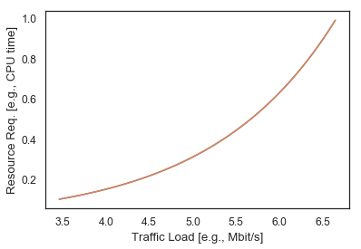

X = df[[thr_col]]

y = df[cpu_col]

lin_reg = LinearRegression()

lin_reg.fit(X, y)

lin_col = 'Linear'

df[lin_col] = lin_reg.predict(X)

joblib.dump(lin_reg, 'ml_models/synth_data/linear.joblib')

boost = GradientBoostingRegressor()

boost.fit(X, y)

boost_col = 'Boosting'

df[boost_col] = boost.predict(X)

joblib.dump(boost, 'ml_models/synth_data/boosting.joblib')

# nice fit

mean_squared_error(df[cpu_col], df[boost_col])

boost.predict([[10.0]])

inverse(10, coeff2=100)

# plotting for cpu 0-100

def plot_cpu_0_100():

    fig, ax = plt.subplots()

    fixed = 80

    # lines

    plt.plot(df[thr_col], df[cpu_col], label='True', color='black', linewidth=2)

    plt.plot(df[thr_col], df[lin_col], color='blue', linewidth=2)

    plt.axhline(y=fixed, label='Fixed', color='green', linewidth=2)

    # fill in between

    ax.fill_between(df[thr_col], df[cpu_col], fixed, where=df[cpu_col]<fixed, facecolor='white', edgecolor='grey', hatch='//')

    ax.fill_between(df[thr_col], df[lin_col], df[cpu_col], where=df[lin_col]<df[cpu_col], facecolor='lightgrey', edgecolor='grey', hatch='\\')

    # # text

    ax.text(10.5, 60, 'Over-allocation', bbox={'facecolor': 'white'})

    ax.annotate('Under-allocation', xy=(10.2, 5), xytext=(11, 5), arrowprops={'facecolor': 'black'}, verticalalignment='center')

    plt.xlabel(thr_col)

    plt.ylabel(cpu_col)

    plt.xlim(10)

    #plt.ylim(0, 1)

    plt.legend()

    fig.savefig('plots/example_alloc.pdf', bbox_inches='tight')

# plot_cpu_0_100()

# plotting for cpu 0-1

fig, ax = plt.subplots()

fixed = 0.8

# lines

plt.plot(df[thr_col], df[cpu_col], label='True', color='black', linewidth=2)

plt.plot(df[thr_col], df[lin_col], color=sns_cmap[0], linewidth=3, linestyle="dashed")

# plt.plot(df[thr_col], df[boost_col], color='red', linewidth=2)

plt.axhline(y=fixed, label='Fixed', color=sns_cmap[3], linewidth=3, linestyle="dotted")

# fill in between

ax.fill_between(df[thr_col], df[cpu_col], fixed, where=df[cpu_col]<fixed, facecolor='white', edgecolor='lightgrey', hatch='//')

ax.fill_between(df[thr_col], df[lin_col], df[cpu_col], where=df[lin_col]<df[cpu_col], facecolor='lightgrey')

# # text

ax.text(4, 0.5, 'Over-Allocation', bbox={'facecolor': 'white'})

ax.annotate('Under-Allocation', xy=(3.7, 0.05), xytext=(4.5, 0.1), arrowprops={'facecolor': 'black'}, verticalalignment='center')

plt.xlabel(thr_col)

plt.ylabel(cpu_col)

plt.xlim(3.5)

plt.ylim(0, 1)

plt.tick_params(axis='both', direction='inout', length=5, bottom=True, left=True, right=True, top=True)

plt.legend()

fig.savefig('plots/example_alloc.pdf', bbox_inches='tight')

# for presentation as png

fig.savefig('plots/example_alloc_lin.png', dpi=150, bbox_inches='tight')

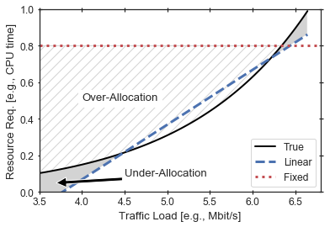

# 2nd: plot fixed resource alloc at 80%

fig, ax = plt.subplots()

fixed=0.8

# lines

plt.plot(df[thr_col], df[cpu_col], label='True', color='black', linewidth=2)

plt.axhline(y=fixed, label='Fixed', color='green', linewidth=2)

# fill in between

ax.fill_between(df[thr_col], df[cpu_col], fixed, where=df[cpu_col]<fixed, facecolor='white', edgecolor='lightgrey', hatch='//')

ax.fill_between(df[thr_col], df[cpu_col], fixed, where=df[cpu_col]>fixed, facecolor='lightgrey')

# # text

ax.text(4, 0.5, 'Over-allocation', bbox={'facecolor': 'white'})

ax.annotate('Under-allocation', xy=(6.5, 0.85), xytext=(6.25, 0.4), arrowprops={'facecolor': 'black'}, verticalalignment='center', horizontalalignment='center')

plt.xlabel(thr_col)

plt.ylabel(cpu_col)

plt.xlim(3.5)

plt.ylim(0, 1)

plt.legend()

fig.savefig('plots/example_alloc_fixed.png', dpi=150, bbox_inches='tight')

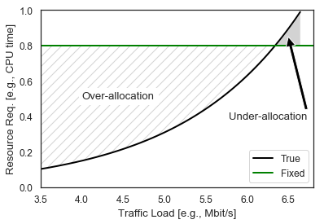

Script-2:

import warnings

warnings.simplefilter(action='ignore', category=FutureWarning)

import os

import math

import pandas as pd

import numpy as np

import matplotlib.pyplot as plt

import seaborn as sns

import joblib

from sklearn.base import BaseEstimator

from sklearn.model_selection import KFold, train_test_split, cross_val_score, GridSearchCV

from sklearn.linear_model import LinearRegression, Ridge

from sklearn.ensemble import RandomForestRegressor, GradientBoostingRegressor

from sklearn.svm import SVR

from sklearn.neural_network import MLPRegressor

from sklearn.preprocessing import LabelEncoder, StandardScaler, PolynomialFeatures

from sklearn.model_selection import train_test_split

from sklearn.preprocessing import MinMaxScaler

from sklearn.metrics import mean_squared_error

%matplotlib inline

sns.set(font_scale=3, style="white")

class FixedModel(BaseEstimator):

    def __init__(self, fixed_value):

        self.fixed_value = fixed_value

    def fit(self, X, y):

        return self

    def predict(self, X):

        n_samples = X.shape[0]

        return [self.fixed_value for _ in range(n_samples)]

# define column names

cpu_col = 'Resource req. [e.g., CPU]'

thr_col = 'Traffic load [e.g., Mbit/s]'

# generate synthetic data

def gen_benchmark(cpu, coeff1=1, coeff2=1):

    return coeff1 * math.log2(1 + coeff2 * cpu)

def synthetic_benchmark():

    cpu_list = np.arange(0.1, 1, .01)

    data = []

    for cpu in cpu_list:

        data.append([cpu, gen_benchmark(cpu, coeff2=100)])

    return pd.DataFrame(data, columns=[cpu_col, thr_col])

# inverse function to calculate cpu given a throughput

def inverse(thru, coeff2=1):

    return (1/coeff2) * (2**thru - 1)

# prepare data

df = synthetic_benchmark()

X = df[[thr_col]]

y = df[cpu_col]

def cross_validation_rmse(model, X, y, k=5, save_model=False):

    scores = cross_val_score(model, X, y, scoring="neg_mean_squared_error", cv=k)

    rmse = np.sqrt(-scores)

    name = type(model).__name__

    print(f"CV RMSE of {name}: {rmse.mean()} (+/-{rmse.std()})")

    if save_model:

        model.fit(X, y)

        joblib.dump(model, f'ml_models/synth_data/{name}.joblib')

    return rmse

def barplot_rmse(scores, labels, data_name):

    assert len(scores) == len(labels)

    rmse_mean = [s.mean() for s in scores]

    rmse_std = [s.std() for s in scores]

    x = np.arange(len(labels))

    fig, ax = plt.subplots(figsize = (8, 6))

    plt.barh(x, rmse_mean, color='grey', xerr=rmse_std, capsize=5)

    ax.set_xlabel('RMSE')

    ax.set_yticks(x)

    ax.set_yticklabels(labels)

    fig.savefig(f'plots/{data_name}_rmse.pdf', bbox_inches='tight')

models = [LinearRegression(), Ridge(), SVR(), RandomForestRegressor(),

          GradientBoostingRegressor(), MLPRegressor(max_iter=1500),

          FixedModel(fixed_value=0.8)]

labels = ['Linear', 'Ridge', 'SVR', 'Forest', 'Boosting', 'MLP', 'Fixed']

rmse = [cross_validation_rmse(model, X, y) for model in models]

barplot_rmse(rmse, labels, 'synth_default')

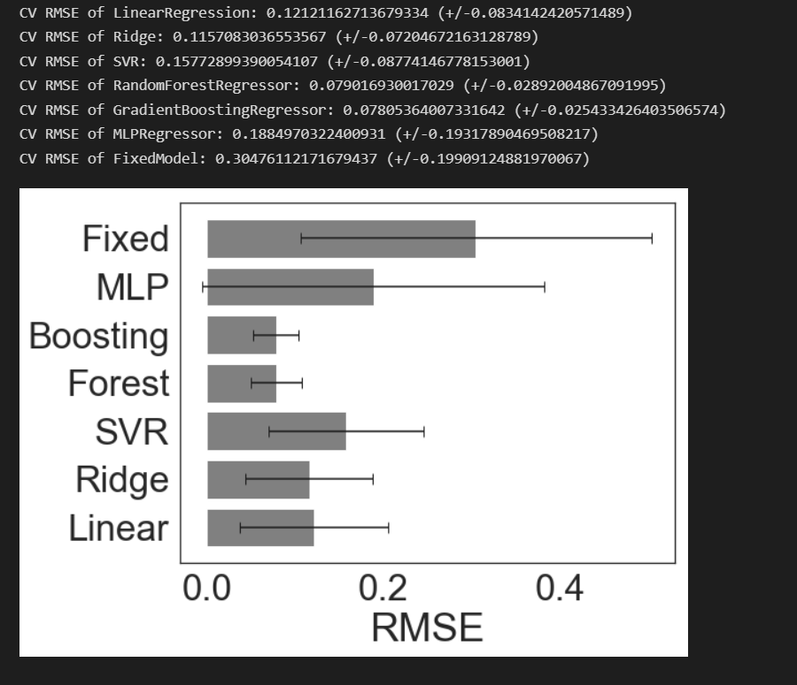

scaler = MinMaxScaler()

X_scaled = scaler.fit_transform(X)

os.makedirs(f'ml_models/synth_data', exist_ok=True)

joblib.dump(scaler, f'ml_models/synth_data/scaler.joblib')

rmse = [cross_validation_rmse(model, X_scaled, y) for model in models]

barplot_rmse(rmse, labels, 'synth_scaled')

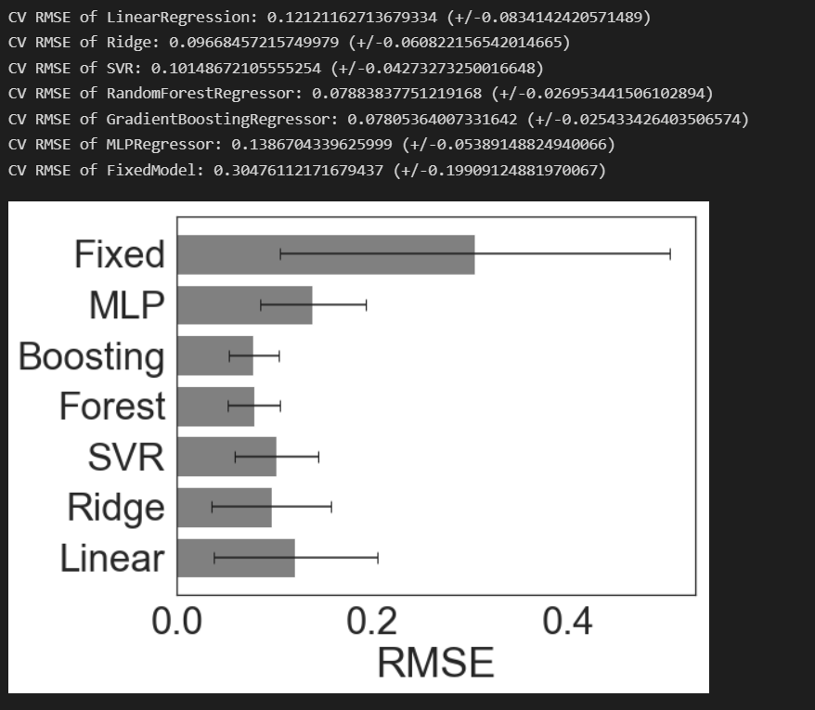

def tune_hyperparams(model, X, y, params):

    grid_search = GridSearchCV(model, params, cv=5, scoring="neg_mean_squared_error")

    grid_search.fit(X, y)

    return grid_search.best_estimator_

# hyperparam tuning

params_ridge = {'alpha': [0.1, 1, 10]}

params_svr = {'kernel': ['linear', 'poly', 'rbf'], 'C': [1, 10, 100],

              'epsilon': [0.001, 0.01, 0.1]}

params_forest = {'n_estimators': [10, 100, 200]}

params_boosting = {'learning_rate': [0.01, 0.1, 0.3], 'n_estimators': [10, 100, 200]}

params_mlp = {'hidden_layer_sizes': [(64,), (128,), (256)], 'alpha': [0.001, 0.0001, 0.00001],

              'learning_rate_init': [0.01, 0.001, 0.0001]}

params = [{}, params_ridge, params_svr, params_forest, params_boosting, params_mlp, {}]

models_tuned = [tune_hyperparams(models[i], X_scaled, y, params[i]) for i in range(len(models))]

rmse_tuned = [cross_validation_rmse(model, X_scaled, y, save_model=True) for model in models_tuned]

barplot_rmse(rmse_tuned, labels, 'synth_tuned')

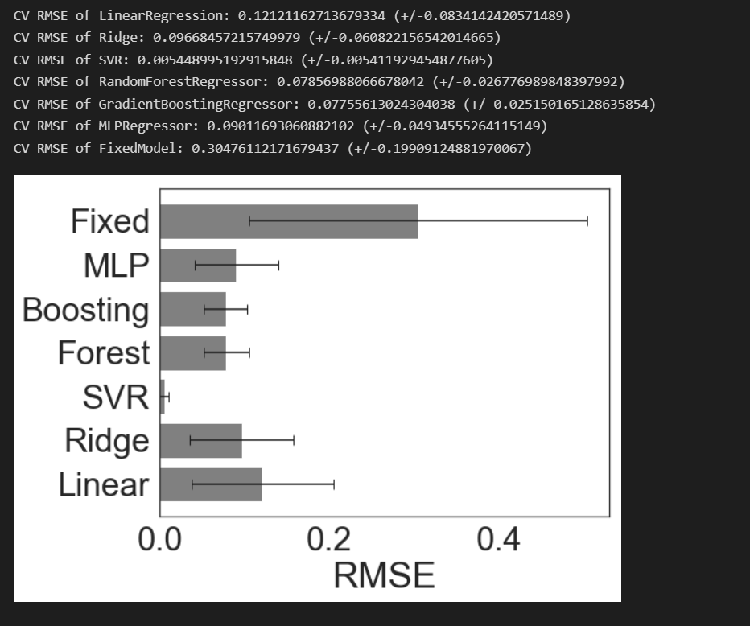

# plot

sns.set(font_scale=1, style="white")

def plot_predictions(models, labels, X, y):

    assert len(models) == len(labels)

    fig, ax = plt.subplots()

    plt.plot(X[thr_col], y, label='True', color='black', linewidth=2)

    for i in range(len(models)):

        models[i].fit(X, y)

        plt.plot(X[thr_col], models[i].predict(X), label=labels[i])

    plt.xlabel(thr_col)

    plt.ylabel(cpu_col)

    plt.ylim(0, 1)

    plt.legend()

plot_predictions(models_tuned, labels, X, y)

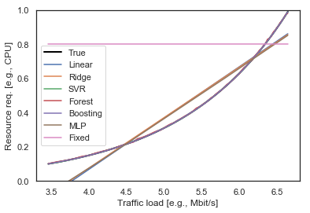

Script-3:

import warnings

warnings.simplefilter(action='ignore', category=FutureWarning)

import os

import pandas as pd

import numpy as np

import matplotlib.pyplot as plt

import seaborn as sns

import joblib

import time

from sklearn.base import BaseEstimator

from sklearn.model_selection import KFold, train_test_split, cross_val_score, GridSearchCV

from sklearn.linear_model import LinearRegression, Ridge

from sklearn.ensemble import RandomForestRegressor, GradientBoostingRegressor

from sklearn.svm import SVR

from sklearn.neural_network import MLPRegressor

from sklearn.preprocessing import LabelEncoder, StandardScaler, PolynomialFeatures

from sklearn.model_selection import train_test_split

from sklearn.preprocessing import MinMaxScaler

from sklearn.metrics import mean_squared_error

sns.set(font_scale=1.1, style='white')

class FixedModel(BaseEstimator):

    def __init__(self, fixed_value):

        self.fixed_value = fixed_value

    def fit(self, X, y):

        return self

    def predict(self, X):

        n_samples = X.shape[0]

        return [self.fixed_value for _ in range(n_samples)]

def select_and_rename(df, mapping):

    dff = df[list(mapping.keys())]

    # rename

    for k, v in mapping.items():

        dff.rename(columns={k: v}, inplace=True)

    return dff

def replaceSize(df):

    df["size"] = df["size"].str.replace("ab -c 1 -t 60 -n 99999999 -e /tngbench_share/ab_dist.csv -s 60 -k -i http://20.0.0.254:8888/", "small")

    df["size"] = df["size"].str.replace("ab -c 1 -t 60 -n 99999999 -e /tngbench_share/ab_dist.csv -s 60 -k http://20.0.0.254:8888/bunny.mp4", "big")

    df["size"] = df["size"].str.replace("ab -c 1 -t 60 -n 99999999 -e /tngbench_share/ab_dist.csv -s 60 -k -i -X 20.0.0.254:3128 http://40.0.0.254:80/", "small")

    df["size"] = df["size"].str.replace("ab -c 1 -t 60 -n 99999999 -e /tngbench_share/ab_dist.csv -s 60 -k -X 20.0.0.254:3128 http://40.0.0.254:80/bunny.mp4", "big")

    return df

# Load data from path

web1 = pd.read_csv("vnf_data/csv_experiments_WEB1.csv")

web2 = pd.read_csv("vnf_data/csv_experiments_WEB2.csv")

web3 = pd.read_csv("vnf_data/csv_experiments_WEB3.csv")

# do processing, renaming and selection

mapping = {

    "param__func__mp.input__cmd_start": "size",

    "metric__mp.input.vdu01.0__ab_transfer_rate_kbyte_per_second": "Max. throughput [kB/s]",

}

mapping01 = mapping.copy()

mapping01["param__func__de.upb.lb-nginx.0.1__cpu_bw"] = "CPU"

mapping01["param__func__de.upb.lb-nginx.0.1__mem_max"] = "Memory"

mapping02 = mapping.copy()

mapping02["param__func__de.upb.lb-haproxy.0.1__cpu_bw"] = "CPU"

mapping02["param__func__de.upb.lb-haproxy.0.1__mem_max"] = "Memory"

mapping03 = mapping.copy()

mapping03["param__func__de.upb.px-squid.0.1__cpu_bw"] = "CPU"

mapping03["param__func__de.upb.px-squid.0.1__mem_max"] = "Memory"

web1 = select_and_rename(web1, mapping01)

web2 = select_and_rename(web2, mapping02)

web3 = select_and_rename(web3, mapping03)

web1 = replaceSize(web1)

web2 = replaceSize(web2)

web3 = replaceSize(web3)

mem = 128

web1_small = web1.loc[(web1["size"] == "small") & (web1["Memory"] == mem)]

web1_small = web1_small[["Max. throughput [kB/s]", "CPU"]]

web1_big = web1.loc[(web1["size"] == "big")  & (web1["Memory"] == mem)]

web1_big = web1_big[["Max. throughput [kB/s]", "CPU"]]

web2_small = web2.loc[(web2["size"] == "small")  & (web2["Memory"] == mem)]

web2_small = web2_small[["Max. throughput [kB/s]", "CPU"]]

web2_big = web2.loc[(web2["size"] == "big")  & (web2["Memory"] == mem)]

web2_big = web2_big[["Max. throughput [kB/s]", "CPU"]]

web3_small = web3.loc[(web3["size"] == "small")  & (web3["Memory"] == mem)]

web3_small = web3_small[["Max. throughput [kB/s]", "CPU"]]

web3_big = web3.loc[(web3["size"] == "big")  & (web3["Memory"] == mem)]

web3_big = web3_big[["Max. throughput [kB/s]", "CPU"]]

num_measures = 20

measures = [0 for _ in range(num_measures)]

web1_small = web1_small.append(pd.DataFrame({'Max. throughput [kB/s]': measures, 'CPU': measures}), ignore_index=True)

web1_big = web1_big.append(pd.DataFrame({'Max. throughput [kB/s]': measures, 'CPU': measures}), ignore_index=True)

web2_small = web2_small.append(pd.DataFrame({'Max. throughput [kB/s]': measures, 'CPU': measures}), ignore_index=True)

web2_big = web2_big.append(pd.DataFrame({'Max. throughput [kB/s]': measures, 'CPU': measures}), ignore_index=True)

web3_small = web3_small.append(pd.DataFrame({'Max. throughput [kB/s]': measures, 'CPU': measures}), ignore_index=True)

web3_big = web3_big.append(pd.DataFrame({'Max. throughput [kB/s]': measures, 'CPU': measures}), ignore_index=True)

nginx = web1_small

haproxy = web2_small

squid = web3_small

def plot_vnf_data():

    sns.set(font_scale=1.1, style='white')

    fig, ax = plt.subplots()

    plt.scatter(nginx['Max. throughput [kB/s]'], nginx['CPU'], label='Nginx', marker='.')

    plt.scatter(haproxy['Max. throughput [kB/s]'], haproxy['CPU'], label='HAProxy', marker='+')

    plt.scatter(squid['Max. throughput [kB/s]'], squid['CPU'], label='Squid', marker='x')

    # labels

    ax.set_xlabel('Max. throughput [kB/s]')

    ax.set_ylabel('CPU')

    plt.legend()

    fig.savefig(f'plots/web_vnf_data.pdf', bbox_inches='tight')

plot_vnf_data()

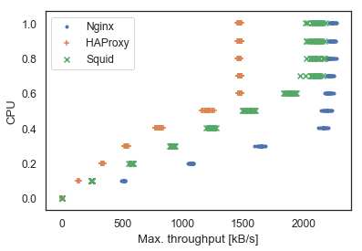

def cross_validation_rmse(model, X, y, vnf_name, k=5, save_model=False):

    scores = cross_val_score(model, X, y, scoring="neg_mean_squared_error", cv=k)

    rmse = np.sqrt(-scores)

    name = type(model).__name__

    print(f"CV RMSE of {name}: {rmse.mean()} (+/-{rmse.std()})")

    if save_model:

        model.fit(X, y)

        joblib.dump(model, f'ml_models/{vnf_name}/{name}.joblib')

    return rmse

def tune_hyperparams(model, X, y, params):

    grid_search = GridSearchCV(model, params, cv=5, scoring="neg_mean_squared_error")

    grid_search.fit(X, y)

    return grid_search.best_estimator_

def barplot_rmse(scores, labels, data_name):

    sns.set(font_scale=1.1, style='white')

    assert len(scores) == len(labels)

    # preparation

    rmse_mean = [s.mean() for s in scores]

    rmse_std = [s.std() for s in scores]

    x = np.arange(len(labels))

    # plot

    fig, ax = plt.subplots() #figsize = (8, 6))

    plt.barh(x, rmse_mean, color='grey', xerr=rmse_std, capsize=5)

    # labels

    ax.set_xlabel('RMSE')

    ax.set_yticks(x)

    ax.set_yticklabels(labels)

    fig.savefig(f'plots/{data_name}_rmse.pdf', bbox_inches='tight')

def train_eval_models(X, y, vnf_name, tune_params=False):

    # prepare models

    labels = ['Linear', 'Ridge', 'SVR', 'Forest', 'Boosting', 'MLP', 'Fixed']

    models = [LinearRegression(), Ridge(), SVR(), RandomForestRegressor(),

              GradientBoostingRegressor(), MLPRegressor(max_iter=1500),

              FixedModel(fixed_value=0.8)]

    # params for tuning

    params_ridge = {'alpha': [0.1, 1, 10]}

    params_svr = {'kernel': ['linear', 'poly', 'rbf'], 'C': [1, 10, 100],

                  'epsilon': [0.001, 0.01, 0.1]}

    params_forest = {'n_estimators': [10, 100, 200]}

    params_boosting = {'learning_rate': [0.01, 0.1, 0.3], 'n_estimators': [10, 100, 200]}

    params_mlp = {'hidden_layer_sizes': [(64,), (128,), (256)], 'alpha': [0.001, 0.0001, 0.00001],

                  'learning_rate_init': [0.01, 0.001, 0.0001]}

    params = [{}, params_ridge, params_svr, params_forest, params_boosting, params_mlp, {}]

    # tune, train, eval

    if tune_params:

        models = [tune_hyperparams(models[i], X, y, params[i]) for i in range(len(models))]

    rmse = [cross_validation_rmse(model, X, y, vnf_name, save_model=True) for model in models]

    # plot

    if tune_params:

        barplot_rmse(rmse, labels, f'{vnf_name}_tuned')

    else:

        barplot_rmse(rmse, labels, f'{vnf_name}_default')

    return models

def prepare_data(data, vnf_name):

    X = data[['Max. throughput [kB/s]']]

    y = data['CPU']

    X = X.fillna(X.median())

    scaler = MinMaxScaler()

    scaler.fit(X)

    os.makedirs(f'ml_models/{vnf_name}', exist_ok=True)

    joblib.dump(scaler, f'ml_models/{vnf_name}/scaler.joblib')

    return X, y, scaler

def predict_plot_all(models, scaler, X, y, vnf_name):

    sns.set(font_scale=1.1, style='white')

    models = [models[0], models[2], models[3], models[6]]

    labels = ['Linear', 'SVR', 'Boosting', 'Fixed']

    markers = ['x', 'v', '^', '+']

    colors = ['blue', 'orange', 'red', 'green']

    fig, ax = plt.subplots()

    plt.scatter(X, y, label='True', marker='o', color='black', s=50)

    X = scaler.transform(X)

    times = []

    for i, model in enumerate(models):

        name = type(model).__name__

        model.fit(X, y)

        os.makedirs(f'ml_models/{vnf_name}', exist_ok=True)

        X_plot = pd.DataFrame({'Max. Throughput [kB/s]': np.arange(200, 2500, 50)})

        X_plot_scaled = scaler.transform(X_plot)

        start = time.time()

        y_pred = model.predict(X_plot_scaled)

        times.append(start - time.time())

        plt.scatter(X_plot, y_pred, label=labels[i], marker=markers[i])

    plt.xlabel('Traffic Load [kB/s]')

    plt.ylabel('CPU')

    plt.tick_params(axis='both', direction='inout', length=5, bottom=True, left=True, right=True, top=True)

    plt.legend()

    # save, avoid cutting off labels

    plt.tight_layout()

    fig.savefig(f'plots/{vnf_name}_model_comparison.pdf')

    return times

def barplot_compare_rmse(scores_default, scores_tuned, labels, data_name):

    sns.set(font_scale=1.1, style='white')

    assert len(scores_default) == len(scores_tuned) == len(labels)

    x = np.arange(len(labels))

    width = 0.35

    # plot

    fig, ax = plt.subplots() # prev: figsize = (8, 5))

    # default

    rmse_mean = [s.mean() for s in scores_default]

    rmse_std = [s.std() for s in scores_default]

    ci95 = [1.96 * std / np.sqrt(len(rmse_std)) for std in rmse_std]

    ax.bar(x - width/2, rmse_mean, width, yerr=ci95, capsize=5, color='gray', label='Default')

    # same for tuned version

    rmse_mean = [s.mean() for s in scores_tuned]

    rmse_std = [s.std() for s in scores_tuned]

    ci95 = [1.96 * std / np.sqrt(len(rmse_std)) for std in rmse_std]

    ax.bar(x + width/2, rmse_mean, width, yerr=ci95, capsize=5, color='lightgray', label='Tuned')

    # labels

    ax.set_ylabel('RMSE')

    ax.set_xticks(x)

    ax.set_xticklabels(labels)

    ax.tick_params(axis='both', direction='inout', length=5, bottom=False, left=True, right=True, top=False)

    ax.legend()

    fig.savefig(f'plots/{data_name}_rmse.pdf', bbox_inches='tight')

def train_tune_eval_models(X, y, vnf_name):

    # prepare models and rmse without tuning

    labels = ['Linear', 'Ridge', 'SVR', 'Forest', 'Boosting', 'MLP', 'Fixed']

    models_default = [LinearRegression(), Ridge(), SVR(), RandomForestRegressor(),

              GradientBoostingRegressor(), MLPRegressor(max_iter=1500),

              FixedModel(fixed_value=0.8)]

    rmse_default = [cross_validation_rmse(model, X, y, vnf_name, save_model=False) for model in models_default]

    # hyperparam tuning

    params_ridge = {'alpha': [0.1, 1, 10]}

    params_svr = {'kernel': ['poly', 'rbf'], 'C': [1, 10, 100],

                  'epsilon': [0.001, 0.01, 0.1]}

    params_forest = {'n_estimators': [10, 100, 200]}

    params_boosting = {'learning_rate': [0.01, 0.1, 0.3], 'n_estimators': [10, 100, 200]}

    params_mlp = {'hidden_layer_sizes': [(64,), (128,), (256)], 'alpha': [0.001, 0.0001, 0.00001],

                  'learning_rate_init': [0.01, 0.001, 0.0001]}

    params = [{}, params_ridge, params_svr, params_forest, params_boosting, params_mlp, {}]

    models_tuned = [tune_hyperparams(models_default[i], X, y, params[i]) for i in range(len(labels))]

    rmse_tuned = [cross_validation_rmse(model, X, y, vnf_name, save_model=True) for model in models_tuned]

    barplot_compare_rmse(rmse_default, rmse_tuned, labels, f'{vnf_name}_default-tuned')

    return models_tuned

vnf_name = 'nginx'

X, y, scaler = prepare_data(nginx, vnf_name)

X_scaled = scaler.transform(X)

models = train_tune_eval_models(X_scaled, y, vnf_name)

predict_plot_all(models, scaler, X, y, vnf_name)

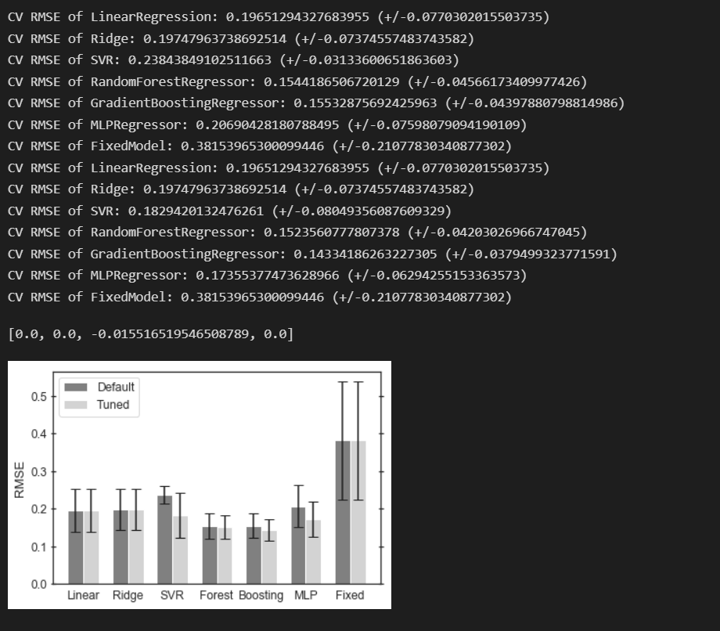

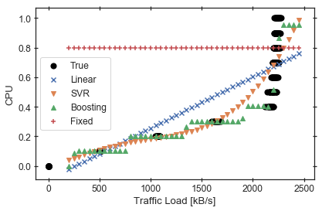

Script-4:

import pandas as pd

import numpy as np

import matplotlib.pyplot as plt

import matplotlib as mpl

import seaborn as sns

import sklearn

import yaml

import sys

import glob

import os

%matplotlib inline

sns.set(font_scale=1.1, style='white')

sns_cmap = sns.color_palette().as_hex()

def sum_cpu(node_res):

    cpu = sum([v['cpu'] for v in node_res])

    return cpu

def read_placement(placement, df_data, flow_dr=250):

    df_data['num_flows'].append(placement['input']['num_flows'])

    df_data['num_sources'].append(placement['input']['num_sources'])

    df_data['source_dr'].append(placement['input']['num_flows'] * flow_dr)

    df_data['num_instances'].append(placement['metrics']['num_instances'])

    df_data['max_e2e_delay'].append(placement['metrics']['max_endToEnd_delay'])

    df_data['total_delay'].append(placement['metrics']['total_delay'])

    df_data['runtime'].append(placement['metrics']['runtime'])

    df_data['total_cpu'].append(sum_cpu(placement['placement']['alloc_node_res']))

    return df_data

def read_results(results):

    data = {'num_sources' : [], 'num_flows': [], 'source_dr': [], 'num_instances': [],

            'max_e2e_delay': [], 'total_delay': [], 'runtime': [], 'total_cpu': []}

    # iterate through result files

    for res in glob.glob(results):

        # open and save metrics of interest

        with open(res, 'r') as f:

            placement = yaml.load(f, Loader=yaml.SafeLoader)

            data = read_placement(placement, data)

    return pd.DataFrame(data).sort_values(by=['num_flows'])

# read results

dataset = 'web_data'

sources = 'three_source_dr250'

results = f'placement_data/{dataset}/{sources}/'

df_true = read_results(results + 'true/*.yaml')

df_fixed = read_results(results + 'fixed/*.yaml')

df_linear = read_results(results + 'linear/*.yaml')

df_boost = read_results(results + 'boosting/*.yaml')

df_svr = read_results(results + 'svr/*.yaml')

df_ml = read_results(results + 'ml/*.yaml')

def plot(x_col, x_label, y_col, y_label, save_plot=True, plot_fixed=True):

    sns.set(font_scale=1.1, style='white')

    fig, ax = plt.subplots()

    if plot_fixed:

        plt.plot(df_fixed[x_col], df_fixed[y_col], label='Fixed', color=sns_cmap[3], marker='+',

                 linewidth=3, linestyle="dotted", markersize=10, markeredgewidth=1.5)

    plt.plot(df_linear[x_col], df_linear[y_col], label='Linear', color=sns_cmap[0], marker='x',

             linewidth=2, linestyle="dashed", markersize=7, markeredgewidth=1.5)

    plt.plot(df_ml[x_col], df_ml[y_col], label='SVR+Boosting', color=sns_cmap[2], marker='s',

             linewidth=2)

    plt.xlabel(x_label)

    plt.ylabel(y_label)

    plt.ylim(bottom=0)

    plt.tick_params(axis='both', direction='inout', length=5, bottom=True, left=True, right=True, top=True)

    plt.legend()

    plt.tight_layout()

    if save_plot:

        fig.savefig(f'plots/{dataset}_{y_col}.pdf')

    return fig, ax

plot('source_dr', 'Traffic Load [kB/s]', 'total_cpu', 'Total Allocated CPU')

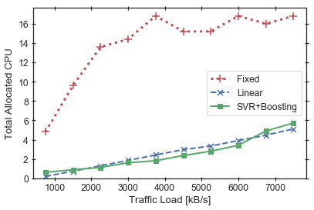

fig, ax = plot('source_dr', 'Traffic Load [kB/s]', 'total_cpu', 'Total Allocated CPU', plot_fixed=False)

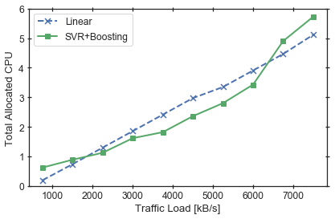

# plot both

def plot_both(x_col, x_label, y_col, y_label):

    sns.set(font_scale=1.1, style='white')

    fig, ax = plt.subplots(nrows=1, ncols=2, figsize=(8, 4))

    ax[0].plot(df_fixed[x_col], df_fixed[y_col], label='Fixed', color=sns_cmap[3], marker='+',

               linewidth=3, linestyle="dotted", markersize=10, markeredgewidth=1.5)

    ax[0].plot(df_linear[x_col], df_linear[y_col], label='Linear', color=sns_cmap[0], marker='x',

               linewidth=2, linestyle="dashed", markersize=7, markeredgewidth=1.5)

    ax[0].plot(df_ml[x_col], df_ml[y_col], label='SVR+Boosting', color=sns_cmap[2], marker='s',

               linewidth=2)

    ax[0].set(xlabel=x_label, ylabel=y_label)

    ax[0].set_ylim(bottom=0)

    ax[0].tick_params(axis='both', direction='inout', length=5, bottom=True, left=True, right=True, top=True)

#     ax[0].legend()

    ax[1].plot([], [], label='Fixed', color=sns_cmap[3], marker='+', linewidth=3,

               linestyle="dotted", markersize=10, markeredgewidth=1.5)

    ax[1].plot(df_linear[x_col], df_linear[y_col], label='Linear', color=sns_cmap[0], marker='x',

               linewidth=2, linestyle="dashed", markersize=7, markeredgewidth=1.5)

    ax[1].plot(df_ml[x_col], df_ml[y_col], label='SVR+Boosting', color=sns_cmap[2], marker='s',

               linewidth=2)

    ax[1].set(xlabel=x_label)

    ax[1].set_ylim(bottom=0)

    ax[1].tick_params(axis='both', direction='inout', length=5, bottom=True, left=True, right=True, top=True)

    ax[1].legend()

    # avoid cutting off figure labels

    plt.tight_layout()

    fig.savefig(f'plots/{dataset}_{y_col}_both.pdf')

plot_both('source_dr', 'Traffic Load [kB/s]', 'total_cpu', 'Total Allocated CPU')

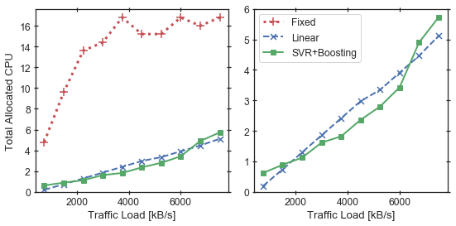

plot('source_dr', 'Traffic Load [kB/s]', 'num_instances', 'Number of Instances')

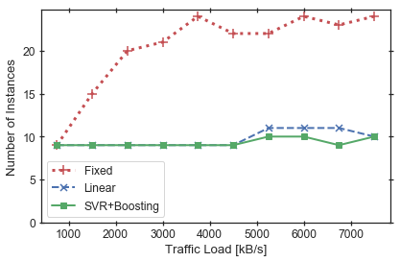

plot('source_dr', 'Traffic Load [kB/s]', 'total_delay', 'Total Delay [ms]')

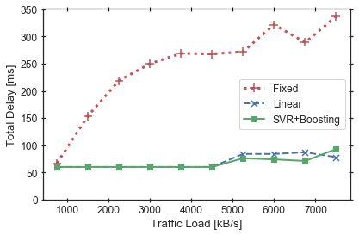

plot('source_dr', 'Traffic Load [kB/s]', 'max_e2e_delay', 'Max. End-to-End Delay [ms]')

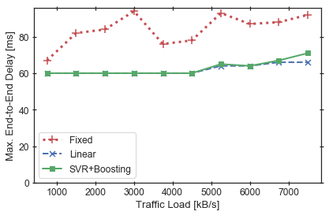

Script-5:

import warnings

warnings.simplefilter(action='ignore', category=FutureWarning)

import os

import pandas as pd

import numpy as np

import matplotlib.pyplot as plt

import seaborn as sns

import joblib

import random

import glob

import yaml

import timeit

import math

from sklearn.base import BaseEstimator

from sklearn.model_selection import KFold, train_test_split, cross_val_score, GridSearchCV

from sklearn.linear_model import LinearRegression, Ridge

from sklearn.ensemble import RandomForestRegressor, GradientBoostingRegressor

from sklearn.svm import SVR

from sklearn.neural_network import MLPRegressor

from sklearn.preprocessing import LabelEncoder, StandardScaler, PolynomialFeatures

from sklearn.model_selection import train_test_split

from sklearn.preprocessing import MinMaxScaler

from sklearn.metrics import mean_squared_error

sns.set(font_scale=1.1, style='white')

class FixedModel(BaseEstimator):

    def __init__(self, fixed_value):

        self.fixed_value = fixed_value

    def fit(self, X, y):

        return self

    def predict(self, X):

        n_samples = X.shape[0]

        return [self.fixed_value for _ in range(n_samples)]

# function for processing and simplifying the dataset

def select_and_rename(df, mapping):

    # select subset of columns

    dff = df[list(mapping.keys())]

    # rename

    for k, v in mapping.items():

        dff.rename(columns={k: v}, inplace=True)

    return dff

def replaceSize(df):

    df["size"] = df["size"].str.replace("ab -c 1 -t 60 -n 99999999 -e /tngbench_share/ab_dist.csv -s 60 -k -i http://20.0.0.254:8888/", "small")

    df["size"] = df["size"].str.replace("ab -c 1 -t 60 -n 99999999 -e /tngbench_share/ab_dist.csv -s 60 -k http://20.0.0.254:8888/bunny.mp4", "big")

    df["size"] = df["size"].str.replace("ab -c 1 -t 60 -n 99999999 -e /tngbench_share/ab_dist.csv -s 60 -k -i -X 20.0.0.254:3128 http://40.0.0.254:80/", "small")

    df["size"] = df["size"].str.replace("ab -c 1 -t 60 -n 99999999 -e /tngbench_share/ab_dist.csv -s 60 -k -X 20.0.0.254:3128 http://40.0.0.254:80/bunny.mp4", "big")

    return df

web1 = pd.read_csv("vnf_data/csv_experiments_WEB1.csv")

web3 = pd.read_csv("vnf_data/csv_experiments_WEB3.csv")

mapping = {

    "param__func__mp.input__cmd_start": "size",

    "metric__mp.input.vdu01.0__ab_transfer_rate_kbyte_per_second": "Max. throughput [kB/s]",

}

mapping01 = mapping.copy()

mapping01["param__func__de.upb.lb-nginx.0.1__cpu_bw"] = "CPU"

mapping01["param__func__de.upb.lb-nginx.0.1__mem_max"] = "Memory"

mapping03 = mapping.copy()

mapping03["param__func__de.upb.px-squid.0.1__cpu_bw"] = "CPU"

mapping03["param__func__de.upb.px-squid.0.1__mem_max"] = "Memory"

web1 = select_and_rename(web1, mapping01)

web3 = select_and_rename(web3, mapping03)

web1 = replaceSize(web1)

web3 = replaceSize(web3)

# select sub-datasets with small and large flows

# and with specific memory

mem = 128

web1_small = web1.loc[(web1["size"] == "small") & (web1["Memory"] == mem)]

web1_small = web1_small[["Max. throughput [kB/s]", "CPU"]]

web3_small = web3.loc[(web3["size"] == "small")  & (web3["Memory"] == mem)]

web3_small = web3_small[["Max. throughput [kB/s]", "CPU"]]

# add 20 "measurements" at 0 CPU and throuhgput

num_measures = 20

measures = [0 for _ in range(num_measures)]

web1_small = web1_small.append(pd.DataFrame({'Max. throughput [kB/s]': measures, 'CPU': measures}), ignore_index=True)

web3_small = web3_small.append(pd.DataFrame({'Max. throughput [kB/s]': measures, 'CPU': measures}), ignore_index=True)

def prepare_data(data):

    X = data[['Max. throughput [kB/s]']]

    y = data['CPU']

    X = X.fillna(X.median())

    scaler = MinMaxScaler()

    scaler.fit_transform(X)

    return X, y

def barplot(times, labels, ylabel='Time [s]', filename=None):

    assert len(times) == len(labels)

    times_mean = [np.array(t).mean() for t in times]

    print(times_mean)

    times_std = [np.array(t).std() for t in times]

    x = np.arange(len(labels))

    sns.set(font_scale=1.1, style='white')

    fig, ax = plt.subplots(figsize=(8, 4))

    plt.bar(x, times_mean, yerr=times_std, capsize=5, color='gray')

    ax.set_xticks(x)

    ax.set_xticklabels(labels)

    ax.set_ylabel(ylabel)

    if filename is not None:

        fig.savefig(f'plots/{filename}.pdf', bbox_inches='tight')

# prepare data

X_nginx, y_nginx = prepare_data(web1_small)

X_squid, y_squid = prepare_data(web3_small)

X = X_nginx

y = y_nginx

vnf_name = 'nginx'

# generate synthetic data

def gen_benchmark(cpu, coeff1=1, coeff2=1):

    return coeff1 * math.log2(1 + coeff2 * cpu)

def synthetic_benchmark(n):

    cpu_list = [random.random() for _ in range(n)]

    thr_list = [gen_benchmark(cpu, coeff2=100) for cpu in cpu_list]

    X = pd.DataFrame(data={'Throughput': thr_list})

    y = np.array(cpu_list)

    return X, y

def training_times(models, X, y, scaler):

    # measure training times

    times = []

    for model in models:

        print(type(model).__name__)

        X_scaled = scaler.transform(X)

        t = %timeit -o model.fit(X, y)

        times.append(t)

    return times

labels = ['Linear', 'Ridge', 'SVR', 'Forest', 'Boosting', 'MLP', 'Fixed']

models = [LinearRegression(), Ridge(), SVR(verbose=True), RandomForestRegressor(n_estimators=10),

          GradientBoostingRegressor(), MLPRegressor(max_iter=1500),

          FixedModel(fixed_value=0.8)]

model_names = [type(model).__name__ for model in models]

models = [joblib.load(f'ml_models/{vnf_name}/{name}.joblib') for name in model_names]

scaler = joblib.load(f'ml_models/{vnf_name}/scaler.joblib')

models = [joblib.load(f'ml_models/{vnf_name}/{name}.joblib') for name in model_names]

scaler = joblib.load(f'ml_models/{vnf_name}/scaler.joblib')

X_rand = pd.DataFrame(data={'Rand max. throughput': [random.randrange(0, 3000) for _ in range(1)]})

times = []

for model in models:

    print(type(model).__name__)

    X_scaled = scaler.transform(X_rand)

    t = %timeit -o model.predict(X_scaled)

    times.append(t)

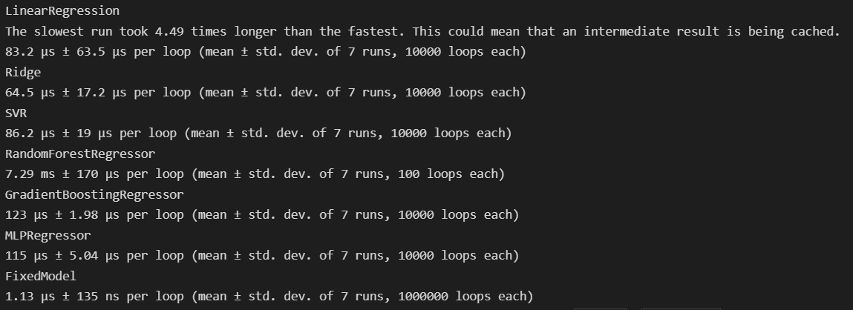

all_times_ms = [[i * 1000.0 / t.loops for i in t.all_runs] for t in times]

all_times_ms = [0.041868121428571416, 0.04201067571428731, 0.059522719999998634, 0.8912386999999821, 0.10723779999999741,

                0.06644656000000201, 0.0009462411285714519]

labels = ['Linear', 'Ridge', 'SVR', 'Forest', 'Boosting', 'MLP', 'Fixed']

barplot(all_times_ms, labels, ylabel="Prediction time [ms]", filename='prediction_times')

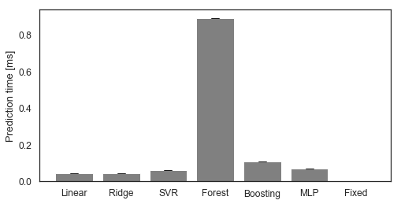

def sum_cpu(node_res):

    cpu = sum([v['cpu'] for v in node_res])

    return cpu

def read_placement(placement, df_data, flow_dr=250):

    df_data['num_flows'].append(placement['input']['num_flows'])

    df_data['num_sources'].append(placement['input']['num_sources'])

    df_data['source_dr'].append(placement['input']['num_flows'] * flow_dr)

    df_data['num_instances'].append(placement['metrics']['num_instances'])

    df_data['max_e2e_delay'].append(placement['metrics']['max_endToEnd_delay'])

    df_data['total_delay'].append(placement['metrics']['total_delay'])

    df_data['runtime'].append(placement['metrics']['runtime'])

    df_data['total_cpu'].append(sum_cpu(placement['placement']['alloc_node_res']))

    return df_data

def read_results(results):

    data = {'num_sources' : [], 'num_flows': [], 'source_dr': [], 'num_instances': [],

            'max_e2e_delay': [], 'total_delay': [], 'runtime': [], 'total_cpu': []}

    # iterate through result files

    for res in glob.glob(results):

        # open and save metrics of interest

        with open(res, 'r') as f:

            placement = yaml.load(f, Loader=yaml.SafeLoader)

            data = read_placement(placement, data)

    return pd.DataFrame(data).sort_values(by=['num_flows'])

# read results

dataset = 'web_data'

sources = 'runtime'

results = f'placement_data/{dataset}/{sources}/'

df_results = []

df_results.append(read_results(results + 'linear/*.yaml'))

df_results.append(read_results(results + 'ridge/*.yaml'))

df_results.append(read_results(results + 'svr/*.yaml'))

df_results.append(read_results(results + 'forest/*.yaml'))

df_results.append(read_results(results + 'boosting/*.yaml'))

df_results.append(read_results(results + 'mlp/*.yaml'))

df_results.append(read_results(results + 'fixed/*.yaml'))

# df_results.append(read_results(results + 'ml/*.yaml'))

labels = ['Linear', 'Ridge', 'SVR', 'Forest', 'Boosting', 'MLP', 'Fixed']

placement_times = [df['runtime'] for df in df_results]

barplot(placement_times, labels)

def comparison_barplot_one(pred_times, place_times, labels, filename=None):

    sns.set(font_scale=1.1, style='white')

    assert len(pred_times) == len(place_times) == len(labels)

    # prepare data

    pred_times_mean = [np.array(t).mean() for t in pred_times]

    pred_times_std = [np.array(t).std() for t in pred_times]

    place_times_mean = [np.array(t).mean() for t in place_times]

    place_times_std = [np.array(t).std() for t in place_times]

    x = np.arange(len(labels))

    width = 0.35

    # plot: separate axes

    fig, ax1 = plt.subplots(figsize = (8, 5))

    ax1.bar(x - width/2, pred_times_mean, width, yerr=pred_times_std, capsize=5, color='gray', label='Prediction')

    ax1.set_ylabel("Prediction time [ms]")

    ax1.set_xticks(x)

    ax1.set_xticklabels(labels)

    ax2 = ax1.twinx()

    ax2.bar(x + width/2, place_times_mean, width, yerr=place_times_std, capsize=5, color='lightgray', label='Placement')

    ax2.set_ylabel("Placement time [s]")

    # labels

    ax1.legend()

    if filename is not None:

        fig.savefig(f'plots/{filename}.pdf', bbox_inches='tight')

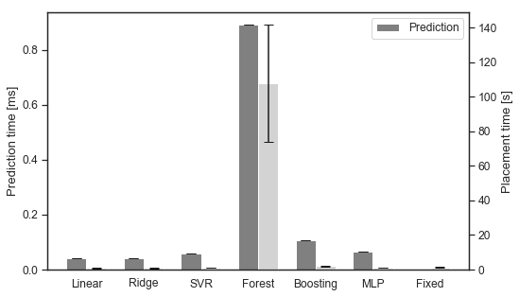

from matplotlib.ticker import ScalarFormatter

def comparison_barplot_two(pred_times, place_times, labels):

    sns.set(font_scale=1.1, style='white')

    assert len(pred_times) == len(place_times) == len(labels)

    fig, (ax1, ax2) = plt.subplots(nrows=1, ncols=2, sharey='all', figsize=(8, 4))

    # prepare data

    pred_times_mean = [np.array(t).mean() for t in pred_times]

    pred_times_std = [np.array(t).std() for t in pred_times]

    # 95% CI (not bootstrapped like seaborn does): https://en.wikipedia.org/wiki/Confidence_interval#Basic_steps

    pred_times_ci95 = [1.96 * std / np.sqrt(len(pred_times_std)) for std in pred_times_std]

    place_times_mean = [np.array(t).mean() for t in place_times]

    place_times_std = [np.array(t).std() for t in place_times]

    place_times_ci95 = [1.96 * std / np.sqrt(len(place_times_std)) for std in place_times_std]

    x = np.arange(len(labels))

    # plot: separate axes

    ax1.barh(x, pred_times_mean, xerr=pred_times_ci95, capsize=5, color='gray', label='Prediction')

    ax1.set_xlabel("Prediction Time [ms]")

#     ax1.set_xscale('log')

    ax1.set_yticks(x)

    ax1.set_yticklabels(labels)

    ax1.tick_params(axis='both', direction='inout', length=5, bottom=True, top=True)

    ax2.barh(x, place_times_mean, xerr=place_times_ci95, capsize=5, color='lightgray', label='Placement')

    ax2.set_xlabel("Total Time [s]")

    # log scale; avoid "power 10" labels

    ax2.set_xscale('log')

    ax2.tick_params(axis='both', direction='inout', length=5, bottom=True, top=True)

    ax2.xaxis.set_major_formatter(ScalarFormatter())

    plt.tight_layout()

    fig.savefig(f'plots/runtimes.pdf', bbox_inches='tight')

comparison_barplot_two(list(reversed(all_times_ms)), list(reversed(placement_times)), list(reversed(labels)))

