**1. Model of DB: class diagram**

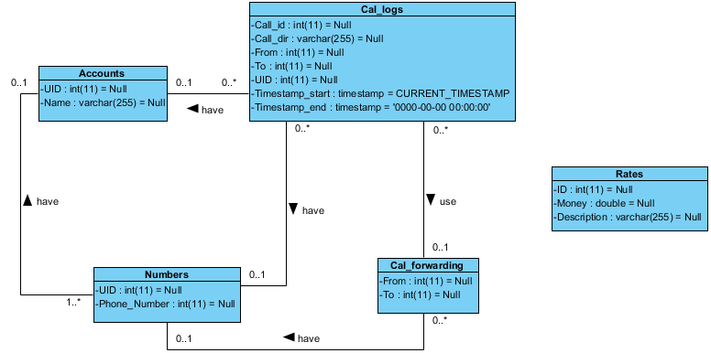

**2. SQL queries**

**1) Total expenses**

SELECT round(SUM(timestampdiff(second, Timestamp_start, Timestamp_end)*money),2) AS 'total expenses'

FROM Rates, Call_logs LEFT JOIN Call_forwarding ON Call_logs.To=Call_forwarding.From

WHERE ((Call_logs.To NOT IN (SELECT Call_forwarding.From FROM Call_forwarding)) AND (Call_logs.To IN (SELECT Numbers.Phone_Number FROM Numbers)) OR (Call_logs.To IN (SELECT Call_forwarding.From FROM Call_forwarding)) AND (Call_forwarding.To IN (SELECT Numbers.Phone_Number FROM Numbers))) AND Call_logs.Call_dir='out' AND money=(SELECT Rates.Money FROM Rates WHERE Rates.ID='1') OR

Call_logs.Call_dir='in' AND money=(SELECT Rates.Money FROM Rates WHERE Rates.ID='2') OR

((Call_logs.To NOT IN (SELECT Call_forwarding.From FROM Call_forwarding)) AND (Call_logs.To NOT IN (SELECT Numbers.Phone_Number FROM Numbers)) OR (Call_logs.To IN (SELECT Call_forwarding.From FROM Call_forwarding)) AND (Call_forwarding.To NOT IN (SELECT numbers.Phone_Number FROM Numbers))) AND Call_logs.Call_dir='out' AND money=(SELECT Rates.Money FROM Rates WHERE Rates.ID='3')

**Results for Query 1:**



**2) Top 10: most active users**

SELECT Call_logs.UID, Accounts.Name, SUM(timestampdiff(second, Timestamp_start, Timestamp_end)) AS 'total_time, sec'

FROM Call_logs LEFT JOIN Accounts ON Accounts.UID=Call_logs.UID

GROUP BY Call_logs.UID

ORDER BY SUM(timestampdiff(second, Timestamp_start, Timestamp_end)) DESC

LIMIT 10

**Results for Query 2:**

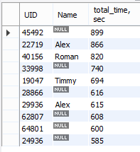

**3) Top 10: users with highest chargers and daily distribution for each of them**

SELECT Call_logs.UID, round(SUM(timestampdiff(second, Timestamp_start, Timestamp_end)*money),2) AS 'charges', SUM(timestampdiff(second, Timestamp_start, Timestamp_end)) AS 'total_time'

FROM Rates, Call_logs LEFT JOIN Call_forwarding ON Call_logs.To=Call_forwarding.From

WHERE ((Call_logs.To NOT IN (SELECT Call_forwarding.From FROM Call_forwarding)) AND (Call_logs.To IN (SELECT Numbers.Phone_Number FROM Numbers)) OR (Call_logs.To IN (SELECT Call_forwarding.From FROM Call_forwarding)) AND (Call_forwarding.To IN (SELECT Numbers.Phone_Number FROM Numbers))) AND Call_logs.Call_dir='out' AND money=(SELECT rates.Money FROM Rates WHERE Rates.ID='1') OR

Call_logs.Call_dir='in' AND money=(SELECT Rates.Money FROM Rates WHERE Rates.ID='2') OR

((Call_logs.To NOT IN (SELECT Call_forwarding.From FROM Call_forwarding)) AND (Call_logs.To NOT IN (SELECT Numbers.Phone_Number FROM Numbers)) OR (Call_logs.To IN (SELECT Call_forwarding.From FROM Call_forwarding)) AND (Call_forwarding.To NOT IN (SELECT Numbers.Phone_Number FROM Numbers))) AND Call_logs.Call_dir='out' AND money=(SELECT rates.Money FROM Rates WHERE Rates.ID='3')

GROUP BY Call_logs.UID

ORDER BY round(SUM(timestampdiff(second, Timestamp_start, Timestamp_end)*money),2) DESC

LIMIT 10

**Results for Query 3:**

