Tutorial of LiverT2sRelax
- LoadOrgImg: load the original images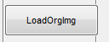

- Choose the series 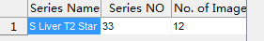

- LoadT2sMap: load the calculated T2* mapping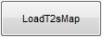

4. Choose a image with high contrast

5. Add ROI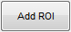
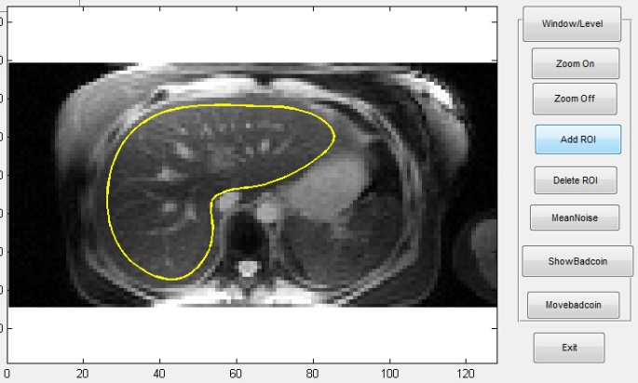

Add a whole liver ROI shown in the left figure for SAPE analysis.

Begin with left click of mouse
End up with right click of mouse

Or
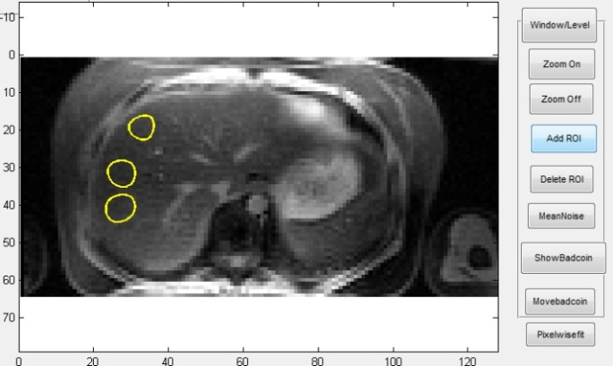

Add several small ROIs with mouse for mROI analysis

6. Delete ROI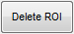
Delete the last added ROI
7. Choose a curve-fit model
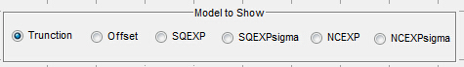
Note: NCEXPsigma is the default

8. Whole liver analysis
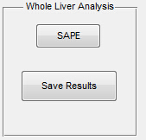
SAPE: calculate the R2* with the semiautomatic parenchyma extraction method combined with the NCEXP-fixsigma method.

Save Results: save the whole liver mask and all the resulting R2* values, including the ATF, PWFmedian and PWFmean R2*, save at the path of loaded images

NOTE: For the whole liver analysis, only NCEXP-fixsigma model is used.
SAPE:
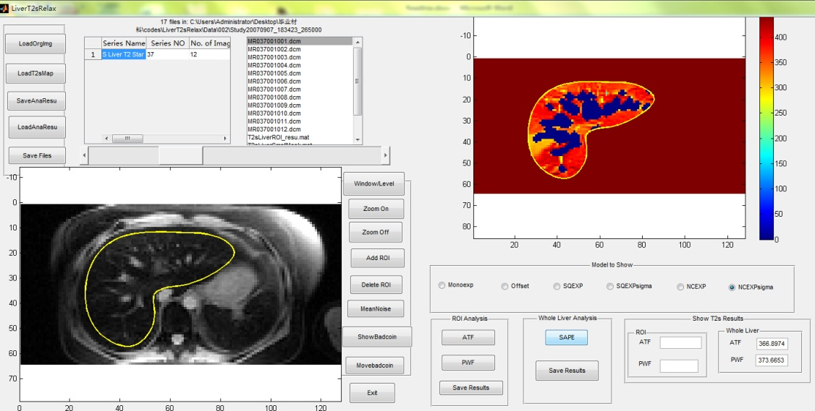

9. Showbadcoin: show the pixels of vessels after SAPE on the MainImg
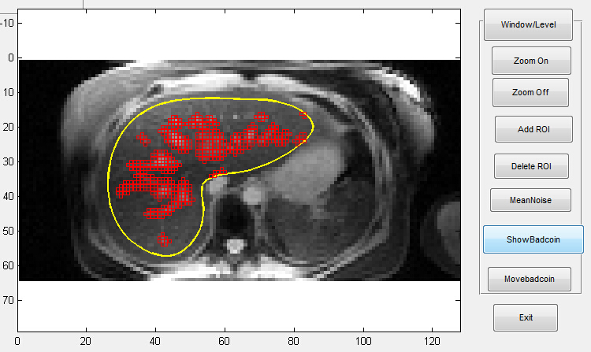
10. Movebadcoin: delete the pixels of vessels added by the ShowBadcoin
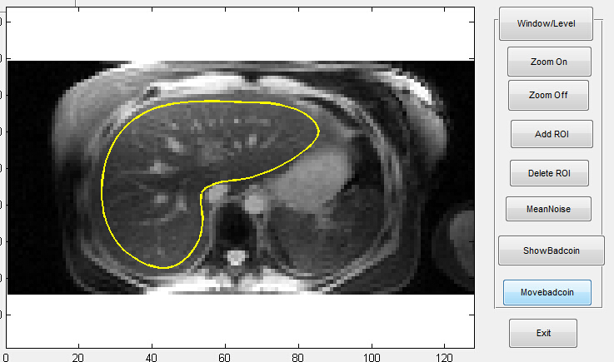

11. Resulting R2* show in
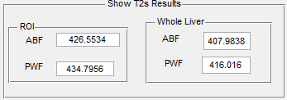
Note: For ROI, the default displayed results are for NCEXP-fixsigma model. If the model is choosed, the corresponding results will be shown. For the PWF, the median R2* is shown.

12. mROI Analysis
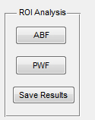
ABF: average before fitting, only one fit, the result will be shown on the Show T2s Results
PWF: pixel wise fitting, the median will be shown on the Show T2s Results. If the T2* map is loaded, it will takes little time. If not, the pixel wise fitting will be performed and takes long time.
Save Results: save the ROI mask and all the resulting R2* values for all models, save at the path of loaded images

Note: After ABF, several figures will be produced. If three ROI was drawn, the first curve is for ROI 1, second for ROI2, third for ROI3, and four for ROI1+ROI2+ROI3
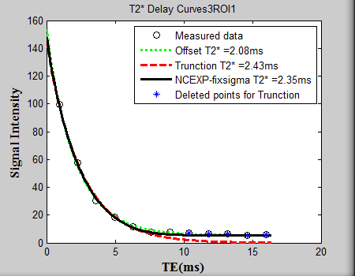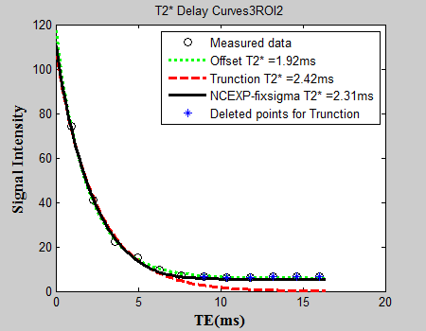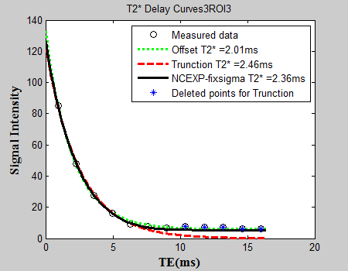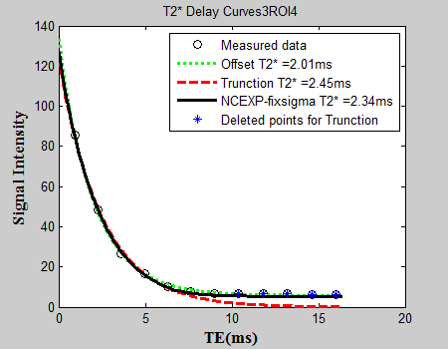
Resulting R2* show in
Note: For ROI,the default displayed results are for NCEXP-fixsigma model. If the model is choosed, the corresponding results will be shown. For the PWF, the median R2* is shown.

Other pushbuttons:
MeanNoise: calculate the standard deviation of the noise
Write to Excel: after both ROI analysis(3 ROIs is used) and Whole Liver Analysis, the results will be writen to excel.

